“AI assistant designer immediately creates a background that matches the image” GIST develops a 3D background atmosphere design system based on generative AI

- Professor Seungjun Kim’s research team proposes the ‘LumiMood’ system to create an effective 3D background atmosphere... Selected as a paper to be presented at the international academic conference ACM CHI 2024
- ‘LumiMood’ automatically adjusts the lighting and post-processing effects of the 3D background to match the image... Expects the creation of new forms of content and the creative potential of AI

▲ (From the left) Professor Seungjun Kim, doctoral student Jeongseok Oh, and undergraduate student Seungju Kim

Generative artificial intelligence (AI), such as ChatGPT, which solves given problems using learned data, is attracting attention around the world. A domestic research team has developed a technology that automatically suggests 3D background atmosphere by applying generative artificial intelligence to the design field, raising expectations for its potential use as a new creative tool.

The Gwangju Institute of Science and Technology (GIST, President Kichul Lim) announced that Professor Seungjun Kim's research team in the School of Integrated Technology has developed an algorithm for generating atmospheres in 3D backgrounds using generative AI and a user interface (UI) system that can be used effectively, called LumiMood.

This research outcome was recognized for its academic value and excellence and was presented on the 13th at CHI (Conference on Human Factors in Computing Systems)*, a prestigious international conference in the field of human-computer interaction (HCI) hosted by the American Computer Society (ACM).

* CHI 2024: Held in Honolulu, Hawaii, USA, May 11-16, 2024

‘LumiMood’ was developed to solve the problem of designers having to manually adjust complex parameters related to lighting and post-processing effects while creating 3D backgrounds.

Mood is a human creative element that can be created through a lot of experience and know-how, but there are limits to how designers can utilize it by referring to photos in a short period of time.

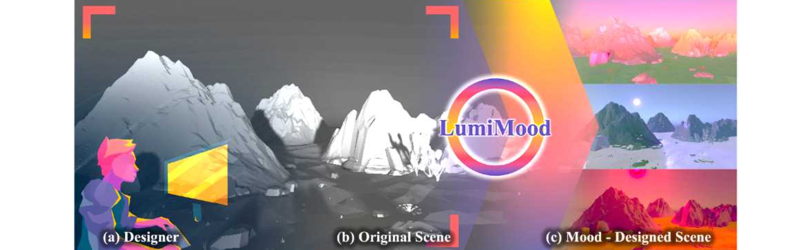▲ LumiMood system overview. LumiMood receives a 3D background as input from the designer and creates the atmosphere of the scene by adjusting lighting and post-processing effects.

The ‘LumiMood’ system combines generative artificial intelligence (AI), which has recently attracted attention, to suggest the atmosphere of a 3D background by automatically modifying lighting and post-processing effect parameters.

The research team used the image-emotion dataset to train an AI model that inputs specific emotional keywords and generates images that match them. This model allows designers to describe the desired atmosphere in natural language and easily create example images.

Once the image is created, ‘LumiMood’ automatically adjusts the lighting and post-processing effects of the 3D background to match the image. The ‘LumiMood’ system has a user interface (UI) that can work with Unity, the most widely used game engine, and was developed so that even users familiar with existing engines can easily use it.

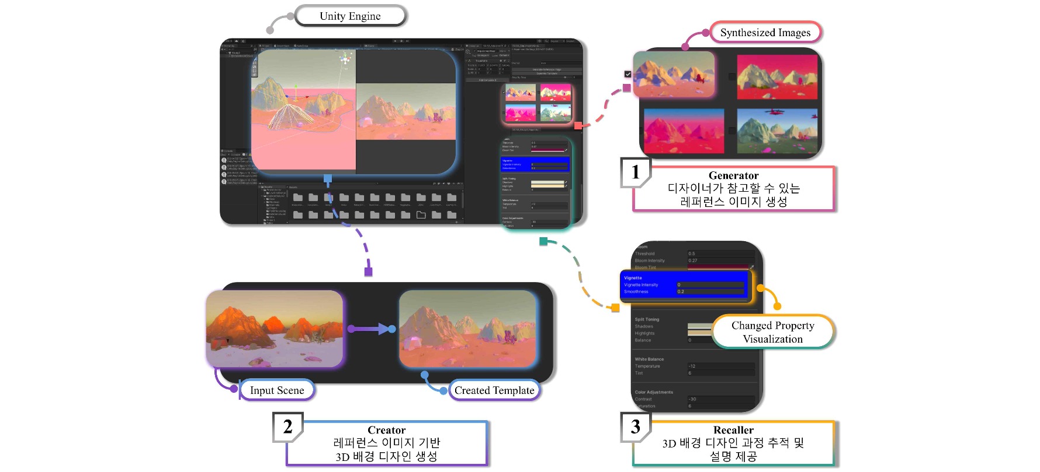▲ Creation of 3D background design. By training an AI image generation model with mood keywords, researchers developed a model that can synthesize references to the mood desired by designers. They implemented an algorithm that can adjust the lighting and post-processing of a given 3D background based on the generated reference image, and they proposed a system that can effectively convey this to designers.

The satisfaction evaluation for ‘LumiMood’ was conducted on 40 experts and novice designers. As a result of the survey, 88% of all respondents were satisfied with the design proposed by 'LumiMood'. In particular, expert designers said that when using 'LumiMood', the number of manipulations was reduced by 49% until a satisfactory design was realized. As a result, They answered that design time was reduced by 25%.

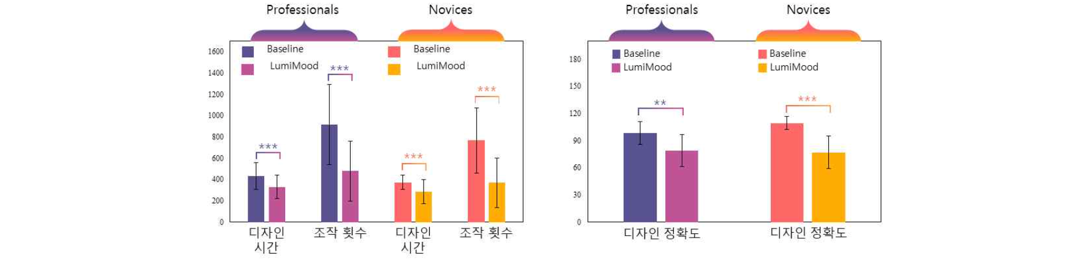▲ User evaluation results for expert and novice designers. When expert and novice designers used the system developed in this study, they were able to produce better designs with less time and effort.

In addition, the researchers analyzed the impact of design automation by AI on the design process through ‘LumiMood’ research.

These results can be used to provide direction on how currently emerging AI design systems should be implemented considering users.

Professor Seungjun Kim said, "Artificial intelligence is already enabling automation in various visual arts fields such as character design, background production, and special effects with reduced cost and time benefits. When ‘LumiMood’ is applied to an actual work environment, it is expected to improve productivity by helping designers reduce the effort and time they spend to achieve a desired background atmosphere while continuously changing complex parameters."

This research, led by Professor Seungjun Kim of the GIST School of Integrated Technology and conducted by doctoral student Jeongseok Oh, was supported by the Culture, Sports and Tourism Research and Development Support Project. Professor Seungjun Kim is currently an adjunct professor at the GIST AI Graduate School and is conducting research on the development of intelligent interactive technology using AI to improve accessibility to digital systems for human users.

The HCIS Lab (Human-Centered Intelligent Systems Lab), led by Professor Seungjun Kim, was recognized for its excellence by presenting three full-paper papers and two poster papers at the ACM CHI conference, and 'LumiMood' research will be conducted at the HCIS Lab in 2024. The ‘LumiMood’ research was conducted with support from the HCI + AI convergence research for human-centered physical system design in 2024 (GIST-MIT joint research project).



