GIST develops new anode material for ‘non-flow zinc-bromine battery’ Applying nitrogen-doped carbon material... Confirming self-discharge suppression, high-efficiency charging and discharging performance, and overwhelming durability

- Professor Chanho Pak’s team at the Graduate School of Energy Convergence overcame the ‘crossover’ phenomenon, the cause of performance degradation of non-flow zinc-bromine water batteries... Achieving an average charge/discharge efficiency of 96% and energy efficiency of 76.6%
- Expected use of future energy storage system (ESS) with high performance and stability without risk of fire... Published in ‘Chemical Engineering Journal’, a renowned international academic journal in the field of chemical engineering

▲ (From the left) Professor Chanho Pak, integrated master’s and doctoral program student Youngin Cho, Dr. Jong Gyeong Kim, and master’s student Dong Hee Kim.

A technology has been developed that overcomes low performance, a chronic drawback of non-flow zinc-bromine water-based batteries, which are attracting attention as next-generation batteries. It is expected to accelerate the development of practical energy storage systems (ESS) that combine high performance and stability.

The Gwangju Institute of Science and Technology (GIST, President Kichuk Lim) announced that Professor Chanho Pak's research team at the Graduate School of Energy Convergence has developed carbon current collector* technology for the anode of a non-flow zinc-bromine water-based battery.

* current collector: During the battery manufacturing process, the electrode process goes through the process of uniformly coating the current collector with a slurry mixed with various materials such as active materials and solvents. In this case, the current collector refers to a film with a thickness of about 10 μm (micrometer), and it plays the role of transferring electrons from the outside to the active material or conversely sending them out from the active material so that an electrochemical reaction occurs when charging and discharging the battery.

The positive electrode of the battery is composed of positive active material, conductive material, binder, and current collector, and determines the capacity of the battery.

A no-flow zinc-bromine water battery is a device that stores energy by utilizing the redox reaction of zinc and bromine. There is no possibility of ignition due to the use of a water-based electrolyte, and the ‘no-flow’ method that removes the electrolyte reservoir and pump from existing batteries is inexpensive to manufacture and has the advantage of a long lifespan.

However, the problem of performance degradation due to bromine crossover* phenomenon during the charging process is an obstacle to commercialization.

* bromine crossover: During the battery charging process, bromine ions form bromine and bromine complexes inside the positive electrode, which diffuse to the negative electrode, oxidizing the zinc metal electrodeposited on the negative electrode and causing a self-discharge reaction, resulting in poor battery performance and life.

To solve this phenomenon of reduced performance, much research is being done on electrolyte additives and separators, but additive technology causes problems such as uneven dispersion of the electrolyte and increased resistance. Separation membrane technology has the problem that it is difficult to completely block bromine diffusion and the overall cost increases.

In addition, in order to be commercialized as an energy storage device (ESS) electrode, it is essential to develop an electrode that can store more active materials per single cell. In this case, the characteristics required for the anode material are high capacity and structural stability at high temperature and high voltage.

The research team improved the performance and stability of the battery by uniformly forming nitrogen-doped mesoporous carbon across the entire graphite felt (GF) electrode, and it can be applied as an anode for a practical no-flow zinc-bromine water-based battery system.

Furthermore, this carbon material was uniformly applied to the entire thick GF using the evaporation-induced self-assembly method* to create an anode that changes structural and chemical properties.

* evaporation-induced self-assembly (EISA): A method of inducing self-assembly of precursors and surfactants by slowly evaporating the solvent from an organic solvent solution containing the precursor.

The newly developed carbon material ▴ forms stable medium-sized pores of 3-5 nm, ▴ increases the affinity for the aqueous solution of the graphite felt anode with appropriate oxygen and nitrogen contents, and ▴ stores bromine and bromine conjugates generated during the charging process. It adsorbed to suppress the bromine crossover phenomenon and showed excellent oxidation/reduction reaction dynamics during a stable charge and discharge process.

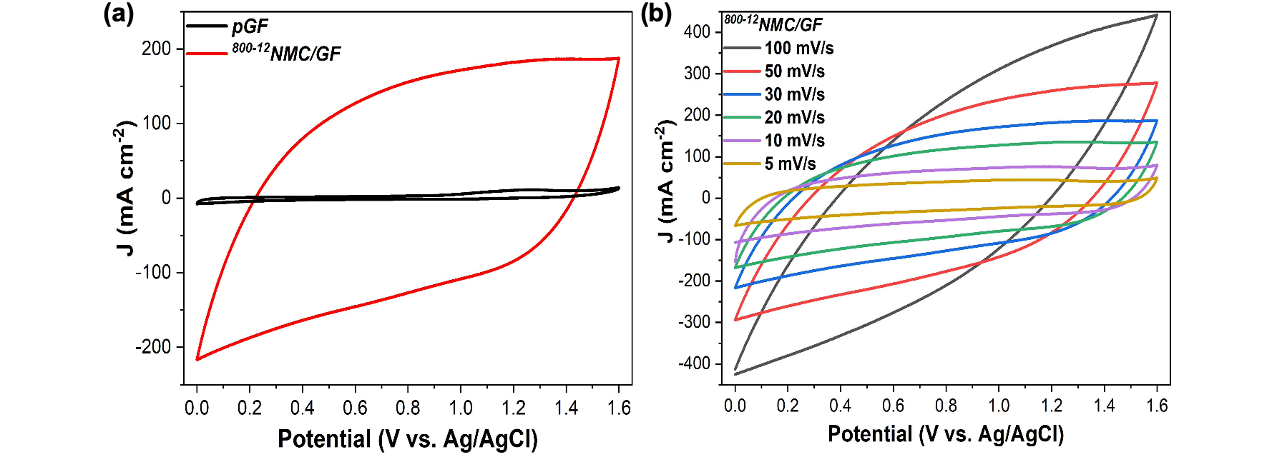▲ Comparison of bromine oxidation/reduction reaction kinetics of graphite felt anodes developed in this study (left) and evaluation of reversibility as a function of scan rate (right): Cyclic voltammetry experiments during electrochemical evaluation show improved reactivity and reversibility through the introduction of the developed carbon material compared to conventional graphite felt.

In a long-term battery operation evaluation of over 10,000 cycles, it showed excellent cell performance with an average charge/discharge efficiency of 96% and energy efficiency of 76.6% and unprecedented durability, confirming its potential for use as an anode.

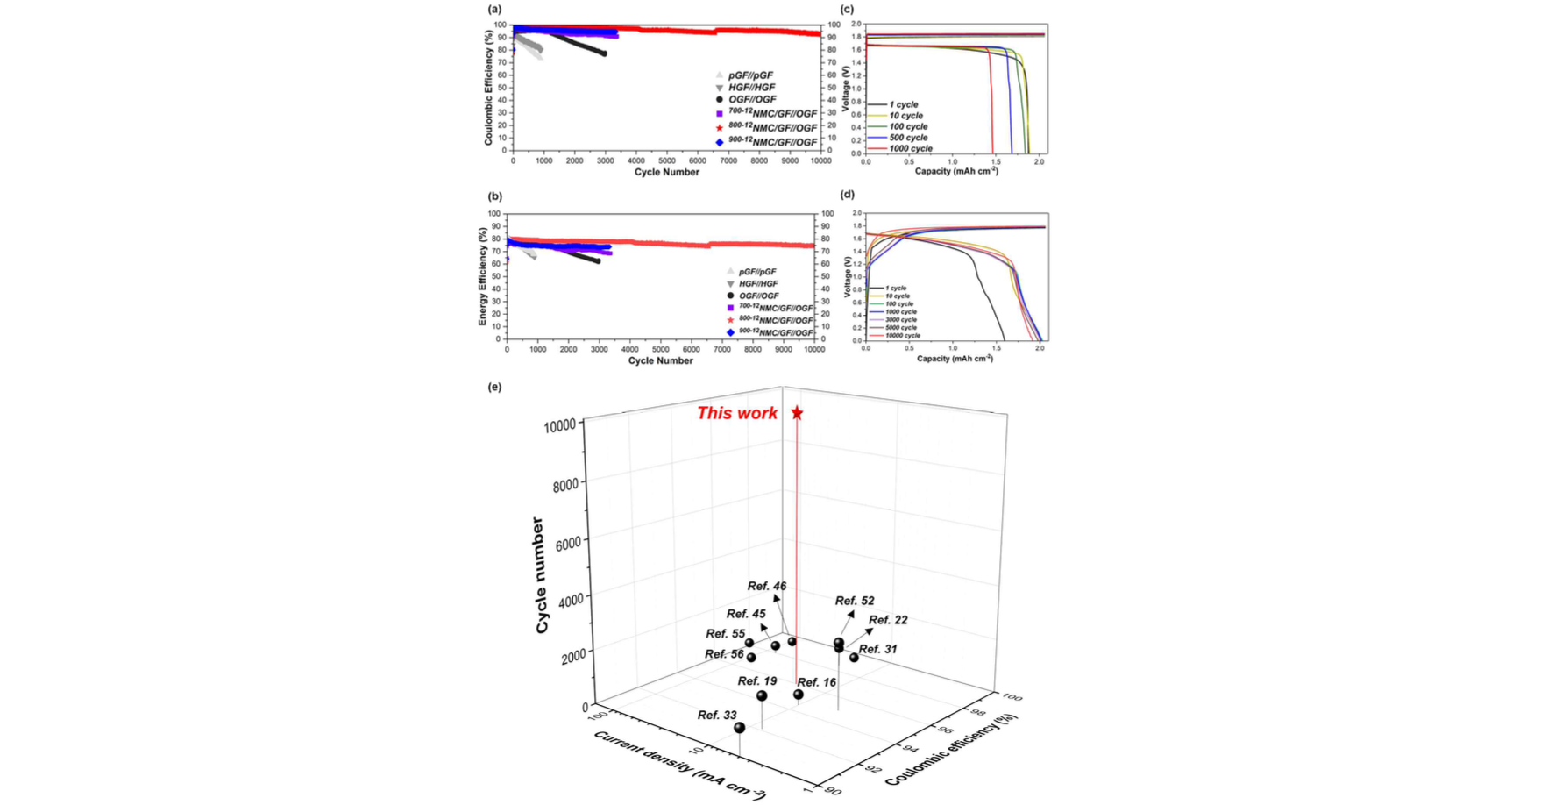▲ Comparison of unit battery evaluation results for each graphite felt anode: The charge/discharge and energy efficiency results shown in the battery operation evaluation over 10,000 cycles and the charge/discharge voltage graph for each cycle show the excellence of the graphite felt anode developed in this study. Compared to battery evaluation results shown in other studies, it shows overwhelmingly excellent durability.

GIST Professor Chanho Pak said, "The results of this research will accelerate the development of practical energy storage systems (ESS) made of economical, non-flow water-based batteries. In the future, it is expected to emerge as a next-generation technology that can solve the fire problem of current ESS made of lithium-ion batteries."

This research, led by Professor Chanho Pak of the GIST Graduate School of Energy Convergence and conducted by integrated course student Youngin Cho, was supported by a joint research project from the National Institute of Science and Technology of the Ministry of Science and ICT and was published online on April 22, 2024, in ‘Chemical Engineering Journal’, a top 3.5% international academic journal in the field of chemical engineering.



