GIST develops a non-cathode lithium metal battery with improved performance and stability by introducing a three-dimensional integrated structure

- The joint research team of Professors KwangSup Eom and Gun Young Jung of the School of Materials Science and Engineering used existing lithium-ion batteries to limit the growth of lithium on the surface while increasing storage efficiency, more than doubling the energy density and confirming stability during about 190 charge and discharge cycles
- Solves the key issues of developing next-generation lithium metal batteries and lays the foundation for research on ultra-high energy density non-cathode lithium batteries... Published in the top international academic journal ‘Energy & Environmental Science’

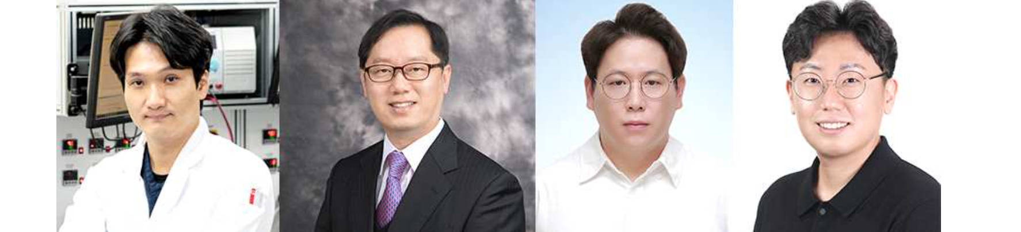▲ (From left) Professor KwangSup Eom, Professor Gun Young Jung, Dr. Ki-Yeop Cho, and Dr. Sungjun Cho

As interest in renewable energy policies increases to respond to the global climate change crisis, interest is also growing in the development of next-generation secondary batteries with high energy density to effectively respond to the volatility of renewable energy.

The Gwangju Institute of Science and Technology (GIST, President Kichul Lim) announced that a joint research team led by Professor KwangSup Eom and Professor Gun Young Jung of the School of Materials Science and Engineering has developed a technology to increase the durability and stability of lithium metal batteries by stably storing lithium using a three-dimensional integrated structure* as a carrier for lithium metal.

* 3D-integrated architecture: A three-dimensional lithium carrier manufactured by stacking materials with different properties.

Lithium-ion batteries, which are currently widely used, use graphite as an anode material, and if this is replaced with a lithium metal anode, the energy density* can be increased by more than two times while using the existing lithium-ion battery system.

However, the unstable reactivity of lithium metal anodes and the growth of dendritic crystals due to low charge/discharge efficiency, volume expansion, and battery explosion risk are obstacles to the commercialization of lithium metal batteries*.

* energy density: The total amount of energy that a battery can store. Generally expressed per volume (Wh/L) or weight (Wh/kg) of the battery.

* lithium dendrite: A phenomenon in which lithium metal grows into a non-uniform and sharp shape on the surface of the cathode during the battery charging and discharging process.

* lithium metal battery: A battery that uses lithium metal as a negative electrode material in the current lithium-ion battery system.

Recently, efforts to overcome the technical limitations of lithium metal cathodes by utilizing a three-dimensional lithium carrier* to store lithium metal inside it have received a lot of industrial and academic attention, but it has been pointed out that it is difficult to store lithium metal stably due to lithium precipitation on the surface of the carrier.

* three-dimensional lithium carrier (3D-structured host): A cell component that is designed in three dimensions to have an internal volume that replaces the two-dimensional planar collector provided for the function of supplying current to the electrodes inside the battery.

The research team paid attention to the fact that the lithium affinity of different metals varies depending on the degree of inconsistency between lithium metal and the internal crystal structure of the material, and the precipitation location of lithium metal can be adjusted accordingly.

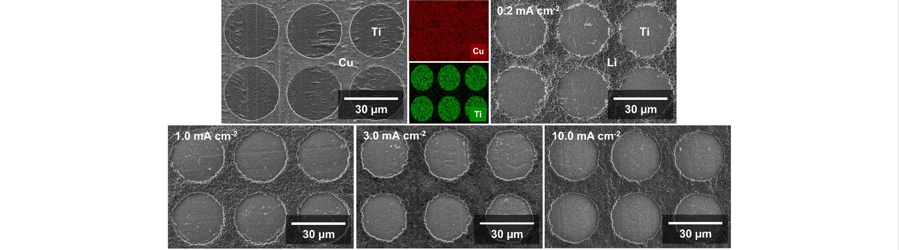▲ Electron microscope image of lithium metal with controlled precipitation location. Lithium metal does not precipitate on the surface of titanium (Ti), which has a large crystallographic mismatch with lithium (Li), and lithium metal precipitates only on the surface of copper (Cu), which has a relatively small mismatch. The precipitation site of lithium has high selectivity even at high current densities.

The site selectivity of lithium precipitation was confirmed by forming a titanium (Ti) pattern with a large crystallographic mismatch with lithium metal on the surface of a commercial copper thin film, and it was proven that the location of lithium precipitation can be controlled with high selectivity even at high current densities.

The research team also designed a three-dimensional integrated structure to improve the low lithium storage efficiency of the three-dimensional lithium carrier. The wet-etching* method was introduced in the design of the integrated structure to simplify the manufacturing stage of the integrated structure. In particular, an approach was developed to increase the storage efficiency of lithium while limiting dendritic growth of lithium by using copper chloride, a by-product of the etching reaction, to increase the affinity for lithium inside the carrier.

* wet-etching: A selective etching method that creates patterns using differences in the reactivity of materials to specific etchants.

The research team confirmed that the cycle life of the lithium metal anode increased by more than two times when a three-dimensional integrated structure was introduced compared to when a general three-dimensional support was used.

Commercial copper thin films and general three-dimensional carriers experienced short circuit* after about 80 charge/discharge cycles, but the developed three-dimensional integrated structure showed stable performance for about 190 cycles.

* short-circuit: A phenomenon in which two parts with a potential difference come into electrical contact. Excessive current may flow at the contact point, causing fire or explosion due to heat generation.

In addition, the performance and stability of the non-cathode lithium metal battery*, which is evaluated as the most advanced next-generation battery system, were significantly improved, proving the excellence of the three-dimensional integrated structure.

* anode-free lithium metal batteries: Batteries that do not use anode materials but only use lithium stored in the anode material (see the glossary).

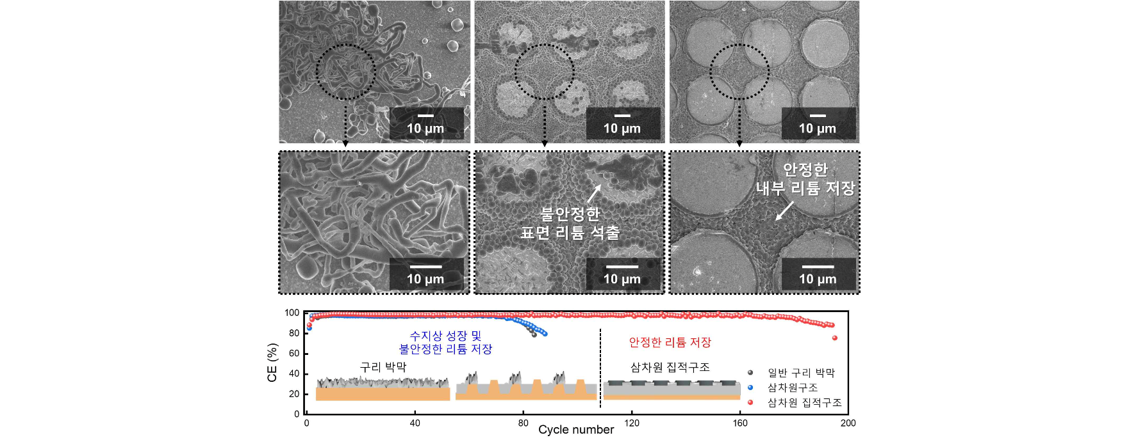▲ Comparison of lithium storage behavior of copper thin film, general three-dimensional structure, and three-dimensional integrated structure. (Top) Electron micrograph after lithium precipitation reaction, (Bottom) Comparison of cycle performance of lithium metal anode.

Professor KwangSup Eom said, "This research result suppresses the formation of lithium dendrites, which has been the biggest problem in the development of next-generation lithium metal batteries and also confirms that lithium electrodeposition behavior can be controlled through materials. It is significant in that it has laid the foundation for future research on ultra-high energy density non-cathode lithium batteries."

This research, led by Professor KwangSup Eom and Professor Gun Young Jung of the GIST School of Materials Science and Engineering and led by Dr. Ki-Yeop Cho and Dr. Sungjun Cho, was conducted with support from the National Research Foundation of Korea's Mid-career Researcher Support Project and the GIST Next Generation Energy Research Institute, and the research results are in the fields of energy and environmental science and was recently published in the top international academic journal 'Energy & Environmental Science' (IF=32.5, JCR top 0.5%).



