“Human-Centered XR Experiences Break the Boundary between Reality and Virtuality” Seungjun Kim's team receives two honorable mentions at ACM CHI 2024

- “More realistic walking in a virtual environment” (ErgoPulse): Creation of a ‘lower body haptic’ feedback system that stimulates muscles with electricity based on biomechanical simulation
- “Leading user experience in future mobility” (SYNC-VR): Providing a realistic VR experience through various sensory inputs to reduce motion sickness symptoms frequently complained of by VR experiencers in self-driving vehicles

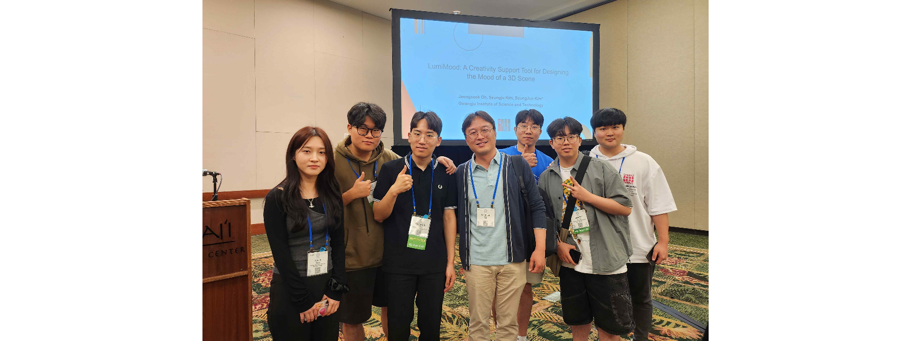▲ CHI 2024 conference attendance photo: (from left) doctoral student Yumin Kang, researcher Seokhyun Hwang, doctoral student Jeongseok Oh, Professor Seungjun Kim, doctoral students Dohyeon Yeo and Seongjun Kang, master’s student Bocheon Gim

The Gwangju Institute of Science and Technology (GIST, President Kichuk Lim) announced Professor Seungjun Kim's research team in the School of Integrated Technology won two 'Honorable Mentions' by presenting a paper on ➀ the implementation of 'lower body haptics' for a vivid walking experience in a virtual environment and ➁ improving the virtual reality (VR) experience in autonomous vehicles at the CHI (Conference on Human Factors in Computing), a prestigious international academic conference in the field of human-computer interaction (HCI) hosted by the American Computer Society (ACM).

The ACM CHI 2024 academic conference, in which Professor Seungjun Kim's research team won two ‘Honorable Mentions’, was held in Honolulu, Hawaii, USA from May 11 to 16.

The Human-Centered Intelligent Systems Lab (HCIS Lab), led by Professor Seungjun Kim, conducts interdisciplinary research on human-centered design and demonstration of human-physical system interaction by fusing human-computer interaction (HCI) and artificial intelligence (AI) technologies. In particular, the lab focuses on interpreting the mechanisms by which AI-driven contextual analysis and decision-making affect user experience, and on proactive interaction by predicting user states, intentions, and context.

Professor Seungjun Kim's research team was recognized for its excellence by winning the 'Honorable Mention Paper Award (within 5%)' for two of the three papers (ErgoPulse, SYNC-VR) presented at 'ACM CHI 2024'.

[Paper 1] The first research outcome of Professor Seungjun Kim’s research team, which won the ‘Honorable Mention’, is ‘ErgoPulse’, an innovative VR haptic feedback system that integrates electrical muscle stimulation (EMS) and biomechanical simulation.

This system delivers real-time force to the user's lower body, creating realistic physical interactions in a VR environment, and can innovatively improve immersion in VR games and training programs.

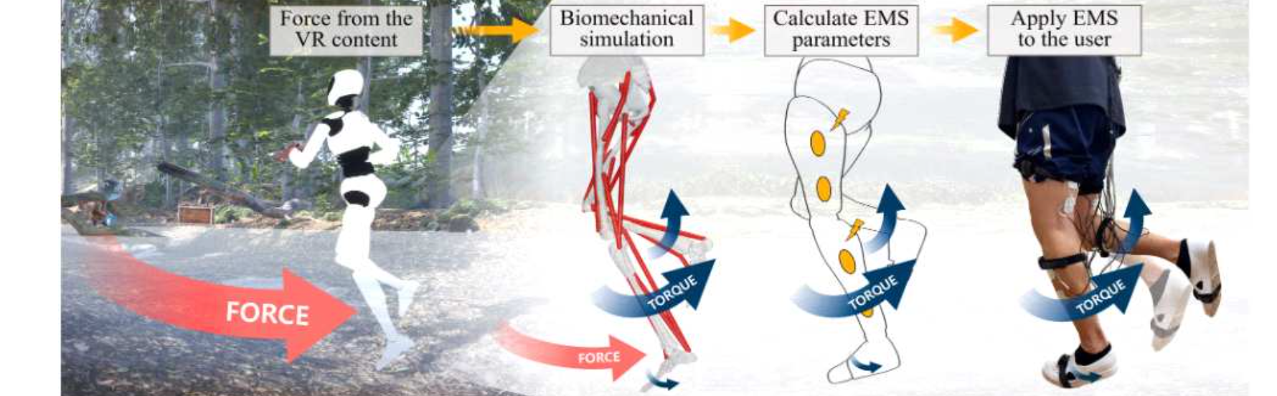▲ ErgoPulse system overview. The ErgoPulse system, which provides force feedback in a virtual environment, estimates joint torque through biomechanical simulation. The estimated torque is then converted into electrical muscle stimulation through the ErgoPulse system's EMS (Electrical Muscle Stimulation), delivering realistic lower body muscle sensation to the user.

‘ErgoPulse’ was developed to overcome several limitations of existing VR lower body haptic feedback technology. Existing lower body haptic feedback systems typically rely on ground anchors that are large, cumbersome to install, and restrict the user's movement.

Although these devices are effective in simulating various surface textures, they greatly restrict the user's freedom of movement. Some systems use small actuators, but these are limited in their ability to provide a wide range of forces across the entire lower body.

The ErgoPulse system complements the shortcomings of existing systems by combining biomechanical simulation and personalized EMS to calculate and deliver the torque required for lower body joints in real time.

* This system consists of two main parts: ➀ Biomechanical simulation: This part uses a combination of the open source biomechanical model OpenSim and the Nvidia PhysX engine. This calculates the torque required for each user's lower body joints, and operates based on the Unity platform. The calculated torque accurately reflects the force required at each joint, realizing physical interaction in the VR environment in real time. ➁ Electrical muscle stimulation (EMS): The calculated torque is converted into muscle stimulation through EMS. By adjusting the EMS to the position and intensity customized for each user, the user can accurately and effectively feel the various forces experienced in the VR environment.

‘ErgoPulse’ opens up new possibilities for effectively transmitting large-scale forces while allowing the user’s lower body movement more freely. Users evaluated that the haptic feedback provided by ‘ErgoPulse’ provides a more accurate and realistic experience than existing EMS-based systems.

This suggests that ‘ErgoPulse’ can significantly improve user immersion by providing realistic interaction in a VR environment.

Additionally, ‘ErgoPulse’ overcomes the physical limitations and technological trade-offs of existing systems. The system has made technological advancements that allow it to provide large amounts of force to the user's lower body while maintaining light weight, low power usage, and instantaneous responsiveness.

Professor Seungjun Kim said, "The VR technology from this research has opened the way for more practical and effective use in various fields such as daily life, training, and education. ErgoPulse can be used for human-robot interaction in the real world, so it is expected to expand into industrial and robotics fields in the future."

Since 2021, Professor Seungjun Kim's research team has been conducting research as part of the GIST-Massachusetts Institute of Technology (MIT) CSAIL collaborative research project, focusing on developing various interface technologies to provide realism in VR and robotics technologies to enhance multi-modal user experience.

This research was conducted with support from HCI + AI convergence research (GIST-MIT joint research project) for human-centered physical system design in 2024 and the convergence cultural virtual studio project to implement an artificial intelligence-based metaverse.

[Paper 2] Professor Seungjun Kim's research team took as a new challenge a self-driving vehicle to maximize passenger comfort and entertainment while traveling and proposed an innovative virtual reality system 'SYNC-VR', which also won an 'Honorable Mention'.

In the rapidly changing future mobility, technological innovation continues to change the way we experience travel. Self-driving vehicles are at the forefront of this change, giving passengers the freedom to engage in a variety of activities unrelated to driving.

‘SYNC-VR’ was highly evaluated for its novelty as an approach to solving motion sickness frequently experienced by passengers of self-driving vehicles.

‘SYNC-VR’ approaches the solution to motion sickness by synchronizing visual, tactile, auditory, and proprioceptive feedback with actual vehicle movement. This synchronization helps passengers enjoy an immersive VR environment without the discomfort of motion sickness.

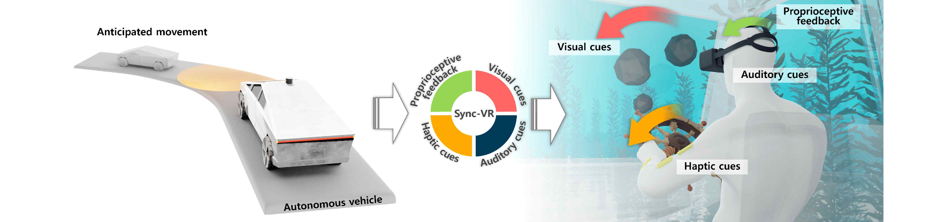▲ System redesign of SYNC-VR. It supports an immersive experience and a motion sickness reduction effect through the linkage of four different sensory stimuli, including vision, hearing, touch, and proprioception, within an autonomous vehicle.

'SYNC-VR' integrates various sensory inputs to provide a realistic VR experience based on the movements of autonomous vehicles and features four main functions: visual cues, proprioceptive feedback, tactile feedback, and auditory cues.

* ▴ Visual Cues: VR systems match vehicle movements with visual content, allowing the simulated virtual world to reflect the rotation, collision, and acceleration of the real world. ▴ Proprioceptive feedback: Interactive VR scenarios engage passengers in activities that require body movements consistent with the vehicle's movements. For example, it reduces motion sickness by supporting the body against the seat during a sudden stop. ▴ Tactile feedback: Using electrical muscle stimulation (EMS), SYNC-VR provides tactile feedback that simulates the sensation of touching and manipulating virtual objects. This tactile element can enhance the sense of presence and participation in the virtual world. ▴ Auditory Cues: Use immersive audio effects that match VR content to enrich the overall sensory experience.

In this study, they selected turns and acceleration, bumpy roads (e.g., speed bumps) and inconsistent movements (e.g., starting after a pause) similar to actual driving situations to determine the effectiveness of 'SYNC-VR' in driving situations on real roads.

Professor Seungjun Kim said, "SYNC-VR is a future technology that will significantly improve travel entertainment and comfort. As autonomous vehicles become more common in the future, the integration of immersive technologies such as SYNC-VR is expected to play a pivotal role in redefining the in-vehicle passenger experience."

Professor Seungjun Kim's research team also presented the results of the experience-oriented technology development of ‘SYNC-VR’ at the 2024 Korea Science Festival.

The 'SYNC-VR' research was supported by the 2024 HCI + AI Convergence Research for Human-Centered Physical System Design (GIST-MIT Joint Research Project), the GIST AI-based Convergence Human Resources Development Support Project, and the Ministry of Science and ICT's Human-Centered Game AI Basic Research Laboratory Project.



