“Hand tremor rehabilitation training with a robot” Professor Jiyeon Kang’s joint research team develops a customized robot rehabilitation system for the treatment of tremors

- Development of ‘SPINDLE’, a game-based robot training system... Helping patients with tremors practice daily life activities similar to real life through simulation through virtual reality
- By providing optimal resistance and visual feedback tailored to the user's movements, effective recovery of motor function is expected through various training requiring 3D rotational movement... Published in the international academic journal ‘IEEE TNSRE’

▲ (From left) Professor Jiyeon Kang of the GIST School of Integrated Technology and Professor Amit Kandel of the State University of New York at Buffalo School of Medicine

Among people with neurological disorders, motor impairment accompanied by muscle weakness and tremors, especially in the hands, causes serious difficulties in performing daily activities.

A joint Korean-American research team is expected to develop a new robotic rehabilitation system that simulates daily life activities in virtual reality (VR), contributing to improving quality of life by restoring motor functions of those with hand tremors and muscle weakness.

The Gwangju Institute of Science and Technology (GIST, President Kichul Lim) announced that Professor Jiyeon Kang's research team in the School of Integrated Technology developed a robotic rehabilitation system for the treatment of tremor* in collaboration with the University of New York at Buffalo (SUNY Buffalo) School of Medicine.

The ‘SPINDLE (Spherical Parallel INstrument for Daily Living Emulation)’ system developed by the research team, meaning ‘Spherical Parallel INstrument for Daily Living Emulation’, was designed to train various daily living activities through virtual reality.

In general, training robots focus on assisting roles, but ‘SPINDLE’ is characterized by promoting the recovery of hand function frequently used in daily life by adding resistance to the user-robot interface in a customized way.

* tremor: Tremors are a neurological disorder related to muscle control, usually accompanied by tremors in the hands or arms. This not only deteriorates the patient's quality of life by making it difficult for patients to perform simple daily activities such as eating, but also complex tasks such as writing, and also has a negative impact on social activities and work.

Existing drug treatments for the treatment of tremors have many side effects and may have limited effectiveness, and surgical methods include high-risk treatments such as brain stimulation (DBS), but these have the limitation that they are not suitable for all patients.

Recently, rehabilitation methods using robots have been proposed, but they mainly focus on reproducing simple movements, which is unfortunate because they do not sufficiently support complex activities in daily life.

SPINDLE, developed by the team, is a game-based robot training system that enables three-dimensional rotational movements and automatically adjusts the resistance level to match the user's performance, enabling people with tremors to practice simulated activities of daily living through virtual reality.

This system helps users strengthen their muscles and improve their hand dexterity and ability to perform movements in everyday life.

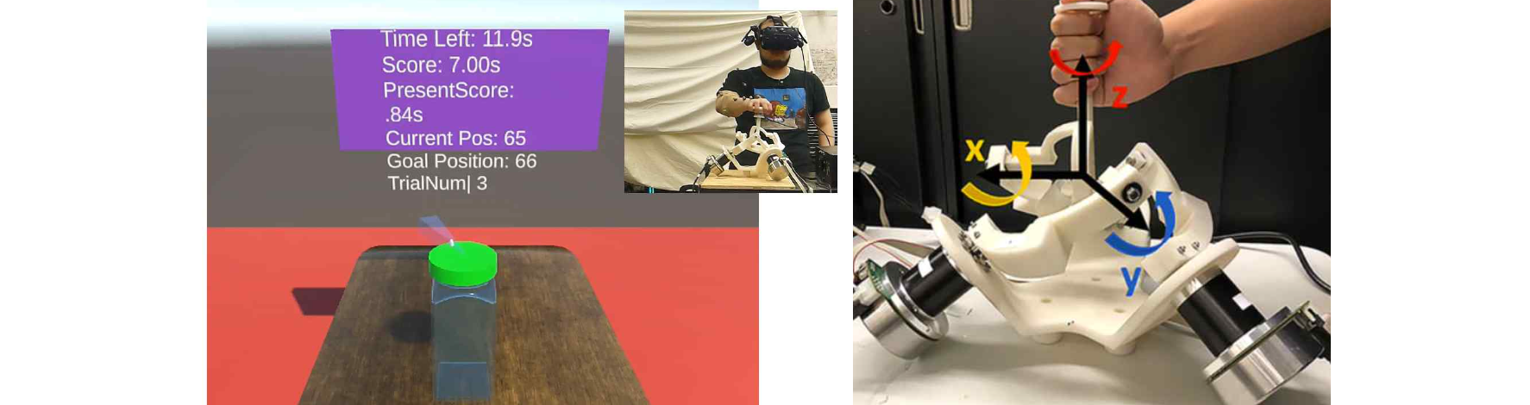▲ Simulation of activities of daily living (ADL) using SPINDLE: The picture on the left shows the subject performing a task of daily living (turning a bottle cap) with visual information experienced by the user in virtual reality. The picture on the right is a SPINDLE parallel robot that can rotate in all three dimensions of x-y-z.

‘SPINDLE’ is designed to reproduce the various three-dimensional movements that patients experience in their daily lives based on a link structure including three moving rotation joints.

It measures the user's movements through a 6-axis force/torque sensor and provides visual feedback in real time through virtual reality to help effectively train various daily life activities.

In an experiment with 9 healthy participants mimicking the symptoms of tremor, the research team used the SPINDLE robot system to test daily life movements such as turning a book, pouring water, and opening a laptop in a virtual reality environment to determine the optimal way to adjust the level of resistance.

When performing daily movements with customized resistance, it was confirmed that the electromyography signal of the participant's muscles decreased by at least 10 to 20% on average compared to small or large resistance. This suggests that the customized resistance reduces the amount of effort participants have to exert to stabilize their hand tremor symptoms.

The range of motion, i.e. three-dimensional rotation of the shoulder (average 47-50°), elbow flexion/extension (average 47-50°), and three-dimensional rotation of the wrist (average 39-110°) was found to have no statistically significant differences between the range of motion of daily life activities and that implemented in SPINDLE.

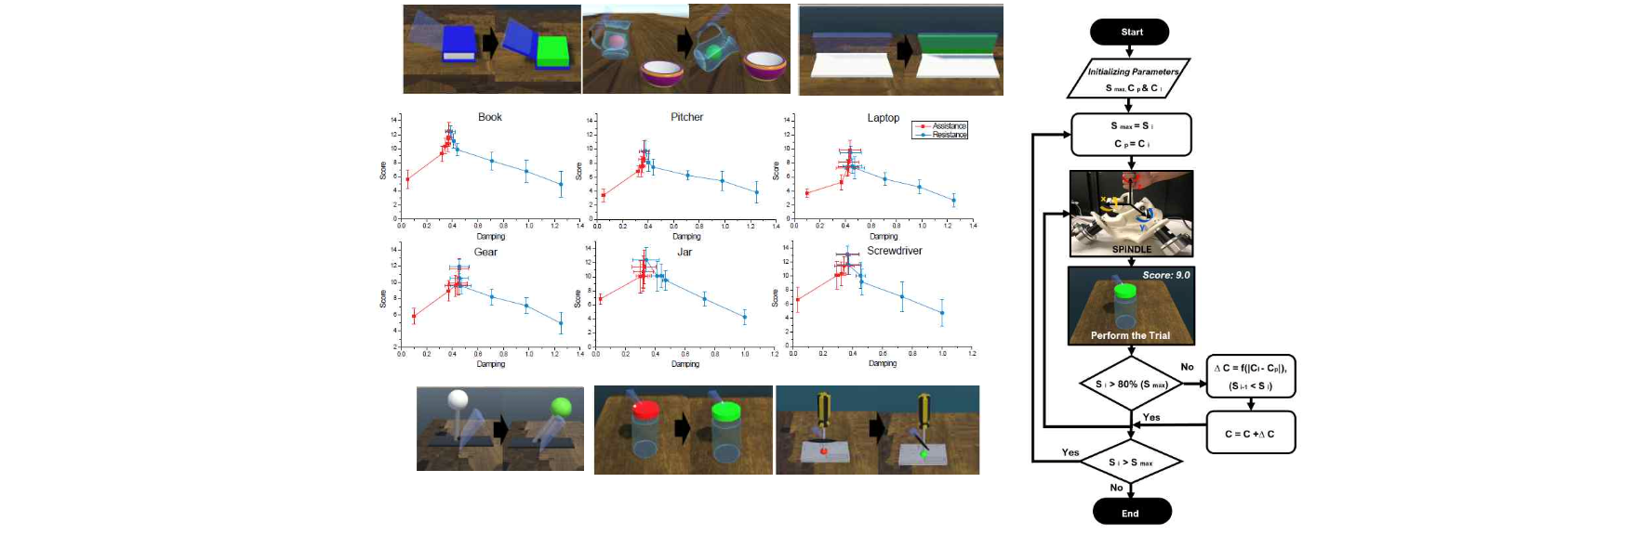▲ SPINDLE-based daily living activity tasks and Resist-as-needed patient-specific training algorithm designed based on real object manipulation characteristics. The algorithm changes the difficulty of the task depending on the subject's degree of task performance (arm control ability), such as increasing the difficulty level (resistance) to enable robot training.

Professor Jiyeon Kang said, "The SPINDLE system is small in size (H 42cm×W 40cm× L 35cm) and can be easily used at home, and is expected to provide new hope for patients with hand tremor disorders by improving their daily performance. This is expected to present a new paradigm in the field of robotic rehabilitation. We are currently conducting follow-up studies for stroke patients in collaboration with the National Rehabilitation Center."

This study, conducted by Professor Jiyeon Kang's research team in the GIST School of Integrated Technology in collaboration with Professor Amit Kandel MD, SUNY Buffalo School of Medicine, was supported by the National Research Foundation of Korea (NRF) and the National Science Foundation (NSF) and was published online on May 3, 2024, in ‘IEEE TNSRE’, a top 5% international journal in the field of neurorehabilitation engineering.



