GIST-Seoul National University joint research team develops a low-temperature deep ultraviolet ray process to secure high-performance ferroelectric materials for memory

- Deep ultraviolet (DUV)-based defect control, central asymmetric crystallization control of oxide thin films, and securing ferroelectricity... Expected to develop next-generation ferroelectric electronic devices and high-performance memory electronic circuits, etc.
- Published in the international journal 「Materials Science and Engineering: R: Reports」 in the field of materials engineering

▲ (From left) GIST Professor Myung-Han Yoon, Seoul National University Professor Min Hyuk Park, GIST Ph.D. student Jun-Gyu Choi, GIST master’s student Sangwoo Lee, and Seoul National University doctoral student Se Hyun Kim

A method has been developed to obtain ferroelectric oxide at a temperature 100°C lower than conventional methods. Ferroelectrics are materials that exhibit electropolarization without the application of an external electric field, and memory devices based on ferroelectrics are attracting attention as the next generation of high-performance semiconductor memory devices due to their low drive power and fast processing speed compared to conventional flash memory.

The Gwangju Institute of Science and Technology (GIST, President Kichul Lim) announced that the joint research team of Professor Myung-Han Yoon of the School of Materials Science and Engineering and Professor Min Hyuk Park of the Department of Materials Science and Engineering at Seoul National University has identified a low-temperature deep ultraviolet (DUV)*-based defect control and crystallization mechanism to secure high-performance ferroelectric oxides.

Among ferroelectrics, hafnium zirconium oxide (HZO) is advantageous in the integration process with core materials (complementary metal oxide semiconductor, CMOS) in the semiconductor and electronic industries, and it is attracting attention because it induces excellent ferroelectricity and low tunneling effect even at a relatively low thickness of several nanometers.

However, in order to secure an orthorhombic crystal phase showing ferroelectricity in HZO with a thickness of less than 10 nm (nanometers), a heat treatment process of 400 to 500 °C is essential, and the crystallization mechanism of HZO and the technology to control it have not yet been clearly revealed.

* deep ultraviolet (DUV): ultraviolet rays with a wavelength of 300 nm or less

The research team noted that oxygen vacancies play an important role in the formation of an orthorhombic crystal structure that exhibits ferroelectricity.

By introducing a deep ultraviolet-based photoactivation process after a typical heat treatment process using rapid thermal processing, oxygen defects were induced in the 8 nm HZO thin film and an orthorhombic* crystal structure was successfully formed.

* Orthorhombic system: It is a shape in which two vectors are stretched to different lengths in the cubic system (cube shape). It is in the shape of a square pillar with a rectangular base, and the length and height of both sides of the base are different.

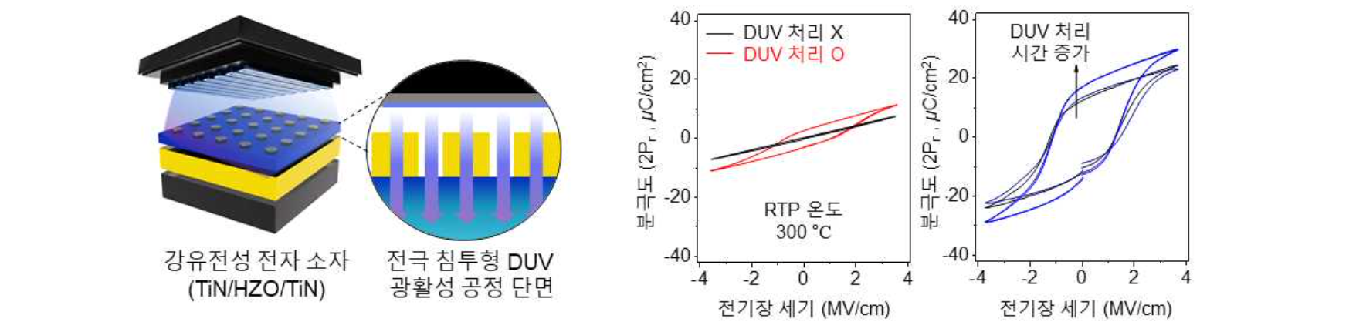▲ Schematic diagram of the DUV photoactivation process used in this study (left) and difference in spontaneous polarization of ferroelectric HZO material depending on the presence or absence of the DUV photoactivation process and processing time (right). When introducing the DUV photoactivation process, ferroelectric properties can be secured at a low temperature of 300°C, and ferroelectric properties improve as processing time increases.

The research team succeeded in securing excellent ferroelectricity and stability based on low leakage current by introducing a relatively simple post-process of irradiating deep ultraviolet rays directly to the memory device that completed the fabrication of the upper and lower electrodes in an inert gas atmosphere* at 300°C. Through analysis of the interatomic bond energy and super-resolution microscopy analysis, the effect and mechanism of oxygen defects, which were increased by about 6% by the deep ultraviolet photoactivation process, on the control of the crystal phase of HZO were identified.

* inert gas atmosphere: An environment filled with gases that do not absorb deep ultraviolet rays, such as nitrogen or argon gas.

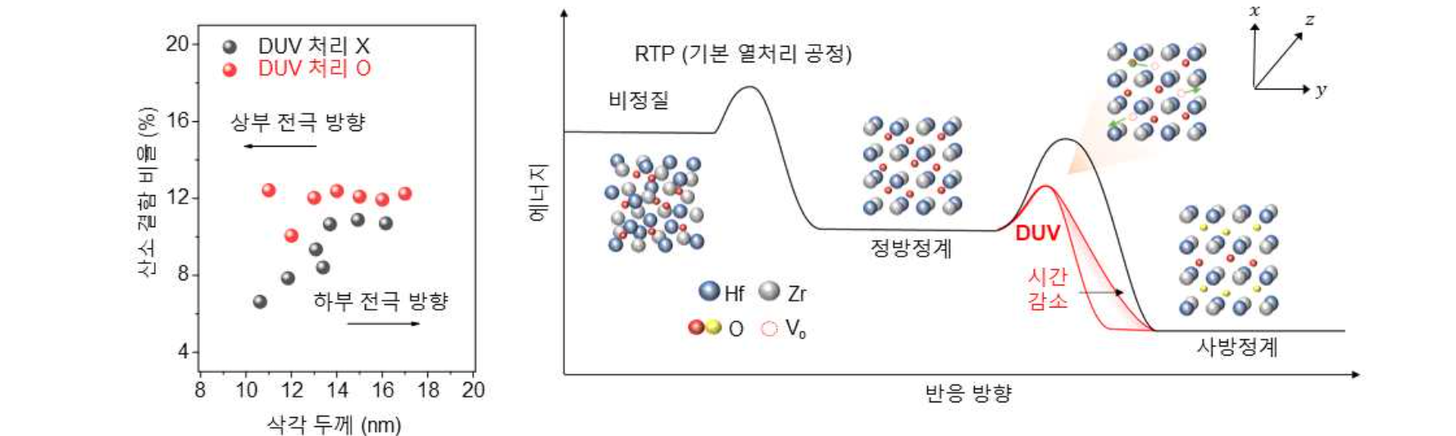▲ A schematic diagram showing the ratio of oxygen defects according to HZO depth with or without the DUV photoactivation process (left) and a schematic diagram of the oxygen defect-based HZO thin film crystallization control mechanism proposed in this study (right). Through the DUV photoactivation process, excellent ferroelectric properties can be secured by consuming less time and energy than existing processes.

GIST Professor Myung-Han Yoon said, "This research achievement has great academic significance in that it controls the metal oxide crystal phase by changing atomic-level microscopic properties such as oxygen defects through deep ultraviolet light irradiation and identifies the related mechanism."

Seoul National University Professor Min Hyuk Park said, "By securing the ferroelectricity of HZO at low temperatures through a low-cost, large-area photoprocessing process, there is great potential for use in the electronic and memory industries."

This research is the result of joint research between Professor Myung-Han Yoon's research team at GIST, which studies photochemical property control of functional oxide thin film materials, and Professor Min Hyuk Park's research team at Seoul National University, which studies ultra-high-performance ferroelectric materials and memory devices. GIST Ph.D. student Jun-Gyu Choi, master's degree student Sangwoo Lee, and Seoul National University doctoral student Se Hyun Kim participated as co-first authors, and the study was conducted with support from the National Research Foundation of Korea and the GIST New and Renewable Energy Research Institute.

The research results were published online on May 7, 2024, in ‘Materials Science & Engineering: R: Reports’, a renowned international journal in the field of electronic devices and materials science.



