“The science of instant adhesion to mussel byssus!” GIST develops ultra-fast nanoparticle assembly technology, enabling particle assembly within 10 seconds... 1000 times faster than before

- Professor Hyeon-Ho Jeong's team, inspired by the attachment mechanism of mussels, assembled nanoparticles at high density on the surface at a speed up to 1,000 times faster than existing methods
- Overcoming the limitations of mass production and commercialization of advanced nano devices with nanoparticle solution process assembly technology... Presented in 「Advanced Materials」, a renowned international academic journal in the materials field, selected as the opening illustration

▲ (Clockwise from the right in the front row) School of Electrical Engineering and Computer Science students JuHyeong Lee of the combined master's and doctoral course, Professor Hyeon-Ho Jeong, student Doeun Kim of the doctoral course, Jiyeong Ma of the combined master's and doctoral course, Gyurin Kim of the combined master's and doctoral course, Jang-Hwan Han, postdoctoral researcher, and student Hyun Min Kim of the combined master's and doctoral course.

Mussels release a protein called ‘byssal’ in the water environment. The hair-like leg-shaped ‘byssal’ acts as an adhesive to help mussels stick to rocks. At this time, the fatty acid secreted together with the protein separates the hydroxyl group* on the surface and can instantly physically adhere to it.

A Korean research team succeeded in developing an ultra-fast electrostatic assembly technology for nanoparticles, inspired by the ‘byssal’ of mussels.

* hydroxyl group: A monovalent group expressed as -OH. In the case of organic substances, it is also called a hydroxy group. It causes problems by slowing down the assembly speed of nanoparticles.

The Gwangju Institute of Science and Technology (GIST, President Kichul Lim) announced that Professor Hyeon-Ho Jeong's research team in the School of Electrical Engineering and Computer Science has designed a nanoparticle assembly technology based on the hydroxyl group separation mechanism of red persimmon.

Traditional nanoparticle assembly techniques require additional equipment or energy, and even electrostatic force-based assembly techniques require pretreatment and long process times in the order of hours, limiting their ability to achieve the speeds (1-20 m/min) required for industrial scale production and commercialization.

The research team improved the attachment speed of nanoparticles through proton* assistance. The results of this research are expected to enable assembly within a few seconds at a speed up to 1,000 times faster than before, enabling the mass production and commercialization of nanoparticle-based devices, which were previously considered impossible.

* proton (symbol H+): Refers to a positive ion that has lost an electron from a hydrogen atom and is created when water is ionized or decomposed. The concentration of protons produced in water regulates pH and can affect chemical reactions that occur in water.

Nanoparticles with a size of 100 nm or less exhibit new properties, unlike classical materials used previously. Recently, in order to put these nanoparticles to practical use, a colloid*-based solution process that can be mass-produced by controlling the desired size, shape, and properties has been developed, and is attracting attention as a key element of future technological development in various fields.

However, despite this enormous potential, commercialization has been difficult due to the lack of technology to quickly and uniformly deliver colloidal functional nanoparticles of less than 100 nm to the entire surface of a 2-inch wafer substrate within 10 seconds using a single coating method.

* colloid: A type of mixture in which particles ranging in size from 1 nanometer to 100 micrometers are dispersed and floating in a solvent.

Nanoparticle assembly technology is a method of effectively arranging nanoparticles on a surface using electrical interaction between nanoparticles and the target surface. The most important point in this study is to remove the hydroxyl groups that most substances generate on the surface when they interact with water.

The research team added protons to remove hydroxyl groups and adjusted the surface potential to strengthen the electrostatic attraction to the nanoparticle surface. This method makes it possible to assemble particles on the front side of the wafer within 10 seconds. As a result, nanoparticles can be assembled at high density on the surface at a speed up to 1,000 times faster than existing methods, increasing the possibility of commercialization for business applications.

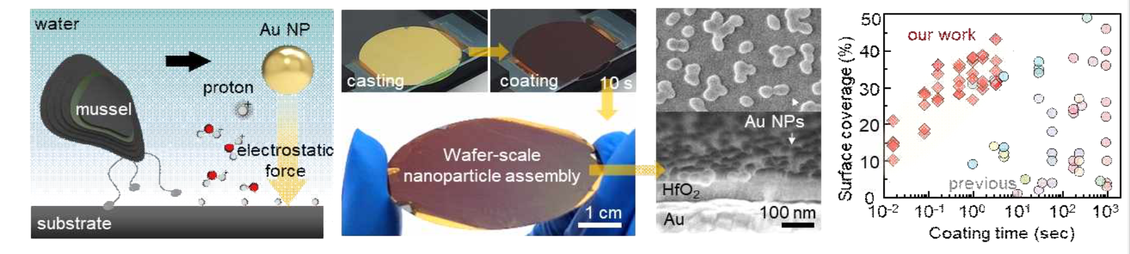▲ Mussel-inspired nanoparticle assembly technology (left), nanoparticles assembled during a 10-second process (center), and speed of electrostatic force-based assembly technology (right): proton-assisted, mimicking the attachment mechanism of mussels in water. The concept and process of high-speed nanoparticle assembly technology, securing a coating speed of up to 1000 times that of existing nanoparticle assembly technology.

Proton-assisted electrostatic assembly methods have increased the diversity of material choices, including dielectric or polymer materials with insulating properties. Nanoparticles can be assembled in seconds on large-area assemblies ranging from micropatterns to 2-inch wafers, and on a variety of geometric platforms, from rigid glass to flexible 3D shaped plastics.

In addition, because the method can selectively assemble nanoparticles across the entire wafer and maintain uniformity and constant electrostatic performance, it enables a variety of optical effects, such as “defect healing,” where only unevenly coated areas that are partial defects in the process can be recoated, and “pick-and-place,” where particles can be placed in the desired space to create specific patterns.

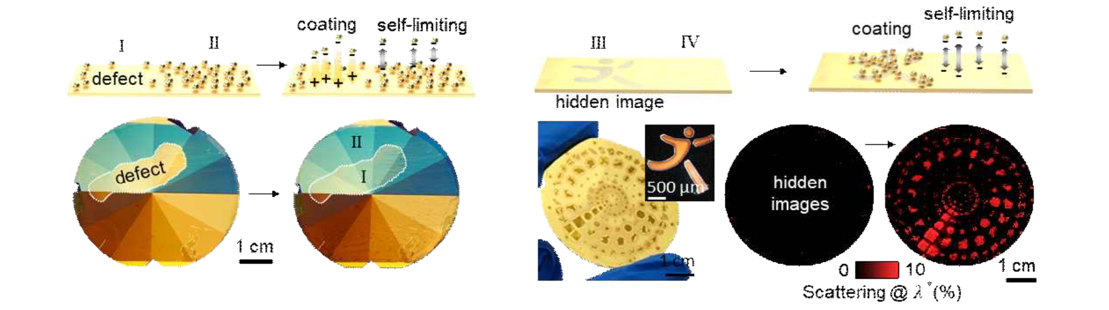▲ 'Healing' of process defects (left) and 'pick and place' particle patterning (right): Selective assembly of nanoparticles based on surface potential enables selective assembly only for specific coating defects (left), and because patterning is possible, hidden patterns that cannot be distinguished with the naked eye can be visualized through nanoparticle assembly (right)

If a wafer-level optical device is realized using this method, it can not only serve as a pigment that realizes full color without fading, but can also be used as a device including molecular sensing, reflective displays, and optical encryption devices.

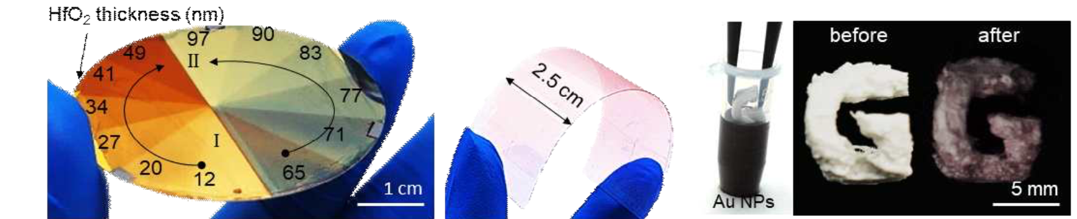▲ Diversification of material selection through particle assembly technology without pretreatment, full-color metasurface based on glassy materials (left), flexible thin film electrode (center), 3D printed structure (right): Nanoparticles without pretreatment on various geometric/material platforms can be assembled within seconds, creating optical effects in a short period of time.

Professor Hyeon-Ho Jeong said, "This research outcome is expected to be an efficient solution that bridges the gap between industrial production of high-performance nanodevices through fast and easy nanoparticle assembly. In particular, cutting-edge devices and technologies such as optical medical diagnostic devices, AR/VR technology, and optical communication systems are expected to become new breakthroughs that can be applied to real life."

The research, led by Professor Hyeon-Ho Jeong of GIST's School of Electrical Engineering and Computer Science and conducted by PhD student Doeun Kim, was supported by the National Research Foundation of Korea (NRF) Nano and Materials Technology Development Project and the Banwon Project for Encouraging Doctoral Student Research, the GIST-MIT Collaborative Research Project, and the Joint Research Project of the Joint Secretariat of the Korea Advanced Institute of Science and Technology, and was published on April 18, 2024, as a Frontispiece in Advanced Materials, an international journal in the field of materials.

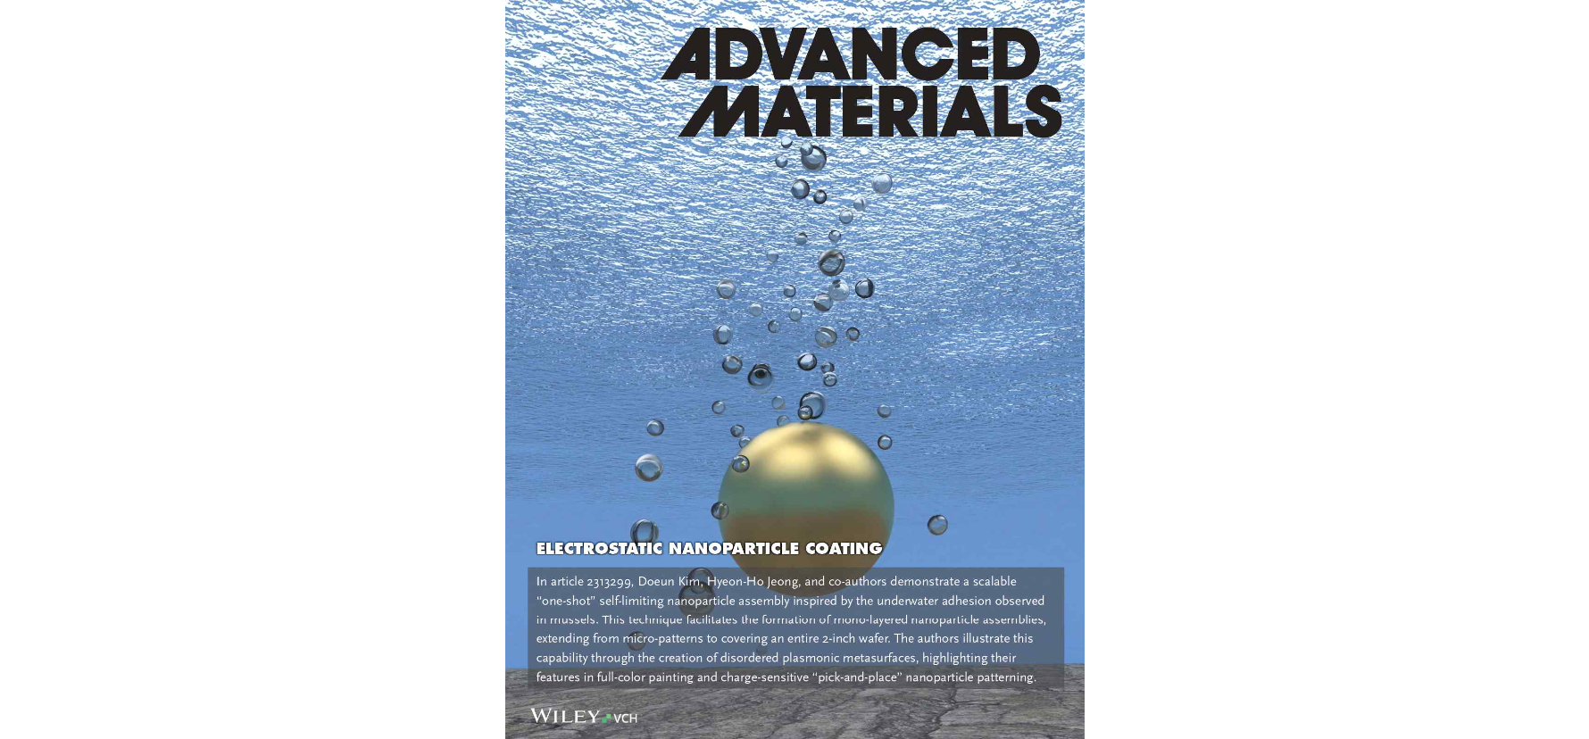▲ Frontispiece image: Selected as the frontispiece for ‘Advanced Materials’, an international academic journal in the field of materials.



