“A biomaterial effective in treating peripheral nerve damage has been discovered” GIST developed a hydrogel nerve conduit that is sterile, non-toxic, has improved mechanical properties, and is easy to manufacture

- Development of a hydrogel-based medical nerve conduit that can be manufactured simultaneously with sterilization using gamma rays... Expected to be used as a new platform for producing nerve conduits and bioimplant materials
- Professor Jae Young Lee’s team from the School of Materials Science and Engineering published in ‘Advanced Healthcare Materials,’ a renowned academic journal in the field of biomaterials

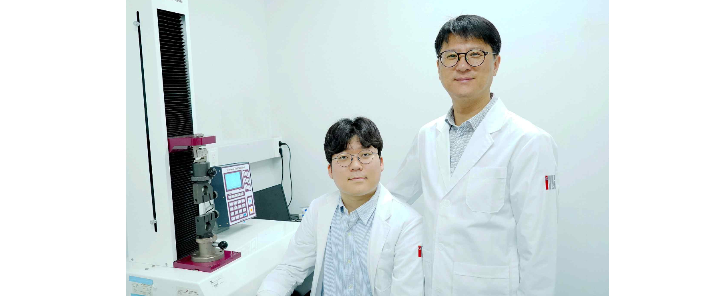▲ (From the left) Junghyun Kim, integrated master’s and doctoral student in the School of Materials Science and Engineering (first author), Professor Jae Young Lee

A Korea research team is attracting attention by developing a simple, non-toxic, sterilized medical nerve conduit manufacturing method for treating peripheral nerves, which have a very low chance of spontaneous regeneration once damaged.

The Gwangju Institute of Science and Technology (GIST, President Kichul Lim) announced that Professor Jae Young Lee's research team in the School of Materials Science and Engineering has developed a chemical-free medical nerve conduit that can be sterilized and manufactured simultaneously using gamma rays, a type of radiation.

* nerve conduit: A medical insertion device that promotes nerve regeneration by connecting both damaged nerves. Nerve conduits guide nerves to connect properly. Nerve conduits guide nerves to connect correctly, inhibit the infiltration of myofibroblasts, and protect regenerating nerves from external shocks.

Autologous transplantation is the best method for treating peripheral nerves, but it has problems such as limited supply of autologous nerves, size mismatch with the damaged nerve, and donor site morbidity*.

* donor site morbidity: refers to a reaction in which the body of a person who has received an organ or tissue donation rejects the donated organ or tissue received from an external source. Higher morbidity may increase the likelihood of complications following transplantation.

Existing hydrogel-based artificial nerve conduits made of natural and synthetic polymers have excellent advantages including biocompatibility but has low mechanical strength, is easy to break, and has the disadvantage of being difficult to insert into the body using sutures, resulting in low clinical treatment efficiency in the field.

In addition, when producing artificial nerve conduits based on hydrogel, chemical cross-linking agents are used or chemical modifications are required to introduce various functional groups* including methacrylate. In this process, toxic by-products are generated. Additional sterilization processes are required, and the manufacturing steps are complicated.

* functional group: refers to an active part in the molecular structure of a chemical substance within a polymer that can form a new compound by combining a specific part with another molecule or participating in a chemical reaction.

Above all, sterilization is very important in the production of nerve conduits. Currently, nerve conduit products approved by the FDA are sterilized through ethylene oxide* gas and gamma ray* irradiation. However, this sterilization method has the potential to modify the inherent properties of the material, and it has been reported that ethylene oxide gas is a carcinogen, so confirmation of residual gas is also necessary.

* ethylene oxide: One of the powerful chemicals used to sterilize medical devices, it is reported to be toxic to humans.

* gamma rays: Currently used for sterilization of various human implants, including surgical equipment. Crosslinking using gamma rays has recently been attracting attention as green chemistry because it does not use toxic agitators and does not produce impurities after the reaction.

Therefore, it is necessary to develop a manufacturing method that uses natural polymers with guaranteed biocompatibility and does not use by-products or toxic substances, and to manufacture hydrogel nerve conduits with mechanical strength and toughness simultaneously with sterilization.

The research team crosslinked the gelatin polymer by irradiating 30kGy (kilogray) high-energy gamma rays and then produced a ‘double network* hydrogel nerve conduit’ through additional ion crosslinking of alginate. This method is simple to manufacture, can be sterilized, and has improved mechanical properties.

* cross-link: In chemistry and biology, it is a short sequence of bonds or bonds that connect one polymer chain to another polymer chain. These linkages can take the form of covalent or ionic bonds, and the polymers can be synthetic or natural polymers (e.g. proteins).

* double network: A structure in which two types of polymers form two different networks and are combined to form the interior. The double network structure results in high mechanical properties, elasticity, and flexibility and is used in various tissue engineering scaffolds.

The ‘double network hydrogel nerve conduit’ produced by the research team has an extreme tensile strength of up to 71.4 kPa (kilopascal). It showed a high Young's modulus of 77 kPa (kilopascals)*, as well as superior sealability, bending resistance, and mechanical properties compared to single-network nerve conduits.

* Young's modulus: elasticity modulus that indicates the degree to which an object is stretched and deformed

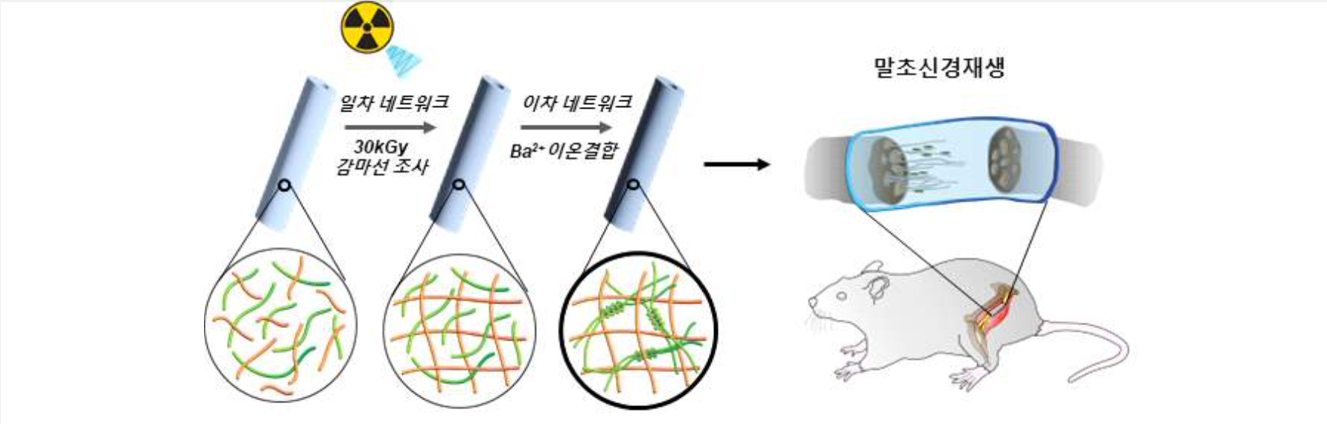▲ Schematic diagram of a gamma-ray irradiated double-network hydrogel (=hydrogel) nerve conduit: The double-network hydrogel nerve conduit produced by high-energy gamma-ray irradiation and ionic bonding of alginate does not use toxic substances such as agitators and is simple to manufacture. It can be sterilized upon production.

Furthermore, the research team inserted ‘gamma-irradiated hydrogel nerve conduit’ into a mouse model of peripheral nerve amputation and verified the nerve regeneration effect in small animals.

It was confirmed that the gamma-ray irradiated dual network hydrogel nerve conduit maintained structural stability and remained in the body for more than 6 weeks. Through electrophysiological analysis using electromyography, evaluation of muscle degeneration and regeneration, and histological analysis of peripheral nerves 6 and 12 weeks after surgery, a significantly increased nerve regeneration effect was confirmed compared to the control medical silicone nerve conduit.

As a result, it was confirmed that the dual network hydrogel nerve conduit, which can be manufactured simultaneously with sterilization, can be applied to peripheral nerve regeneration and is more effective than conventional medical silicone nerve conduit.

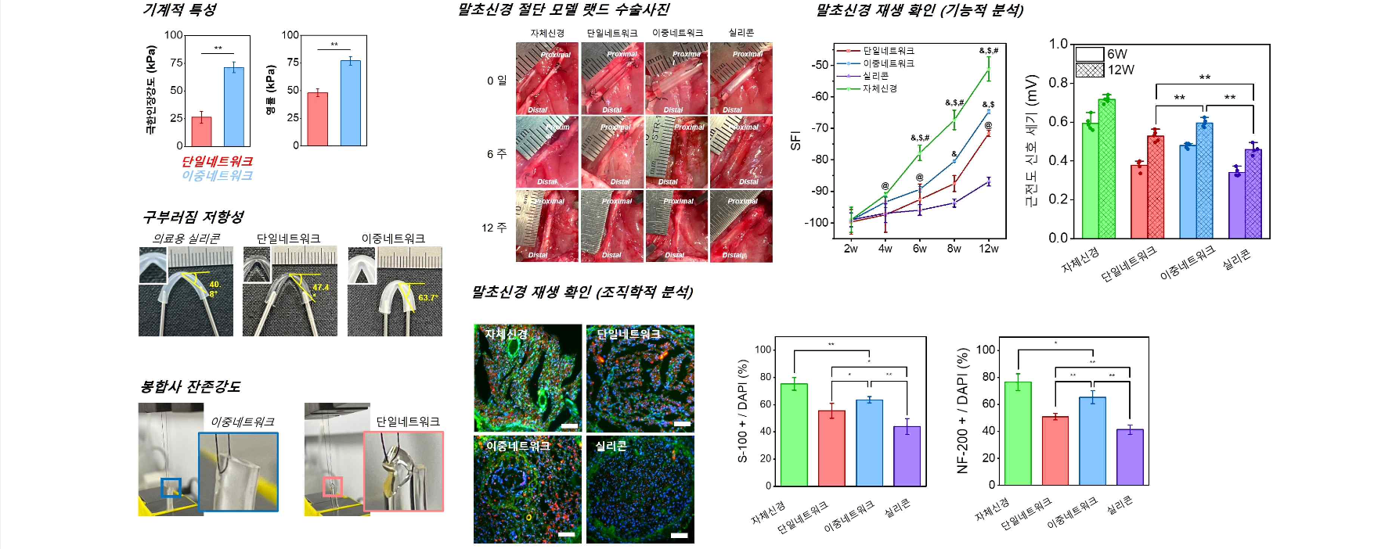▲ Confirmation of improved mechanical properties, bending resistance, suture residual strength, and nerve regeneration using an animal model of peripheral nerve amputation (functional and histological analysis): Improved mechanical properties, resistance to ball breaking, and improved mechanical properties of the double-network hydrogel nerve conduit made with gamma rays. Suture residual strength and possibility of use as a nerve conduit for peripheral nerve regeneration.

Professor Jae Young Lee said, "The results of this research confirm that the manufacturing method is simple and, above all, possible to produce a sterilized hydrogel renal conduit using a chemical-free method without the use of toxic agitators or by-products. In the future, it is expected to be used as a new platform for manufacturing bio-implantable materials such as implants as well as nerve conduits."

This research, conducted by Professor Jae Young Lee's team in the School of Materials Science and Engineering, was supported by the National Research Foundation of Korea's mid-career researcher support project and was published online in 'Advanced Healthcare Materials', an international academic journal in the field of biomaterials, on April 2, 2024.



