“Doing well even in an unfamiliar environment where you have not studied”
GIST develops world-class ‘real-time environmental adaptation AI’

- Professor Kyoobin Lee's research team improved the image recognition performance of AI models that deteriorate in operating environments different from the learning environment and ranked first in the world in benchmarks... It is expected to be used in self-driving cars, etc. as it can respond to weather, lighting, and terrain
- Confirmation of the possibility that AI can continue to grow and operate stably in various environments and conditions... Scheduled to be presented at CVPR, a world-class international conference in the field of computer vision in June

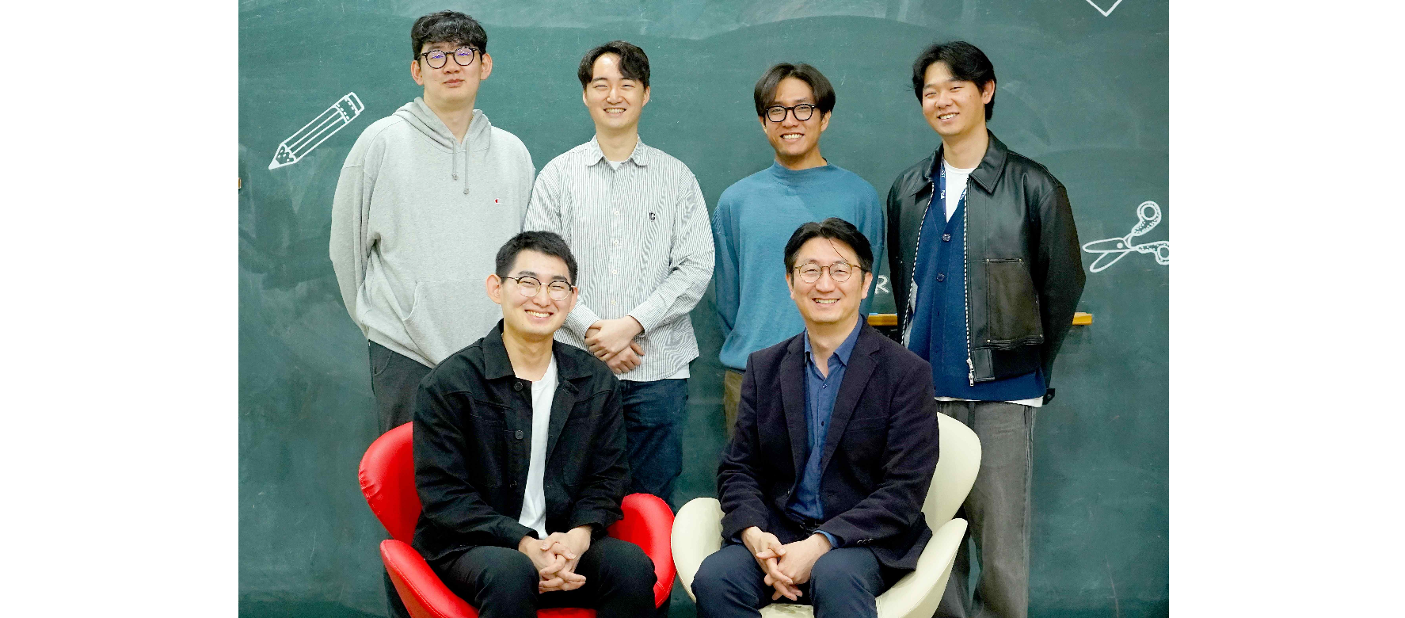▲ (Clockwise from the right in the front row) Professor Kyoobin Lee, doctoral students Yeonguk Yu, Sungho Shin, Seunghyeok Back, Minhwan Ko , and Sangjun Noh

Because artificial intelligence (AI) models have fixed internal parameters* that are optimized for one learning environment, using the AI model in an operating environment* that is different from the previous learning environment* may result in performance degradation.

For example, an AI model learned only from photos taken in sunny weather is optimized for this, so image recognition performance deteriorates on rainy days. Therefore, in order to maintain image recognition performance even after the AI model has finished learning, technology is needed to adjust the AI model to a new operating environment.

* parameter: Refers to a variable used in calculations to change input (image) into output (recognition result). This is a value that changes when learning an AI model.

* learning environment (source domain): Refers to the environment where images are acquired for learning AI models. For example, if a road was photographed in clear weather to learn a self-driving car AI model, “clear weather” becomes the learning environment.

* operating environment (Target Domain): This is the environment encountered when operating the actual model after the learning of the AI model is completed. If it is currently snowy, 'snowy weather' becomes the operating environment and this is simply a certain value. It is not fixed and can change over time.

The Gwangju Institute of Science and Technology (GIST, President Kichul Lim) announced that Professor Kyoobin Lee’s research team in the School of Integrated Technology has developed ‘Test-time adaptation’ technology for AI models.

The results of this research are expected to be used in future self-driving cars by overcoming the limitations of existing AI models, where performance deteriorates when images obtained in an operating environment different from the learning environment are input.

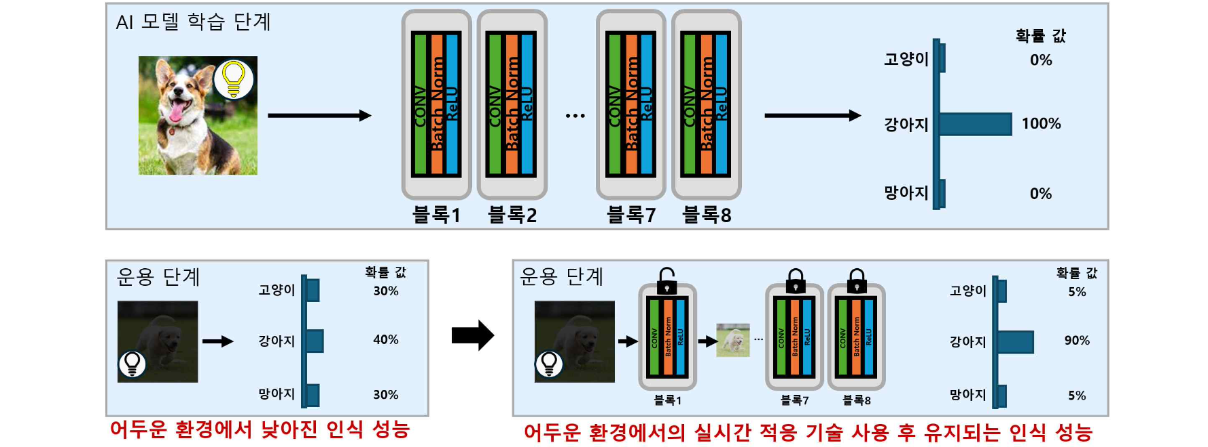▲ Overview of real-time adaptation technology. The AI model learned to recognize dogs in a bright environment (top of picture). At this time, the recognition performance for dog images in a dark environment may deteriorate during the operation phase (bottom left of the figure). The proposed method improves performance by extracting appropriate feature maps from selected blocks through adaptation to the dark environment (bottom right of the figure).

'Real-time environment adaptation technology' is a technology that improves performance by adapting the parameters of the AI model to the operating environment even after learning is completed. It fine-tunes the parameters of the AI model in real time to ensure that the AI model operates well in new environments or conditions.

Unlike previous research, the research team developed a technology that adapts an AI model sensitive to various changing factors such as weather and lighting to a given environment in real time by selecting blocks that are sensitive to environmental changes.

In order to learn an AI model, the correct label for the input image is required, but it is difficult to learn the actual AI model in operation because it does not have the correct label for the input image.

To solve this problem, real-time adaptation research uses a method of generating the correct answer label for the input image and learning it from the AI model itself. In other words, in real-time adaptation research, research has been conducted on how to generate accurate correct answer labels.

Previous studies have not used techniques to select environment-sensitive blocks, resulting in poor performance due to changes that extend to blocks that do not see environmental characteristics. They have also used inefficient methods to generate correct answers, resulting in relatively poor quality answers.

On the other hand, the research team achieved the world's highest level in the performance evaluation benchmark of adaptation technology by using block selection technology and answer generation technology suitable for real-time environment adaptation.

The research team performed real-time adaptation of the AI model using two methods. The first method is ‘environment sensitive block selection technology’. When the AI model looks at the image, some blocks see characteristics that vary depending on the environment (e.g. weather, lighting), but some blocks are not sensitive to the environment. Therefore, only blocks that changed depending on environmental changes were found and only those parts were adjusted to suit the new environment.

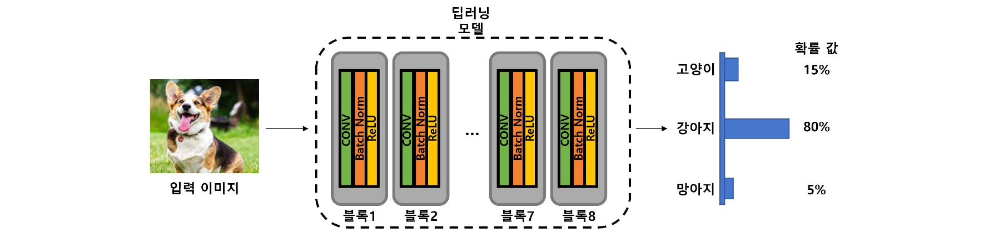▲ Deep learning model structure diagram in which probability values are calculated for the input image (dog). Deep learning models are made up of blocks made up of multiple layers. In general, it is known that blocks in the front stage are sensitive to the environment (brightness, color, noise), and blocks in the back stage are sensitive to shape (shape of the object, presence or absence of the object).

The second method is ‘generating correct answers based on left-right pairs’. The AI model was shown the same image twice by flipping left and right, and the AI model was trained in an operating environment to output the same results with high reliability in both left and right flipped images, thereby improving accuracy.

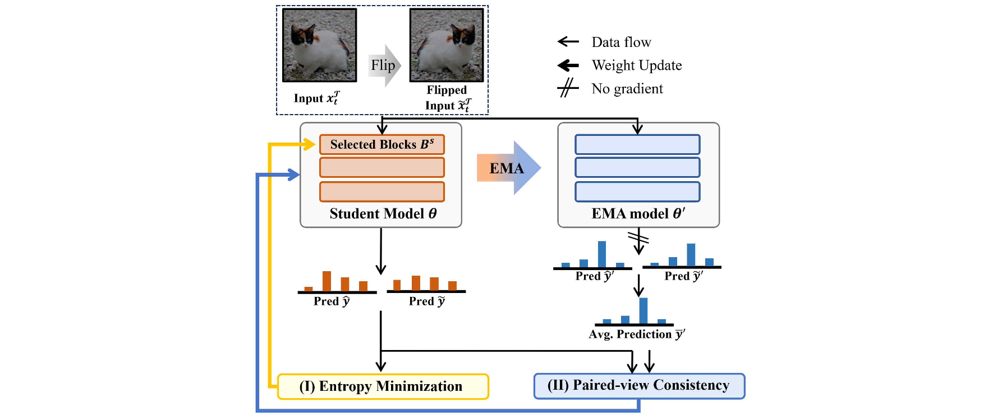▲ Overview of the proposed method. The proposed method first reverses the image (cat) obtained in the operation stage left and right, and then inputs it to the model. Afterwards, the parameters of the environmentally sensitive blocks are updated to reduce the entropy for a given image (solid yellow line). In addition, all parameters are updated so that each output approaches the probability distribution created by averaging the probability distributions output for the left and right images (solid blue line).

As a result of comparing with existing research in benchmark*, we succeeded in lowering the error rate from 26.3% to 23.9%, which is a 9.1% improvement in accuracy.

* benchmark: An experimental procedure that allows easy quantitative performance comparison of methodologies studied in a technology field. This means that when performing an experiment, only the methodology is different, the same data and procedures are used, and the results are compared.

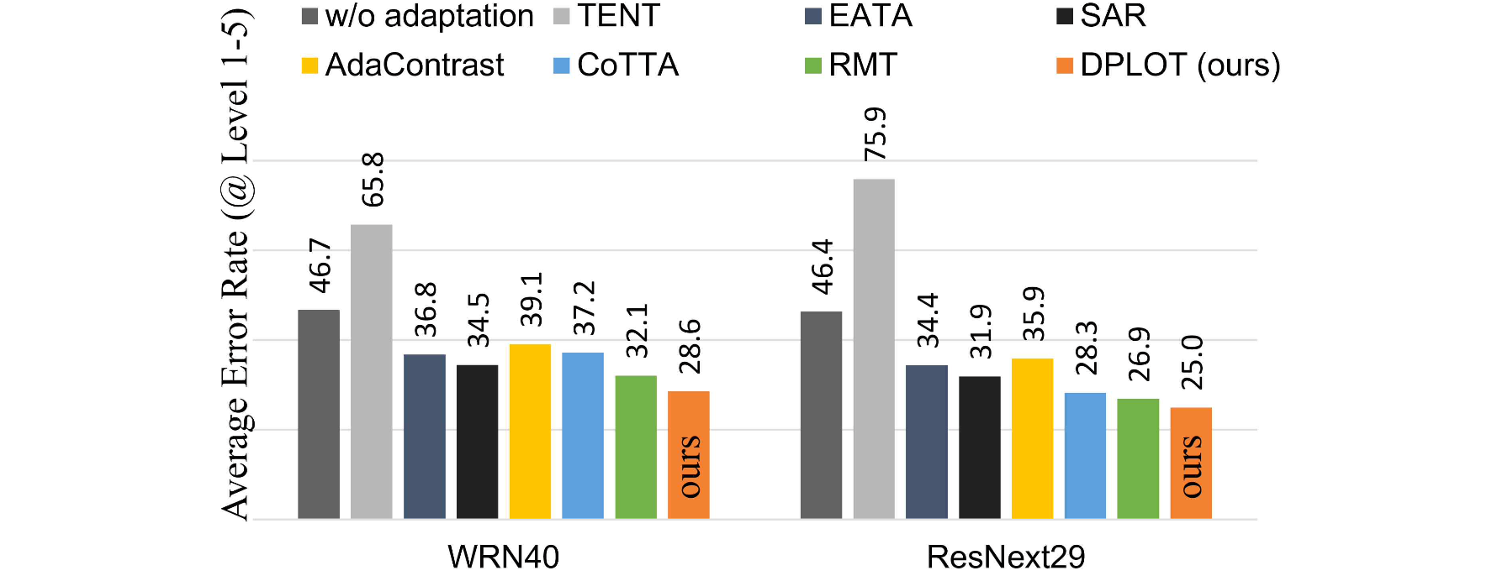▲ Real-time adaptation research benchmark performance results. It can be seen that the method developed in this study (orange) has a lower error rate than other methods.

Professor Kyoobin Lee said, "Through this study, we confirmed that artificial intelligence systems can continue to grow and operate stably in various environments and conditions. In the future, it is expected that it will be able to be used in autonomous vehicles by accurately recognizing objects without shaking despite environmental changes due to weather, lighting conditions, geographical characteristics, etc."

This research, led by Professor Kyoobin Lee of the School of Integrated Technology and conducted by doctoral student Yeonguk Yu, was supported by the Ministry of Science and ICT and LG Electronics and is scheduled to be announced on June 19, 2024, at ‘CVPR (Computer Vision and Pattern Recognition)’, the world’s most prestigious academic conference in the field of computer vision.



