“Black and white photos and movies converted by AI are so cool.” Professor Hae-Gon Jeon’s research team has developed AI technology to correct color → black and white of photos and videos at a professional level

- AI Graduate School Professor Hae-Gon Jeon's team developed an algorithm that replicates correction techniques and styles from the portfolios of famous domestic photographers... Anyone can create black and white photos in the professional field and apply them to video as well
- The preference for color → black and white reproduction results based on research results is higher than the original black and white release version of the movie ‘Parasite’... Scheduled to be announced in June at the world’s leading vision society, CVPR

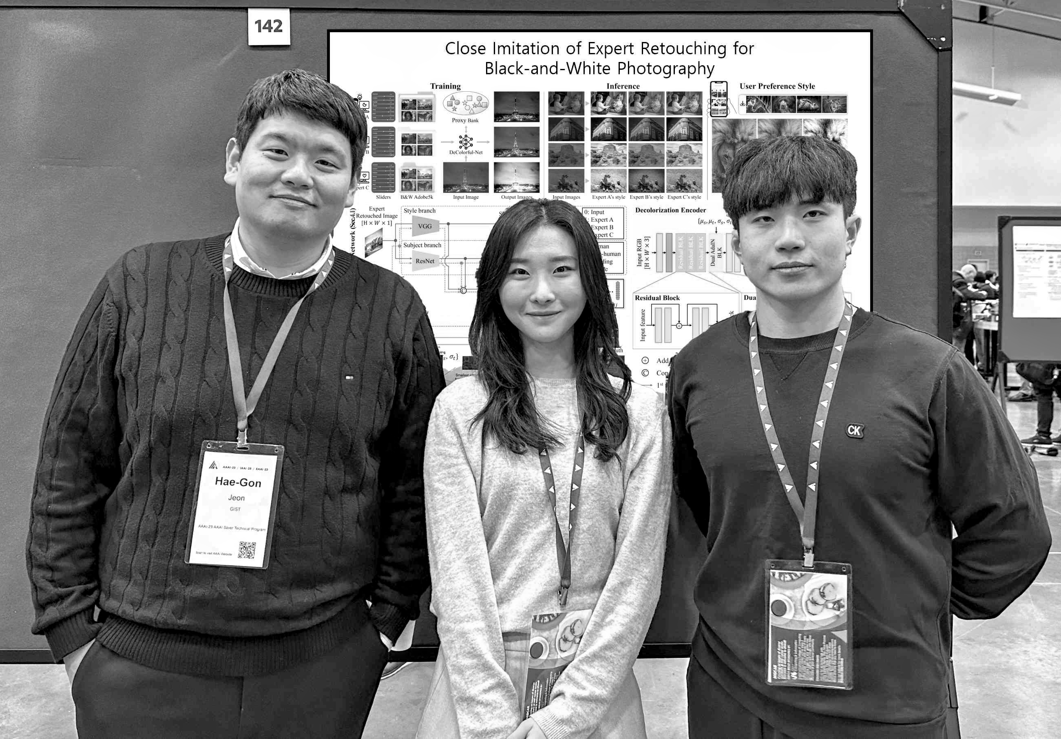
▲ (From the left) AI Graduate School Professor Haegon Jeon, integrated student Jisu Shin,and integrated student Seunghyun Shin

Barbara Davidson, who won the Pulitzer Prize in 2011, mentioned the advantages of black and white photography: “In color photography, the artist's intention is sometimes damaged by the color, but in black-and-white photography, emotions and directing intentions can be expressed by focusing more on the subject.”

The Gwangju Institute of Science and Technology (GIST, President Kichul Lim) announced that Professor Hae-Gon Jeon's research team at the AI Graduate School developed an algorithm that uses artificial intelligence (AI) technology to replicate black-and-white photo correction techniques from the portfolios of black-and-white photographers.

Unlike color photography, black and white photography allows you to express a photograph by moving away from color and focusing on texture, lines, patterns, and contrast. Taking advantage of these characteristics, black and white photography has recently been receiving new attention as it has been widely used to create aesthetic effects on social networking services (SNS) such as Instagram.

So far, in research in the field of computer vision, color → black and white image conversion has been treated simply as a preprocessing step to perform other tasks rather than to improve aesthetic completeness with the goal of not losing information during the conversion process.

To obtain black-and-white photos for aesthetic purposes, you must purchase a camera specifically designed for black-and-white photos, which is much more expensive than a regular camera, or ask a professional for correction. Therefore, black-and-white photography at the artist's level, which takes more time and costs than ordinary color photography, was disappointing in terms of practicality.

Focusing on this, the research team developed a black-and-white photo generation algorithm that very precisely reproduces the aesthetic elements of professional photographers from color photos.

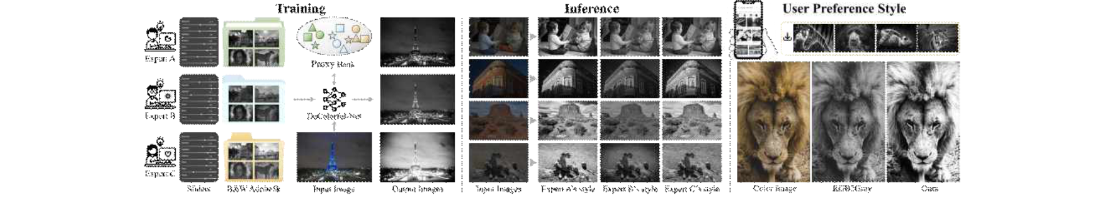▲ The overall pipeline of this study. After building a photo dataset from experts and learning to closely replicate them, it can convert any style of photo downloaded from the Internet into a black and white photo.

In order to build learning data, the research team recruited three domestic professional photographers and commissioned them to convert color photos to black and white in their own style*, creating a black-and-white photo dataset (5,000 photos per photographer, a total of 15,000) with the artist's unique personality.

Based on this, the research team additionally performed stratification and classification work based on which photographer edited each photo dataset and what the target subject was among the photos by each photographer.

* style: The style used in this material refers to the brightness of the result that the author subjectively prefers when retouching a photo. It refers to contrast, additional effects, etc.

Afterwards, the research team applied an artificial neural network based on Deep Metric Learning to create aesthetically pleasing black-and-white photos. The algorithm extracts the photographer's unique style characteristics from the photographer's portfolio and consists of a ‘first neural network’ and a ‘second neural network’ that reproduces aesthetic elements of retouching at a level very close to the correction method of actual experts.

The ‘first neural network’ generates proxy*, a vector representing each layer. The research team learned that a proxy formed detailed clusters for each subject. The learned ‘first neural network’ classifies the photographer’s unique style differences into a hierarchical structure, and the algorithm was designed to use the detailed clusters as vectors reflecting the correction style for each subject.

* proxy: Vector representing values belonging to the same cluster in the embedding space

* embedding space: In a deep learning neural network, it refers to a low-dimensional space that represents the intermediate value passing through the neural network when an input image is given.

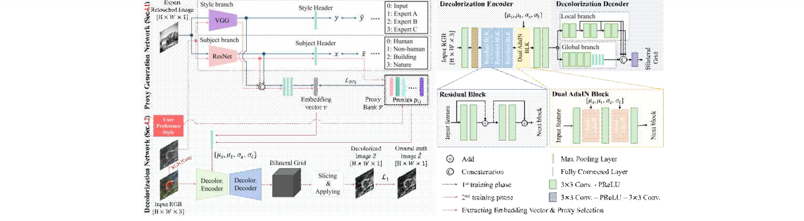▲ Black and white photo generation network structure proposed in this study. It is divided into a first neural network that extracts styles as vectors from a pile of photos, and a second neural network that reproduces the aesthetic elements of the extracted vectors to create black-and-white photos.

Next, when the proxies defined in the previous process were provided to the ‘second neural network’ along with the input image, black and white images matching the style contained in each proxy were extracted. To solve the problem that photo retouching is not only applied to the whole photo but also to each area differently, they designed a second neural network that divides the photo into semantic parts to enable area-specific retouching.

The algorithm learned in this way can fine-tune the ‘first neural network’* to suit the user’s personally preferred photos. In other words, it is possible to imitate a new photographer's style based on the parameters of the network learned with the proposed dataset.

* fine-tuning: This is a method of fine-tuning the variable values of a neural network by additionally learning a once-learned neural network.

As a result of investigating the black-and-white photos and Galaxy/iPhone/Instagram filters obtained through the algorithm developed by the research team and the preferences of the general public, it was confirmed that most people preferred the results of the algorithm proposed by the research team.

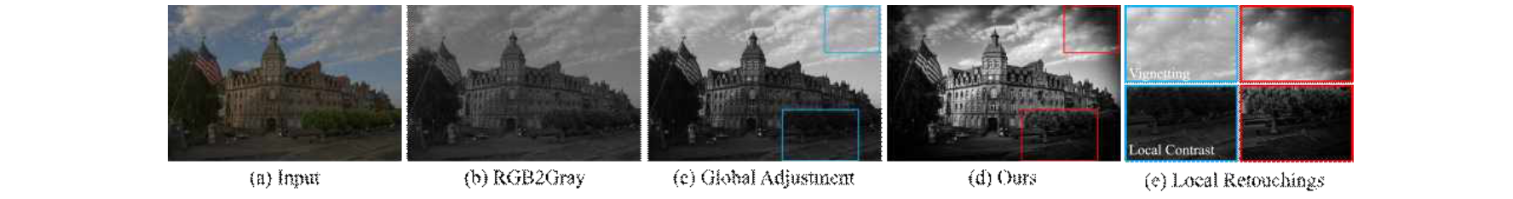▲ Comparison of input image (a) using a basic black and white conversion algorithm (b), the same correction applied to the whole image (c), and the result of the algorithm that can apply different correction effects to different regions (d). The algorithm is able to produce a more aesthetically pleasing black and white image by applying different corrections to different regions, as highlighted in (e).

The survey was conducted using the survey platform ‘Amazon M-Turk’, targeting a total of 80 men and women in their 20s to 50s, 10 men and women according to age and gender. As a result of converting 20 photos with each filter and ranking the filters they liked for each photo, the algorithm developed by the research team was the highest. (Highest score of 4.58 points, runner-up iPhone14Pro 4.12 points)

Furthermore, for the movies ‘Parasite’ and ‘Mad Max,’ the results compared ▴ preferences for the original black-and-white version of the two movies and ▴ the black-and-white image recreated by the research team’s algorithm in color. Likewise, the preference for the results according to the algorithm developed by the research team was overwhelmingly high.

The movie video comparison experiment was conducted with a total of 10 videos, and whether the black-and-white re-released movie and the video generated by the algorithm developed by the research team were better, ranging from ▴ strongly agree (5 points) to ▴ strongly disagree (-5 points). The video produced by the research team's algorithm received an average score of 2.36, confirming a much more preferable result than the original black-and-white film.

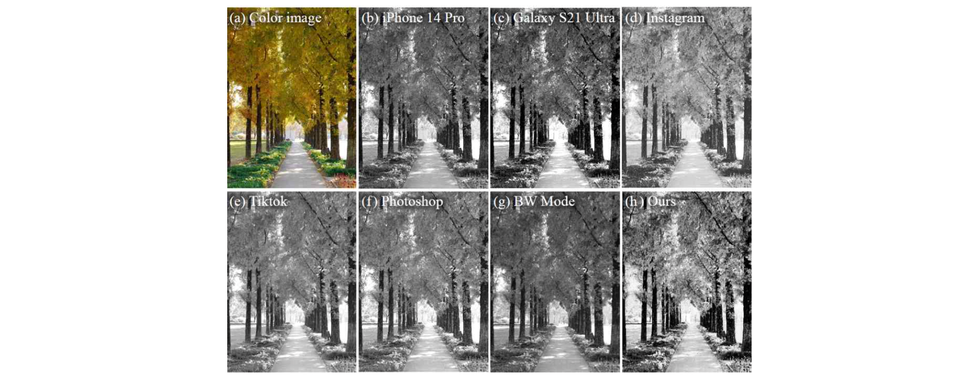▲ A comparison photo between this research algorithm and filters from existing photo correction applications. Given a color image (a), each black and white filter supported by iPhone (b), Galaxy (c), Instagram (d), TikTok (e), Photoshop (f), and photographer's camera (g). The results of applying and the results (h) corrected through the algorithm of this study are shown.

Professor Hae-Gon Jeon said, "Through the results of this research, it has become possible for the general public to easily obtain aesthetically valuable black-and-white photos, which used to require advanced background knowledge of photography and expensive cameras, through our algorithm. It is expected to be used in future photo retouching applications and video post-processing processes in the media industry."

This research, led by Seunghyun Shin, a combined master's and doctoral student in Professor Hae-Gon Jeon's lab at the GIST AI Graduate School, and participated by Professor Inwook Shim of Inha University, was carried out in collaboration with the Ministry of Science and ICT's 'AI Innovation Hub' project and the 'Science and Technology Project to Open the Future of the Region' project with support from the Ministry of Information, Communication (Special Research and Development Zone), Gwangju Metropolitan City, and the the 'Convergence Culture Virtual Studio for Implementation of Artificial Intelligence-based Metaverse' project hosted by GIST and is scheduled to be announced on June 19, 2024, at ‘CVPR (Computer Vision and Pattern Recognition)’, the world’s leading academic conference in the field of computer vision.



