The movement of a billiard ball reveals the secret of ‘quantum chaos’ GIST identifies a method for determining the state of quantum mechanical chaos

- Professor Keun-Young Kim’s team presents the ‘Quantum Mechanical Billiard Ball Chaos Model’ that distinguishes between chaos and order in the quantum mechanical system... Expected to provide a deeper understanding of quantum black holes and the early phenomena of the universe.
- Applied to the development of quantum devices and quantum computers... Published in the international academic journal 「Physical Review D」, selected as an editors' suggestion

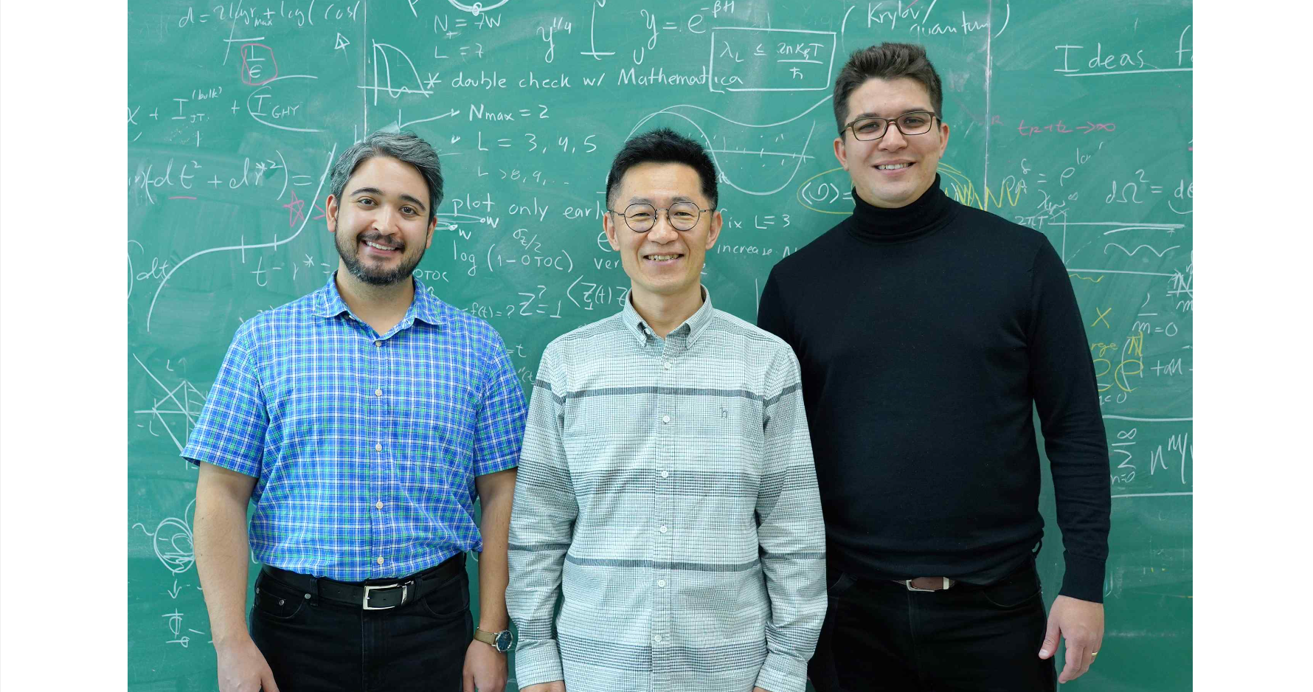▲ (From left) Dr. Hugo Camargo, Professor Keun-Young Kim, and Dr. Viktor Jahnke

The Gwangju Institute of Science and Technology (GIST, President Kichul Lim) announced that Professor Keun-Young Kim's research team in the Department of Physics and Photon Science has identified a method of determining whether a quantum mechanical system is in a state of chaos by introducing 'spectral complexity'.

This research outcome overcomes the limitations of existing quantum chaos judgment methods that are unrelated to the flow of time and quantum state, while more accurately identifying the nature of quantum chaos, thereby improving the understanding of quantum black holes and early phenomena of the universe. It is expected that it can also be applied to the development of quantum devices and quantum computers.

Spectral complexity is a quantity that defines how the complexity of a given system changes over time using the quantized energy level of the quantum mechanical system. It can be used as a quantity that shows typical time changes in quantum chaos in quantum chaos research based on random matrix theory or quantum many body systems with quantum chaos states.

In classical mechanics, ‘chaos’ means that the path of an object changes significantly even if the initial conditions of the object change even slightly. The ‘Butterfly effect’, the most famous example of classical chaos, refers to a phenomenon in which the slight wind created by the flapping of a butterfly’s wings leads to unexpected and huge changes, such as a storm.

The question of what quantum mechanical chaos corresponds to classical mechanical chaos is a fundamental problem in physics, but it is one of the difficult problems that is not yet fully understood.

In order to provide a partial answer to this problem, an attempt was made to explain quantum chaos using a specific statistical distribution of the intervals between energy levels in a quantum mechanical system. However, this method cannot handle dynamic phenomena that change over time and has limitations in explaining chaotic phenomena that change depending on specific quantum states.

To overcome these limitations, the research team used spectral complexity to analyze the quantum dynamics of billiard balls existing on a stadium-shaped billiard table.

▲ Stadium-shaped billiard room: If R=a, the playing field becomes circular and the classical movement of the billiard room is not in a state of chaos. If R≠a, the classical movement in the billiard room is in a state of chaos.

In the case of classical mechanical billiard balls, if the shape of the billiard table is circular (R=a), there is no chaos, and if it is not circular (R≠a), chaos occurs. Correspondingly, in the case of quantum mechanical billiard balls, if the shape of the billiard table is circular (R=a), the spectral complexity is large (black). If it is not circular (R≠a), the spectral complexity is small (various colors). In this way, spectral complexity can be used as a way to determine quantum chaos.

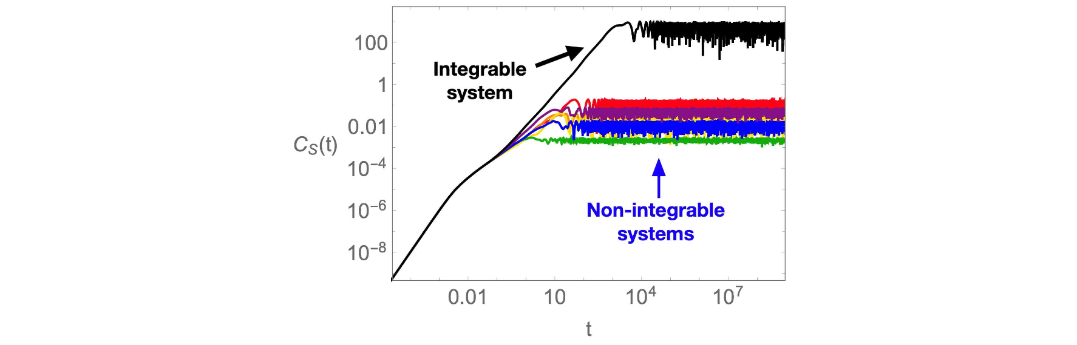▲ Spectral complexity: Spectral complexity is large in an integral system (test). In a chaotic system (non-integrable system, various colors), the spectral complexity is small.

Professor Keun-Young Kim said, "Through this research outcome, we have confirmed the possibility of defining quantum chaos and clearly understanding its nature. In the future, if the quantum mechanical thermal balance phenomenon is understood through this, it can be applied to the development of quantum devices and quantum computers. Research on quantum chaos in quantum black holes is expected to provide a deeper understanding of quantum gravity and the phenomena of the early universe."

This research was conducted by GIST Department of Physics and Photon Science Professor Keun-Young Kim, Dr. Hugo Camargo, Dr. Viktor Jahnke, Dr. Hyunsik Jeong from the Universidad Autónoma de Madrid, Spain, and Dr. Mitsuhiro Nishida from the Asia-Pacific Center for Quantum Theoretical Physics (APCTP) and was supported by the National Research Foundation of Korea mid-career research project, the quantum information science human infrastructure development project, and the GIST AI-based convergence talent training support project, and was published in 'Physical Review D', a prestigious international academic journal in the field of physics. It was selected as an editors' suggestion and published on February 27, 2024.



