“It’s called global warming, but why are the strongest cold wave coming from the Arctic?”
Korea-US international joint research team, long-term climate analysis for the 21st century...
Winter cold waves expected to decrease on the Korean Peninsula after 2040

- The Korea-US international joint research team led by GIST Professor Jin-Ho Yoon predicts that cold waves from the Arctic will still occur or occur more frequently on the Korean Peninsula over the next 10 years, but will decrease after 2040
- Intensifying global warming is suppressing the southward flow of cold air from the Arctic and reducing the ‘warm Arctic-cold continent phenomenon’... Published in <npj Climate and Atmospheric Science>, a renowned international academic journal in the field of meteorology

▲ (From left) Doctoral student Yungi Hong and Professor Jin-Ho Yoon

It is said that the average temperature of the Earth is increasing due to global warming, but why are there unprecedented cold waves from the Arctic in some areas? The Korea-US international joint research team presented an outlook on future changes in the ‘warm Arctic-cold continent phenomenon*’, which has been identified as one of the main causes of winter cold waves.

* Warm Arctic Cold Continent (WACC): Refers to a phenomenon in which warming of the Arctic changes atmospheric circulation, leading to a cold wave in mid-latitude regions in winter.

The Gwangju Institute of Science and Technology (GIST, President Kichul Lim) analyzed the ‘Community Earth System Model Large Ensemble Project (CESM1 LENS)’ by an international joint research team led by Professor Jin-Ho Yoon of the School of Earth Sciences and Environmental Engineering. It was confirmed that the ‘Warm Arctic Cold Continent phenomenon’ will significantly decrease after the mid-21st century, corresponding to 2040, and that through this, winter cold waves on the Korean Peninsula are also expected to decrease.

According to a recent CNN report (“Brutal arctic blast expands its reach as the South deals with deadly snow and ice”, January 16, 2024), the United States experience drecord-breaking cold temperatures in January 2024 in most regions, including the South and East, and at least five people died as a result.

On the other hand, in the case of Korea, according to the Korea Meteorological Administration's ‘Monthly Climate Analysis Information’, the average temperature in December of last year and January of this year was both higher than normal and the number of cold wave days was also low.

What does it mean that even in the same mid-latitude region, the climates are so different? The research team analyzed that this phenomenon suggests that record-breaking cold temperatures, like those in the United States, may occur in Korea, which is gradually becoming warmer during the winter.

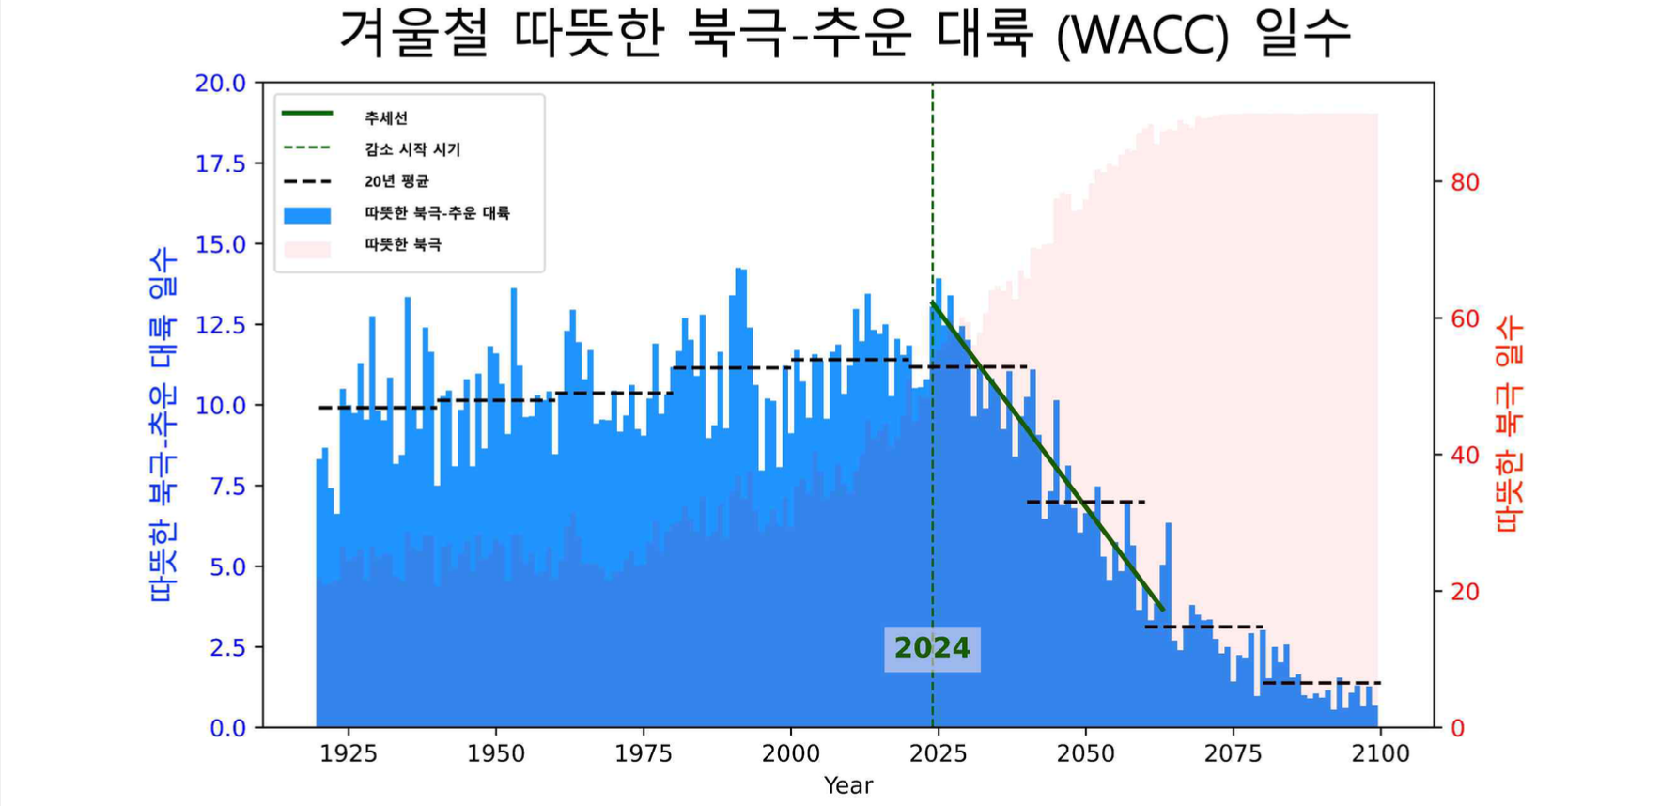▲ Number of warm Arctic-Cold Continent (WACC) days in winter from 1920 to 2100 shows the frequency of ‘warm Arctic’ and ‘warm Arctic-cold continent’ days. ‘Warm Arctic’ refers to the Barents Kara Sea (30-70°E, 70-80°N), and ‘cold continent’ refers to East Asia (80-130°E, 35-50°N). The left and right axes represent the number of ‘warm Arctic-cold continent’ and ‘warm Arctic’ days, respectively. The green lines and years show the linear trend and the year the decline began.

The research team predicts that as global warming accelerates, the ‘warm Arctic-cold continent’ phenomenon will gradually increase by the 2030s due to the weakening of the Arctic vortex, which prevents cold winds from moving south in the Arctic region, and also predicted that cold waves from the Arctic will still occur or occur more frequently over the next 10 years.

However, according to the research team's climate model analysis, it is predicted that the frequency of the warm Arctic-cold continent phenomenon will continue to decrease after this period. The research team explained that this means that global warming, which will intensify in the future, will suppress the southward flow of cold Arctic air.

Doctoral student Yungi Hong, who participated as the first author, said, "Identifying the timing of changes in the warm Arctic-cold continent phenomenon through this study can help predict winter cold waves and improve winter cold wave predictions in climate models."

Professor Jin-Ho Yoon said, "Our research provides future projections of when the ‘warm Arctic-cold continent’ phenomenon will peak and begin to decline. Understanding these changes will contribute to establishing effective climate change response strategies in areas experiencing cold waves from the Arctic."

This research was led by Professor Jin-Ho Yoon and doctoral student Yungi Hong of the GIST School of Earth Sciences and Environmental Engineering, including Professor Shih-Yu (Simon) Wang of Utah State University, Professor Seok-Woo Son of Seoul National University, Professor Sang-Woo Kim of Seoul National University, Professor Jee-Hoon Jeong of Chonnam National University, Professor Baekmin Kim of Pukyong National University, and KAIST Professor Hyungjun Kim with support from the National Research Foundation of Korea's Ocean Polar Basic Technology Development Project and mid-sized research project.

The research results were published online on Monday, March 11, 2024 in ‘npj Climate and Atmospheric Science’, a sister journal of Nature, a renowned international academic journal in the field of meteorology.



