“Robot floats on its own in the space station”
GIST releases first weightless autonomous flying robot dataset

- Professor Pyojin Kim’s team developed and disclosed the world’s first dataset collected by the autonomous flying robot ‘Astrobee’ in a zero-gravity environment within the International Space Station (ISS)... providing a starting point for developing autonomous navigation algorithms
- In collaboration with NASA Ames Research Center, published in the international academic journal <IEEE Robotics and Automation Letters>

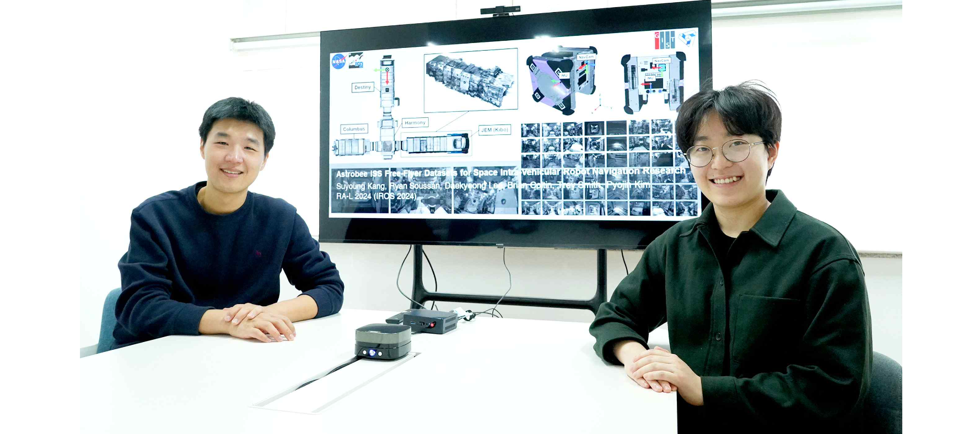▲ (From left) GIST School of Mechanical Engineering Professor Pyojin Kim and Sookmyung Women's University first author Suyoung Kang

With the advent of the Space 4.0 era, international interest is focused on fostering space research and commercial activities, and domestic researchers are collaborating with the National Aeronautics and Space Administration (NASA) to utilize artificial intelligence (AI) robots, and a dataset for research on the International Space Station (ISS) has been released.

At the Gwangju Institute of Science and Technology (GIST, President Kichul Lim), Professor Pyojin Kim's research team from the School of Mechanical Engineering collaborated with Sookmyung Women's University (President Yun-geum Jang) to develop the world's first autonomous flying robot that operates in a zero-gravity environment and announced that they had developed an integrated dataset of sensor data collected through NASA Astrobee*.

The research team worked with NASA Ames Research Center to integrate and distribute sensor data measured and collected within the International Space Station, which was previously difficult to access, and conducted research on space-based autonomous flight technology.

* Astrobee: A cube-type robot with autonomous flight capabilities developed by NASA Ames Research Center. This robot helps astronauts focus more on core tasks that only humans can do.

Astrobee assists astronauts in performing various tasks such as measuring noise within the space station, recording experiments, and moving cargo through autonomous operation or remote control. At this time, Visual SLAM* technology, which allows the robot to determine its location and fly autonomously within the International Space Station, is essential.

* Visual SLAM (Simultaneous Localization and Mapping): SLAM technology provides the location necessary for robot autonomous driving and generates map information, which is the spatial infrastructure. In particular, much research, development, and application has been conducted in the field of autonomous driving. Visual SLAM is SLAM that uses camera images and is widely used not only for the autonomous driving of robots, autonomous vehicles, and drones, but also as the basis for technologies such as 3D shape restoration of space or objects and VR/AR, and is widely used as a base technology for robotics, autonomous driving, and augmented reality. It plays a key role in fields such as (AR).

In addition, in outer space, a zero-gravity environment, not only can robots move and rotate freely in all directions, but robots also have difficulty recognizing their surroundings and determining their location due to changes in light or interference from floating objects. Therefore, in order to study stable autonomous flight despite obstacles and changes in the robot within the spacecraft, it is essential to acquire datasets from various scenarios that reflect these spatial characteristics.

However, the research and development of reliable navigation technologies that can be utilized inside the International Space Station is limited by a lack of data and resources, and the domestic research environment in particular faces the dual challenges of a lack of platforms to study robots in zero gravity and limited access to the ISS.

Professor Pyojin Kim's research team proposed the world's first dataset for research on autonomous flight within a space station. The research team analyzed scenarios that pose difficulties in video navigation and compared and evaluated Visual SLAM and VIO* algorithms.

* VIO (Visual Inertial Odometry): Technology to estimate the position and posture of a moving object by combining visual data and inertial measurement devices

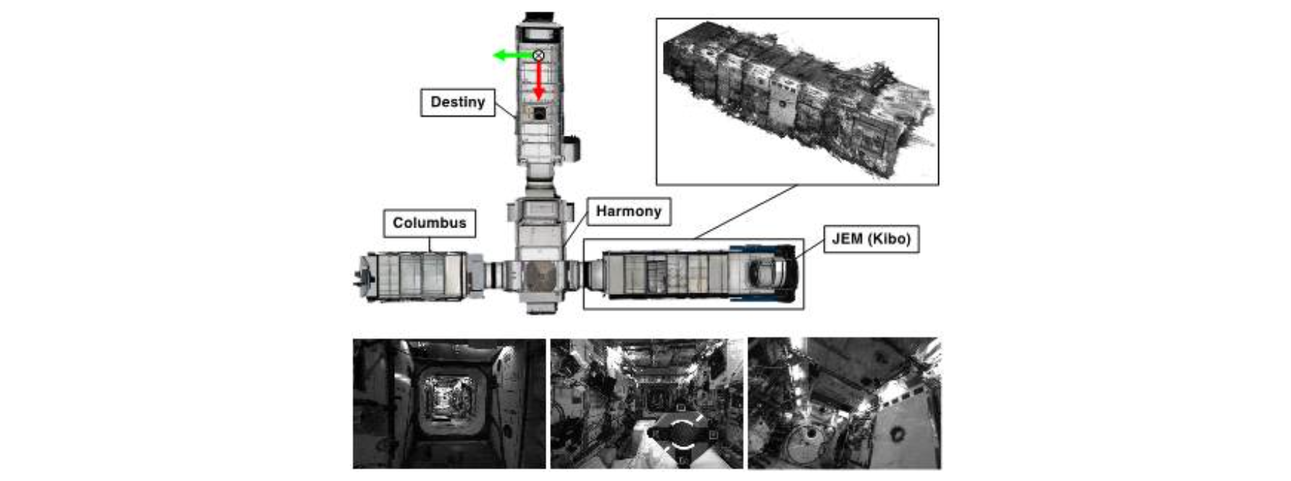▲ Astrobee Dataset Collected spaces and examples: Four modules of the International Space Station where Astrobee robots operate. A 3D reconstruction model created based on actual trajectories and images.

The Astrobee dataset developed by the research team includes various scenarios that can occur in a zero gravity environment. A total of 23 datasets were released through four categories consisting of Free Flight, Calibration, Intra Vehicular Activity, and Test and Debugging.

It includes data obtained during actual missions, from simple turns and driving to extreme turns and surrounding exploration, and integrates and provides all sensor information necessary for autonomous flight experiments and performance evaluation.

Furthermore, the research team used data collected from Astrobee to evaluate navigation algorithms suitable for a zero-gravity space environment.

A comparative experiment was conducted through a benchmark using a total of six state-of-the-art positioning algorithms (an evaluation environment composed of the same data set), and the geometry-based algorithm showed stable and accurate performance in most scenarios.

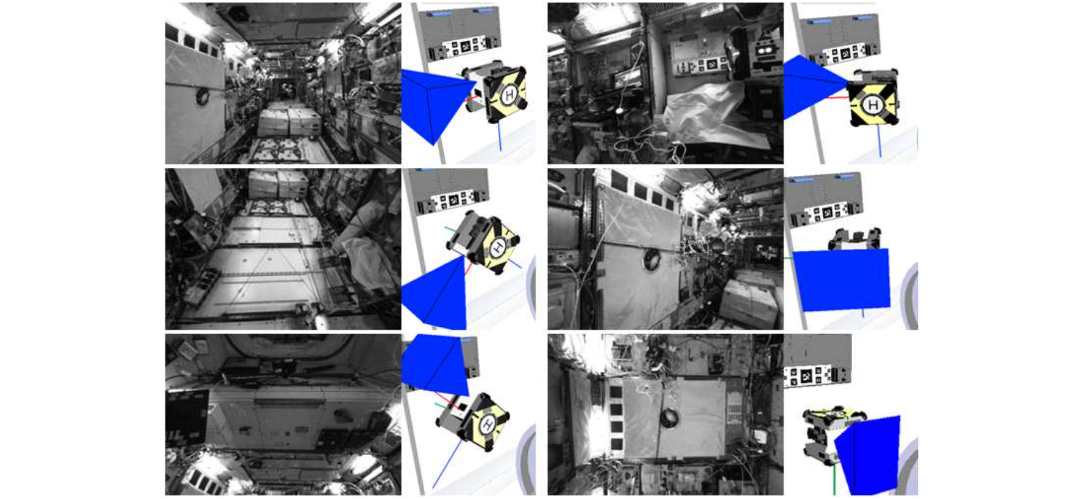▲ Astrobee robot’s various motions and resulting field of view: This is an example of images collected by Astrobee within the Kibo module of the International Space Station. It contains various rotational motions performed in zero gravity and corresponding image information.

Anyone interested can download the dataset from the website below.
https://astrobee-iss-dataset.github.io/

Professor Pyojin Kim said, "The greatest significance of this research outcome is that it provided direction for the development of a more efficient and stable navigation system for future space missions through various data sets and autonomous navigation experiment results obtained from the actual International Space Station. Furthermore, it is expected that the released dataset will suggest various research directions, including in related 3D computer vision and robotics research fields."

Professor Kim also said, "The ultimate goal is to develop an autonomous navigation algorithm that enables rapid and accurate cooperation with astronauts based on the newly developed dataset and experimental results."

This research, led by Professor Pyojin Kim of the School of Mechanical Engineering at GIST and conducted by Suyoung Kang, an undergraduate student at Sookmyung Women's University, was supported by the National Research Foundation of Korea's Basic Research Project and was published online on February 12, 2024, in 'IEEE Robotics and Automation Letters (RA-L)', a top 30% journal in the robotics field.



