“Why have large-scale atmospheric currents become so powerful?”
GIST leads joint research between Korea and the U.S. to identify causes of abnormal climate phenomena in the Northern Hemisphere during winter

- The Korea-US joint research team led by Professor Jin-Ho Yoon's team analyzed climate data and model forecast data from the past 70 years and found that 'global warming' was the main cause of changes in North American winter air flow and confirmed the mechanism of occurrence
- Clearly reveals the impact of greenhouse gas emissions on the global climate system... Published in <npj Climate and Atmospheric Science>, a renowned international academic journal in the field of meteorology

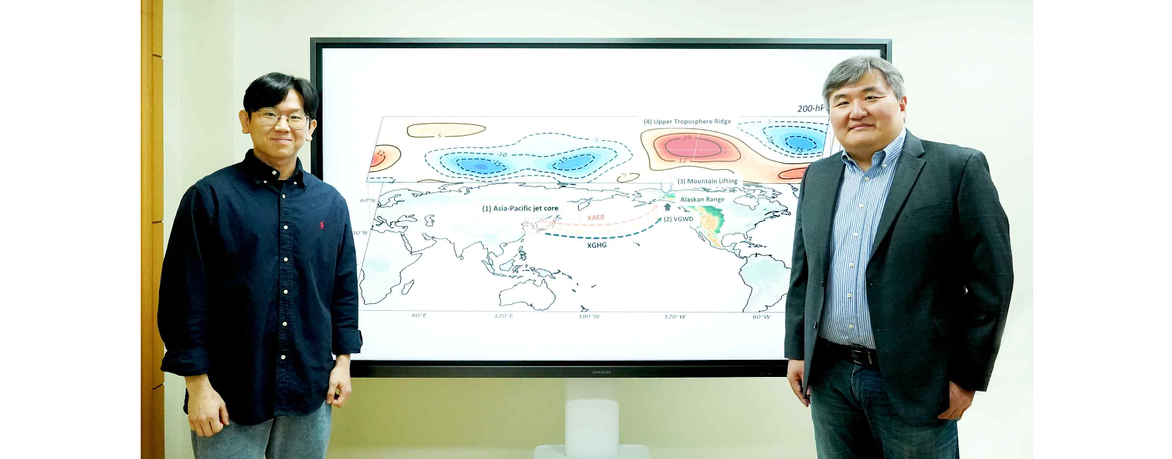▲ (From left) School of Earth Sciences and Environmental Engineering doctoral student Jueun Lee and Professor Jin-Ho Yoon

While abnormal climate phenomena are occurring throughout the world due to global warming, research results have shown that extreme weather phenomena such as droughts and heavy rains are occurring more and more frequently in mid-latitude regions.

A joint Korean-American research team revealed that extreme heavy rainfall and droughts have been occurring alternately in recent years, especially in the western part of North America, including California, and that this phenomenon has been confirmed to be closely related to large-scale atmospheric flow and its changes.

At the Gwangju Institute of Science and Technology (GIST, President Kichul Lim), an international joint research team led by Professor Jin-Ho Yoon of the School of Earth Sciences and Environmental Engineering comprehensively analyzed various climate data from the past 70 years (1951-2020) and climate model simulation results based on greenhouse gases and aerosol forcing. As a result of the analysis*, it was found that human-induced global warming further amplifies the large-scale flow of the winter atmosphere, which leads to significant changes in relationships among widely known telecorrelation patterns*.

* For past climate change, the team used the NOAA/CIRES/DOE 20th Century Reanalysis version 2 and 3 data from the National Oceanic and Atmospheric Administration (NOAA), the Cooperative Institute for Research in Environmental Sciences (CIRES), and the Department of Energy (DOE), the ERA 20th Century Reanalysis and ERA5 reanalysis from the European Centre for Medium Term Weather Forecasts (ECMWF), and the NCEP-NCAR reanalysis from the National Centers for Environmental Prediction (NCEP) and the National Center for Atmospheric Research (NCAR). For greenhouse gas and aerosol forcing climate projections, we used the Community Earth System Model version 1 (CESM1) Large Ensemble Community Project (LENS) from the National Center for Atmospheric Research.

* telecorrelation pattern: In climatology, ‘telecorrelation pattern’ refers to a phenomenon in which climate change in one region is linked to climate change in another distant region. These phenomena occur through dynamic processes in the climate system, such as atmospheric wave changes and air-ocean interactions.

In addition, the large-scale atmospheric flow (planetary wave) that determines the weather in the Northern Hemisphere in winter develops a high pressure in the western United States and a pressure trough in the eastern United States. Recently, the correlation between these two changes has become increasingly deeper, and the power is increasing. As they strengthen each other, they change into the North American Winter Dipole (NAWD) pattern, which is known to have a significant impact on the winter climate in North America. In addition, it was confirmed to have an effect on winter precipitation patterns and changes in western North America.

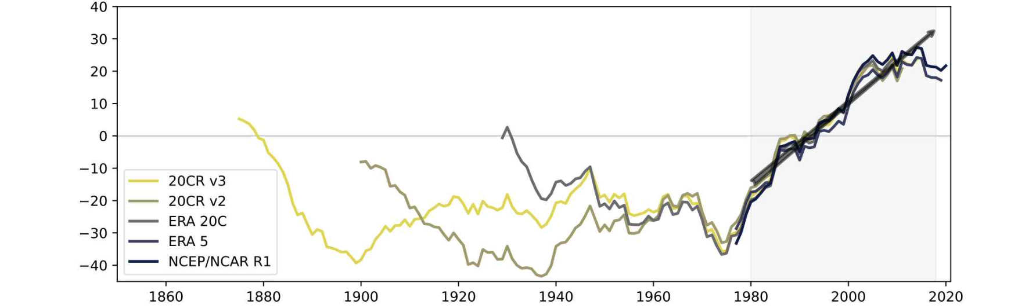▲ Time series illustration of high pressure strengthening in the upper troposphere (200-hPa) of western North America during Northern Hemisphere winter (December-January-February). Illustration of a time series of anticyclone intensification over western North America calculated from multiple historical climate data. Recently, high pressure over western North America has strengthened, leading to amplification and stagnation of large-scale atmospheric waves in winter.

The research team analyzed that these phenomena were caused by the jet stream in the Pacific region moving northward due to global warming caused by an increase in greenhouse gases.

In particular, the researchers paid attention to the fact that as this jet stream moves north, it causes more southerly winds to blow into the mountainous areas of Alaska, ultimately causing stronger updrafts. Global warming was pointed out as the main factor in the strengthening of high pressure forming in the area.

The findings provide further support for the idea that both the ▴ northward shift of the jet stream, ▴ the strengthening of high pressure over the western United States, and ▴ the intensification of large-scale atmospheric flows can be caused by greenhouse gas emissions from human activities, which many previous studies have not found a clear link between, the researchers explained.

Additionally, as a result of this study, large-scale atmospheric flow will continue to strengthen with future climate warming. It is predicted that the increase in unpredictable extreme hydroclimate* events and strengthened planetary waves* in western North America will further emphasize the impact of regional climate change.

* hydroclimate: This refers to a field that monitors long-term changes in the water cycle and water balance between the atmosphere and the land surface, and predicts and evaluates their impact on droughts, floods, water management, etc.

* planetary wave: A large-scale wind system, such as a belt-shaped wind, commonly observed in the middle of a planet's atmosphere. It is like a wave with a long wavelength in the westerly wind belt that occurs mainly in the upper troposphere in mid-latitudes.

Professor Jin-Ho Yoon said, "This research will help us further understand changes in the global climate system due to global warming. It presents more clearly that this phenomenon can be caused entirely by the influence of greenhouse gas emissions caused by human activities, and the mechanism proposed by the research team can be applied as an important consideration in future climate prediction modeling."

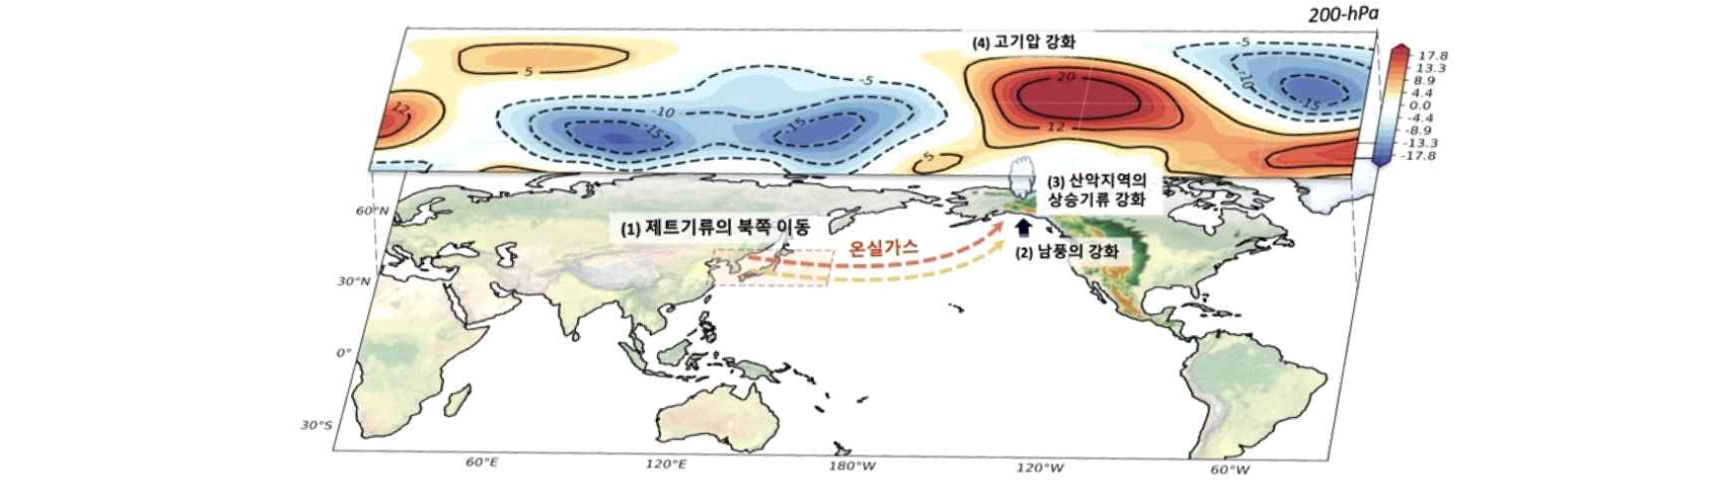▲ Schematic diagram of the change in the Pacific jet stream due to forcing caused by human activities and the resulting mechanism of high pressure strengthening in the western United States (1), the northward movement of the Pacific jet in the climate outlook model greenhouse gas forcing experiment (2), and the resulting strengthening of the incoming southerly wind at the jet exit (3), formation of a strong updraft due to the Alaskan mountainous terrain (4), resulting in strong anticyclone in the upper troposphere.

This research, which was conducted with support from the National Research Foundation of Korea, was led by Professor Jin-Ho Yoon and doctoral student Jueun Lee of the GIST School of Earth Sciences and Environmental Engineering, with the participation of Professor S.-Y. Simon Wang of Utah State University, Professor Seok-Woo Son of Seoul National University, Professor Daehyun Kim of Seoul National University, Professor Jee-Hoon Jeong of Chonnam National University, and Professor Hyungjun Kim of KAIST.

The research results were published online on March 7, 2024, in ‘npj Climate and Atmospheric Science’, a sister journal of Nature, a renowned international academic journal in the field of meteorology.



