“One step closer to the era of clean energy”
GIST develops 100-watt water electrolysis prototype... Production of eco-friendly, low-power green hydrogen using ammonia water

- Professor Jaeyoung Lee's research team achieved 57% energy savings compared to regular water electrolysis through a double-layer structure electrode using a platinum-iridium (Pt-Ir) catalyst... Enables mass production of high-purity hydrogen without carbon emissions.
- Published in the international academic journal ‘Journal of Energy Chemistry’

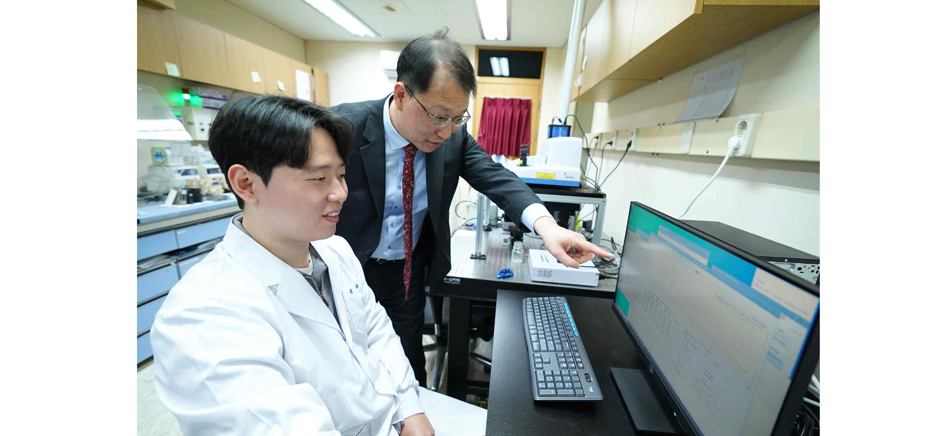▲ (From left) GIST doctoral student Donghyun Yoon and Professor Jaeyoung Lee

A Korean research team has succeeded in producing green hydrogen using ammonia (water) with little energy and without producing greenhouse gases. The results of this research are expected to contribute to the expansion of the eco-friendly hydrogen economy and stable energy supply.

At the Gwangju Institute of Science and Technology (GIST, President Kichul Lim), Professor Jaeyoung Lee's research team in the School of Earth Sciences and Environmental Engineering is working with 'TKG Huchems', which plays a pivotal role in the chemical industry based on nitric acid and ammonia, which are the core of the precision chemistry (basic inorganic chemistry) field. They announced that they had succeeded in developing the most efficient electrode for ammonia (water) electrolysis and further developed a 100 watt (W) class water electrolysis prototype for green hydrogen production through a scale-up approach.

* ammonia (water) electrolysis: A technology that electrochemically generates nitrogen and hydrogen using ammonia at the anode (anode) and water at the cathode (cathode) across an anion exchange membrane, without an additional separation process, producing high purity hydrogen.

The ammonia (water) electrolysis process can be operated at low reaction temperature (room temperature -80°C) and normal pressure. Unlike existing hydrogen production processes through fossil fuel reforming, it has the advantage of producing green hydrogen that does not emit any carbon dioxide.

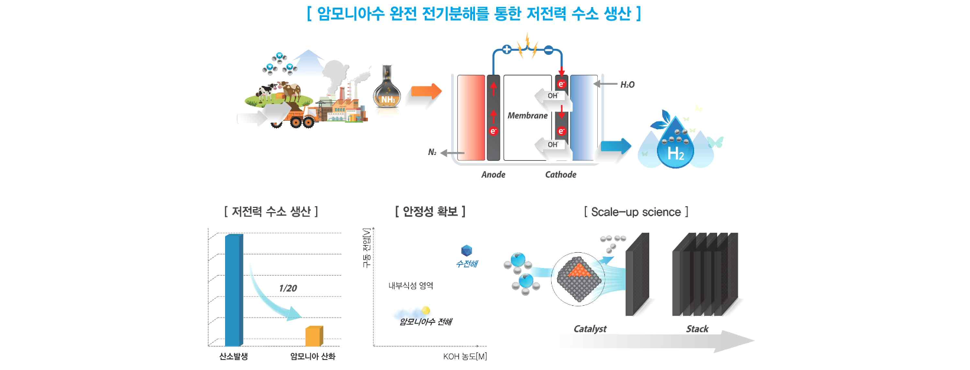▲ Green hydrogen production system and electrode scale-up research using low-power ammonia (water) electrolysis: Research on the production and development of a stack-module prototype with a total area of 200 cm² to overcome the technological limitations of small-scale (0.2-5.0 cm²) reactors that can only determine the basic properties of electrocatalysts and pave the way for industrialization.

Additionally, compared to general water electrolysis, which is a similar process, it takes about 1/3 of the power to produce substantially the same amount of hydrogen at a theoretical voltage that is 95% lower (0.06 V vs. 1.23 V).

On the other hand, it has the disadvantage of low hydrogen production speed and efficiency compared to existing thermal decomposition processes. To overcome this, it is essential to develop electrodes that can react stably at high current densities.

By making the electrode with a platinum-iridium (Pt-Ir) catalyst into a bilayer structure to better transfer the ammonia material while improving its durability, the team achieved a higher current density than conventional ammonia (water) electrolysis and reliably produced large amounts of hydrogen.

The catalyst layer, which is dense and has many small pores, effectively performs the mass transfer function of ammonia (water). It was confirmed that the catalyst layer electrode with a double-layer structure that prevents loss of the outermost catalyst shows high activity and durability against the ammonia oxidation reaction.

As a result, the research team optimized the reaction temperature and ammonia (water) concentration using a membrane-electrode integrated electrolysis reactor (single-cell) including a double-layer electrode. By stacking eight membrane-electrode assemblies (MEAs), they succeeded in developing a 100-watt ammonia (water) electrolysis stack with a total area of 200 cm.

The newly developed 100-watt ammonia (water) electrolysis stack* achieved a hydrogen production of 25 L h-1 at a current density of 175 mA cm-2. The high purity of the produced hydrogen was confirmed by gas chromatographic analysis.

* stack: a key device in a water electrolysis facility that actually produces hydrogen by decomposing supplied water

Professor Jaeyoung Lee said, "This research outcome is significant in that it confirms the potential of a zero-emission, eco-friendly new technology by optimizing the ‘scaled up’ stack-module system, while also reducing power consumption by more than 57%. Through follow-up research with ESUS Co., Ltd., we will grow the technology to present a new paradigm for eco-friendly green hydrogen production."

This research, conducted by Professor Jaeyoung Lee's team in GIST's School of Earth Sciences and Environmental Engineering, was conducted by the leading engineering research center (ERC Ecosystem Research Center) with support from TKG Huchems, the National Research Foundation of Korea, and the Korea Institute of Energy Technology Evaluation and Planning (KETEP) funded by the Ministry of Trade, Industry and Energy and was published online on February 7, 2024, in ‘Journal of Energy Chemistry’ (IF=13.599), an authoritative international journal ranked in the top 2.78% in the field of chemistry and applied technology.



