GIST develops a nano optical filter modeled after the eyes of Arctic reindeer... Can be used in self-driving cars, etc. without color distortion even in sunlight

- GIST Professors Hyeon-Ho Jeong and Young Min Song, a joint research team, developed the world's first nano optical filter 1/2000th the thickness of a human hair... Reduces power usage by 50% and increases modulation speed by 50%
- Expected to be used in self-driving cars, mobile robots, CCTV, etc... Published in 「Microsystems & Nanoengineering」, a renowned international academic journal in the field of instrumentation and measurement

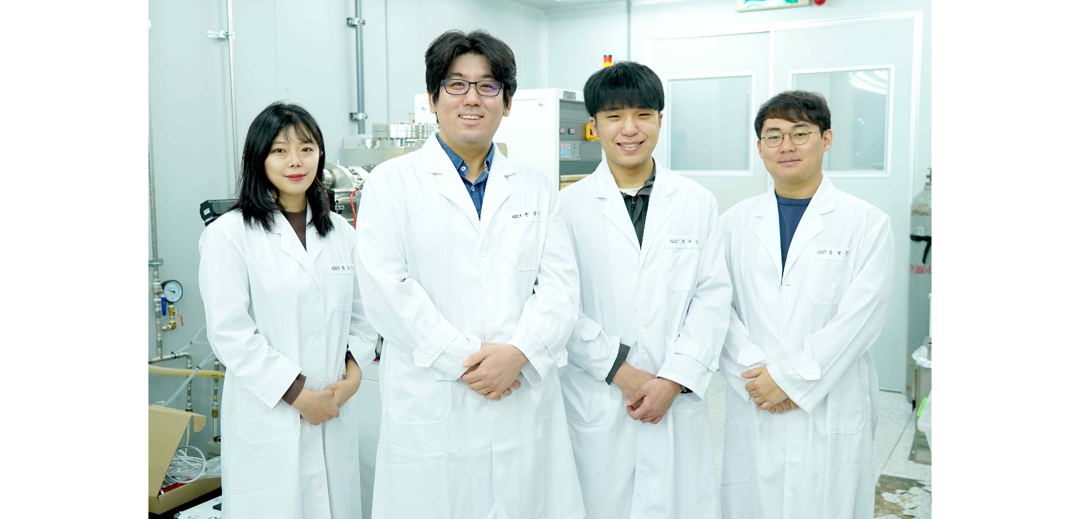▲ (From the left) Researcher Doeun Kim (Ph.D. course), Professor Hyeon-Ho Jeong, Researcher Gyurin Kim (integrated course), and Researcher Juhwan Kim (integrated course)

The eyes of reindeer living in the Arctic region change from gold in the summer to blue in the winter. Blue eyes maximize light absorption in the blue light environment of polar winter, which evolved to be advantageous for finding food in snow.

At the Gwangju Institute of Science and Technology (GIST, President Kichul Lim), a joint research team of Professor Hyeon-Ho Jeong and Professor Young Min Song of the School of Electrical Engineering and Computer Science was inspired by the eyes of Arctic reindeer and developed an active nano optical filter that electrically adjusts light transmittance* to maintain the color of objects constant regardless of the color of external light.

Unlike existing active optical filters that only have two states, on and off, which transmit or block light, the device developed in this study can freely change color temperature from warm to cool by continuously changing colors. It is expected to be used in self-driving cars, mobile robots, CCTV, etc.

* transmittance: When light is sent to an object, it refers to the intensity of the light passing through compared to the intensity of the light returning.

Arctic reindeer adjust the reflectivity of the tapetum inside their eyes to adapt to the seasonal changes in sunlight. Through this, it has a color correction ability that allows objects to be viewed in a consistent color regardless of the season.

* tapetum: An organ found in the eyes of many vertebrates, located just behind the retina, which reflects light and transmits light enough for the optic nerve to see.

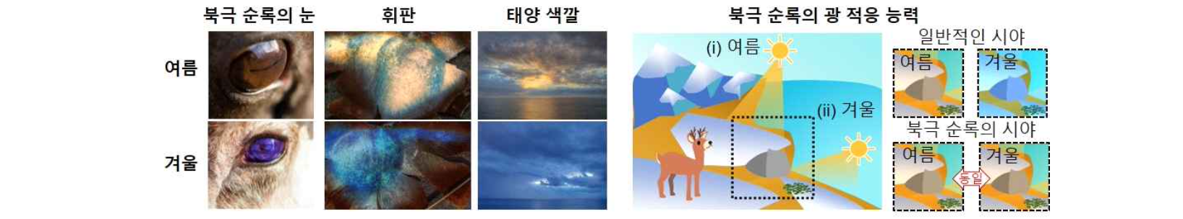▲ Arctic reindeer's eyes adapt to the seasons: Arctic reindeer change their eye color depending on the season, due to changes in the reflectivity of their tapetum to adapt to the color of sunlight. With their eyes adapting to external light conditions, they generally adjust to seasonal changes. Although the color of an object changes depending on the environment, Arctic reindeer see it as the same color.

The research team used a structure that is a mixture of metal nanoparticles and electrically-operated polymers* to give it an active light control function that can modulate color according to electrical signals.

This device is the world's first filter that corrects the color of an object with only a thickness of 50 nanometers (approximately 1/2000th of the thickness of a human hair). Compared to the previous color correction filter technology (based on the world's highest level), power consumption was reduced by 50% (0.4μW/cm2 → 0.15μW/cm2) and the modulation speed was improved by 1.5 times (0.2 Hz → 0.3 Hz).

* polymer: refers to a high molecular weight substance made up of numerous low molecular weight molecules linked together.

▲ Active nano optical filter inspired by Arctic reindeer: (Left) Schematic diagram of the operation of the active nano optical filter, which has color filtering and modulation capabilities through changes in optical properties according to voltage changes. (Right) The structure of the active nano optical filter is composed of a mixed structure of metal nanoparticles and polymers whose optical properties (refractive index) change depending on electrical signals.

The results of this study can be used as a device to increase the success rate of object recognition based on camera images. When applied to self-driving cars, object recognition is possible without color distortion even when driving in situations where light conditions change irregularly, such as day and night (natural light) and tunnel driving (artificial light).

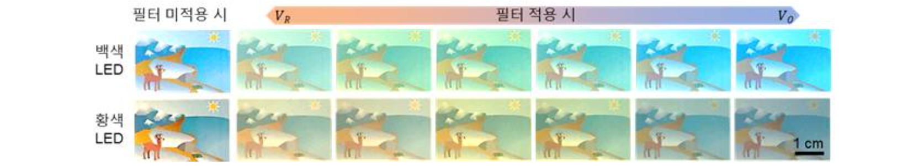▲ The ability of the active nano optical filter, inspired by Arctic reindeer snow, to maintain object color according to light conditions: When viewing an object with two light sources, white and yellow light, applying the manufactured filter can correct the object to the same color.

The first author, student Gyurin Kim, said, "This research is meaningful in that plasmonics* can be applied to actual industrial fields. In particular, it can be implemented with a thickness of several tens of nanometers without a complex structure, which could help develop object recognition technology in the future."

* plasmonics: This refers to a phenomenon in which electrons in a metal interact when exposed to light.

Professor Hyeon-Ho Jeong's nanosystems laboratory began with the production of three-dimensional nanostructures using semiconductor processing methods and continues to conduct various nanotechnology-based research such as nanodisplays, adaptive filters, sensors using chirality, and nanorobots.

Regarding the results of this study, Professor Jeong said, "The idea of controlling the color of light with trace amounts of voltage is intriguing, and we hope this is a 'harbinger' of many exciting things to come from our lab."

This research, led by Professor Hyeon-Ho Jeong and Professor Young Min Song of the School of Electrical Engineering and Computer Science and conducted by researchers Gyu-rin Kim, Doeun Kim, Soeun Ko, Jang-Hwan Han, Juhwan Kim, and Joo Hwan Ko, is part of the Future Promising Convergence Technology Pioneer Project promoted by the Ministry of Science and ICT and received support from the National Research Foundation of Korea and was published online on February 1, 2024, in ‘Microsystems & Nanoengineering’, a top 3% journal in the Instruments & Instrumentation field.



