GIST opens the era of ‘infinite radiation’ for expensive gallium nitride (GaN) semiconductors

- Professor Dong-Seon Lee’s team implemented gallium nitride remote homo-epitaxy using metal-organic chemical vapor deposition.
- Confirmed that GaN semiconductors can be copied indefinitely... Expected to significantly reduce production costs and dominate the power semiconductor market

▲ (From the left) School of Electrical Engineering and Computer Science Professor Dong-Seon Lee and doctoral student Hoe-Min Kwak

A path has been opened to produce gallium nitride (GaN) semiconductors, which are attracting attention as next-generation power semiconductors, as if they were copied at industrial sites. It is expected that it will be possible to mass-produce highly crystalline and expensive gallium nitride (GaN) semiconductors at a very low price.

The Gwangju Institute of Science and Technology (GIST, President Kichul Lim) announced that the research team of Professor Dong-seon Lee of the School of Electrical Engineering and Computer Science has developed remote homo-epitaxy* technology for gallium nitride (GaN)* semiconductors using only metal-organic chemical vapor deposition*.

Epitaxy technology, which grows semiconductor materials into well-aligned thin films, is essential for semiconductor manufacturing. GaN remote homo-epitaxy using epitaxy technology forms a two-dimensional material* on a GaN wafer. GaN semiconductors of the same quality as the wafer can be grown and easily removed, allowing continuous production of gallium nitride semiconductors with a single GaN wafer.

In particular, GaN semiconductors are attracting attention as a power semiconductor material for next-generation electric vehicles due to their characteristics of high-speed switching, low loss, and high efficiency, and are expected to be utilized in the industry.

* metal-organic chemical vapor deposition (MOCVD): A process of growing a semiconductor thin film using a metal-organic compound. The metal-organic compound precursor evaporates and is transferred to the wafer in a gaseous state and is converted into a solid through a chemical reaction within the evaporator and grown as a thin film on the wafer.

* epitaxy: A technology that grows the same or similar material into a thin film so that it has crystallinity on top of the crystal lattice of the wafer used in semiconductor manufacturing. Depending on the material, the size of each atom and the spacing between atoms are different, so it is possible to grow only materials with the same or similar lattice as the wafer.

* growth: In semiconductor terms, it refers to growing a high-quality, thin film layer with crystallinity on a wafer through physical and chemical methods.

* two-dimensional material: A material formed as a single structural film with an atomic thickness, such as graphene.

Due to technical limitations, conventional epitaxy requires wafers roughly 1,000 times thicker than 1 mm to achieve practical semiconductor materials of about 1 μm (micrometer) thickness.

Accordingly, in 2017, Professor Jihwan Kim's research team at MIT received great attention by proposing a ‘remote epitaxy’ technology that could overcome existing difficulties by using the molecular beam epitaxy method*.

* molecular beam epitaxy (MBE): A method of laminating (growing) a desired material on a substrate by depositing various materials in the form of molecules in an ultra-high vacuum.

The ‘remote epitaxy’ technology proposed by Professor Jihwan Kim’s team is a unique method of forming a very thin two-dimensional material like graphene on a wafer and growing semiconductor materials on it.

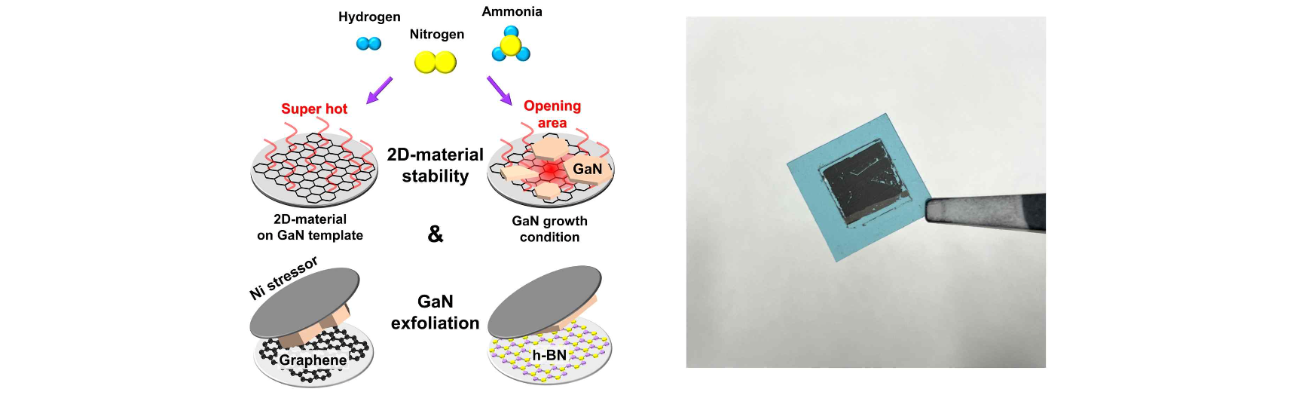▲ Experiment schematic and image of sample after exfoliation through nickel stressor. Before GaN growth, the stability of the two-dimensional material formed on the wafer was tested and then GaN growth was performed. Nickel was deposited on the grown GaN surface and peeled off using thermal release tape.

Not only can you obtain a high-quality semiconductor material in the form of a thin film that ‘copies’ the characteristics of the wafer, but you can also ‘peel’ it from the wafer, which theoretically makes it possible to reuse the wafer indefinitely.

This technology uses the principle that the electrical properties of the wafer surface penetrate the graphene membrane. Since the semiconductor material is not directly bonded to the wafer with the two-dimensional material in between, only the semiconductor material can be peeled off.

In particular, GaN semiconductors, which are widely used in LED displays and electric vehicle charging devices, require GaN wafers to achieve the highest efficiency, but since the price is about 100 times more expensive than sapphire wafers, sapphire wafers, which have a crystalline quality of 1/1,000th of the level, have been used. Accordingly, remote epitaxy technology that can reuse expensive GaN wafers is receiving great attention.

Until now, it has been known that GaN remote epitaxy technology can only be implemented by using molecular beam epitaxy and metal-organic chemical vapor deposition method together. This is because when only the ‘metal-organic chemical vapor deposition method’ is applied to remote homo-epitaxy technology, the surface of the GaN wafer decomposes under high temperature growth conditions and the two-dimensional material insertion layer is damaged.

In response to this, Professor Dong-Seon Lee's team used only the ‘metal organic chemical vapor deposition’ method, which is widely used in industry. By growing a low-temperature GaN buffer layer on a GaN wafer on which a two-dimensional material is formed, GaN remote homo-epitaxy technology, which can grow and exfoliate a GaN semiconductor by completely covering and protecting the two-dimensional material, was implemented for the first time.

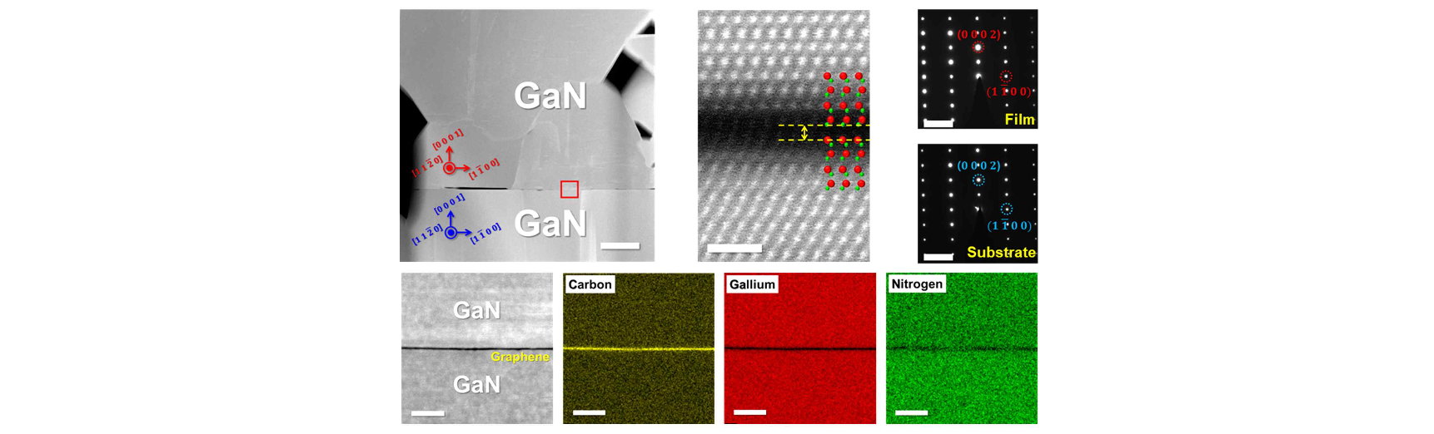▲ Precise analysis to confirm remote homo-epitaxy. Using a transmission electron microscope, they confirmed the epitaxial relationship between the GaN wafer, graphene, and grown GaN on an atomic scale, and verified that graphene remained even after growth.

Professor Dong-Seon Lee said, "This study implemented the ‘GaN remote homo-epitaxial’ technology, which was previously considered impossible. Although it is still in its early stages, we hope to lead the technology in the micro LED and next-generation GaN power semiconductor markets applied to future displays based on this technology."

This research, led by Professor Dong-Seon Lee and conducted by doctoral student Hoe-Min Kwak, was supported by the collaboration of Professor Sang Ho Oh's research team at the Korea Institute of Energy Technology and the nano-material technology development project and individual research project (mid-level research) of the National Research Foundation of Korea under the Ministry of Science and ICT was published online on December 12, 2023, in 'ACS Applied Materials & Interfaces', a renowned international journal in the fields of materials science and chemistry.



