Presenting a new quantum theory that can be implemented using classical methods using lasers

- Professor Byoung S. Ham presents the theory of ‘quantum sensing’ and ‘non-local quantum correlation’ based on quantum eraser... removing the mysterious veil of quantum mechanics
- Expectations for the development of quantum sensors and quantum information technology compatible with classical technologies... Published in the international academic journal 「Scientific Reports」

▲ School of Electrical Engineering and Computer Science Professor Byoung S. Ham

At the Gwangju Institute of Science and Technology (GIST, President Kichul Lim), School of Electrical Engineering and Computer Science Professor Byoung S. Ham, a distinguished scholar in the field of quantum memory, presented a new theory on ‘quantum sensing’ and ‘non-local quantum inertia’, which are one of the core phenomena of quantum mechanics.

‘Quantum sensing’ is a technology that detects the distance to an object and its physical properties by shining a laser on a target and detecting the reflected light. It is used to accurately detect objects with low light reflectivity, such as tires on the road or clothing on a dark road at night.

It belongs to key future technologies in various technological fields such as astronomical/bio/medical imaging, radar, and lidar.

‘Nonlocal quantum correlation’ is the most important core technology of quantum technology and is a quantum phenomenon that is impossible with any classical method, commonly known as the EPR paradox.

When a particle is split in two, the spins of the electron and positron must be in opposite directions. Therefore, the spin direction information of the electron must be transmitted to the positron. Even if it is far away, it is transmitted immediately, so the speed of information transmission is faster than the speed of light. In other words, it is known as a quantum phenomenon between two physical systems that are distant in space and time, where changes in one immediately affect changes in the other.

Professor Byoung S. Ham recently announced that 'quantum sensing' and 'non-local quantum correlation' that transcend classical resolution through phase-controlled transformation using linear optics of 'quantum eraser'*, rather than quantum methods based on conventional entangled photons. He pioneered a new horizon in quantum technology by suggesting a method that could be implemented using a classical method using an ordinary laser.

* Quantum eraser: In quantum mechanics, it is one of the thought experiments conducted with thoughts. It shows the characteristics of quantum ‘wave-particle duality’ and the uncertainty principle and is used to reveal how measuring or monitoring the characteristics of quantum affects the behavior of quantum.

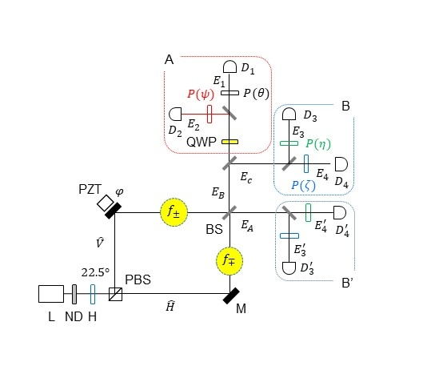
▲ Quantum sensing structure based on quantum eraser

Professor Byoung S. Ham said, "Only by clearly understanding the measurement that forms the basis of quantum mechanics can we scientifically understand the mystery of quantum entanglement. Ultimately, it is expected that it can become the foundation for future quantum information technology that is compatible with currently used classical optical technology."

This research was conducted with support from the ITRC Quantum Internet Project and the GIST Research and Development Project of the Ministry of Science and ICT, and was published online in the international academic journal ‘Scientific Reports’ on January 19, 2024.

Meanwhile, according to the results of Elsevier, a global academic information analysis company, analyzing the influence of paper citations from 1960 to 2022, Professor Byoung S. Ham ranks first in the field of optics in Physics & Astronomy. Ranked in the world's top 0.92% (excluding self-citations).



