GIST-KAIST develops new drug substance for fatty liver treatment

- A joint research team of Professor Jin Hee Ahn of GIST and Professor Hail Kim of KAIST developed a new drug substance for the treatment of fatty liver disease with a new mechanism that simultaneously suppresses fatty liver accumulation and liver fibrosis
- JD Bioscience Co., Ltd., a startup founded by Professor Jin Hee Ahn, is currently conducting phase 1 clinical trials in Australia after preclinical research... Published in the international academic journal 「Nature Communications」

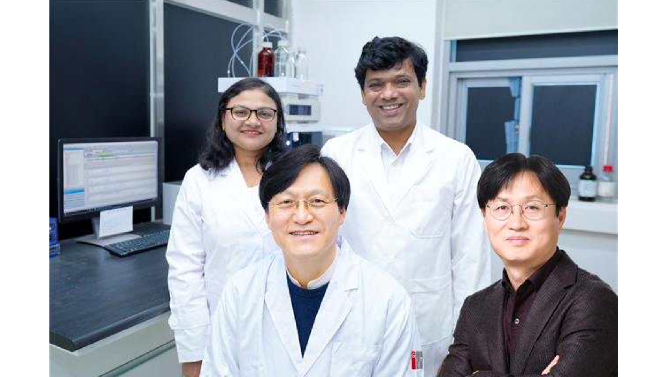▲ (front row, counterclockwise from left) GIST Professor Jin Hee Ahn (CEO of JD Bioscience Co., Ltd.), KAIST Professor Hail Kim, GIST Researcher Pagire, and GIST Researcher Suvarna

A Korean research team has succeeded in developing a new drug candidate for the treatment of nonalcoholic fatty liver disease (NAFLD) that acts on peripheral tissues. As there is currently no optimal treatment for non-alcoholic steatohepatitis (NASH), this is expected to develop a treatment that has proven safety while simultaneously suppressing fatty liver accumulation and liver fibrosis.

At the Gwangju Institute of Science and Technology (GIST, President Kichul Lim), the research team of Professor Jin Hee Ahn of the Department of Chemistry and the research team of Professor Hail Kim of the KAIST Graduate School of Medical Science and Engineering developed a new compound that can inhibit the disease-specific protein (HTR2A) through many years of basic research. JD Bioscience, a start-up company founded by Professor Jin Hee Ahn, announced that it had succeeded in proving efficacy and safety through preclinical testing (animal testing).

The prevalence of non-alcoholic fatty liver disease is 20-30%, and steatohepatitis disease has a high prevalence of more than 5% of the world's adult population, but there is no commercialized treatment to date.

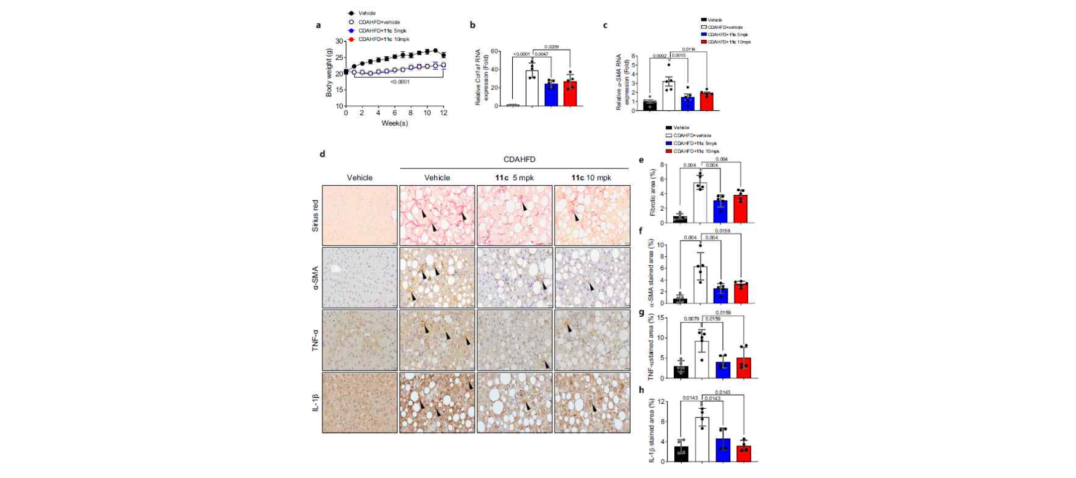▲ Effect of GM-60106 (11c) on improving liver fibrosis: When GM-60106 was administered to a steatohepatitis model (rat) for 3 months, the expression of genes related to tissue fibrosis was significantly reduced (b-c). As a result of a detailed analysis of the tissues of the animal model, it was confirmed that the rate of tissue fibrosis was reduced and the expression rate of genes related to tissue fibrosis and inflammation was also significantly reduced (e-h).

Non-alcoholic fatty liver disease is a chronic disease that starts from fatty liver and progresses to steatohepatitis, fibrosis, cirrhosis, and liver cancer. Since the mortality rate increases due to cardiovascular disease and liver-related complications, appropriate treatment is required in the early stages of the disease.

This new compound, developed by a joint research team at GIST and KAIST, is an innovative new drug candidate that shows therapeutic effects on steatohepatitis. It has a dual mechanism of action that simultaneously inhibits fat accumulation in the liver and liver fibrosis by inhibiting the serotonin receptor protein (5HT_{2A}).

The research team confirmed that this substance has a therapeutic effect by simultaneously suppressing liver steatosis and liver fibrosis* caused by fat accumulation in the liver by 50 to 70% in animal models of fatty liver and steatohepatitis.

* fibrosis: A phenomenon in which part of the liver hardens, and is used as a key indicator of improvement in steatohepatitis.

This substance is designed as a compound with optimal polarity and lipid affinity to minimize blood-brain barrier permeability, so it does not affect the brain, preventing depression. The research team explained that it has minimal central nervous system (CNS) side effects, such as suicidal impulses, and has excellent inhibition against disease targets in tissues other than the brain (IC₅₀*=14 nM). In addition, as a result of comparing the efficacy with competing drugs in phase 3 clinical trials, it was found that the efficacy in improving liver fibrosis was significantly superior.

* IC₅₀ (half maximal inhibitory concentration): The concentration of a substance that inhibits a specific biological or biochemical function by 50%.

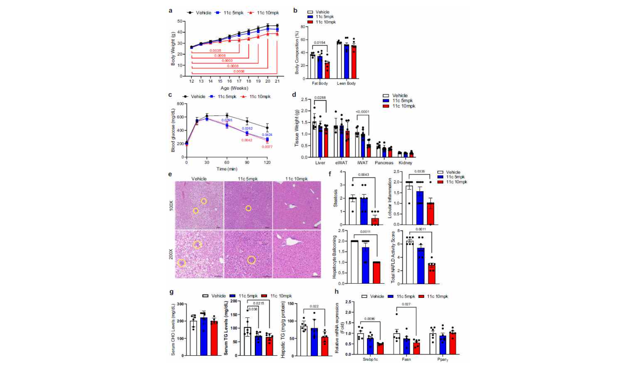▲ Fat improvement effect of GM-60106 (11c): When GM-60106 was administered to an obese animal model (rat) for 2 months, body weight, body fat mass, and blood sugar were significantly reduced (a-d). Additionally, the steatohepatitis level (NAFLD Activity Score) and the expression of genes involved in adipogenesis along with blood/liver fat decreased (e-h).

The results were evaluated on a total of 88 healthy adults in a phase 1 clinical trial, which is the stage of confirming side effects and safe drug doses in healthy people based on pharmacological action data obtained through preclinical trials. No serious side effects occurred and safety was confirmed to be good.

In addition, preliminary efficacy evaluation on eight adults with steatohepatitis is currently in progress.

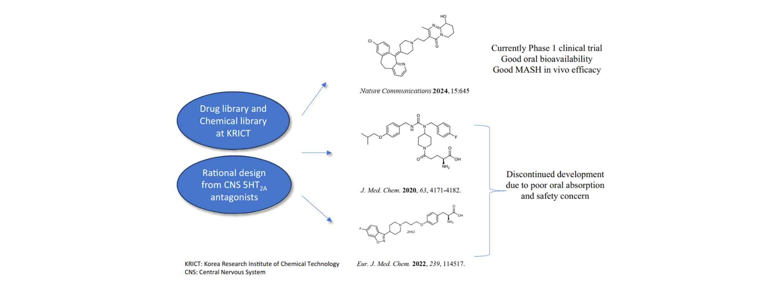▲ Development of new therapeutic candidates: The research team has attempted to develop a 5HT2A inhibitor that acts on peripheral tissues, but there were problems such as difficulty in oral administration and safety issues. In this study, a therapeutic candidate to overcome this problem was identified and phase 1 clinical trials are currently in progress.

Professor Jin Hee Ahn said, "This study aims to develop a treatment with minimal side effects and guaranteed safety by discovering new targets for the treatment of non-alcoholic steatohepatitis. Currently, global phase 1 clinical trials are underway in Australia through JD Bioscience Co., Ltd., an innovative new drug development bio venture."

Professor Ahn also said, "The new drug candidate being developed by the research team has the advantage of not only having a preventive effect by suppressing liver fat accumulation but also having a direct therapeutic effect on liver fibrosis, with high safety, making it different from other competing drugs."

KAIST Professor Hail Kim said, "To date, there has been no attempt to develop a drug that can be used in non-obese patients for this disease, which has no treatment other than weight control. It is expected that this research will enable the development of treatment technologies for various metabolic diseases, including non-alcoholic steatohepatitis, without affecting body weight."

This research, conducted jointly by Professor Jin Hee Ahn's research team at GIST, Professor Hail Kim's research team at KAIST, and the research team at JD Bioscience Co., Ltd., was conducted with support from the Ministry of Science and ICT and the National New Drug Development Project and was published on January 20, 2024, in the international academic journal ‘Nature Communications’.

The company also presented clinical study results of GM-60106 (development code name), a candidate for the treatment of metabolic-associated steatohepatitis (MASH)*, at the NASH-TAG Conference 2024, held in Utah, U.S.A., from April 3-4, and was selected as the best abstract.



