GIST reveals for the first time the possibility of controlling the symmetry of ‘van der Waals materials’, which are expected to be used as future materials

- GIST-Seoul National University researchers confirm for the first time in the world a new path to control the symmetry of materials through ‘iron vacancies’
- Expected to contribute to the development of physics and spintronics... Published in the international journal 「Advanced Materials」

▲ (From left) Professor Jong Seok Lee, doctoral student Hwiin Ju, and Dr. Kai-Xuan Zhang

At the Gwangju Institute of Science and Technology (GIST, President Lim Ki-cheol), a research team led by Professor Jong Seok Lee of the Department of Physics and Photon Science and Professor Je-Geun Park of the Department of Physics and Astronomy at Seoul National University used atomic vacancies in 'Fe₃GeTe₂', a van der Waals* material that is self-magnetic and has topological properties, and announced that they had confirmed for the first time that it was possible to control the symmetry of a material.

The research team succeeded in verifying that the inversion symmetry is broken by iron vacancies in ‘Fe₃GeTe₂’, a representative van der Waals magnetic material that has both ferromagnetism* and topological properties*, using second harmonic generation technology.

* van der Waals material: A layered structure material with very weak interlayer bonds formed by van der Waals forces.

* ferromagnetism: The property of a material to become magnetized and become a magnet even when no external magnetic field is applied to it.

* topological properties: Topologically defined quantum states and their characteristics is a branch of mathematics that theorizes that certain shapes can be transformed into the same shape and categorized into the same class if they are handled as if they were clay.

The van der Waals material system can not only examine two-dimensional physical phenomena due to the weak bonding force between adjacent layers but can also be used as an electronic device based on various physical properties such as quantum conduction phenomenon, ferroelectricity, and magnetism.

In particular, the biggest advantage of the van der Waals material system is that multifunctional nanodevices can be realized by stacking various materials with various properties at the atomic layer level.

The symmetry of a material in time and space plays a key role in determining the types and characteristics of physical phenomena that can occur in that material, and when the inversion symmetry* is broken. The electromagnetic and optical properties of materials can appear nonlinearly in response to external stimuli.

In addition, various interesting properties can be revealed, such as the confirmation of ferroelectricity in which the polarity between the positive (+) and negative (-) poles can be maintained and controlled.

* inversion symmetry: Having symmetry even when the coordinate system for a point in space is inverted. A topological material is a material that preserves its electronic structure as long as its chemical structure does not change. By utilizing this stability, it is possible to implement quantum devices that are resistant to external noise and have no information loss.

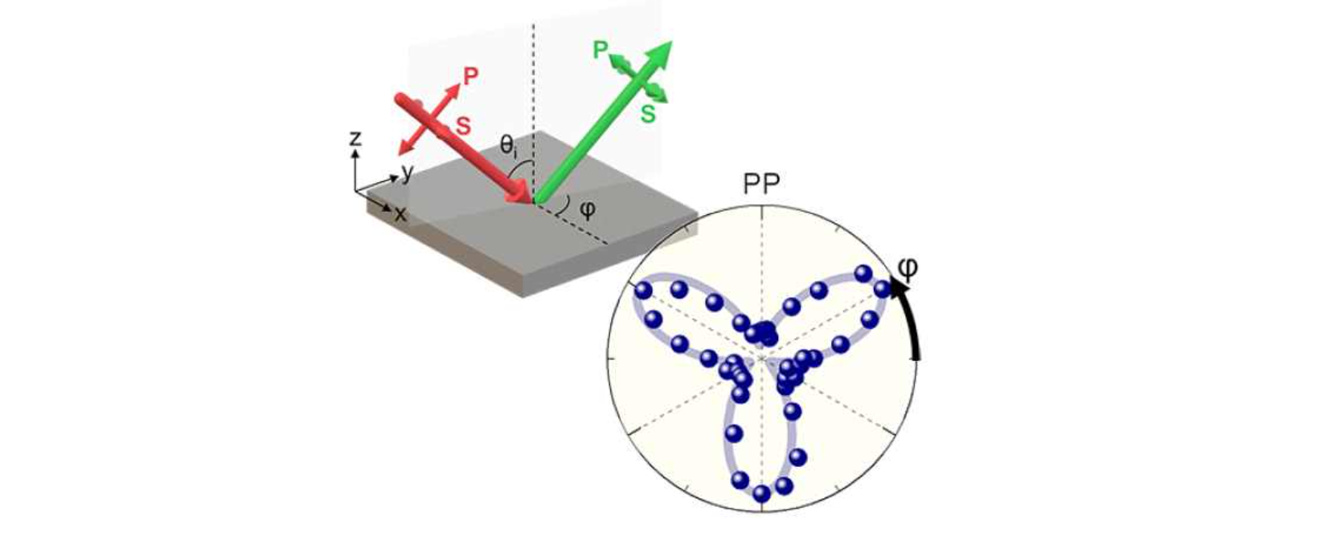▲ Schematic diagram of second harmonic measurement in Fe₃GeTe₂ and second harmonic results: Second harmonic light is generated (green) by light incident on Fe₃GeTe₂ (red). When measuring while rotating Fe₃GeTe₂, large second harmonic light with 3-fold symmetry is observed (blue dot).

The two-dimensional van der Waals material ‘Fe₃GeTe₂’, which exhibits such topological singularity and is also a ferromagnet, is being actively studied as a candidate material for future spintronics* materials. In addition, characteristics such as large spin-orbit torque and formation of skyrmion*, which have high potential for application in the future spintronics field, were also confirmed.

* spintronics: As the integration of devices increases due to miniaturization of electronic devices, the concept of spintronics, a technology that uses spin instead of electrons, has emerged to overcome the limitations of reduced device performance due to heat generation.

* skyrmion: A particle that utilizes the quantum mechanical property called ‘spin’, and is a spin structure formed by arranging spindles in a vortex shape.

This phenomenon is difficult to occur if the inversion symmetry is not broken, but since the inversion symmetry is maintained in ‘Fe₃GeTe₂’, it is also important to identify the cause.

The research team confirmed that the second harmonic signal proportional to the degree of inversion symmetry breaking in 'Fe₃GeTe₂' in which the amount of iron vacancies was adjusted increased significantly as the amount of iron vacancies increased, showing that inversion symmetry can be broken by iron vacancies.

The team also found through space group analysis that the inversion symmetry of the entire structure is broken due to the breaking of the screw axis symmetry, suggesting that this mechanism is possible in a wide range of materials with layered structures similar to Fe₃GeTe₂, where the inversion symmetry can be controlled by impurities.

Professor Jong Seok Lee said, "This research result suggests a new approach that can control the inversion symmetry of materials through atomic vacancies. It is expected to greatly contribute to the development of physics and spintronics in the future."

The research was supported by the Korea Research Foundation's Mid-Career Researchers Program and the Nano and Materials Technology Development Project, and was published online December 31, 2023, in Advanced Materials, a world-leading journal for basic and applied research in materials science.



