GIST develops 3D LiDAR and AI for target recognition and enemy identification for national security... Focus on cutting-edge defense science and technology capabilities

- GIST and 9 other industry-academic research institutes selected the project ‘Development of ultra-small intelligent drones for autonomous mission performance in communication/GPS shadow environments’... Received KRW 24.4 billion in support for 5 years until 2028
- Conduct joint research in 6 fields (micro drone, solid-state battery, 3D LiDAR, SLAM, artificial intelligence, autonomous flight)... GIST focuses on research in 3D LiDAR and artificial intelligence technology

▲ Kyi Hwan Park, Director of GIST Future Defense Science and Technology Research Center, is the institutional research director of the project ‘Development of ultra-small intelligent drones for autonomous mission performance in communication/GPS shadow environments’ project.

The Gwangju Institute of Science and Technology (GIST, President Kichul Lim) has begun developing small/light/low-power 3D LiDAR and artificial intelligence (AI)-based target recognition and enemy identification SW technology for national security.

GIST Future Defense Science and Technology Research Center (Director Kyi Hwan Park, Professor of School of Mechanical Engineering) is working on a project called 'Communication/GPS Shadow Environment', a civil-military technology development project of the Agency for Defense Development's Civil-Military Cooperation Promotion Agency, jointly invested by the Ministry of Trade, Industry and Energy and the Defense Acquisition Program Administration. It was announced that it was selected for the project 'Development of ultra-small intelligent drones for autonomous mission performance'.

The ‘Poongsan Consortium’*, which jointly carries out research and development among 9 industry-academia-research institutes, including Poongsan Co., Ltd., the lead research institute, received KRW 24.4 billion from the government budget for 5 years (November 2023 - October 2028) to research and develop six areas, including ▴ ultra-small intelligent drone ▴ polymer solid-state battery ▴ ultra-small/light/low-power 3D LiDAR (LiDAR) ▴ lidar/image-based location determination (SLAM) ▴ artificial intelligence (AI)-based target recognition and peer identification SW technology ▴ level 4 (highly automated)* autonomous flight, and demonstrate it in simulated and real environments.

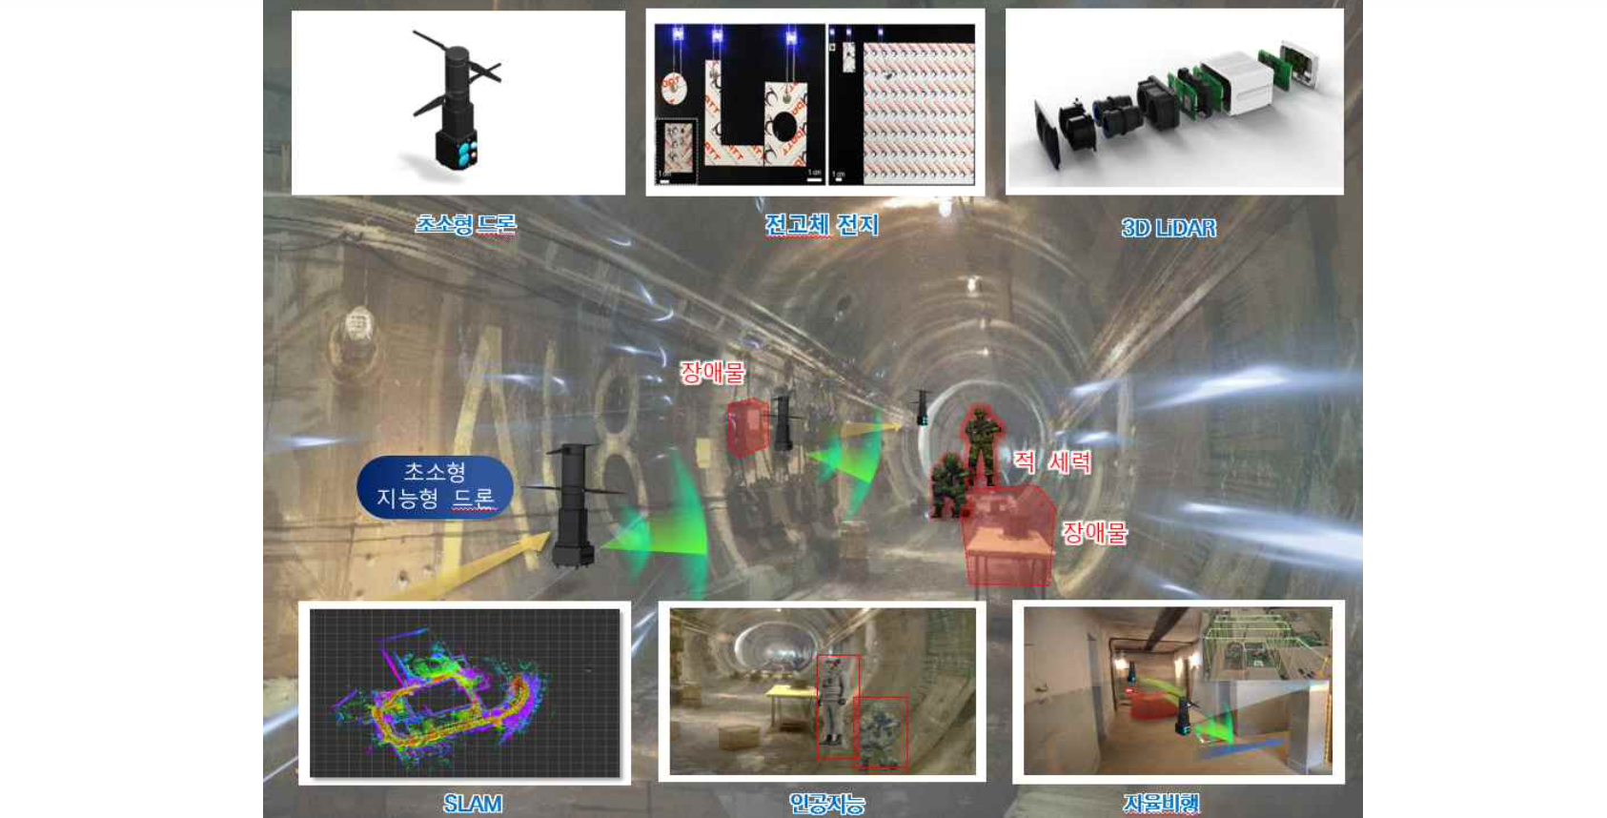▲ Ultra-small intelligent drone operation concept diagram: Drone composition core parts and operation concept diagram for performing special missions such as reconnaissance and rescue/rescue search to understand the situation of enemy forces and obtain information inside a bunker where communication/GPS is not available. (Photo source: Project research and development plan)

To this end, GIST completed building a consortium with Poongsan Co., Ltd. in July of last year and signed an agreement with the Civil-Military Cooperation Promotion Agency of the Agency for Defense Development in December.

* 9 industry-academic research institutes (5 universities, 3 companies, 1 research institute) participating in the Poongsan Consortium: GIST, DGIST, UNIST, Yonsei University, Pukyong National University, Poongsan Co., Ltd., UBATT Co., Ltd., A2mind Co., Ltd., KETI

* Level 4: [Autonomous driving technology] Divided into 6 levels from level 0 to level 5. Level 4 or higher is the fully autonomous driving stage where a moving object (drone) can cope on its own in an unknown space without GPS/communication signals.

This technology is at a cutting-edge, high-difficulty level that has not yet been introduced domestically or internationally. Two fields, including ▴ ultra-small/light/low-power 3D LiDAR ▴ AI-based target recognition and enemy identification software, will be entrusted to GIST (Director of Institutional Research: Professor Kyi Hwan Park, School of Mechanical Engineering) and a lidar specialist company, and will be developed with a government budget of approximately 7.2 billion won over 5 years.

To this end, Professor Kyi Hwan Park's research team (participating professors: Sunkyu Lee and Lee Ki-hoon Lee) is working with a world-class lidar sensor company founded in 2016 by graduates of the Sensor and Actuator Laboratory (supervisor: Kyi Hwan Park) to develop the core sensors of this project, including ▴ no-mechanical scanner solid-state-based ultra-compact, lightweight, and low-power three-dimensional lidar technology, ▴ digital signal processing algorithm technology for accurate and fast signal acquisition in low light and harsh environmental conditions, and ▴ lidar heat reduction technology.

Professor Park's research team ultimately plans to develop a 3D LiDAR with a measurement distance of more than 30m and sufficient angular resolution (0.65 degrees × 0.65 degrees or less) for map-based 3D localization (SLAM) and dynamic/static obstacle detection/avoidance.

In addition, Professor Kyoobin Lee's research team (participating professor: Moon-Sang Kim) of the School of Integrated Technology has developed robust situational awareness technology and visualization/user interface (UI) technology even in harsh environments to address low light, smoke, and fire that occur in indoor bunkers and disaster sites by improving EO/IR (optical/infrared) through ▴ AI technology that recognizes target status and identifies enemies ▴ techniques to visualize map information and target type/location ▴ focusing on research with the goal of developing UI technology that takes into account ease of operation.

GIST Future Defense Science and Technology Research Center Director Kyi Hwan Park said, "Through this project, we hope that industry, academia and research institutes, including GIST, together with the Army will serve as an opportunity to further expand the responsibility and role of science and technology for national security by presenting innovative exemplary cases of civil-military research cooperation."

Meanwhile, the GIST Future Defense Science and Technology Research Center is a GIST-Army cooperative research center that opened in July 2019 based on a business agreement with the Army Infantry School in December 2018 and has continued to cooperate with the Army to plan various tasks in the field of military-use technology.

Based on this, GIST is expanding ▴ joint technology planning and research cooperation in the fields of robots, mobility, and AI ▴ conducting manpower training in the field of defense science and technology ▴ holding academic and combat development seminars ▴ cooperating in publishing research materials ▴ exchanging technology and professional researchers. In order to promote it more closely, last November, a business agreement (MoU) was signed with the Army Commerce College (Infantry School, Mechanization School, Artillery School, Engineering School, and Chemical, Biological and Radiological School) and the 'Gwangju and Jeonnam AI science and technology powerhouses based on Defense Innovation 4.0' has been concluded.



