“Paint is fatally toxic even after decades” GIST confirms paint additives remain toxic to reproduction in soil

- Professor Tae-Young Kim's team confirmed through mass spectrometry that paint additives (alkylamines) cause reproductive toxicity in soil organisms... Outcome of international joint research between Germany and Brazil
- Reveals the need to supplement paint additive regulatory policies and replace safe substances

▲ (From left) Postdoctoral researcher Woo-Young Song and Professor Tae-Young Kim

The Gwangju Institute of Science and Technology (GIST) announced that a research team led by Professor Tae-Young Kim of the School of Earth Sciences and Environmental Engineering has confirmed through an international collaborative study that an ingredient added as a dispersant* in paints has reproductive toxicity that threatens soil ecosystems and inhibits reproduction even decades later.

* dispersant: A type of surfactant, a substance that has the property of mixing things that are originally immiscible, such as water and oil.

In Korea, the impact of paint microplastics* on soil ecosystems is not well understood, but according to the European Chemicals Agency, paint accounts for the second highest proportion of microplastics entering the soil, after tires, so research is needed.

* microplastic: refers to solid plastic particles with a size of 5 mm or less and 1 nm or more produced by decomposing plastic products or produced for commercial and industrial purposes

The research team focused on how paint dust generated by aging building exterior walls affected soil organisms.

Paint chips that fell on the ground were collected from around an abandoned house in the former East German area that still had exterior wall paint from the 1950s and were collected, crushed, and sorted into five groups (500-1000, 250- 500, 100-250, 50-100, and 20-50 μm) based on the size of the powder to see if they were toxic to elegans*.

* Caenorhabditis elegans: A small organism about 1 mm long that inhabits the soil widely and plays a very important role in supplying nutrients to crops and maintaining the soil ecosystem.

As a result, the paint powder showed reproductive toxicity that inhibited the reproduction of Caenorhabditis elegans, and the intensity of toxicity varied depending on the color and size of the paint powder.

The research team confirmed that when 1% (by weight) of paint powder was mixed into the soil, the number of offspring of Caenorhabditis elegans decreased by up to about 60%, and it was revealed through mass spectrometry that the key causative agent for this difference in toxicity is alkyl amines* added to paint as a dispersant.

* alkyl amines: Amines are basic functional groups and compounds with a nitrogen atom. It is a derivative of ammonia, and the form in which the carbon chain replaces the hydrogen atom is called an alkylamine.

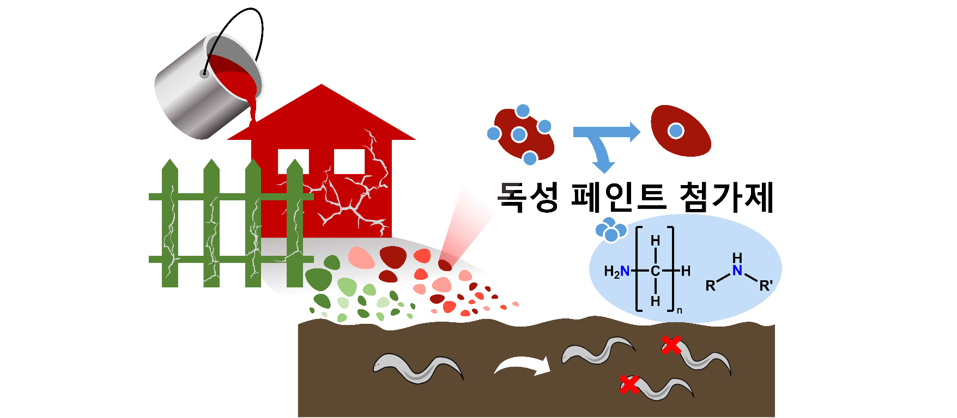▲ Soil toxicity of paint powder on the exterior walls of old buildings. Researchers found that paint particles that corrode and fall from the exterior walls of buildings cause reproductive toxicity to C. elegans. It was discovered that the causative agent was a paint additive called alkylamine.

The research team confirmed that when the level of alkylamine in soil was about 25 ppm (parts per million, by weight), the reproduction of C. elegans was significantly reduced.

Professor Tae-Young Kim said, "The findings provide evidence that exterior paint remains toxic to soil even after decades. Over time, as the paint powder breaks down into smaller pieces, the increased surface area of the paint can cause more toxic additives to leak out, causing a much bigger environmental problem than it is now."

He added, "Additionally, considering the characteristics of these paints, efforts are needed to supplement regulatory policies on paint additives and replace additives with safer substances."

This research was led by Professor Tae-Young Kim and conducted by postdoctoral researcher Woo-Young Song of GIST's School of Earth Sciences and Environmental Engineering with support from the National Research Foundation of Korea's basic research project (mid-level research), and postdoctoral researcher Shin Woong Kim and Professor Matthias C. Rillig of the Free University of Berlin, and Professor Walter R. Waldman of the Federal University of Sao Carlos, Brazil, participated as international co-researchers.

Additionally, the research results were published online on Thursday, December 21, 2023, in Environmental Science & Technology, the most authoritative international journal in the field of environmental chemistry published by the American Chemical Society.



