GIST finds optimal electrolyte concentration for high-speed charging and discharging of eco-friendly water-based supercapacitors

- Analysis of interactions between ions-ions and ions-water molecules in the electrolyte and identification of adsorption/desorption mechanisms with the surface of porous carbon electrodes... Published in 「Energy Storage Materials」, a renowned international journal in the field of materials engineering
- Expected development of high-performance water-based electronic devices such as batteries, hydrogen fuel cells, and sensors

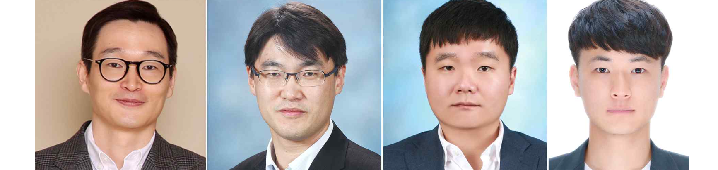▲ (From the left) GIST Professor Seung Joon Yoo, GIST Professor Myung-Han Yoon, Hongik University Professor Dongwook Lee, and GIST doctoral student Jaeil Park

At the Gwangju Institute of Science and Technology (GIST, President Kichul Lim), the joint research team of Professor Seung Joon Yoo and Professor Myung-Han Yoon of the School of Materials Science and Engineering, and Professor Dongwook Lee of the Department of Materials Science and Engineering at Hongik University, announced that they had succeeded in making significant improvements the main performance of a supercapacitor by changing the salt concentration in the electrolyte (solvent + salt).

Unlike lithium-based batteries that use chemical reactions, supercapacitors are energy storage devices that store energy through physical adsorption/desorption of ions at the interface between electrodes and electrolyte. Compared to general capacitors, the storage capacity is much larger and the energy density is high. Therefore, it is also called an ultracapacitor or ultra-high capacity capacitor.

In addition, they have the advantages of ▴ low heat generation compared to high power supply and ▴ semi-permanent cycle life during rapid charging and discharging, making them the next generation of energy storage devices and suitable for applications that require rapidly increasing power supply. Due to these characteristics, the demand for supercapacitors is also increasing due to the increasing use of renewable energy sources such as solar and wind power.

The flammable organic solvent-based electrolyte used in conventional supercapacitors has risks of explosion and environmental problems, so attention has recently been focused on developing an energy storage device using a water-based electrolyte that is free of explosion risk and eco-friendly.

However, water is generally electrolyzed at 1.24 V, making it difficult to widen the operating voltage, and it freezes at 0 °C, limiting its ability to store energy in winter, making it difficult for commercialization research and development.

There has been active research to overcome the problems of conventional water-in-salt electrolysis by using ultra-concentrated water-in-salt electrolyte (WiSE)* with a wide operating voltage, stable solid electrolyte interphase (SEI)*, and adequate ionic conductivity, but there has been no systematic analysis, focusing only on performance improvement without consideration of high-concentration electrolytes.

* SEI (Solid Electrolyte Interphase): Electrolytes generally consist of lithium salt, electrolyte solution, and additives. During the battery charging process, materials in the electrolyte undergo electrolysis to form a solid film at the electrode-electrolyte interface, and this solid film is called SEI.

* Water-in-salt electrolyte (WiSE): Unlike an aqueous solution in which a small amount of salt is dissolved in excess water like a typical aqueous electrolyte, WiSE refers to an ultra-high concentration aqueous solution in which an excess of salt is dissolved in a small amount of water.

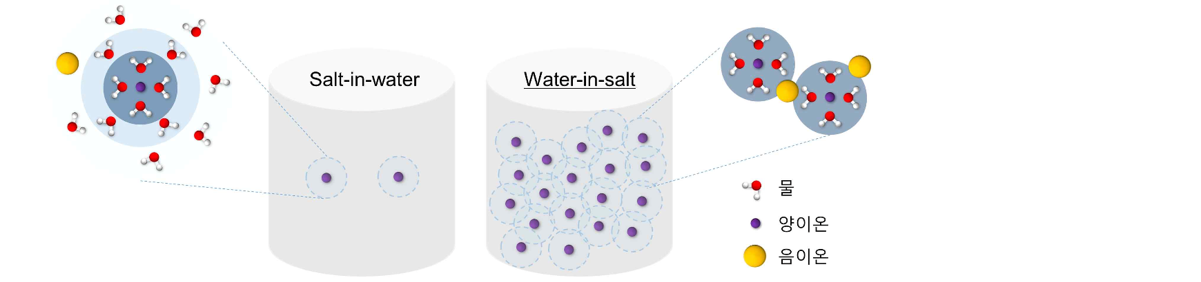▲ Hydration structure of (left) dilute aqueous electrolyte (salt-in-water) and (right) ultra-high concentration aqueous electrolyte (water-in-salt). In a dilute solution, ions exist separated into positive and negative ions by water molecules. In ultra-high concentration solutions, the amount of ions and water molecules is insufficient, so strong ion-ion interactions can occur and unwanted reactivity of water molecules can be suppressed.

To solve this problem, the research team analyzed the physicochemical interactions between ions and ions and between ions and water molecules in an ultra-high concentration aqueous electrolyte based on inexpensive potassium acetate (KOAc) and the structural characteristics of the electrolyte by concentration. By revealing the adsorption/desorption behavior on the surface of the porous electrode, they succeeded in confirming the concentration (5 m (molality): number of moles of solute per 1 kg of solvent) at which ionic conductivity and energy storage characteristics were optimized.

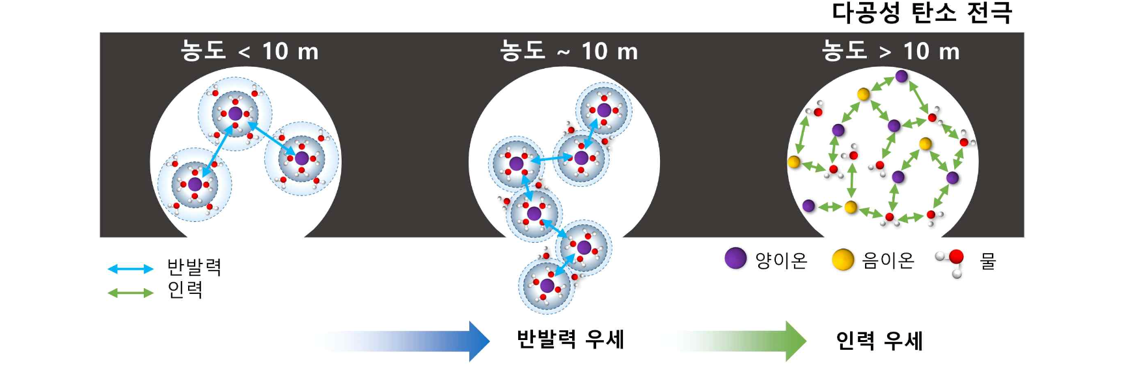▲ The physicochemical interactions between ions and ions and between ions and water molecules according to concentration were analyzed, and, based on this, the adsorption/desorption behavior of ions on the surface of a porous carbon electrode was revealed. Interactions between ions in which repulsion dominates up to 10 m and attraction dominates after 10 m were identified, and the concentration that can optimize this interaction was identified.

In addition, based on the results, the phase equilibrium diagram of ultra-high concentration aqueous electrolyte was presented, and the team succeeded in developing an aqueous supercapacitor that operates stably (charging performance of 74 F/g) without freezing even at -20 °C.

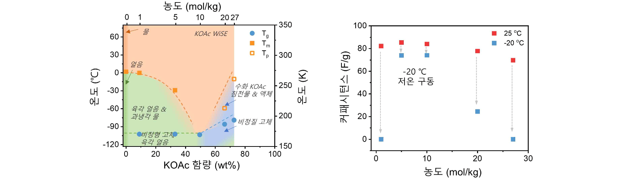▲ (Left) Phase equilibrium diagram of ultra-high concentration aqueous electrolyte based on potassium acetate and (right) energy storage performance at 25 °C and –20 °C depending on concentration. It was confirmed that 5 m and 10 m do not freeze even at –20 °C and show stable energy storage characteristics.

This research outcome, which sets a new standard for creating water-based supercapacitors by optimizing the concentration of ultra-high concentration water-based electrolyte, is expected to greatly contribute to the development of high-performance water-based electronic devices such as batteries, hydrogen fuel cells, and sensors in the future.

Professors Seung Joon Yoo said, "By understanding the physicochemical and structural interactions of components in ultra-high concentration aqueous electrolytes and systematically analyzing the adsorption/desorption behavior of ions on the surface of porous carbon electrodes, we found that optimization of energy storage properties can be achieved by changing the salt concentration alone. This is expected to provide guidelines for the optimization of existing salts or electrolytes to be developed in the future."

This research was led by School of Materials Science and Engineering Professor Seung Joon Yoo (corresponding author) with Professor Myung-Han Yoon (co-corresponding author) and conducted by the School of Materials Science and Engineering doctoral student Jaeil Park with collaboration from Hongik University Professor Dongwook Lee (co-corresponding author).

This research was carried out with support from the Ministry of Science and ICT, the National Research Foundation of Korea, and the Individual Basic Research Project and was published online on December 23, 2023, in ‘Energy Storage Materials’, a top journal in the materials science field (JCR ranking top 5%, IF= 20.4).

