GIST develops the first peptoid-based chiral luminescent material that controls the direction of light vibration

- Development of highly efficient circularly polarized light-emitting material based on peptoid, a biomimetic organic polymer
- Expected to be used in fields such as research on quantum information transmission materials, cell imaging, and data encryption in the future

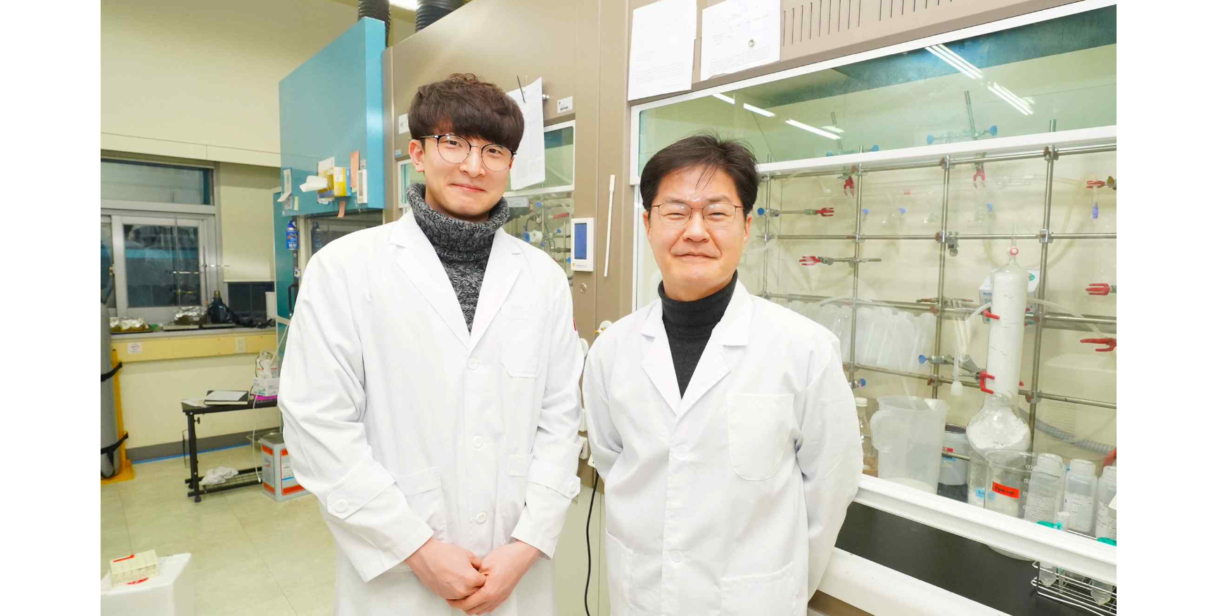▲ (From the left) GIST Department of Chemistry integrated student Jinyoung Oh and Professor Jiwon Seo

A Korean research team is attracting attention for developing the first circularly polarized light-emitting* chiral* material based on peptides* to control the vibrational direction of emitted light. This research is the first step in the development of peptoid-based chiral materials, and it is expected to contribute to the development of organic chiral materials with improved chiral and quantum information transfer efficiency in the future.

* peptoid: A derivative that artificially mimics the structure of peptides, a representative biomolecule that makes up proteins. Biomimetic artificial peptides.

* Circularly-polarized luminescence: When light travels straight, it vibrates and spreads in all directions, including left and right, up and down. Among them, light that travels in a spiral shape in a circle is called circularly polarized light, and the phenomenon in which a specific molecule or material emits this light is called circularly polarized light emission.

* Chiral: One of the terms representing asymmetry used in various scientific fields. This means that when the shape of an object does not match the shape of its mirror image reflected in a mirror, the object has chirality.

Organic molecules with optical activity, which are representative chiral materials, can generate circularly polarized light relatively easily, but they suffer from low efficiency. This research solves the problem of low luminous efficiency, which is a drawback of existing organic molecule-based circularly polarized light-emitting materials, and enables the use of light in various color bands (wavelengths) by introducing various light-emitting molecules (fluorophores, chromophores, dyes, pigments, etc.), which is highly useful in fields such as cell imaging and data encryption.

With the development of quantum technology, quantum information transfer technology through chirality-induced spin selectivity is receiving great attention, especially in the United States. Quantum information is known to be very sensitive and difficult to control.

Recently, the chirality of molecules has been attracting attention as a possibility of controlling it. This research result enables the control of quantum information at room temperature using chiral materials, enabling error correction in quantum computing and the development of various chiral materials in the future.

The peptide chiral materials synthesized and developed by the team exhibited high levels of far-polarized light generation efficiency (asymmetry index, 0.01~0.02) even at low concentrations, and demonstrated for the first time that the directionality of far-polarized light emission can be controlled by adjusting the three-dimensional structure.

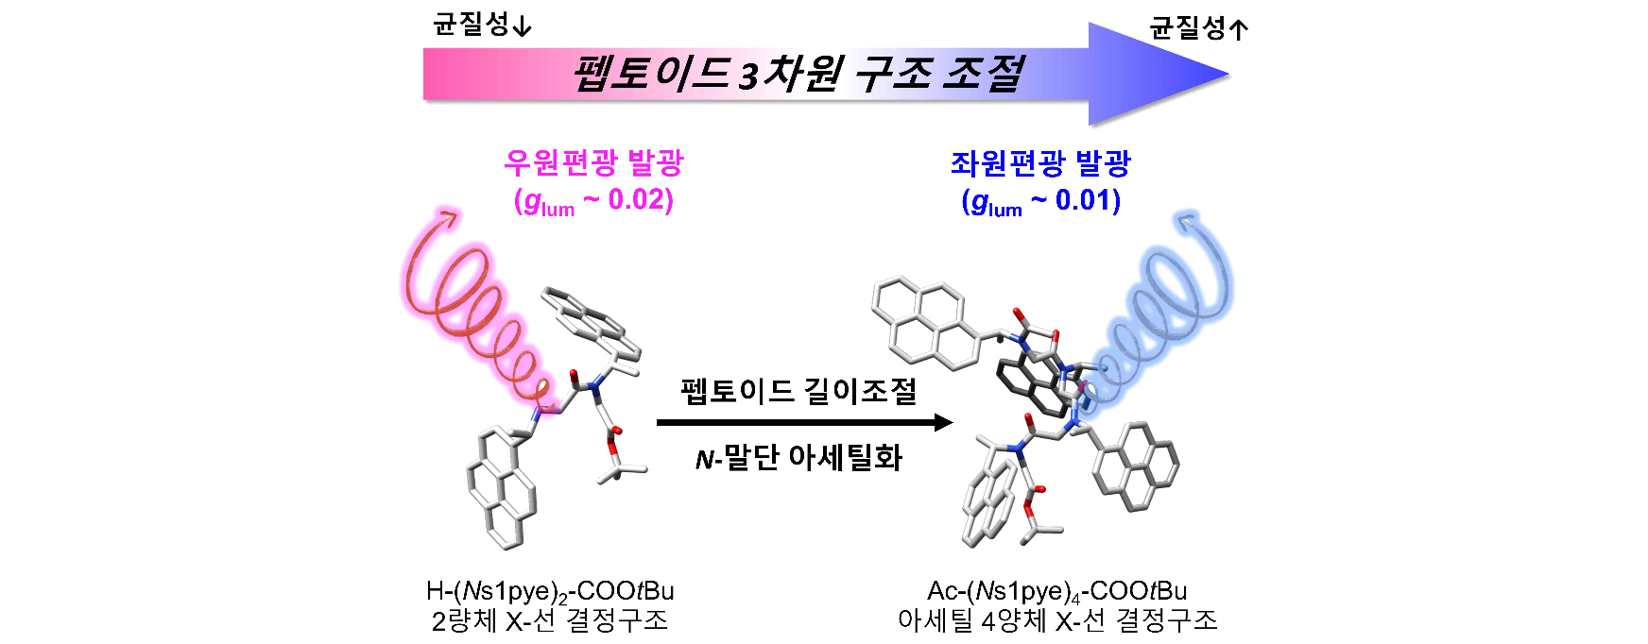▲ Development of peptoid-based circularly polarized light-emitting chiral material: Construction of an organic molecule platform with high circularly polarized light emission efficiency and control of circularly polarized light direction through control of the three-dimensional structure of the peptoid.

The research team, together with Professor Junseong Lee's research team at Chonnam National University, succeeded in revealing the three-dimensional helical structure of peptoid chiral materials through nuclear magnetic resonance spectroscopy* and single crystal X-ray diffraction*. Furthermore, the high circularly polarized luminous efficiency of the developed peptoid chiral material was confirmed with the research team of Professor Kim Chang-soon of Seoul National University.

* nuclear magnetic resonance: This is a spectroscopy equipment used to determine the structure of biomolecules such as proteins, peptides, and nucleic acids.

* single crystal X-ray diffraction: A spectroscopic method used to determine the crystal structure of various molecules such as small organic molecules and proteins.

Professor Jiwon Seo said, "The peptoid-based chiral material developed by the research team allows the introduction of molecules (fluorophores) that emit various light, and the direction of circularly polarized light emission can be easily adjusted depending on the three-dimensional structure of the peptoid. In the future, based on the peptoid chiral material platform, it is expected to contribute to the development of organic chiral materials with improved efficiency in transmitting chiral information and quantum information."

This research was led by GIST Professor Jiwon Seo and conducted by Jintegrated student Jinyoung Oh with the participation of ▴ Seoul National University Graduate School of Convergence Science and Technology Professor Changsoon Kim’s research team ▴ Chonnam National University Department of Chemistry Professor Junseong Lee's research team ▴ GIST Department of Chemistry Professor Hohjai Lee’s research team.

The results of this research, which was supported through the Ministry of Science and ICT and the Korea Research Foundation's Mid-Career Researcher Support Project, Future Materials Discovery Project, and Regional Innovation Leading Research Center (RLRC) project, were published online Dec. 1, 2023, in Small Structures (Impact Factor: 15.9), a top 6.7% international journal in the field of materials science.



