Constipation more than doubles the risk of developing Alzheimer's disease
- Professor Tae Kim's team at GIST and Professor Dong Keon Yon's team at Kyung Hee University Medical Center confirmed that 'reduced gastrointestinal transit time' increases the risk of Alzheimer's disease through research on Alzheimer's disease mouse models and big data from Korea and Japan.
- Published in the prestigious international academic journal
「Journal of Advanced Research」

▲ (From left) GIST Department of Biomedical Science and Engineering Professor Tae Kim and Dr. Jiseung Kang (currently Harvard Medical School)

According to the 'gut-brain axis' theory, which states that the gut and the brain are connected and interact closely, if the balance of microorganisms in the gut is disrupted or gut health deteriorates, brain function and emotional state can also be affected. So what is the relationship between intestinal functional abnormalities and mental illness?

Professor Tae Kim's team from the Department of Biomedical Science and Engineering at the Gwangju Institute of Science and Technology (GIST, President Kichul Lim) and Professor Dong Keon Yon's team from the Center for Digital Health at Kyung Hee University Medical Center confirmed that there is a causal relationship between decreased intestinal motility and Alzheimer's disease through basic-clinical convergence research.

The research team confirmed that constipation increases the risk of Alzheimer's disease through clinical big data research and identified the causal relationship through basic research using animal models.

In an Alzheimer's mouse model, it was confirmed that gastrointestinal transit time was reduced (slow intestinal motility, constipation), and, based on this, they experimentally studied how further slowing intestinal motility would affect Alzheimer's disease pathology.

As a result of administering loperamide, a type of anti-diarrheal drug, to an Alzheimer's mouse model, it was confirmed that amyloid beta protein in the brain and microglial cells, which are immune cells in the brain, significantly increased, and pathological phenomena such as memory decline appeared.

Additionally, RNA sequencing* analysis of colonic tissue revealed increased norepinephrine* secretion and expression of genes related to immune responses. Pathological changes in intestinal tissue were observed, including a decrease in the expression of defense genes against bacteria.

- norepinephrine: A hormone that plays an important role in the body. It is involved in regulating blood pressure and biological rhythm and performs functions such as regulating the body's response in stressful situations.

- RNA sequencing: An experimental methodology that analyzes changes in gene expression by quantifying the amount of mRNA transcripts

In addition, in collaboration with Professor Dong Keon Yon's team at Kyung Hee University Medical Center, it was confirmed that among approximately 3.13 million Koreans and approximately 4.38 million Japanese patients, the risk ratio of Alzheimer's disease was 2.04 times higher in the Korean cohort and 2.82 times higher in the Japanese cohort compared to patients without constipation.
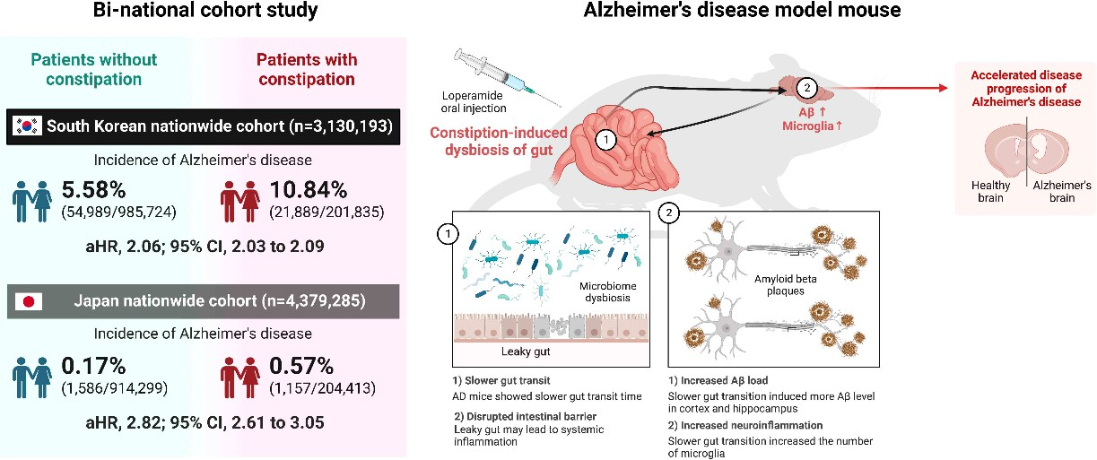
▲ Association between slow bowel movement and increased risk of Alzheimer's disease: identified through a two-country cohort study in Korea and Japan and an Alzheimer's disease mouse model study.

As a result, the research team found that functional decline in intestinal motility can worsen the pathophysiology of Alzheimer's disease.

Professor Tae Kim said, "Since intestinal dysfunction or constipation is highly likely to worsen Alzheimer's disease, active management is necessary. This study is significant in that it reveals the relationship between intestinal motility and Alzheimer's disease from various angles through the convergence of basic and clinical research. Additionally, the results of this study can provide strong support for the currently emerging gut-brain axis hypothesis."

This research, conducted by Professor Tae Kim and Dr. Jiseung Kang (currently Harvard Medical School) of GIST's GIST Department of Biomedical Science and Engineering and Professor Dong Keon Yon and student Myeongcheol Lee from the Center for Digital Health at Kyung Hee University Medical Center, was supported by the Ministry of Health and Welfare, the Ministry of Science and ICT, the Ministry of Culture, Sports and Tourism, and GIST Life and Bioscience Convergence and was published online on December 13, 2023, in the Journal of Advanced Research (impact factor 10.7), the world's top comprehensive scientific journal. Professor Tae Kim was also introduced to ‘People who make Korea shine’ by the national Biological Research Information Center (BRIC).


