GIST leads the way in achieving ‘zero carbon emissions’ fuel cells! Secured the world’s highest performance for alkaline hydrazine liquid fuel cells

- Development of non-platinum catalyst with hierarchical pore structure... Achieved highest output performance of 1.24 mW cm⁻²
- The commercialization of next-generation liquid fuel cells is expected to be utilized in drones, kickboards, robots, laptops, etc.

▲ (From the left) KBSI Senior Researcher Beomgyun Jeong (co-corresponding author), GIST doctoral student Sooan Bae (first author), and GIST Professor Jaeyoung Lee (corresponding author)

A Korean research team developed a non-platinum electrode catalyst and succeeded in securing the world's best performance for liquid fuel cells that do not emit greenhouse gases. The results of this research are expected to be helpful in commercializing alkaline liquid fuel cells.

The Gwangju Institute of Science and Technology (GIST, President Kichuk Lim) announced that Professor Jaeyoung Lee's research team in the School of Earth Sciences and Environmental Engineering and Dr. Beomgyun Jeong's research team at the Korea Basic Science Institute (KBSI) jointly developed a cathodic non-platinum-based catalyst for use in alkaline hydrazine liquid fuel cells*.

* hydrazine liquid fuel cell: Hydrazine is a compound of nitrogen and hydrogen and is a flammable liquid compound with an odor similar to ammonia. Hydrazine liquid fuel cells have output performance comparable to hydrogen fuel cells, and they have the advantage of being able to utilize existing liquid fuel storage and transportation infrastructure.

Fuel cells are divided into acid and alkaline depending on the acidity of the electrolyte. Alkaline fuel cells have the advantage of high output without using expensive platinum catalysts.

In alkaline liquid fuel cells, iron-nitrogen-carbon catalysts are attracting attention as catalysts with performance that can replace platinum, but they have the disadvantage of having a lower density of active sites (points where catalytic reactions occur) on the catalyst surface compared to platinum. Because of this, a relatively large amount of catalyst must be used to obtain the desired output performance.

However, if a large amount of catalyst is used, the applied catalyst layer becomes thick, making it difficult for reactants to approach the active site. As a result, the catalyst utilization rate on the electrodes decreases and the output of the fuel cell does not increase as much as the catalyst usage.

The research team significantly improved the output of the hydrazine fuel cell by creating a hierarchical pore structure in the iron-nitrogen-carbon catalyst through a steam activation process and reforming the surface contact characteristics through oxalic acid treatment.

As a result, thanks to the hierarchical pore structure formed inside the catalyst layer, reactants were able to diffuse into the catalyst layer, and iron oxide was removed by oxalic acid, thereby maximizing the contact interface between the aqueous solution, oxygen gas, and catalyst.

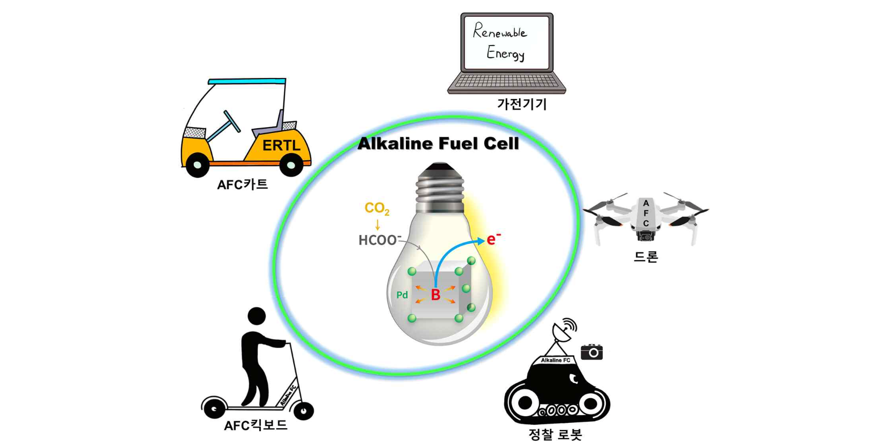▲ Small-scale transportation power devices that can utilize alkaline fuel cells (drones, kickboards, reconnaissance robots, laptops, etc.)

Through this, it was confirmed that a hierarchical pore structure suitable for an alkaline liquid fuel cell operating environment was formed in the iron-nitrogen-carbon catalyst, allowing oxygen gas to smoothly approach the active site. In addition, it was found that the hydrophilic (capable of weakly binding to water molecules) functional groups formed on the surface after removal of iron oxide (Fe₃O₄) nanoparticles generated during the heat treatment process and acid treatment make them easily accessible to water, another reactant.

In this way, reactants such as oxygen gas and water can more easily access the active site, helping to form a three-phase interface (catalyst active site, aqueous solution, oxygen gas) in an electrode area of 25 cm², thereby reducing the activation loss of the catalyst. In addition, it was confirmed that by reducing the interfacial resistance between the electrode and the electrolyte, the output performance increased (1240 mW cm⁻²) by about twice compared to (626 mW cm⁻²) before surface properties were modified.

GIST Professor Jaeyoung Lee said, "This study showed observations that overcome the limitation of catalyst utilization in electrodes, which acts as an obstacle to commercializing carbon-free fuel cells in large-area electrodes. It is expected to have various uses, including as a power source for transportation that requires high output."

KBSI Senior Researcher Beomgyun Jeong said, "This research is significant in that it significantly improved the performance of liquid fuel cells by increasing catalyst utilization through the catalyst's pore structure and surface characteristics."

This research was conducted by Professor Jaeyoung Lee's team at GIST with support from a joint research project between the leading engineering research center (ERC Ecosystem Research Center), the National Research Foundation of Korea, and the G-HUB Overseas Excellent Research Institute and was published online on November 23, 2023, in ‘Chemical Engineering Journal’, a top 3% academic journal in the field of chemical engineering technology.



