How is your sleep?
‘Good sleep’ points revealed by AI

- Using artificial intelligence technology, the accuracy of ‘sleep stage classification’, which is essential for early diagnosis of sleep diseases and analysis of sleep quality, has improved to the world’s highest level
- Expectations for personalized sleep care... Published in 「Expert Systems with Applications」, an internationally renowned academic journal in the field of electrical and electronic engineering

▲ (From the left) Institute of Integrated Technology Professor Kyoobin Lee, student Seongju Lee, student Yeonguk Yu, student Seunghyeok Back, and University of Science and Technology Professor Hogeon Seo

The Gwangju Institute of Science and Technology (GIST, President Kichul Lim) announced that Professor Kyoobin Lee's research team in the Institute of Integrated Technology has succeeded in raising the accuracy of sleep stage classification to the world's highest level using artificial intelligence (AI) technology.

The research team was the first to apply contrastive learning* technology using feature pyramid* to biosignal measurement.

* feature pyramid: A method of including feature information of various sizes extracted from multiple layers of an artificial intelligence model, allowing the model to process information in various frequency ranges.

* contrastive learning: A machine learning technique that increases the similarity between data belonging to the same category and reduces the similarity between data belonging to different categories.

Sleep stage classification plays an important role in diagnosing sleep-related diseases and evaluating sleep quality. In particular, ‘single-channel biosignals’, which measure electrocardiograms, brain waves, electromyograms, etc. with a single sensor, have the advantage of being simple to measure.

However, biological signals are composed of a complex mixture of various frequencies, and in particular, some signals share similar frequency characteristics, making it very difficult to accurately distinguish sleep stages.

The research team proposed a new method using AI technology to classify sleep stages using complex biosignals. There was a previous method of classifying sleep stages using artificial intelligence, but this study improved the accuracy.

The research team named this method ‘SleePyCo’, which can more accurately distinguish various stages of sleep through the ‘supervised contrastive learning framework’ and ‘feature pyramid’ techniques.

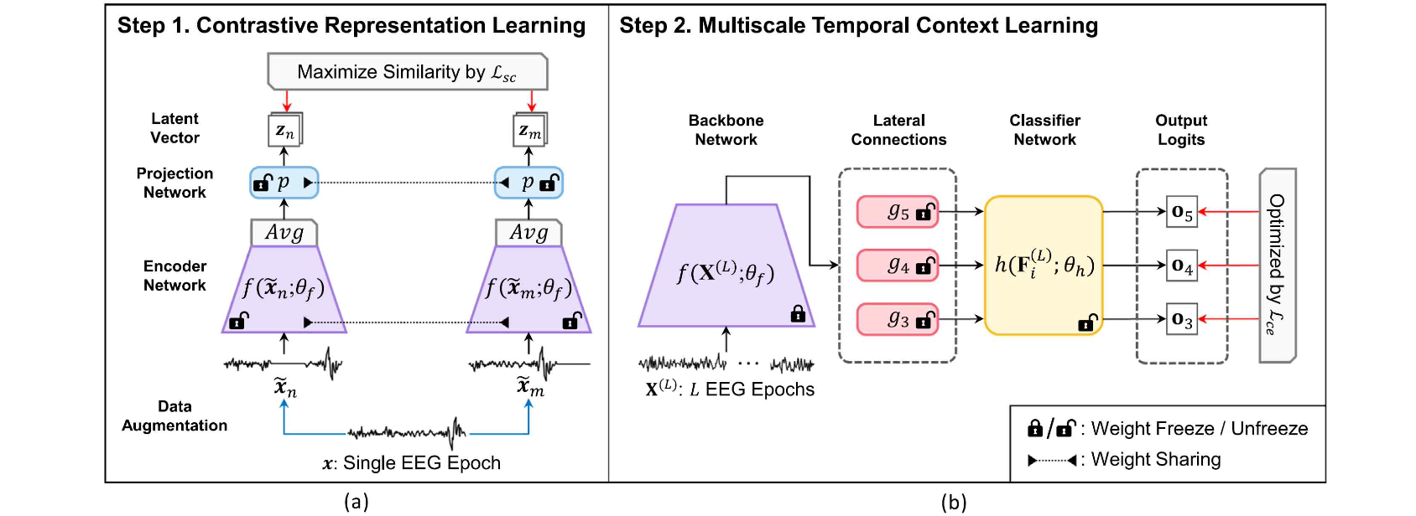▲ An overview of the contrastive learning-based learning framework (SleePyCo) proposed in this study: SleePyCo consists of two main components. (a) based on the contrast representation learning feature pyramid, and (b) consisting of learning the temporal context information of vital signs at different scales

‘SleePyCo’ analyzes signals that occur during sleep in a unique way. Artificial intelligence adjusts signals in the same sleep stage to look similar, and then adjusts signals in different sleep stages to look different, making it possible to distinguish between sleep stages more clearly.

Additionally, the research team proposed a method to more effectively process signals of various frequencies using ‘feature pyramid’ technology. This increases the accuracy of sleep stage classification.

To ensure a fair performance comparison of the research results, the research team confirmed them through four benchmarks (evaluation environments constructed with the same data set).

The sleep stage classification AI improved accuracy by 0.6 percentage points (84.0 → 84.6) on the Sleep-EDFx benchmark, 1.6 percentage points (85.2 → 86.8) on the MASS benchmark, 0.6 percentage points (80.3 → 80.9) on the Physio2018 benchmark, and 0.2 percentage points (87.7 → 87.9) on the SHHS benchmark compared to previous studies, which is among the best in the world to date.

In particular, it is noteworthy that the classification accuracy of the N1* stage and REM* stage, which are difficult to distinguish, was greatly improved by 3.8%p and 2.6%p, respectively. These results indicate that the framework proposed by the research team can better capture and distinguish detailed differences in sleep stages than existing methods.

In addition, the accuracy of overall sleep pattern recognition has also improved significantly, meaning that the AI model can analyze and interpret complex biosignal patterns more precisely.

* N1: The third of the five stages of sleep, called the "early stages of sleep." (Wake-REM-N1-N2-N3 in order of depth of sleep.) This stage is a transitional stage from wakefulness to deep sleep. It shares significant frequency characteristics with the REM sleep stage.

* REM: Abbreviation for Rapid Eye Movement, the second of the five stages of sleep. This stage is especially related to dreaming. It also plays an important role in the overall sleep cycle and is an essential part of maintaining healthy sleep and mental health.

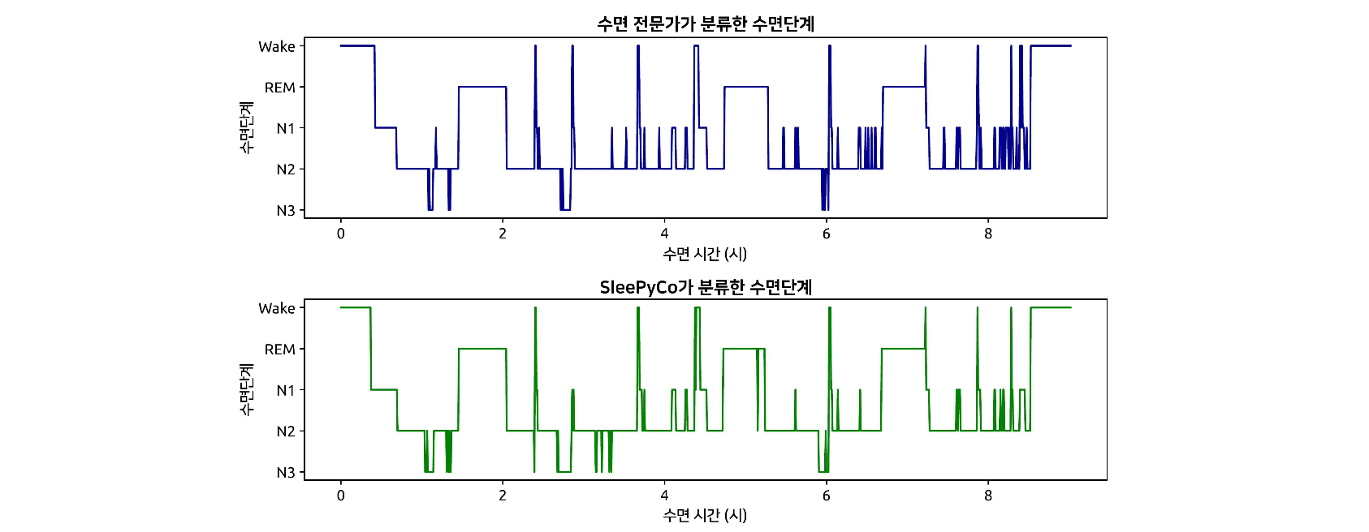▲ Sleep stages classified by sleep experts (top) and sleep stages classified by SleePyCo (bottom): The proposed method in this study achieves high sleep stage classification accuracy of up to 95.6% when compared to the baseline classified by sleep experts. This result indicates that the proposed method performs close to the expert level.

Professor Kyoobin Lee said, "This research outcome shows that AI models can analyze and interpret complex biological signal patterns more precisely. This method will make an important contribution to the early diagnosis and treatment plan of sleep disorders in the future."

This research, led by Professor Kyoobin Lee of the GIST Institute of Integrated Technology and conducted by doctoral student Seongju Lee, was supported by the Cloud Robot Complex Artificial Intelligence Core Technology Development Project of the Ministry of Science and ICT and the Energy Technology Development Project of the Ministry of Trade, Industry and Energy. The technology is being made public so that everyone can easily use it. (https://github.com/gist-ailab/SleePyCo)

The paper was published online Nov. 18, 2023, in Expert Systems with Applications, a top-ranked journal in the field of electrical and electronic engineering.

