GIST-KAIST joint research team develops world-class organic electronic devices

- By proposing a new molecular structure and aligning the microstructure, the molecular structure-charge transfer correlation of mixed conductors is identified and the charge mobility characteristics are greatly improved... Published in 「Advanced Materials」, a famous international journal in the field of materials engineering
- Expected to make significant contributions to the development of next-generation implantable electronic devices and high-performance neuromorphic electronic circuits

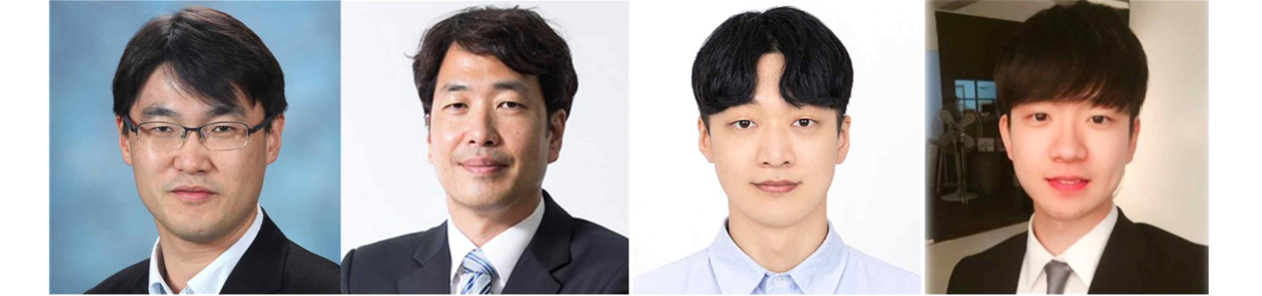▲ (From left) GIST Professor Myung-Han Yoon, KAIST Professor Bumjoon Kim, GIST student Il-Young Jo, and KAIST student Dahyun Jeong

At the Gwangju Institute of Science and Technology (GIST, President Kichul Lim), a joint research team led by Professor Myung-Han Yoon of the School of Materials Science and Engineering and Professor Bumjoon Kim of the Department of Biological and Chemical Engineering at KAIST (Korea Advanced Institute of Science and Technology) has developed the world's best organic mixed conductor* material, announcing that they had succeeded in implementing an ultra-high-performance electrochemical transistor aligned in one direction in an active channel.

* organic mixed conductor: An organic material that has both ionic conductivity and electrical conductivity within the electrolyte and is used for ion-based bioelectric signals in water, such as nerve, heart, and muscle signals, and metal electrodes. It is used as an active layer for bioimplantable electronic devices that can link electronic and hole-based solid-state electrical and electronic signals such as silicon semiconductors.

Electrochemical devices based on organic mixed conductors (organic electrochemical transistors*) can amplify and switch signals through ion implantation, so they can be implanted in the body to check various bioelectrical signals such as brain, heart, and muscle, and can be utilized as neuromorphic devices that simulate the human brain, which is attracting attention as a next-generation biointerface system.

On the other hand, organic materials, which have significantly lower electrical properties compared to inorganic-based semiconductors, have been an obstacle to practical use due to the low amplification and switching characteristics of transistor devices made with them.

* organic electrochemical transistor: One of the transistors that operates within an electrolyte. A device that switches and amplifies electrical signals by inducing doping/dedoping of the semiconductor layer through electrical and electrochemical reactions between ions present in the electrolyte and the semiconductor layer due to the applied gate voltage.

In general, various structure control processes have been reported to control the microstructure at the molecular level to improve the charge properties of conductive polymer* materials. The ‘mixed conductor’ used as the active layer of an electrochemical transistor has high side chain flexibility and hydrophilicity in its molecular structure, so the intermolecular cohesion is strong, so it was difficult to expect any significant performance improvement even if a general microstructure control process was applied.

To solve this problem, the research team developed a new mixed conductor material in which an alkyl-ethylene glycol hybrid side chain structure was introduced to provide appropriate hydrophobicity and structural stability to the molecular structure. By applying a microstructure control process to realize a mixed conductor thin film that is highly aligned in one direction at the molecular level, organic materials-based electricity with the world's highest electrochemical transistor characteristic evaluation index (> 800 F cm-1V-1s-1) succeeded in developing a chemical transistor.

* conductive polymer: A polymer that has electrical conductivity like a metal conductor. Unlike general organic polymers, it refers to a polymer that simultaneously possesses the electrical, magnetic, and optical properties of a metal or semiconductor.

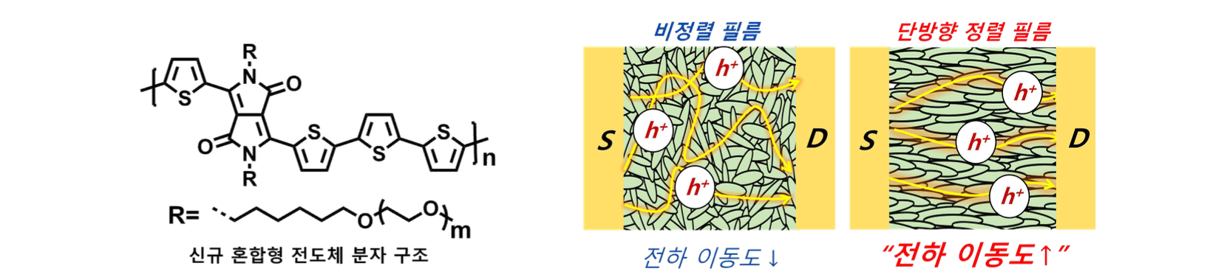▲ (Left) The molecular structure of the mixed conductor developed in this study and (Right) the film shape produced by general coating (non-aligned film) and microstructure alignment technology (unidirectional aligned film) and the resulting charge transfer schematic diagram. The higher the degree of alignment of the polymer film microstructure, the more smooth charge transfer characteristics it can exhibit.

This research outcome overcomes the low electrical performance that was pointed out as a drawback of organic mixed conductors. In the future, it is expected to greatly contribute to the development of high-performance bioelectronic devices such as organic material-based high-performance neuromorphic devices and biosignal sensors.

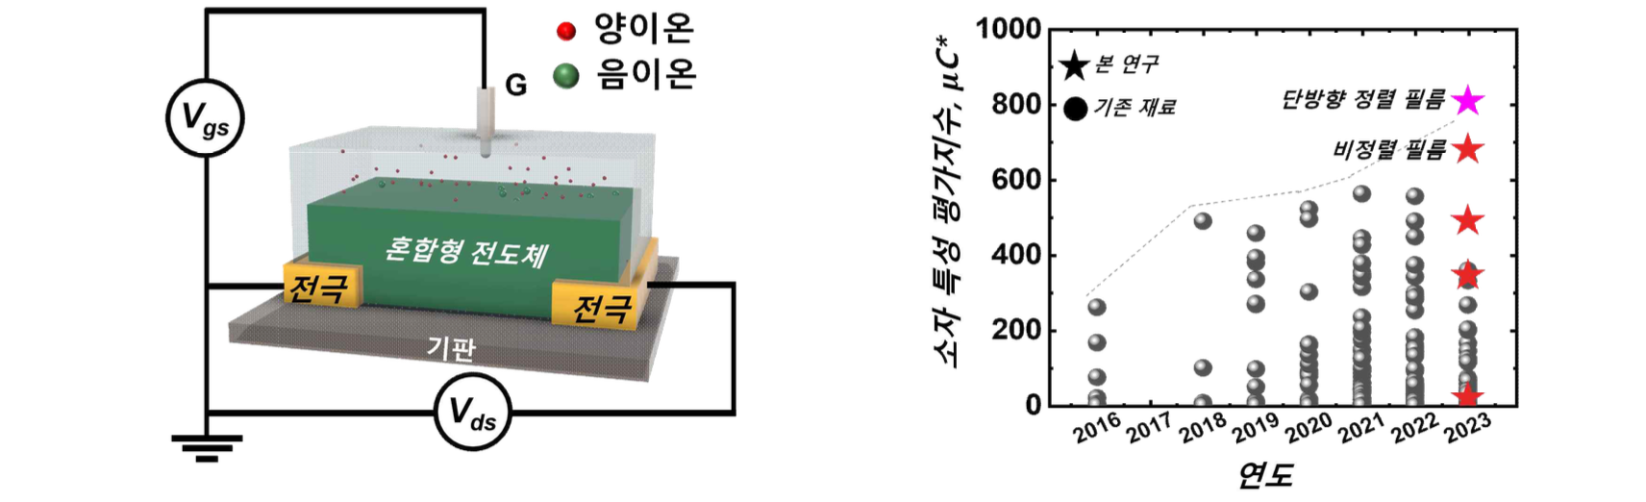▲ (Left) Electrochemical transistor device structure produced in this study. (Right) Characteristic evaluation graph of organic-based electrochemical transistor fabricated using the proposed alignment technology. Through microstructure alignment technology, superior electrochemical transistor performance is realized compared to existing materials.

GIST Professor Myung-Han Yoon said, "Through technology to control the molecular structure and microstructure of mixed conductors, the charge mobility characteristics of mixed conductors, which had been pointed out as shortcomings, were greatly improved. This is expected to greatly contribute to the development of next-generation implantable electronic devices and high-performance neuromorphic electronic circuits in the future."

KAIST Professor Bumjoon Kim said, "This study is a rational molecular design and synthesis strategy proposed by a joint research team to achieve the world's highest performance evaluation index of organic electrochemical transistors, which have recently been in the spotlight as bio-interface devices. It is also significant in that it demonstrates technological convergence in various fields, including molecular structure control engineering technology."

This research was led by GIST Professor Myung-Han Yoon and KAIST Professor Bumjoon Kim as joint corresponding professors and jointly conducted by GIST doctoral student Il-Young Jo and KAIST doctoral student Dahyun Jeong with support from the National Research Foundation of Korea and was published online on November 21, 2023 in ‘Advanced Materials’, a top 2% paper in the materials science field (IF= 29.4).



