GIST announces ‘immersive paper’, an experiential learning method... Making AI technology easy and fun with interactive content

- Human-centered AI game expert Professor Kyung-Joong Kim's research team easily delivers reinforcement learning technology through an immersive article
- A paper was published in the international academic journal 「IEEE Computational Intelligence Magazine」... Unlike existing papers, you can experiment and experience it directly through a web browser

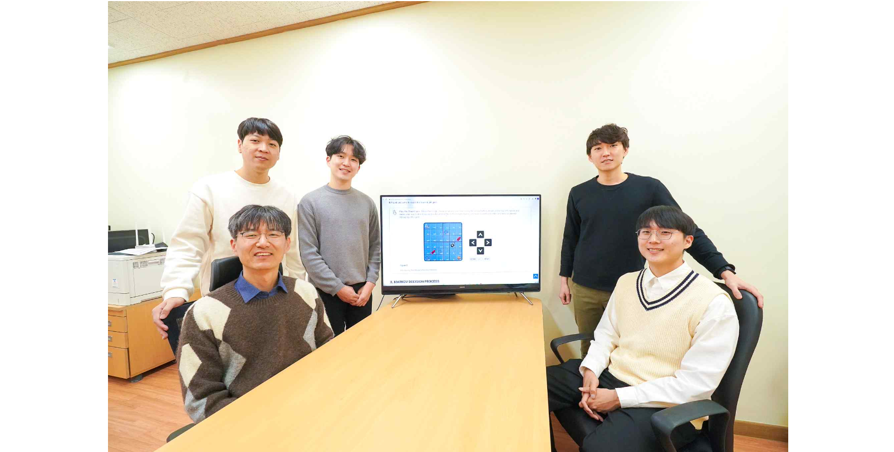▲ (Clockwise from left) Professor Kyung-Joong Kim, students Insik Chung, Hoyoun Jung, Seungwon Oh, and Isaac Han

Everyone is well aware of the influence and importance of artificial intelligence (AI), but it is still a field that is difficult for the general public to approach. Among them, ‘Reinforcement Learning’ is a technology so difficult that researchers must review a lot of data and take specialized courses to understand the core concepts.

Meanwhile, an ‘immersive paper’ that makes it easy to learn AI technology through games has been released and is attracting attention.

Gwangju Institute of Science and Technology (GIST, President Lim Ki-cheol) has published a new type of immersive paper (paper title: Monte Carlo and Temporal Difference Methods in Reinforcement Learning) by Professor Kyung-Joong Kim's research team in the School of Integrated Technology that easily explains reinforcement learning, which is a core technology in the AI field.

The IEEE Computational Intelligence Magazine (IEEE CIM) called for immersive articles that explain AI technology in an easy-to-understand manner under the theme of "AI eXplained," and selected a total of three articles, including a paper by Professor Kyungjoong Kim's research team, to be published in the November 2023 issue and released online in advance.

The IEEE Computational Intelligence Magazine (IEEE CIM) called for immersive articles that explain AI technology in an easy-to-understand manner under the theme of "AI eXplained," and selected a total of three articles, including a paper by Professor Kyung-Joong Kim's research team, to be published in the November 2023 issue and released online in advance.

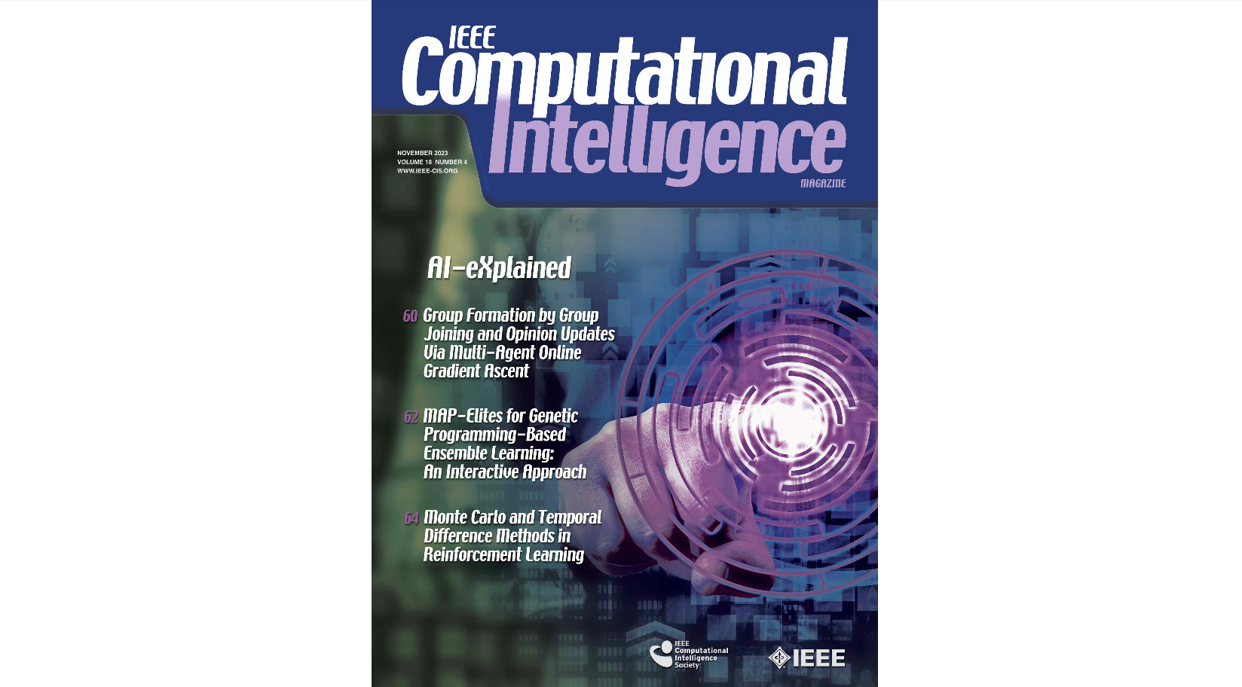▲ IEEE CIM November issue cover

Immersive papers first appeared through ‘IEEE CIM’ in November 2022, and unlike traditional papers, they can include interactive content. Readers can experiment and experience it directly through a web browser.

It is accepted as a very experimental attempt among researchers as a method of delivering content that is differentiated from existing papers and is receiving great attention. To date, a total of six immersive articles, including the research team's paper, have been published. Recently, there has been a movement to attempt immersive papers in IEEE Transactions on Games, so it is expected that people will be able to experience more cases in the future.

Reinforcement learning learns through the results of the game, and a representative example is the ‘Monte Carlo’ method, which waits until the result of the game (win/loss or final score) is clear before proceeding with learning. Recently, ‘Temporal Difference Learning’, which involves learning by predicting the outcome of a game even if the outcome is not confirmed, has become very popular.

* Monte Carlo method: a method of estimating values through repeated trials

* Temporal Difference Learning: a method of making continuous predictions and learns using the differences in prediction results

Professor Kyung-Joong Kim's research team developed a variety of interactive content to make reinforcement learning*, which is one of the more difficult topics to understand in the AI field, easy to access.

* reinforcement learning: a method in which artificial intelligence learns through rewards and trial and error, widely known through Google DeepMind's Alpha Go and Open AI's ChatGPT

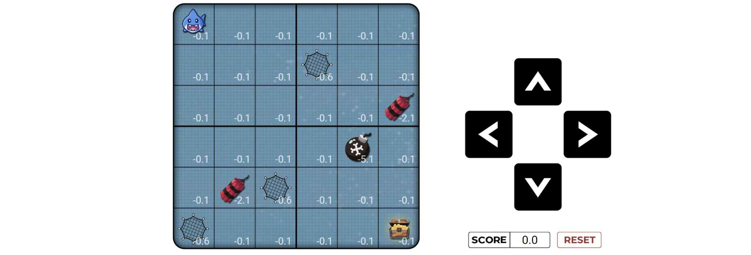▲ Shark game is used to easily explain reinforcement learning: This is a game where you control a shark to avoid various obstacles such as bombs and traps to reach a treasure chest. To get a high score, the shark must avoid obstacles and reach the treasure in the shortest possible distance.

To easily explain reinforcement learning, the research team created a simple game with a shark as the main character. It is designed to help readers understand the concept of reinforcement learning while operating the game.

A total of 18 interactive contents are provided to help you understand reinforcement learning. Readers can perform simple reinforcement learning experiments through a web browser and check the results.

The research team also developed tools to draw two-dimensional and three-dimensional graphs to develop various programs that run on the web and to display experiment results in real time.

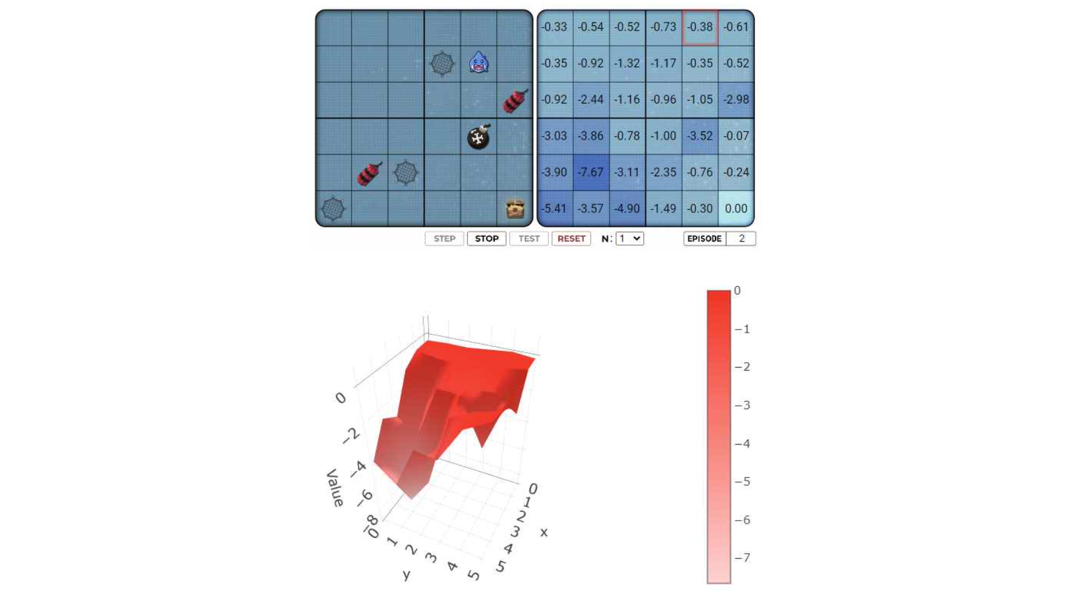▲ Experiments are conducted in a web browser and the results are displayed in a 3D real-time graph: Artificial intelligence uses experience to figure out which location leads to better results. The mountain-shaped 3D graph intuitively shows the good and bad aspects identified by artificial intelligence.

Professor Kyung-Joong Kim said, "There are many ways to effectively communicate research results, but I think the best way is to experience it firsthand. I hope that immersive papers will open a new way for the general public to understand science and engineering without difficulty."

The immersive paper published by this research team can be accessed through the link below.

→ https://ieeexplore.ieee.org/document/10287161
→ https://ieeexplore.ieee.org/document/10287161/interactive

This research was led by Professor Kyung-Joong Kim of the GIST School of Integrated Technology and conducted by doctoral student Isaac Han, doctoral student Seungwon Oh, master's student Hoyoun Jung, and master's student Insik Chung, was supported by the National Research Foundation of Korea's Human-Centered Game Artificial Intelligence Basic Research Laboratory Project and was published in the November 2023 issue of IEEE Computational Intelligence Magazine, a top 11% paper in the AI field.



