GIST improves electronic device operation speed by 100 times... Utilization of human and plant high-speed electronic sensors, etc.

- GIST-Queen Mary University of London joint research team adjusts the driving speed of electrochemical transistor devices by aligning the ion injection direction and molecular arrangement... Optimizing performance tailored to demand
- Expected to revitalize related fields such as development of high-performance neuromorphic devices and high-speed bioelectronic signal sensors... Widely applicable to crop monitoring technology for next-generation smart farms

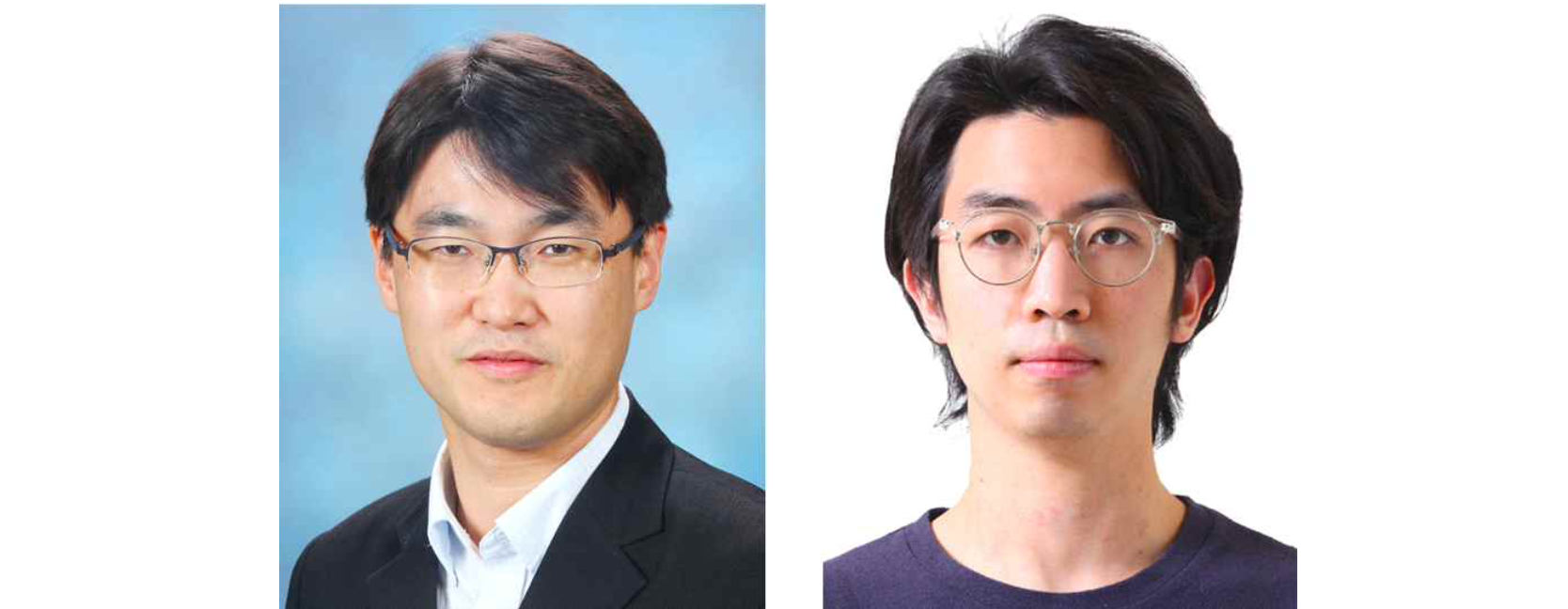▲ (From left) Professor Myung-Han Yoon and Dr. Ji Hwan Kim

The Gwangju Institute of Science and Technology (GIST) has announced that it has developed a "directional control technology for ion implantation in organic composite conductors*," a key material for realizing soft bioelectronic interfaces, and has improved the driving speed of electrochemical transistor devices by more than 100 times.

* Organic mixed ionic-electronic conductor (OMIEC): A material that has both ionic and electrical conductivity, unlike existing conductors that only have electrical conductivity. It is used as an active layer in bioelectronic devices that read ion-based electrical signals in the body, such as nerve signals, or in neuromorphic devices that mimic the human brain.

Professor Myung-Han Yoon's research team in the School of Materials Science and Engineering, together with a research team at Queen Mary University of London (QMUL) in the UK, controlled the molecular arrangement direction using organic semiconductor molecule synthesis technology. By adjusting the ion injection direction using circuit patterning* technology, it was revealed that the driving speed of the device can be greatly improved through ion injection tailored to the molecular direction.

* Patterning: The act of processing the desired conductive wiring or semiconductor active layer shape on an electronic circuit board.

The results of this research are expected to greatly contribute to revitalizing related fields, such as the development of high-performance neuromorphic devices and high-speed bioelectronic signal sensors. When organic mixed conductors are used as bioelectronic interfaces for plants, they can be widely applied to crop monitoring technology for next-generation smart farms.

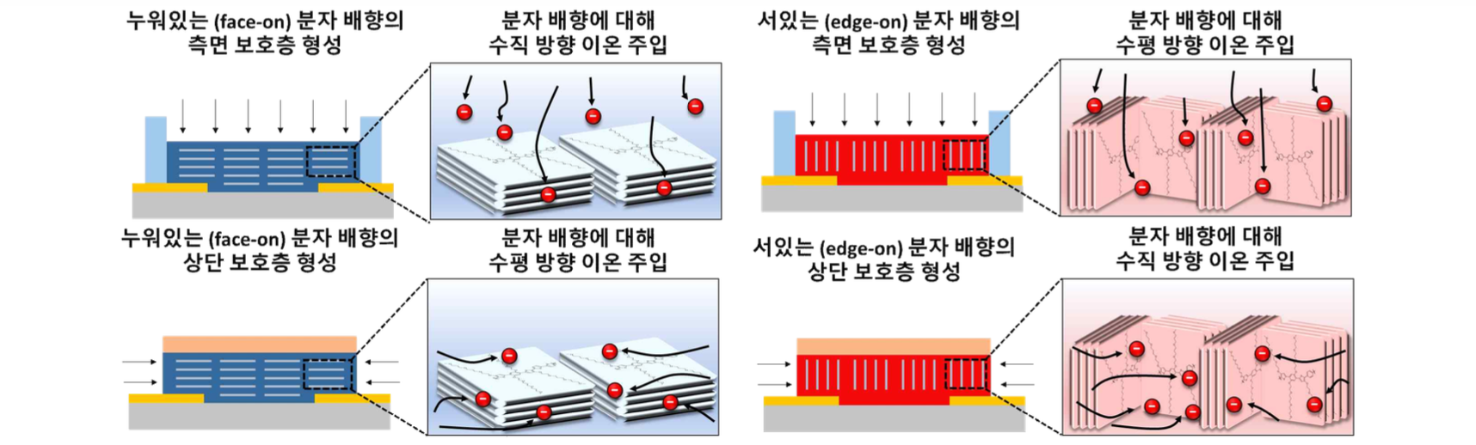▲ Schematic diagram of the ion implantation direction control method using the proposed patterning technology. Optimal device driving performance can be achieved by adjusting the direction according to the molecular orientation of the organic mixed conductor used.

Organic mixed conductors have been in the spotlight as the active layer of neuromorphic devices that mimic the human brain due to their superior capacitance and high electrical switching and amplification characteristics compared to silicon and oxide semiconductors used in commercial electronic devices. Slow ion mobility, a chronic problem of mixed conductors, has been an obstacle to improving the performance of neuromorphic devices.

The research team identified the molecular arrangement direction and ion injection direction as the main factors affecting the ion mobility of organic mixed conductors and the driving speed of devices using them, and the two factors were aligned in one direction.

The molecular orientation of the organic mixed conductor could be controlled through the design of the molecular structure of the conductor, and the direction of ion injection into the device was controlled by changing the method of stacking a passivation layer without ionic conductivity.

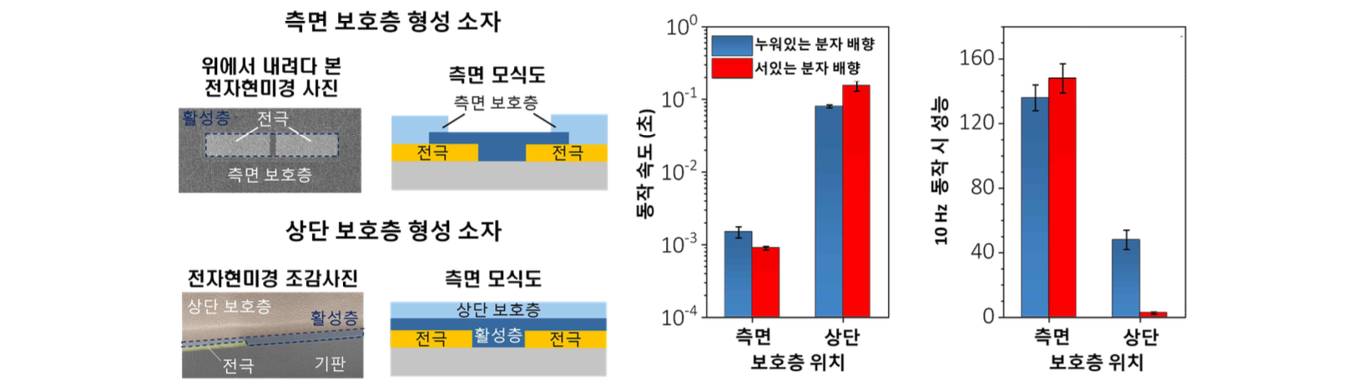▲ (Left) Image of the device with controlled ion implantation direction produced in this study and (Right) Operation speed and performance according to protective layer pattern and molecular orientation

The research team confirmed that when the ion injection direction and molecular orientation are parallel, and the movement speed of ions in the conductor becomes nearly 10 times faster (from 1.8 μ m/s to 17 μ m/s) than when it is perpendicular. As the total distance of ions moving within the mixed conductor decreases when parallel, the movement speed of ions within the material increases. As a result, it was confirmed that the driving speed of the device was improved by more than 100 times.

As a result, by only changing the direction, they succeeded in implementing a device (0.9 ms) with a driving speed more than 100 times faster than a device (155 ms) using the same material.

Professor Myung-Han Yoon said, "Through this study, we found that the molecular orientation of organic mixed conductors, which is known to be only involved in electronic conduction properties, is also involved in ionic conduction properties. This is expected to greatly contribute to accelerating the development of high-performance neuromorphic devices and high-speed human and plant bioelectronic signal sensors in the future."

This research was led by GIST Professor Myung-Han Yoon and Professor Christian Bech Nielsen of Queen Mary University of London, UK, GIST doctoral student Ji Hwan Kim, and Queen Mary University of London student Roman Halaksa with support from the international joint research project of the National Research Foundation of Korea, the Korea Health Industry Development Institute, and the British Medical Research Council and was published online on November 28, 2023 in ‘Nature Communications’, an international renowned academic journal ranked in the top 8% in the multidisciplinary field.



