GIST develops large-area photoelectrode modularization technology, opening the way for mass production of eco-friendly green hydrogen...
「Advanced Science」 cover paper

- Possibility of producing large quantities of green hydrogen by applying ‘modularization technology’ of new photoelectrodes
- For the first time among photoelectrochemical modules, it successfully operated under voltage-free conditions and verified in an actual solar environment

▲ (From left) GIST Professor Sanghan Lee, GIST Professor Heejoo Kim, GIST School of Materials Science and Engineering Dr. Hojoong Choi, and Helmholtz-Zentrum Hereon Dr. Sehun Seo

The path to mass production of ‘green hydrogen’ energy, which is in the spotlight in the carbon-neutral era, has been opened.

The Gwangju Institute of Science and Technology (GIST, President Kichul Lim) announced that the joint research team of Professor Sanghan Lee of the School of Materials Science and Engineering and Professor Heejoo Kim of the Graduate School of Energy Convergence has developed a large-scale organometallic halide perovskite (hereafter referred to as perovskite)* photoelectrochemical module system by applying modularization technology to photoelectrodes.

* perovskite: An organic-inorganic compound with an ABX3 crystal structure, it is in the spotlight as a next-generation optical semiconductor due to its high light conversion efficiency due to its high charge transfer ability and light absorption.

Hydrogen energy is divided into gray, blue, and green hydrogen depending on the production method. ‘Green hydrogen’ is produced through new and renewable energy such as solar energy, so it is the most environmentally friendly of hydrogen energy. To produce green hydrogen using solar energy, the ‘photoelectrochemical water splitting* method’ using an electrolyte containing water and a semiconductor photoelectrode is mainly used.

Recently, researchers have attempted to fabricate photoelectrodes with new materials such as perovskite, which are easy to manufacture and have high efficiency and high stability. For the practical use of photoelectrochemical systems and the mass production of green hydrogen, the development of large-area photoelectrodes is essential, especially for real-world verification under sunlight.

* photoelectrochemical water splitting: This is one of the production methods of green hydrogen, which uses electrolyte-immersed semiconductor photoelectrodes as working electrodes to produce hydrogen and oxygen using electrons and holes generated when light is incident on the photoelectrodes.

However, due to resistance losses that increase as the area of the device increases, the formation of non-uniform thin films, and defects within the material, large-area perovskite photocathodes do not show high efficiency and are difficult to enlarge, making is difficult to commercialize photoelectrodes manufactured based on photoelectrodes.

Since the efficiency of perovskite photoelectrodes decreases rapidly as the area increases, there is an area of a unit device that shows optimal efficiency.

To increase the area of the perovskite-based photoelectrochemical system, the research team connected perovskite photoelectrodes in parallel to achieve high scalability with minimal efficiency loss. In other words, they succeeded in developing a perovskite photoelectrochemical module that can be easily converted to a large area with high efficiency.

The module developed by the research team is a system that includes both perovskite photoanode and photocathode, so it can be operated under voltage-free conditions without the need for external voltage, and it is the first of its kind among photoelectrochemical modules.

▲ Schematic diagram (left) and photo (right) of the perovskite photoelectrochemical module system. It was confirmed that operation under actual sunlight is possible and that solar hydrogen production is possible in a large area compared to a single perovskite photoelectrode unit device.

The perovskite photoelectrochemical module with an area of 4 cm², manufactured by connecting a total of 16 unit elements, was tested in an actual solar environment rather than a laboratory environment. A high photocurrent of 11.52 mA was recorded without external voltage even with a light intensity of about 91% in the laboratory environment.

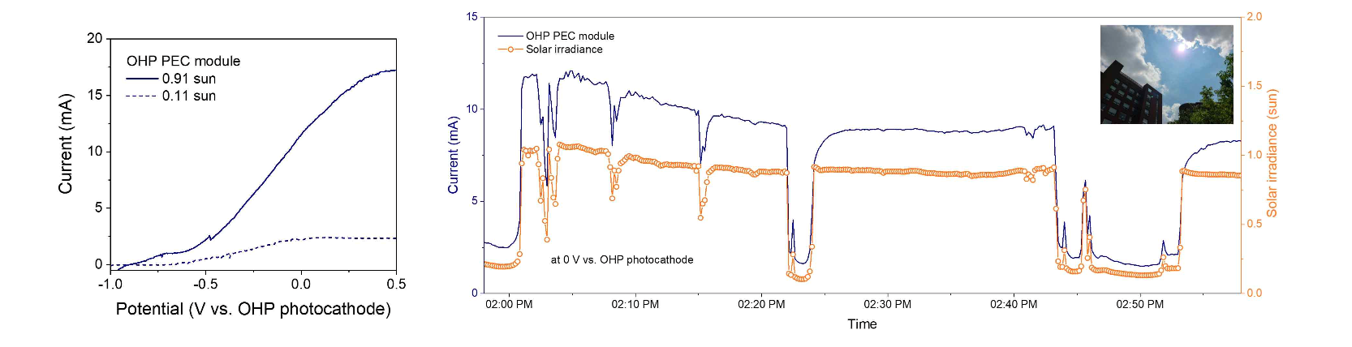▲ Measurement results of perovskite photoelectrochemical module under actual sunlight. The perovskite photoelectrochemical module system developed by the research team confirmed successful voltage-free operation in an actual solar environment.

Professor Sanghan Lee said, "This research result suggests the possibility of developing a large-area perovskite photoelectrochemical system through a photoelectrode modularization technology that is different from existing methods. We look forward to the commercialization of technology that can produce green hydrogen in large quantities through future follow-up research and modularized photoelectrodes."

This research was led by Professor Lee Wan of GIST's Professor Sanghan Lee of the School of Materials Science and Engineering and Professor Heejoo Kim of the Graduate School of Energy Convergence as a co-corresponding author and was conducted by GIST's Dr. Dr. Hojoong Choi and Dr. Dr. Sehun Seo, a group leader at the German Helmholtz-Zentrum Hereon after graduating from GIST with a Ph.D.

It was supported by the National Research Foundation of Korea's future hydrogen source technology development, ERC leading research project, and GIST development project (Research Institute for Solar and Sustainable Energies) and was selected as the cover paper of the international academic journal ‘Advanced Science’ (IF=15.1) and published on November 24, 2023.

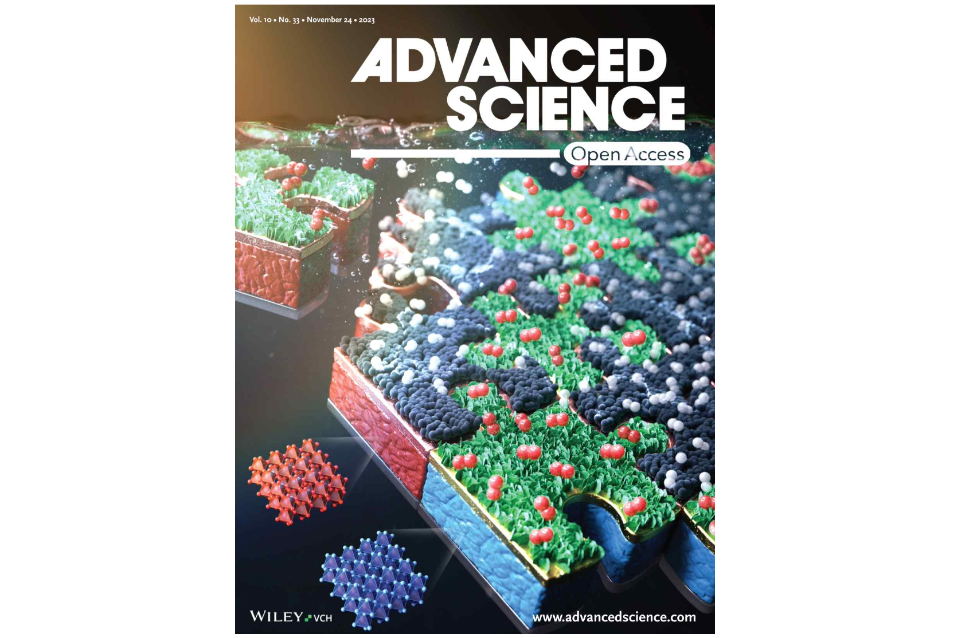▲ 「Advanced Science」 cover paper selection



