Professor SeungJun Kim’s research team develops ‘explainable self-driving car’ technology

- Professor Seungjun Kim’s team presented a paper at the top international conference ‘UbiComp 2023’ as a result of joint research with the MIT Computer Science and Artificial Intelligence Laboratory (CSAIL)
- Development of technology to use biosensors to assess passenger road situational awareness and explain complex AI models' decisions... Expected applications include advanced battlefield design

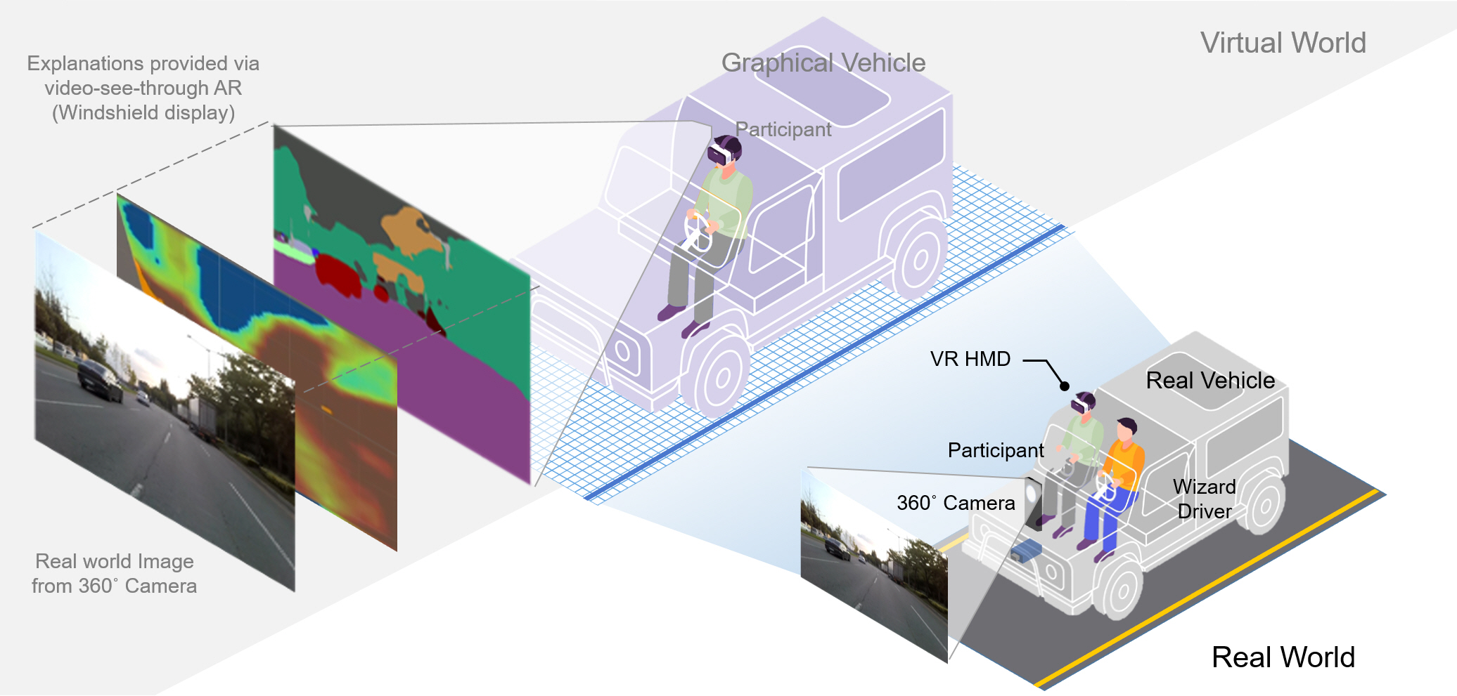▲ Self-driving algorithm design and evaluation technology that can explain virtual reality applications

In an autonomous driving environment, can artificial intelligence (AI) decisions be explained so that passengers can understand them?

* Explainable AI (XAI): The goal is to create a more trustworthy artificial intelligence environment by creating an AI system that humans can easily understand.

The Gwangju Institute of Science and Technology (GIST, President Kichul Lim) is the result of joint research between Professor SeungJun Kim's research team in the School of Integrated Technology and the Massachusetts Institute of Technology (MIT) Research Laboratory (CSAIL). By developing technology to design and evaluate the driving decision-making of artificial intelligence in autonomous vehicles centered on passengers, they presented a method to explain and visualize the results of the autonomous driving algorithm (reason for cognitive judgment) to passengers.

In environments where safety is important, such as autonomous driving, deep learning technology that can interpret and explain the reasons for decision-making is required for the reliability of artificial intelligence. Existing algorithms were designed centered around developers or AI experts, so they had limitations in assisting passengers in recognizing the road and driving situations in self-driving vehicles.

The research team developed a technology that evaluates the level of situational road awareness of passengers through biometric sensors, visualizes the autonomous driving status accordingly, and explains the decision-making of the complex AI model so that passengers can understand it.

This research has the advantage of augmenting the vehicle interface to evaluate arbitrarily explainable driving algorithms centered on the rider (human) and developing an in-vehicle information system to increase technological acceptance of autonomous vehicles. This is expected to be be applied to the design of advanced electronic equipment (automotive electrical and electronic equipment) such as head-up displays.

On October 12, the research team announced related research results at ‘UbiComp (ACM international joint conference on Pervasive and Ubiquitous Computing) 2023,’ the top international conference in the field of ubiquitous computing.

Professor SeungJun Kim said, "This research outcome received a lot of attention in academic circles because it can evaluate user experience such as cognitive load, tension, reliability, and situational awareness of passengers in a virtual reality environment on the road. Taking advantage of the recently successfully held ‘GIST-MIT Symposium’, we will disseminate the results of international joint research and cooperate for human-centered artificial intelligence research and development."

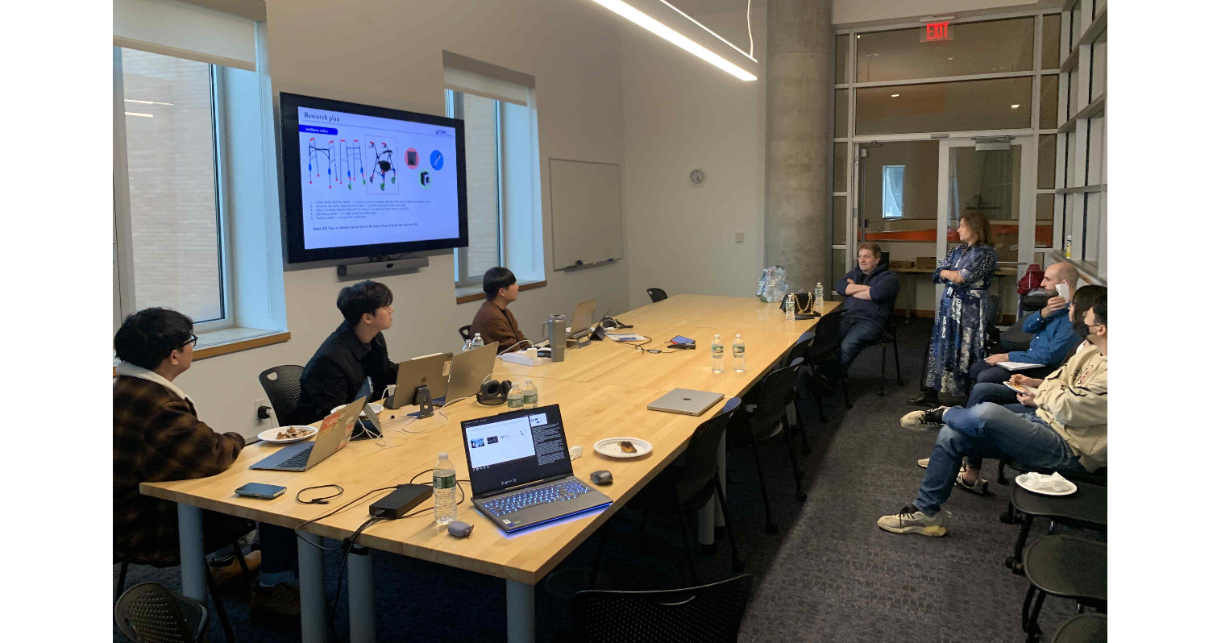▲ Exchange and research cooperation with the MIT Computer Science and Artificial Intelligence Laboratory

This research, led by Professor SeungJun Kim and conducted by doctoral students Gwangbin Kim, doctoral student Dohyeon Yeo, and master's student Taewoo Cho, was supported by the GIST-MIT International Cooperation Project and was led by Daniela Rus, director of the Computer Science and Artificial Intelligence Laboratory (CSAIL) at the Massachusetts Institute of Technology (MIT).

Professor SeungJun Kim's research team is carrying out 'HCI+AI convergence research for human-centered physical system design' in an AI international cooperation project that will be conducted for 5 years from 2021 to 2025 with MIT CSAIL, and is conducting human-computer interaction technology and artificial intelligence. By converging intelligent technologies, they are conducting research on artificial intelligence that can interact with users in various areas such as transportation, sports, rehabilitation, and entertainment.



