Will there be a path to drug treatment for Alzheimer's disease? GIST develops polymer nanocarrier to treat neurodegenerative disease

- Development of polymer nanocarrier technology that efficiently penetrates the ‘blood-brain barrier’ and delivers therapeutic agents to the central nervous system
- Present key design strategies such as nanocarrier size, surface charge, and target receptor

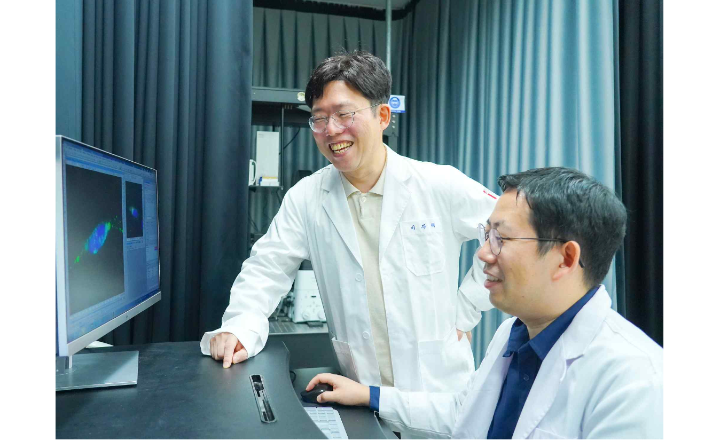▲ (From left) GIST Department of Chemistry Professor Kangtaek Lee and Dr. Yo Han Song

Korean researchers have developed a nanocarrier technology that can increase the efficiency of penetration of drugs for neurodegenerative diseases into the body.

This research outcome is expected to not only suggest a new direction in the development of treatments for the disease by increasing drug penetration efficiency in the body, but it also provides very important information for the research and development of polymer nanocarriers.

Gwangju Institute of Science and Technology (GIST) Department of Chemistry Professor Kang Taek Lee in collaboration with the research team of Associate Professor Ranjit De of POSTECH, has been working on drug delivery systems for Alzheimer's disease, and they have been studying nanoparticle-based therapeutic models for monitoring neurodegenerative diseases such as Parkinson's disease.

The research team has recently continued physicochemical research by measuring the optical properties of upconverting nanoparticles (UCNP)* containing lanthanide, controlling and modifying their chemical properties, and then injecting them into single cells and observing them in real time.

* Lanthanide-doped upconverting nanoparticles (UCNP): Doped with rare earth lanthanide-based elements, these nanoparticles have the property of absorbing near-infrared light as a light source and emitting visible light (upconverting effect).

Recently, various types of drugs have been developed to treat degenerative diseases of the nervous system, but it is very difficult to pass through the ‘Blood-Brain Barrier (BBB)’ and deliver drugs to the central nervous system.

The blood-brain barrier is a physiological membrane with high selective permeability, which can block substances that can cause neurotoxicity from easily penetrating into the central nervous system (CNS). This also limits the entry of various therapeutic drug molecules into the central nervous system.

The blood-brain barrier plays a central role in maintaining the brain's metabolic activity and neurological function, so it is very important to deliver drugs to the brain without damaging this membrane.

Therefore, various attempts are being made to design new polymer nanocarriers that can protect therapeutic drugs and promote transport and penetration through the blood-brain barrier.

Therefore, various attempts are being made to design new polymer nanocarriers that can protect therapeutic drugs and promote transport and penetration through the blood-brain barrier.

* Ligand: a substance that specifically binds to a large molecule such as a receptor

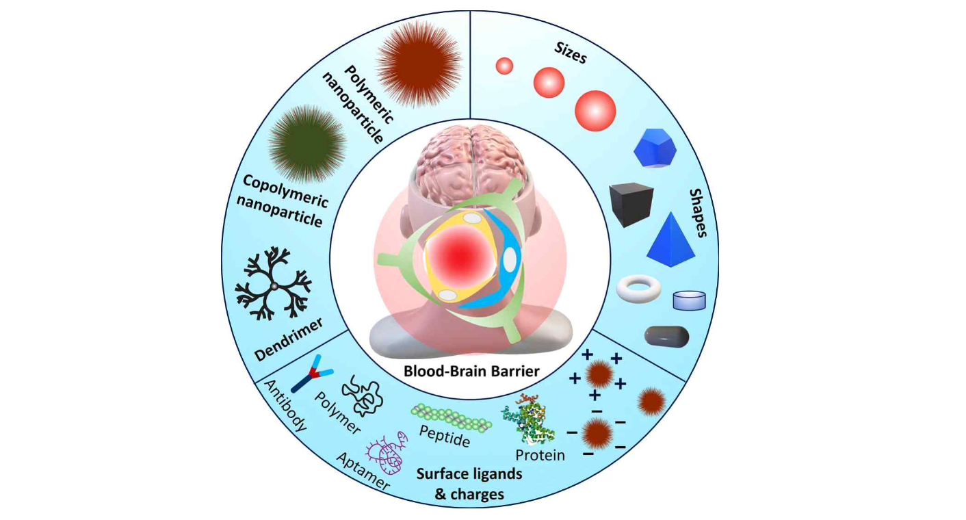▲ Factors that have been studied to date in polymer nanocarriers for BBB penetration and drug delivery. Tunable parameters such as size, shape, surface charge, and ligand-based surface modification of nanocarriers are being studied under various conditions.

The size of nanoparticles suitable for effective blood-brain barrier penetration ranges from 50 to 150 nm, the surface charge ranges from -1 to -45 mV, and the rod-shaped nanocarriers were observed to exhibit better blood-brain barrier penetration compared to spherical nanocarriers of the same volume when in fluid flow.

In addition, it was determined that the use of substances such as antibodies, aptamers, and peptides can minimize drug loss by targeting the endothelial cells that make up the blood-brain barrier through surface modification of the polymer nanocarrier.

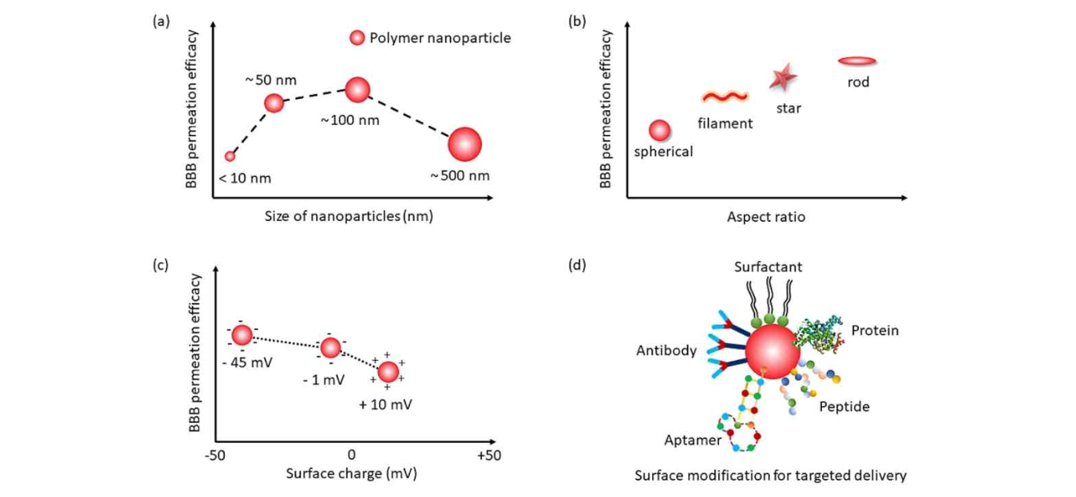▲ Illustration of factors affecting BBB penetration of nanocarriers.
(a) Particle size is 50 to 150 nm (b) When the shape of the nanocarrier is rod-shaped (c) Surface charge penetrates the BBB most efficiently in the range of -1 to -45 mV (d) Antibodies, aptamers. Attaching a ligand, such as a peptide, to the surface of the nanocarrier further increases BBB penetration efficiency.

Professor Kang Taek Lee said, "This study suggested a new direction in the development of treatments for neurological degenerative diseases by increasing the penetration efficiency within the brain to maximize the effectiveness of drug treatment for these diseases. We will continue to conduct research on the safety of nanocarriers for potential inflammation prevention and clinical application."

This research was jointly conducted by GIST Professor Kang Taek Lee (corresponding author), Pohang University of Science and Technology's Dr. Ranjit De (corresponding author), and GIST Dr. Yo Han Song (lead author) with support from the National Research Foundation of Korea's mid-career research project and creative challenge project and was published online on September 26, 2023, in ‘Advances in Colloid and Interface Science’, a renowned international journal in the field of biotechnology.



