Unlocking the secrets of genetic decoding... GIST unravels tRNA chemical modification

- Explanation of chemical modification of tRNA wobble uridine through enzyme-tRNA complex structure
- First case of high-resolution serine-specific tRNA structure identification

▲ (From the left) Department of Chemistry Professor Jungwook Kim and Department of Chemistry doctoral student Jaehun Yoo

A Korean research team has identified the chemical modification mechanism and essential factors of ‘transfer RNA (tRNA)*’, which is involved in the protein synthesis process, a core biological phenomenon.

* tRNA (transfer RNA): RNA involved in protein synthesis through gene expression, decoding genetic codes, and delivering amino acids

* serine-specific tRNA: tRNA binds to one of 20 amino acids and refers to a tRNA to which serine is bound

In addition, until now, the intact high-resolution structure of serine-specific tRNA*, the substrate used for crystallization, was not known, but it was confirmed for the first time in the world through the identification of the co-crystal* structure in this study.

* serine-specific tRNA: tRNA binds to one of 20 amino acids and refers to a tRNA to which serine is bound

* co-cocrystal: A compound in which several molecules have a crystalline structure in one crystal and are bonded in a way that is not ionic or intrinsic bonding

The research team of Professor Jungwook Kim in the Department of Chemistry at the Gwangju Institute of Science and Technology (GIST, President Kichul Lim) identified the chemical modification mechanism and essential factors in tRNA anticodon wobble uridine* by the CmoM enzyme.

* anticodon wobble uridine: The anticodon of tRNA decodes the codon of messenger RNA (mRNA) during protein translation. Here, the first anticodon is called the wobble position, which means that there is a uridine residue at this position.

The research team conducted research on in vivo chemical modification based on the structure of the enzyme*-tRNA complex.

* enzyme: A protein catalyst that mediates chemical reactions in living organisms. It binds to a substrate (here, tRNA) to cause a specific reaction, and then releases a product and participates in the next reaction.

Protein is a key element that makes up our body. DNA, which contains the genetic information for making proteins, is copied in the form of RNA and then transferred to ribosomes, protein production factories, to create proteins of various forms and functions. RNA plays a key role in this process.

In order to synthesize proteins that function normally within cells, the translation process by tRNA in the ribosome* must occur without error. If this does not happen, incorrect proteins are synthesized and essential functions for maintaining life cannot occur.

* ribosome: A cellular organelle responsible for protein synthesis by linking amino acids. It is composed of ribosomal RNA and protein. Ribosomes are divided into large and subunits, and the two units combine to perform protein synthesis.

In order for tRNA to function effectively, chemical modification must occur within the tRNA molecule. Each chemical modification is controlled by a different tRNA modifying enzyme.

If tRNA modification does not proceed, proper protein synthesis becomes difficult and can ultimately be fatal to sustaining life, so it is very important to understand the role of tRNA modification and the regulatory mechanism of enzymes. The principle of tRNA modification can be most effectively understood by obtaining the structure of the complex formed by the modifying enzyme bound to the substrate tRNA.

X-ray crystallography*, which is used for structural research in the field of biochemistry, has revealed the structures of numerous proteins and nucleic acids, including myoglobin, for over half a century, but analysis is only possible with a stable single crystal.

* X-ray crystallography: When X-rays are projected onto a crystal, diffraction occurs in the atoms that make up the crystal. By analyzing this diffraction pattern, the arrangement of the atoms in three-dimensional space and the structure of the entire molecule can be obtained.

In particular, complexes of proteins and RNA are not easy to crystallize, and according to the Protein databank (PDB), where the structures of biomolecules are registered, the structure of protein-RNA complexes accounts for only about 5% of the total.

The research team identified the high-resolution co-crystal structure of the CmoM enzyme and serine-specific tRNA using X-ray crystallography. Through this structure, they confirmed how the enzyme selectively recognizes the substrate tRNA and transfers the methyl group to the anticodon wobble uridine.

It is known that the anticodon wobble uridine position of serine-specific tRNA undergoes more chemical modification than other positions and is particularly important in decoding the genetic code.

Until now, there were many limitations in understanding the operating principles of the CmoM enzyme and the substrate tRNA that accepts methyl groups at the atomic level due to the lack of a complex structure. However, the research team overcame these limitations by uncovering a new structure.

The research team purified the CmoM enzyme and serine-specific tRNA overexpressed in E. coli. Co-crystals were fabricated using sinefungin, an analogue of SAM, a methyl transfer metabolite. The structure was identified through X-ray crystallography experiments [Figure 1]. According to this structure, it was revealed that CmoM mainly interacts with and binds specifically to the loop where the anticodon is located rather than the overall shape of the tRNA molecule.

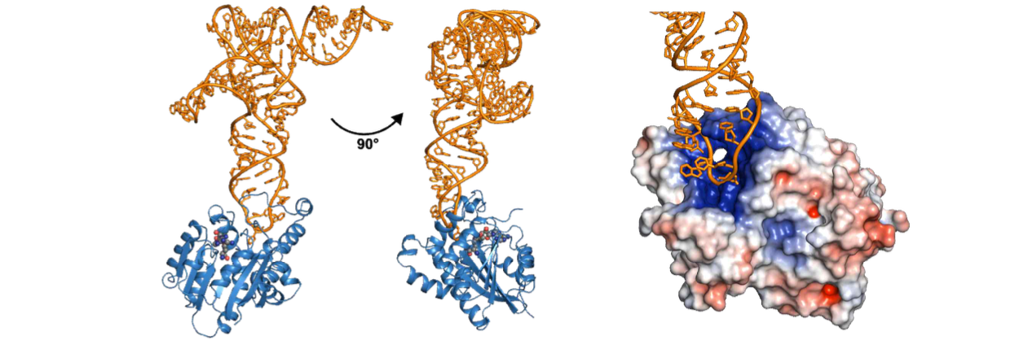▲ The structure of the enzyme CmoM and substrate tRNA complex discovered by the research team. The picture on the left is a typical ribbon depiction, with blue corresponding to CmoM and orange corresponding to tRNA. The picture on the right depicts CmoM through regional charges, with blue indicating a positive charge and red indicating a negative charge. tRNA has a negative charge due to its phosphate group, and it can be confirmed that it enters and binds to the positively charged pocket of the CmoM active site.

In addition, as the substrate tRNA binds to the enzyme, some of the structure of CmoM is rearranged, resulting in a change in the shape surrounding the tRNA [Figure 2]. Likewise, the shape of the anticodon loop of the tRNA was confirmed to have changed locally as it formed a complex. In particular, wobbled uridine was bound to the active site in a form that was significantly tilted toward the enzyme.

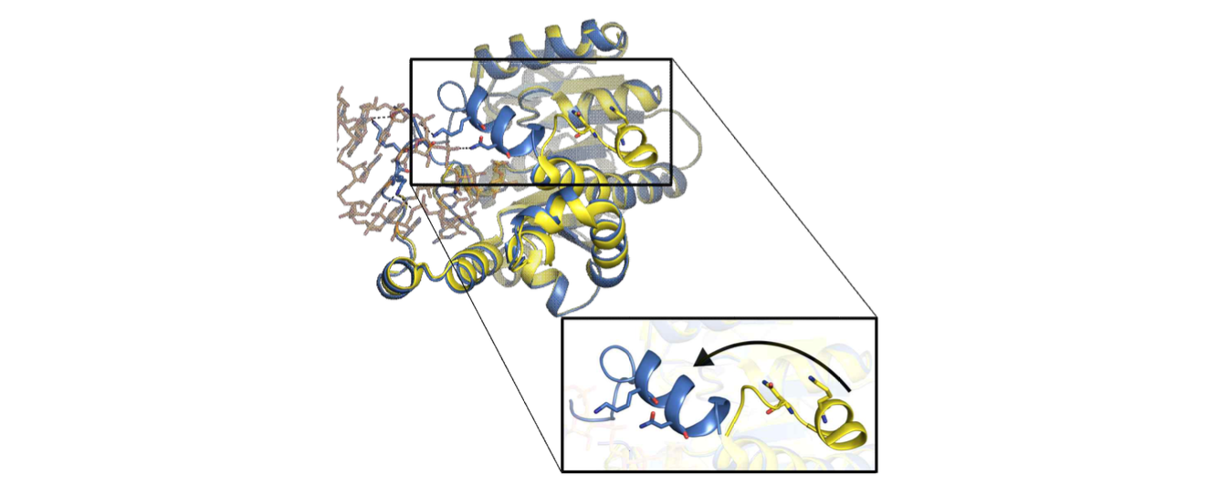▲ Structural change that occurs due to the combination of enzyme and substrate. In the absence of a substrate, the alpha-1 helix is free (yellow), but when tRNA is recognized, the helix takes on a shape that supports and binds to the tRNA (blue).

When point mutations* were made to the amino acid residues of the CmoM enzyme that interact with the tRNA identified through the co-crystal structure, the tRNA modification ability of the enzyme was observed to be greatly reduced or completely disappeared, confirming the information obtained from the X-ray structure functionally [Figure 3].

* point mutation: A form in which the original residue in a protein is replaced with a different amino acid. In this study, it was artificially added to measure the role of the corresponding residue and the enzyme activity.

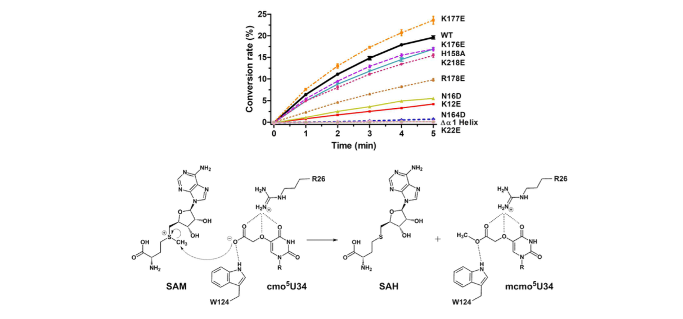▲ Activity measurement and overall methyl transfer mechanism when essential amino acid residues are mutated. The picture above shows that the enzyme activity decreases when point mutations are made to the interacting amino acid residues of CmoM compared to the wild type (WT). The figure below is a reaction scheme depicting wobbled uridine transformation by CmoM, which is the chemical mechanism proposed based on the experimental results obtained in this study.

Professor Jungwook Kim said, "This is a structure-based mechanistic study of tRNAs, which are essential for protein translation, and the protein enzymes involved in tRNA modification, which will provide insight into how modification activity occurs in vivo. It will also provide important clues to understanding the consequences of the absence of modification."

This research was led by Professor Jungwook Kim of the Department of Chemistry and conducted by doctoral student Jaehun Yoo with support from the National Research Foundation of Korea (NRF) Individual Research Support Project (mid-career) and was published online on August 17, 2023, in Nucleic Acids Research, an international academic journal in the field of biochemistry.



