GIST develops high-efficiency water electrolysis catalyst... Opening the possibility of producing green hydrogen with seawater

- Introduction of new technology to form Schottky junction at the heterojunction interface of the electrocatalyst... Innovative improvement in catalytic reaction efficiency
- Confirmed the possibility of producing green hydrogen by electrolyzing salty seawater rather than using the existing water electrolysis system that uses salt-free water (fresh water)

▲ GIST Department of Chemistry Professor Junhyeok Seo

A Korean research team has succeeded in developing a highly efficient water electrolysis catalyst that generates green hydrogen and oxygen using seawater as a raw material.

At the Gwangju Institute of Science and Technology (GIST, President Kichul Lim), Department of Chemistry Professor Junhyeok Seo's research team along with Pohang University of Science and Technology Professor Jeong Woo Han's team developed a technology to improve electron movement using the 'Schottky junction'*, which was used to innovatively improve the efficiency of the water electrolysis catalyst reaction.

* Schottky junction: A type of junction that occurs between a metal and a semiconductor. This occurs when the work function of a metal is greater than that of an n-type semiconductor, and electrons move from the semiconductor to the metal.

Unlike existing water electrolysis systems that use water without salt (fresh water), the research team confirmed the possibility of producing green hydrogen without carbon emissions by using seawater, the most abundant material on Earth.

The research team used an electrochemical reconfiguration reaction method to form a heterojunction* of metal and semiconductor materials. The Schottky junction formed during heterojunction showed an electron transfer efficiency 2.8 times higher than that of ‘nickel-tungsten nitride’, known as a highly efficient water decomposition reaction catalyst.

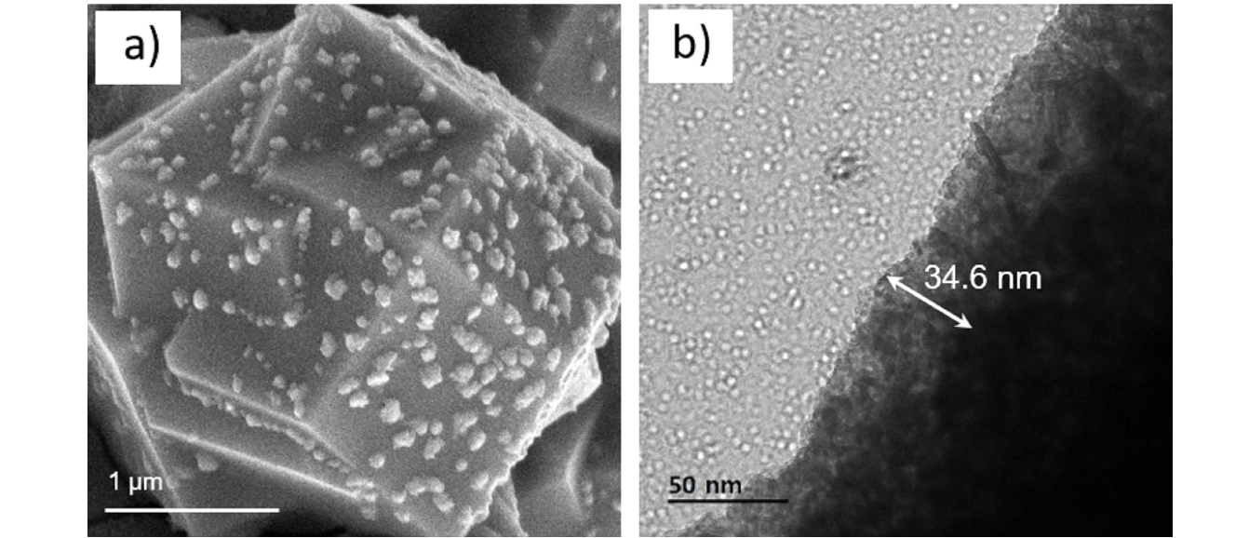▲ a) scanning electron microscope image, b) transmission electron microscope image of [nickel-tungsten nitride]/[nickel-iron oxide hydroxide] heterojunction material, which is a catalyst for electrochemical oxygen generation reaction.

This study confirmed that it can be used as a seawater decomposition cell using highly efficient cathode and oxidation electrodes.

* heterojunction: Two layers of different materials with solid states or the interface between them

The team's technology development strategy is to form Schottky junctions between nickel-iron oxide and nickel-tungsten carbide materials through a reconstitution reaction of nickel-iron oxide, which is known to be a highly efficient material for water oxidation reactions.

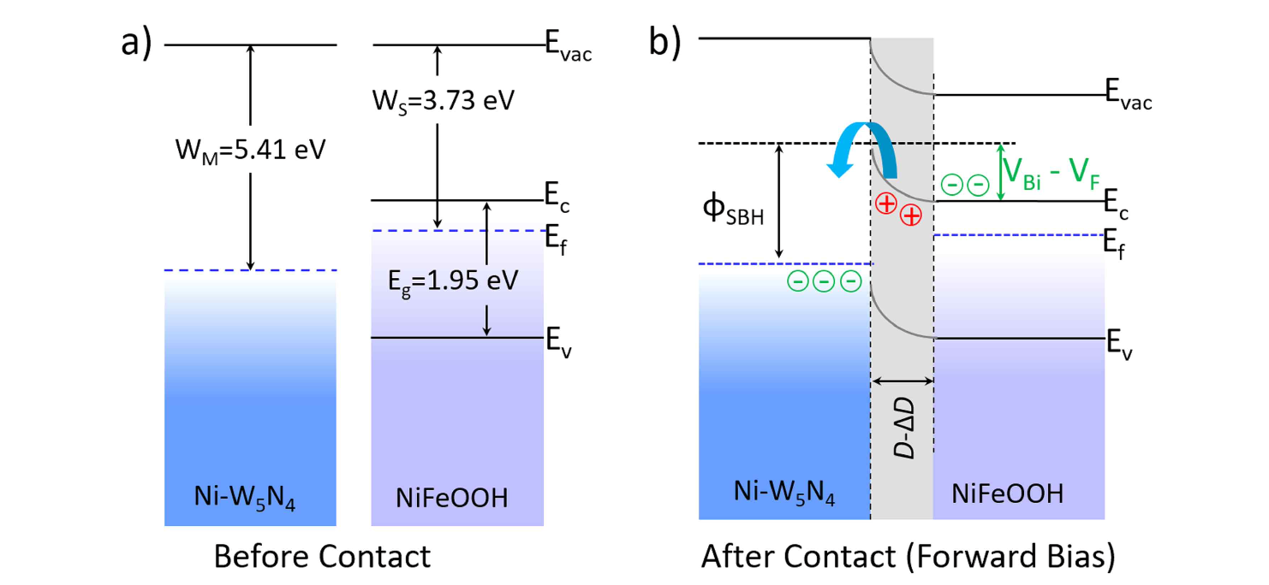▲ Description of electron flow through Schottky junction formed at the [nickel-tungsten nitride]/[nickel-iron oxide hydroxide] interface: a) Before heterozygote creation, b) After heterozygote creation.

The research team was able to form a ‘nickel-iron oxide hydroxide’ layer of a certain thickness on the surface of ‘nickel-tungsten nitride’ through a reorganization reaction. Then, a Schottky junction was formed between the high work function* nickel-tungsten carbide and the low work function nickel-ferric oxide, and electrons were transferred very efficiently, increasing the efficiency of oxygen generation on the electrode surface.

* Work function: Minimum work or energy required to pull out one electron from a substance

The research team experimentally demonstrated the effect of the effective electron transfer process through Schottky junction on the water electrolysis reaction efficiency. Results of seawater decomposition stability tests conducted along with dramatically improved efficiency and catalyst durability.

The developed ‘heterojunction catalyst’ requires only 0.2 V overpotential* at 0.1 A, and showed oxygen generation reactivity with better efficiency than expensive ruthenium oxide catalysts.

In addition, ‘nickel-iron oxide hydroxide’ required an overpotential of 0.01 V at 0.01 A and showed hydrogen generation reactivity that surpassed that of a platinum catalyst. The research team obtained experimental results that reached a high efficiency of 0.1 A with only an overpotential of 0.2 V in an actual seawater decomposition reaction conducted for 10 days, confirming the possibility of commercialization of a highly efficient, highly stable catalyst. [Figure 3]

* overpotential: voltage required more than the theoretical voltage due to resistance and heat loss of electrical energy during actual electrochemical reactions

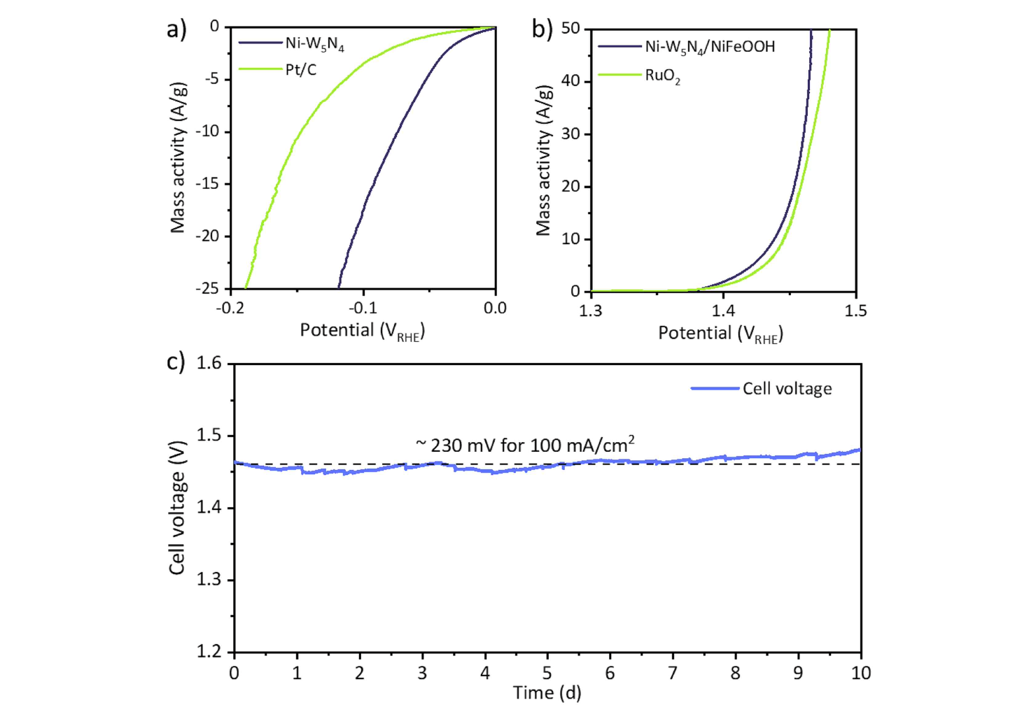▲ Developed in this study: a) comparison of hydrogen production reaction efficiency between [nickel-tungsten nitride] and platinum catalyst, b) comparison graph of oxygen generation reaction efficiency between [nickel-tungsten nitride]/[nickel-iron oxide] heterojunction material and ruthenium oxide catalyst, c. ) Water electrolysis reaction test results using seawater.

Professor Junhyeok Seo said, "This research outcome is significant in that it innovatively improved catalytic reaction efficiency by introducing a new technology to form a Schottky junction at the heterojunction interface of an electrode catalyst in the field of water electrolysis catalyst technology development research. In the future, it may be possible to commercialize the water electrolysis catalyst for green hydrogen production or oxygen production."

The research, led by Department of Chemistry Professor Junhyeok Seo and conducted by postdoctoral researcher Selvaraj Seenivasan and doctoral student Taewaen Lim, was supported by the National Research Foundation of Korea (NRF) Basic Research Project and the Marine Fisheries Technology Commercialization Support Project of the Korea Agency for the Advancement of Marine Science and Technology, and was published online on August 30, 2023, in Applied Catalysis B: Environmental, a top 1% paper in the environmental field.



