100% accurate virus infection diagnosis reduced from 6 hours → 20 minutes

- Improved detection accuracy by applying optimal metal-enhanced fluorescence phenomenon conditions to antigen diagnosis technology
- High sensitivity detection of virus antigen within 20 minutes and verification with 100% accuracy

▲ (From left) Department of Chemistry Professor Min-Gon Kim and researcher Donggu Hong

A domestic research team has developed a rapid influenza antigen diagnosis technology* that can accurately confirm initial viral infection in just 20 minutes by improving the sensitivity of antigen detection by at least 100 times compared to commercially available influenza rapid antigen diagnosis kits.

The results of this research are expected to enable rapid and accurate diagnosis of infection in the early stages of spread, effectively responding to the spread of highly contagious viruses such as respiratory viruses and minimizing losses, and further enabling effective treatment.

* antigen diagnosis technology: A technology that detects viral antigens using antibodies, and is mainly used in self-diagnosis kits that allow users to easily test themselves.

Gwangju Institute of Science and Technology (GIST, President Kichul Lim) Department of Chemistry Professor Min-Gon Kim's research team discovered the optimal metal-enhanced fluorescence phenomenon* and applied it to lateral flow immunoassay* and succeeded in securing high accuracy and specificity for influenza viruses.

* metal-enhanced fluorescence phenomenon: A phenomenon in which light is amplified by transferring surface plasmon energy to the fluorescence energy of the emitter through resonance.

* lateral flow immunoassay: A method of detecting a sample through an antigen-antibody immune reaction by flowing the analysis sample within a strip using capillary action. It is mainly used in rapid antigen diagnostic sensors.

Although the molecular diagnostic* test currently used as a standard method is highly accurate, it takes an average of 6 hours for the analysis results to come out, which limits its ability to effectively deal with the rapidly spreading virus.

On the other hand, antigen diagnosis* technology can be easily used by anyone and results can be confirmed within 20 minutes, but it has the disadvantage of low accuracy.

Therefore, there is a need to develop antigen diagnosis technology that can quickly confirm low-concentration viral infection with high accuracy.

* molecular diagnosis: It is a diagnostic technique that detects changes at various molecular levels that occur within cells through numerical values or images.

* antigen diagnosis: This checks for infection by using a sample collected without going through a gene amplification process. If you put the collected nasal discharge into a test kit, the antigen of the virus and antibodies combine to confirm whether you are infected.

The research team found the optimal metal-enhanced fluorescence phenomenon conditions that could dramatically improve the fluorescence signal by adjusting the distance between the gold nanorods and the fluorescent emitter and applied it to antigen diagnosis technology to improve the detection accuracy of influenza viruses.

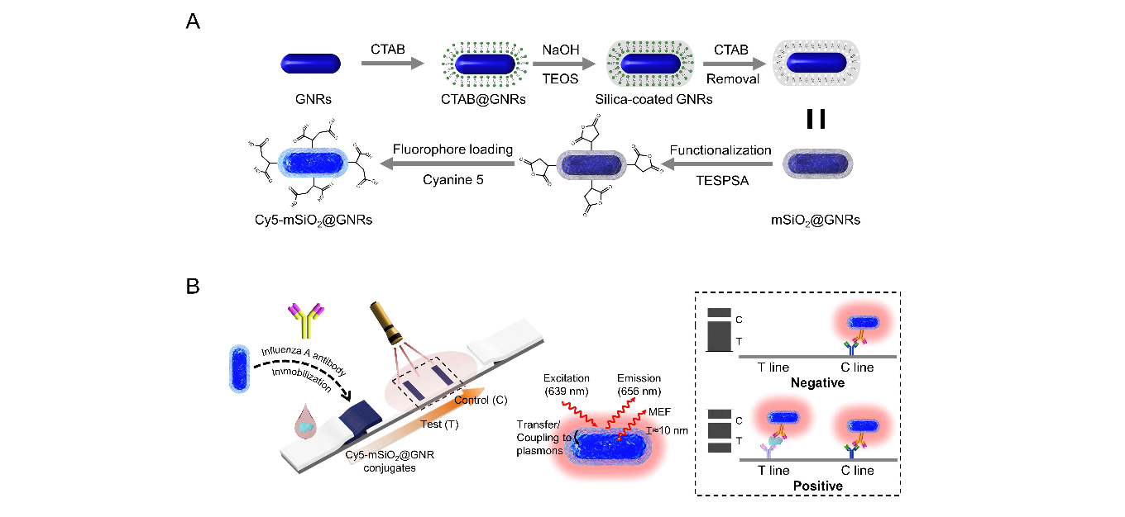▲ Schematic diagram of synthesis of particles that cause metal-enhanced fluorescence phenomenon and application to influenza virus antigen diagnosis technology: A. Gold nanorod (GNR) core-porous silica (mSiO₂) shell-based metal-enhanced fluorescent particle synthesis process B. Influenza virus antigen diagnosis technology using synthesized particles

The research team synthesized fluorescent particles based on a core-shell structure centered on gold nanorods and using porous silica as the shell. The shell with a porous structure can accommodate a large amount of fluorescent light emitting material, making it easy to control the distance between the fluorescent light emitting material and the gold nanorod.

As a result, a plasmonic coupling phenomenon occurred between a large amount of fluorescent material and the gold nanorod at a specific distance (about 10.3 nm), and succeeded in obtaining a dramatically improved fluorescence signal.

In addition, it was confirmed that the degree of improvement of the fluorescence signal according to the distance between the gold nanorod and the fluorescent emitter showed a similar movement to the theoretical calculated value.

The research team applied the optimal metal-enhanced fluorescent particles to a rapid antigen diagnosis technology based on lateral flow immunoassay to detect influenza viruses. Antibodies that specifically react to influenza virus antigens were immobilized on the synthesized fluorescent particles.

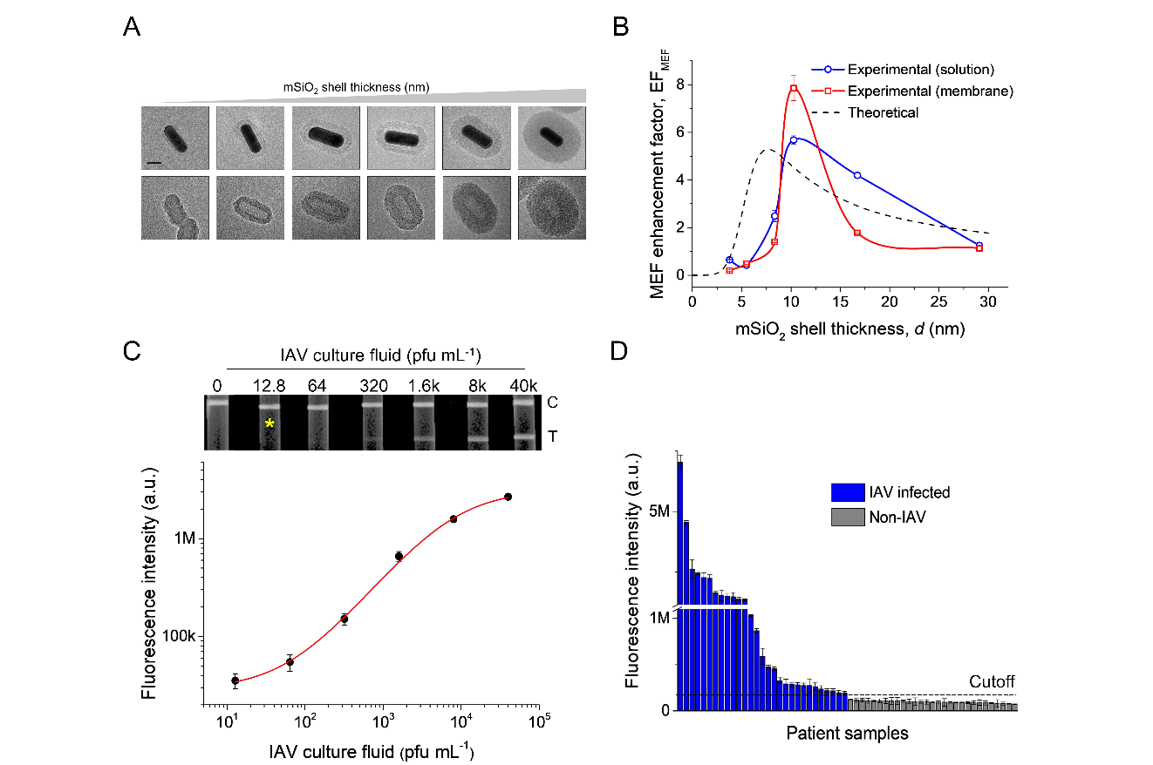▲ Comparison with experimental methods and theoretical calculations that verified the degree of fluorescence signal improvement and detection results of influenza virus antigen (IAV NP) in clinical samples from infected patients: A. Silica shell and gold nanorods with adjusted thickness are etched to become empty. Transmission electron microscope image showing the condition B. Comparison of experimentally obtained results and theoretical calculations of the degree of fluorescence signal improvement according to the thickness of the silica shell C. Showing the results of detecting influenza virus antigens using synthesized particles fluorescence image D. Results of clinical sample analysis from influenza virus positive and negative patients

This technology has improved sensitivity by at least 100 times compared to commercially available influenza virus diagnostic products, and it succeeded in detecting viral antigens with high sensitivity within 20 minutes after sample injection.

The rapid antigen diagnosis technology developed by the research team confirmed a high detection power of 100% when applied to a large number of positive patient samples confirmed through molecular diagnostic tests.

▲ Professor Min-Gon Kim’s research team is testing an influenza rapid antigen diagnosis kit by dropping infected reagent samples into the kit.

Professor Min-Gon Kim said, "Rapid antigen diagnosis technology, which solved the problems of existing virus diagnosis methods, was confirmed to have 100% virus detection accuracy, similar to molecular diagnostic technology. It is expected that it can be applied to the development of sensors to detect various viruses in the future."

This study was conducted by mid-career researchers promoted by the Ministry of Science and ICT and the National Research Foundation of Korea with support from Ministry of Trade, Industry and Energy's through the International Cooperative R&D program and was published online in the international academic journal ACS Nano on August 18, 2023.



