The lifespan of organic solar cells has been increased by more than 1,000 hours

- Stabilization of the surface of the electron transport layer by adding single molecules to the photoactive layer solution
- Significantly increased lifespan by introducing a self-assembling layer... Published in the renowned international academic journal 「ACS Energy Letters」

▲ (From left) GIST Professor Kwanghee Lee, Professor Heejoo Kim, and doctoral student Sanseong Lee

Researchers at the Gwangju Institute of Science and Technology (GIST, President Kichul Lim) have solved the problem of organic solar cells losing performance at high temperatures in a simple way, and they succeeded in dramatically increasing the lifespan by more than 1,000 hours, which is about 50 times the existing value.

GIST's joint research team of Professor Kwanghee Lee of the School of Materials Science and Engineering and Professor Heejoo Kim of the Graduate School of Energy Convergence announced that they had increased the lifespan of organic solar cells without an additional coating process by using single molecules that form their own thin protective layer.

Organic solar cells use organic semiconductors as photoactive layers*, making them flexible and color-adjustable. Because it is transparent and can be used in automobile glass and building windows, it is attracting attention as a next-generation solar cell.

* photoactive layer: A thin layer that plays a key role in absorbing light and producing electricity in solar cells. In organic solar cells, a photoactive layer is formed by coating a solution of a mixture of polymers and single-molecular organic substances.

On the other hand, organic solar cells have the problem of reduced performance at high temperatures. It is known that the main cause is that organic molecules move due to heat and are transformed into a form that is unfavorable for charge transport. Therefore, in order to solve this problem, research is being conducted to suppress movement due to heat by changing the chemical structure of organic matter.

Meanwhile, despite the presence of chemically reactive components on the surface of zinc oxide, which is widely used as an electron transport layer* in organic solar cells, little research has been done on the degradation that can occur at the interface of zinc oxide and photoactive layers in high temperature environments.

* electron transport layer: A layer that efficiently transfers only the electrons and holes generated by the photoactive layer to the anode of the solar cell, and it is coated between the anode and the photoactive layer.

Through Orbitrap/TOF Hybrid SIMS*, the research team discovered that single-molecule organic semiconductors are damaged when they react with impurities present on the surface of zinc oxide, and they confirmed that more damage occurred as the fluidity of single-molecule organic materials increases.

* Orbitrap/TOF Hybrid SIMS: Equipment that observes the composition, distribution, and behavior of compounds through surface analysis/depth analysis/2D and 3D image analysis of solids and analyzes organic/inorganic multilayer thin films such as OLED and Solar Cell. It is used for semiconductor/metal/ceramic surface analysis, fine dust/plastic component analysis, and biomaterial component analysis.

* unimolecular organic matter: Unlike polymer substances linked through polymerization, this refers to organic molecules with a low molecular weight. Single-molecule organic materials used in the photoactive layer of organic solar cells have a structure with many side chains attached to control solubility and crystallinity.

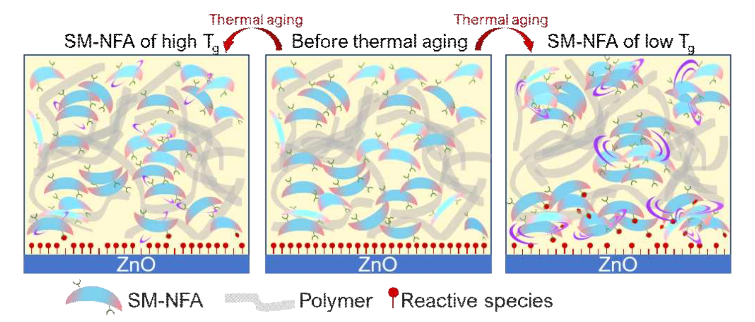▲ Schematic diagram of the difference in deterioration depending on the fluidity of single-molecular organic substances: Single-molecular organic substances with low Tg (denoted as SM-NFA) not only undergo large morphological deformation due to movement due to heat but are also reactive to the surface of zinc oxide (denoted as ZnO). The likelihood of damage increases due to reaction with species (denoted as reactive species). On the other hand, in the case of single-molecule organic materials with a high Tg, the movement due to heat is small, so damage at the interface is also reduced.

In addition, the research team mixed 5-Methyl-1H-benzotriazole (hereinafter referred to as M-BT), a polar and volatile monomolecular organic substance, into the photoactive layer solution, and, when coating the photoactive layer, the monomolecular organic substance self-assembles on the surface of zinc oxide to remove surface impurities and form a protective layer.

* self-assembly: A phenomenon in which randomly existing molecules spontaneously form an organized structure or form due to interactions between components without external intervention.

Among the three types of single-molecule organic semiconductors with different fluidity (Y6, L8BO, DTY6), organic solar cells using a single molecule with high fluidity (DTY6) had the greatest improvement in lifespan (68% improvement after 1,000 hours). It was confirmed that the time it takes for a solar cell to lose 15% of its initial efficiency increased approximately 50 times from 20 hours (excluding M-BT) to over 1,000 hours, greatly improving its lifespan.

Professor Kwanghee Lee said, "The significance of this study is that it breaks away from the trend of existing thermal stability studies that focus only on the morphological stability of the photoactive layer and significantly improves the thermal stability of solar cells by stabilizing the surface of the electron transport layer by simply adding a single monomer to the photoactive layer solution. This can be applied to the printing process for large area, which is expected to help the commercialization of organic solar cells."

This research, led by Professor Kwanghee Lee of the School of Materials Science and Engineering and Professor Heejoo Kim of the Graduate School of Energy Convergence, and conducted by School of Materials Science and Engineering doctoral student Sanseong Lee, was supported by the Korea Basic Science Institute, the Technology Development Program to Solve Climate Change of the National Research Foundation, the GIST Research Institute, and the Nano & Material Technology Development Program and was published on August 31, 2023, in ACS Energy Letters (IF: 23.991), a journal in the top 4% in the material science field. Published online.



