High fat intake causes ADHD and sleep disorders

- Professor Tae Kim’s team confirmed REM sleep abnormalities and behavior similar to attention deficit hyperactivity disorder (ADHD) in a high-fat intake mouse model
- Published in 「Psychiatry Research」, an internationally renowned academic journal in the field of mental science

▲ (From left) GIST Department of Biomedical Science and Engineering
Professor Tae Kim and Dr. Jiseung Kang

It is well known that high fat intake causes physical diseases such as obesity, adult diseases, and metabolic diseases. What is the connection with mental illness?

A joint research team led by Professor Tae Kim and Professor Chang-Myung from the Department of Biomedical Science and Engineering at the Gwangju Institute of Science and Technology (GIST, President Kichul Lim) discovered REM sleep (light sleep) abnormalities and attention deficit hyperactivity disorder (ADHD)-like behavior in a mouse model that ate a high-fat diet.

Through experiments with mice, the research team confirmed the possibility that consuming high fat (diet containing more than 60% fat) for more than a month can cause dysfunction of the brain's dopamine system, leading to sleep disorders and mental illnesses such as ADHD.

It is well known that high-fat diets are associated with various physical diseases such as metabolic diseases, obesity, and cerebrovascular diseases, but there are relatively few studies on the relationship with mental diseases, and research on brain and nervous system mechanisms is still lacking.

The research team confirmed decreased REM sleep, decreased memory, anxiety, lack of pleasure, and hyperactivity in experimental mice fed a high-fat diet. Considering that these behavioral changes were very similar to the symptoms of patients with attention deficit hyperactivity disorder, they also analyzed them at the molecular level.

In the case of a high-fat diet mouse model, the research team identified several dopamine-regulating gene transcripts in the ventral tegmental area of the brain, which is known to produce dopamine and deliver it throughout the body, and the nucleus accumbens, where nerves are gathered on the left and right sides of the brain. It was confirmed that the amount was decreasing. Additionally, continuous exposure to a high-fat diet decreased the amount of dopamine-related gene transcripts.

High-fat diet mouse models showed anxiety, hyperactivity, lack of pleasure, and memory impairment. A high-fat diet decreased wakefulness (sleeplessness) time and increased segmented REM sleep in sleep-wake regulation.

As a result, the research team found changes in the dopamine system and behavioral abnormalities such as anxiety and hyperactivity due to a high-fat diet. They interpreted the sleep abnormality as similar to attention deficit hyperactivity disorder and confirmed that a high-fat diet can cause mental illness.

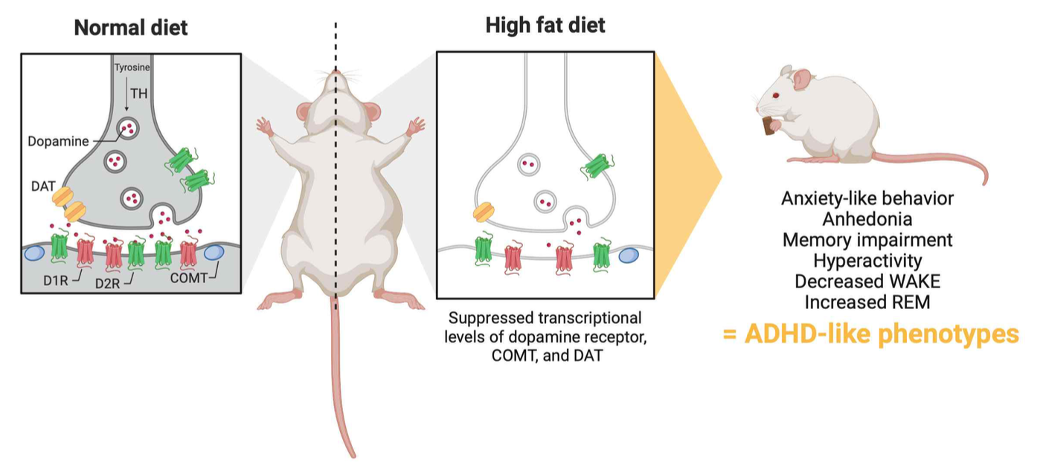▲ Dopamine dysregulation and behavioral abnormalities in high-fat diet model mice: The research team observed changes in the dopamine system and behavioral abnormalities such as anxiety and hyperactivity following a high-fat diet. They interpreted the sleep abnormality as similar to attention deficit hyperactivity disorder and confirmed that a high-fat diet can cause mental illness.

Professor Tae Kim said, "The greatest significance of this study is the discovery of a potential link between high-fat diets and attention deficit hyperactivity disorder. High-fat intake is dangerous for adults as well, but it can worsen attention deficit disorder and sleep disorders during the development of children and adolescents, so attention and thorough management are needed."

This research, led by Professor Tae Kim and Professor Chang-Myung at the GIST Department of Biomedical Science and Engineering and conducted by Dr. Jiseung Kang, was supported by the GIST Integrated Institute of Biomedical Research, the Joint Research Project of Institute of Science and Technology, and the Ministry of Health and Welfare's Dementia Project. It was published online on August 20, 2023 in Psychiatry Research, which is within the top 5.8% journals in the field of mental science.



