Development of an AI platform that quickly and accurately diagnoses the infection level of viral diseases

- Observe and quantify very small bioparticles the size of viruses
- Achieving PCR-level accuracy without gene amplification and labeling processes... Optimized treatment is expected with quick and intuitive results

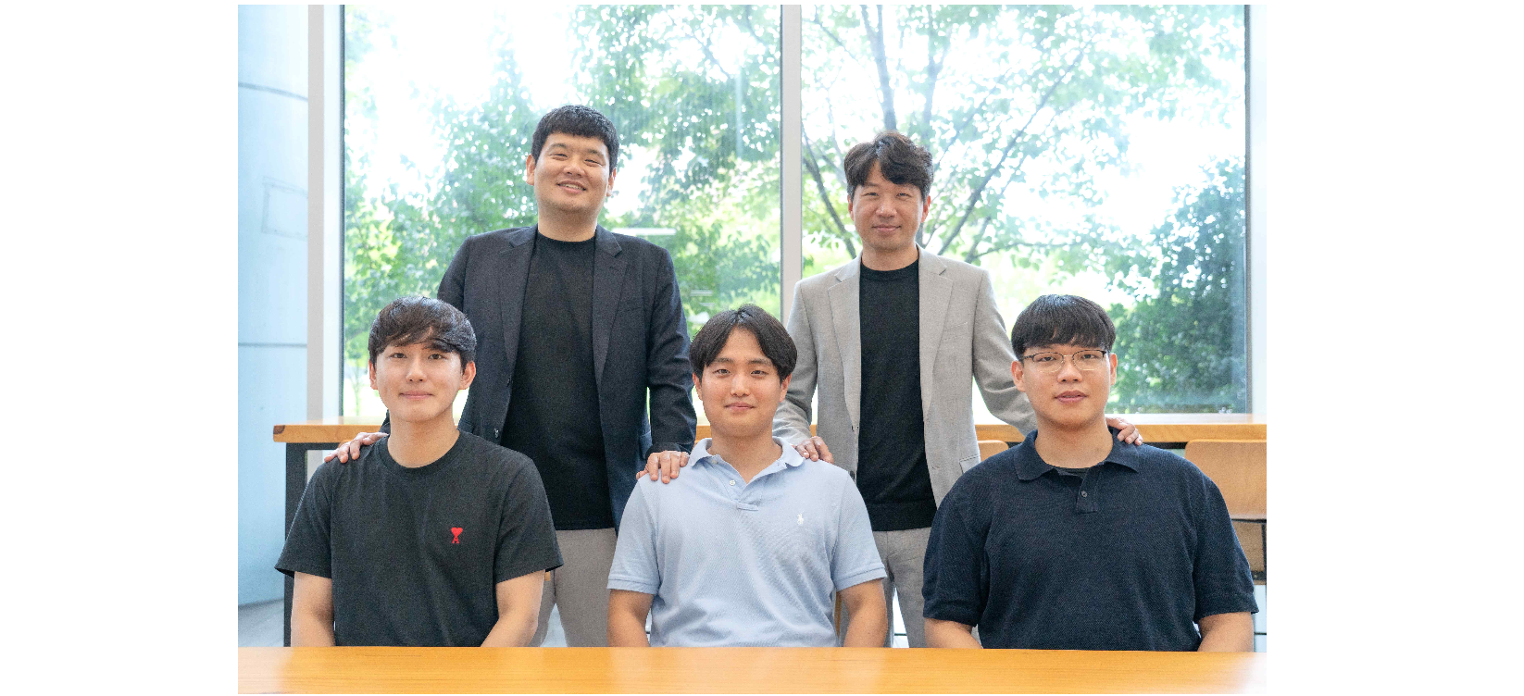▲ Group photo of researchers: (clockwise from the left in the back row) Professor Hae-Gon Jeon, Professor Young Min Song, master's student Jiwon Kang, integrated student Jin-Hwi Park, and Ph.D. student Joo Hwan Ko

When infected with a very small pathogen such as a coronavirus, is it possible to quickly confirm the exact stage of infection (severity) by measuring the amount of virus in the body, as if measuring weight on a scale?

A joint research team led by Professor Young Min Song of the School of Electrical Engineering and Computer Science and Professor Hae-Gon Jeon of the Graduate School of AI Graduate School at the Gwangju Institute of Science and Technology (GIST, President Kichul Lim) developed a platform (DeepGT)* that can quickly and accurately quantify virus-sized bioparticles.

* DeepGT: Biosensing platform based on Gires-Tournois (GT) resonator using deep learning

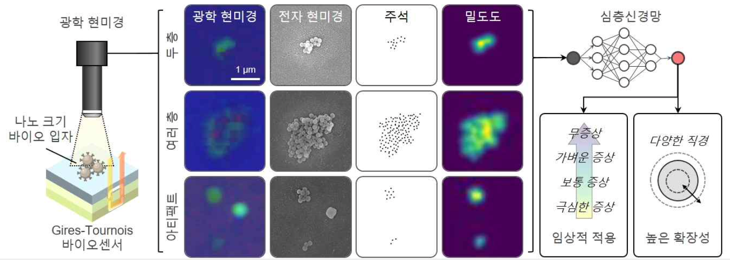▲ Illustrated summary of the DeepGT platform: Learning a deep neural network based on density data reconstructed from nano-sized bio-particle photos obtained through an optical microscope and corresponding electron microscopy photos. It can be applied and expanded clinically through the learned artificial intelligence model, and it can be applied to quantify bio particles of various sizes.

To prevent the resurgence of pandemics such as COVID-19, it is necessary to develop technologies that enable early response by effectively diagnosing new viruses and confirming the stage and severity of infection.

The platform, which detects nanometer (billionth of a meter) sized bio-particles through intuitive color change and accurately predicts the number of particles through deep learning, is expected to be a next-generation virus diagnosis platform that reduces the complexity of existing virus diagnosis and definition while increasing accuracy.

The research team trained bio-particles clustered in various structures using a convolutional neural network* and succeeded in quantifying them with high accuracy using the completed artificial intelligence neural network.

Very small bio particles can be clearly observed through a biosensor (Gaia Tournoir resonance structure)* composed of thin films without complex processes, and they succeeded in inferring how many bio particles exist.

* Convolutional Neural Network: A deep neural network technique that can effectively process images by applying filtering techniques to artificial neural networks. A process in which each element of the filter expressed as a matrix is automatically learned to be suitable for data processing. It is a technique for classifying images through.

* Gires-Tournois Resonator: It is an optical resonance structure in which the front resonator is partially reflective, while the rear resonator shows high reflectivity and generates specific wavelength reflection and a narrow chromatic dispersion spectrum.

The ‘DeepGT platform’ developed by the research team is based only on antigen-antibody reactions without complex sample processing processes such as gene amplification and labeling* used in molecular diagnosis, and its strengths are simplicity and high scalability. In addition, rapid and accurate detection is possible by overcoming the disadvantages of the electrochemical method, which takes a lot of time and inevitably generates noise during measurement.

* Labeling: a technique for activating immunochemical reactions by attaching specific biomolecules to the surface of the medium to antigens that can react with the analyte for immunoassay

The 'Gires-Tournois optical resonance structure', an existing research result of Professor Young Min Song's research team, freely modulates optical properties by inserting a porous complex refractive index layer between a low refractive index layer and a metal reflection layer, and the slow light effect (Slow light effect) in the low refractive index layer, and single absorption with Light Effect* was implemented.

As a result, it was possible to design and manufacture a biosensor with high sensitivity to viruses.

* Slow Light Effect: The effect of slowing down light by inducing a very low group speed of light waves under the influence of the very narrow spectral resonance characteristics of the medium.

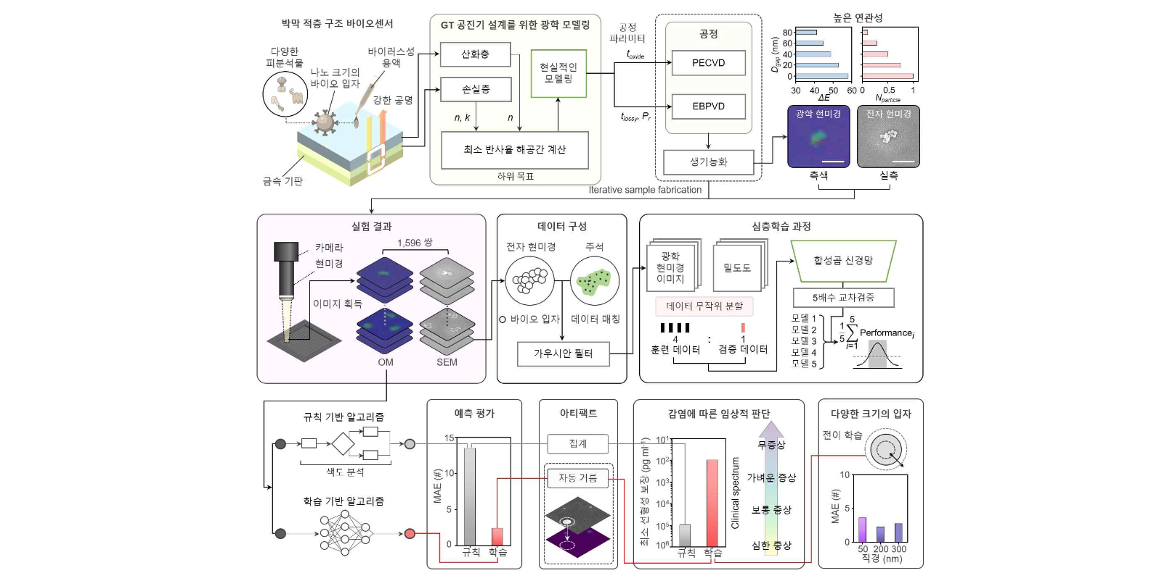▲ DeepGT framework schematic: Quantification of nano-sized bioparticles using Gires-Tournois thin film structure biosensor and deep learning and scalability through transfer learning can be confirmed.

When observing bio-particles smaller than the diffraction limit* using a conventional optical microscope, the outline of individual particles became blurred, making quantification impossible. In order to measure and quantify these particles, expensive equipment such as an electron microscope or photonics devices with complex structures are essential.

* Diffraction Limit: Optical system performance is limited by the diffraction effect. Diffraction is a phenomenon in which waves are transmitted behind obstacles when they pass through them. In order to see an object, the light reflected from the object must enter our eyes.

The research team detected bio-particles with a diameter of 100 nm (nanometers, 1 billionth of a meter) with the completed ‘Gires-Torunois biosensor’, and trained 1,596 pairs of optical microscope pictures taken on the convolutional neural network.

As a result of the verification, it showed a high accuracy of Mean Absolute Error* 2.3669 and even predicted particles that were difficult to observe because they consisted of two or three bio particles. In addition, it accurately predicted the complex structure of multiple layers and achieved a very low limit of detection of 138 pg/ml.

* Mean Absolute Error (MAE): It refers to the average of all absolute errors. Here, error refers to the difference between the value predicted by the algorithm and the actual correct answer. In other words, the better the algorithm guesses the correct answer, the smaller the average absolute error value is, so the smaller the MAE and the better the performance of the algorithm.

Through transfer learning, high quantitative accuracy was achieved with average absolute errors of 3.59, 2.24, and 2.71, respectively, even with a limited number of data on bio-particles with diameters of 50, 200, and 300 nm, which are the typical sizes of zoonotic viruses.

Professor Hae-Gon Jeon said, "This is a case of applying artificial intelligence technology to the field of photonics* to produce socially beneficial convergence research results. Thanks to the researchers' efforts to break down the academic barrier between the two fields, they were able to improve the completeness of the design of artificial intelligence algorithms for analyzing data measured from photonics sensors."

* Photonics: A field of optical research using photons

Professor Young Min Song said, "Through interdisciplinary research in two completely different disciplines, ‘AI deep learning’ and ‘photonics’, the limitations of existing virus sensors have been overcome and clearer and more accurate virus observation has become possible. It is expected that this can be used as a very important technology in the post-corona era."

This research was conducted with support from the Ministry of Science and ICT, the National Research Foundation of Korea's Future Materials Discovery Project, the Future Promising Convergence Technology Pioneer Project, the Future Technology Lab Project, the Sejong Science Fellowship, and the International Technology Center Indo-Pacific (ITC IPAC). The research results were published online in the international academic journal 'Nano Today (IF: 17.4)' on Friday, August 25, 2023.



