“Black box video, artificial intelligence judges!” GIST develops traffic accident negligence evaluation technology

- Professor Yong Gu Lee’s team develops traffic accident negligence evaluation technology that makes legal judgments with artificial intelligence
- Possible to make objective judgment... Drastic reduction in manpower, cost, and time required for accident investigation and disputes

▲ [Photo] (From left) School of Mechanical Engineering Professor Yong Gu Lee and Ph.D. student Sunjae Lee

GIST (Gwangju Institute of Science and Technology, President Kichul Lim) School of Mechanical Engineering Professor Yong Gu Lee succeeded in evaluating the percentage of negligence in traffic accidents by analyzing black box images with artificial intelligence (AI) technology.

By utilizing the results of this research, the insurance industry can drastically reduce the number of experts involved in basic epidemiological investigations and support lawyers in deliberation of disputes. It is also possible to drastically reduce the time required for dispute review. Consumers can also obtain objective information about accidents, so they can save money and time by not filing additional disputes.

Furthermore, this technology is expected to be applied to various fields such as crime prevention and analysis through CCTV image analysis and autonomous driving safety prevention devices.

Professor Yong Gu Lee said, "Now, the era will come when artificial intelligence will go beyond recognition and make legal judgments, and humans will have to think about maintaining the fairness and transparency of artificial intelligence. It is expected that the results of this research can be used to automate accident deliberation, which is dependent on manpower, and dramatically improve the time required."

The study, led by Professor Lee and conducted by Ph.D. student Sunjae Lee, was supported by the Korea Institute of Industrial Technology Promotion and the Information and Communication Planning and Evaluation Institute, and the research results were published last month in the renowned international academic journal 「JCDE (Journal of Computational Design and Engineering)」.

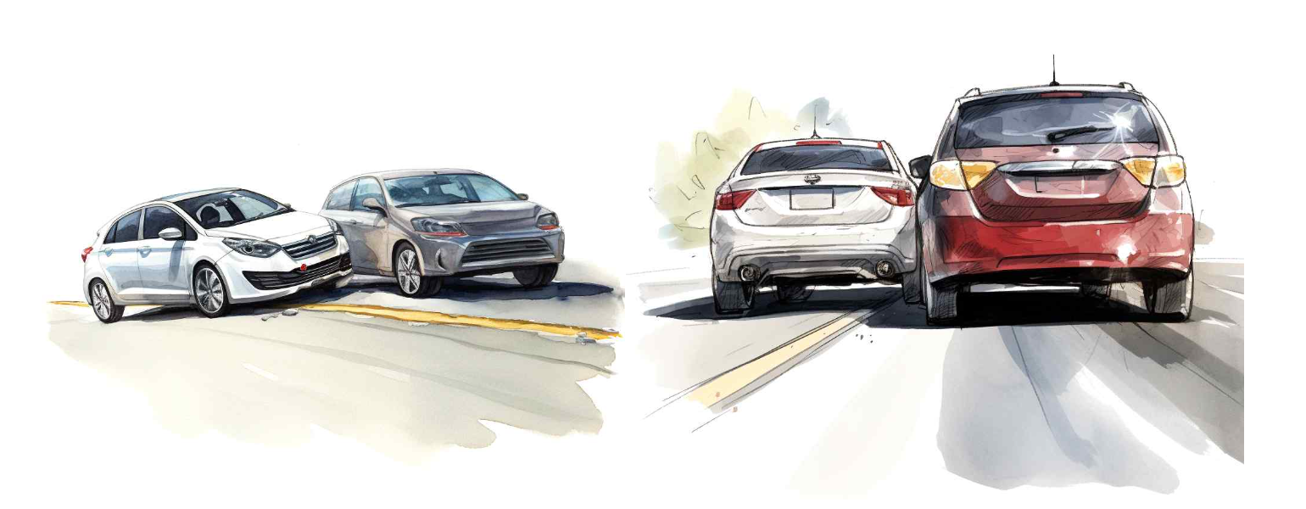[Figure 1 (left)] AI-generated accident case (1): A white car crosses the lane and collides with a gray car that is overtaking.

[Figure 2 (right)] AI-generated accident case (2): A white vehicle passing and a red vehicle driving straight ahead collided.

Although artificial intelligence technology is rapidly developing today, the field of 'legal tech', which combines artificial intelligence and law, is still in its infancy. In particular, there are few examples of using artificial intelligence in the evaluation of the negligence rate in traffic accidents, which requires legal judgment in addition to spatial and temporal cognitive abilities for the accident situation.

More than 100,000 disputes related to traffic accident negligence rate evaluations occur every year, and an astronomical amount of manpower and time is invested, such as deliberation by a committee of 50 lawyers for about 75 days per case.*

* Property Insurance Association, as of 2022

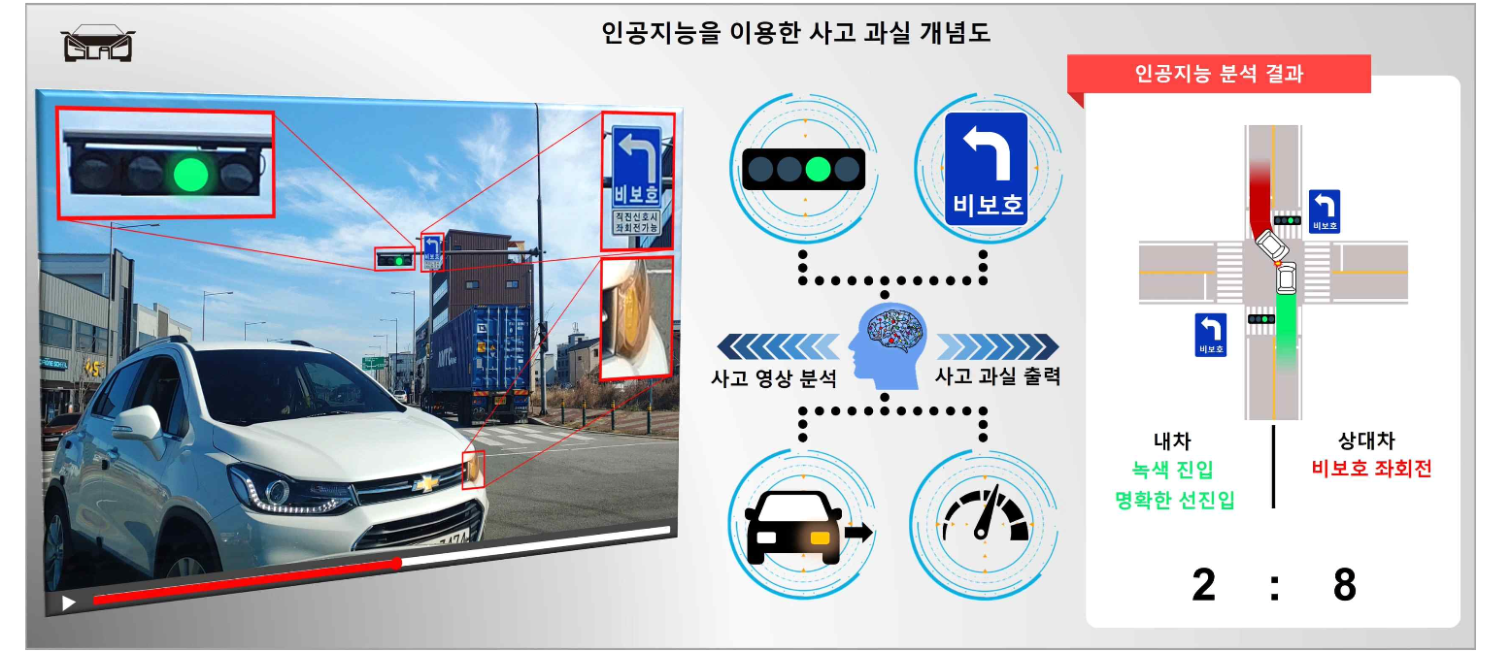[Figure 3] Conceptual diagram of traffic accident error evaluation technology using artificial intelligence

In this situation, the research team drew attention by analyzing 1,200 accident videos recorded on the black box, training it on an artificial intelligence network, and developing a technology that evaluates negligence in traffic accidents.

Since the black box video contains information about the accident situation as it is, it was conceived that the most objective evaluation would be possible if artificial intelligence, which has no subjective point of view, evaluates the fault of the accident.

To analyze the accident video, 'spatial information' such as roads and lanes and 'temporal information' such as the movement of the vehicle in the accident must be analyzed at the same time, so the research team utilized 3D CNN* technology that enables simultaneous analysis.

* 3D CNN (3D Convolutional Neural Networks): A network based on CNN, a deep learning structure imitating the human optic nerve. The well-known 2D CNN deals with two-dimensional data such as images, while 3D CNN analyzes and learns videos by adding a time axis.

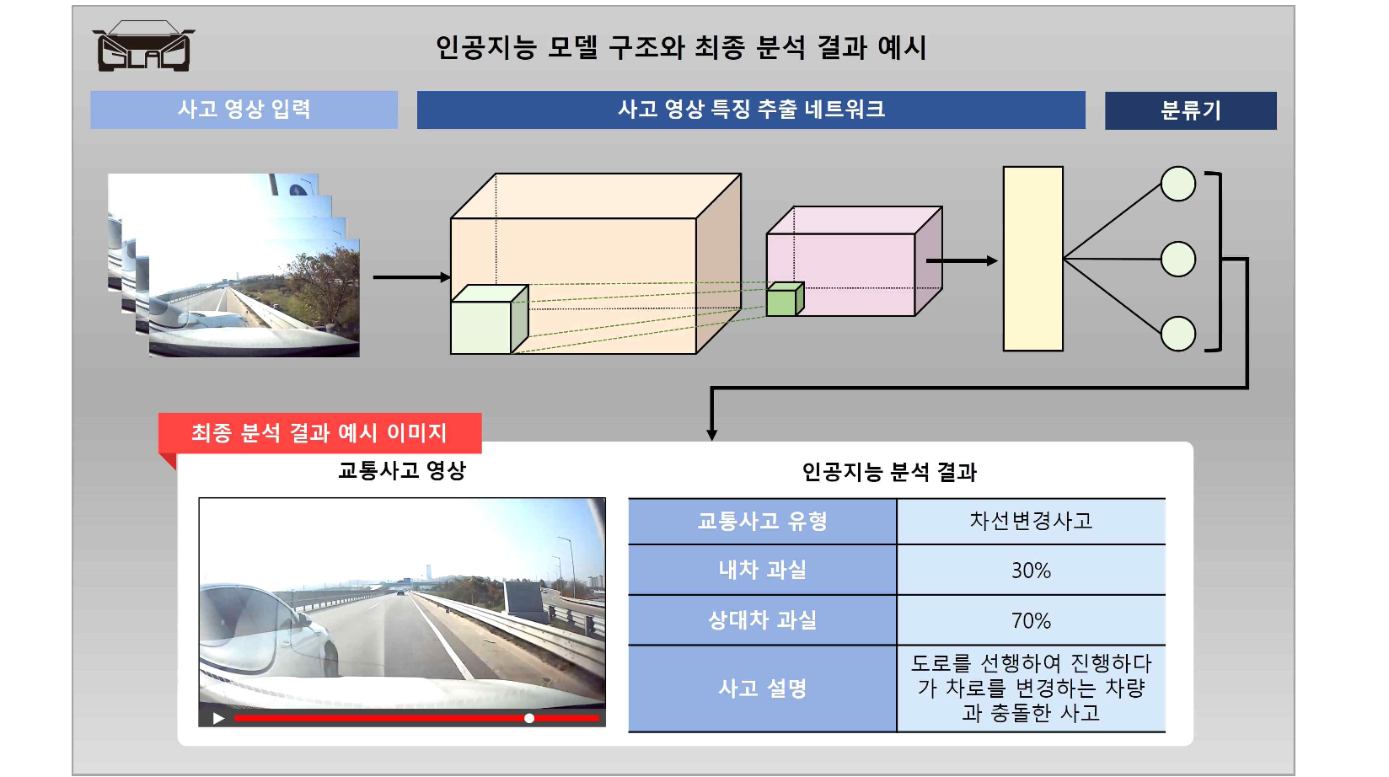[Figure 4] Example of artificial intelligence model structure and final result

Existing artificial intelligence video analysis technology was mainly a method of classifying repetitive movements such as running or swimming, but in accident videos, various movements such as lane changes and collisions must be combined over time to determine the final accident at fault.

The research team revealed that they were able to develop the technology by accumulating accident-related information over time and then analyzing the accumulated information to evaluate the final accident error.



