Development of defect-free ‘quasi-two-dimensional’ perovskite solar cell materials

- Expected to be applicable to various optoelectronic semiconductor devices

▲ (From left) School of Materials Science and Engineering Professor Kwanghee Lee, Graduate School of Energy Convergence Professor Heejoo Kim

Gwangju Institute of Science and Technology (President Kichul Lim Ki-cheol) School of Materials Science and Engineering Professor Kwanghee Lee and Graduate School of Energy Convergence Professor Heejoo Kim joint research team applied simple post-processing technology to quasi-two-dimensional (qusai-2D)* perovskite** material to address material defects***. It was announced that they had developed a solar cell material that secured efficiency and stability.

* quasi-two dimension: A structure that is not a periodic three-dimensional structure within the mathematical plane and is not a completely two-dimensional structure and has a finite atomic or nanoscale thickness.

** perovskite: The crystal structure of a mineral discovered in the Ural Mountains of Russia in 1839, derived from the name of mineralogist Lev Perovski (1792-1856). The perovskite structure is attracting attention as a next-generation solar cell material due to its high charge transfer ability and light absorption.

*** defect: A part in a crystal where the periodic arrangement of atoms is broken. It is known as one of the causes of deterioration of perovskite solar cells.

Perovskite solar cells are attracting attention as next-generation solar cells because they show similar efficiencies to existing commercially available silicon-based solar cells.

However, for commercialization, it is essential to secure long-term stability as well as efficiency, and the deterioration in device performance due to the hygroscopic nature of the perovskite material itself is becoming a major obstacle to securing long-term stability.

* hygroscopic: The property of a material to absorb moisture in the air.

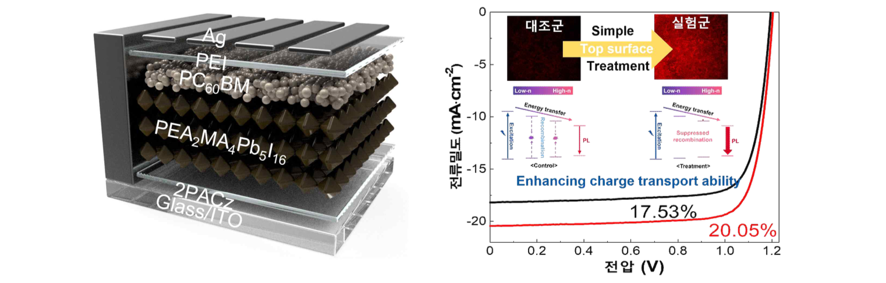(Picture 1) Structure of the quasi-two-dimensional perovskite material-based solar cell fabricated in this study (left) and characteristics of the quasi-two-dimensional perovskite material and solar cell improved through post-processing of the developed functional single molecule (right). - Through the functional monomolecular post-processing method developed in this study for quasi-two-dimensional perovskite materials, not only can the crystal arrangement of the material be controlled in the vertical direction but more efficient charge transport was achieved passivating defects on the surface and inside. Through this, the improved optical properties of the material itself and the development of a more high-performance quasi-two-dimensional perovskite material-based solar cell were achieved.

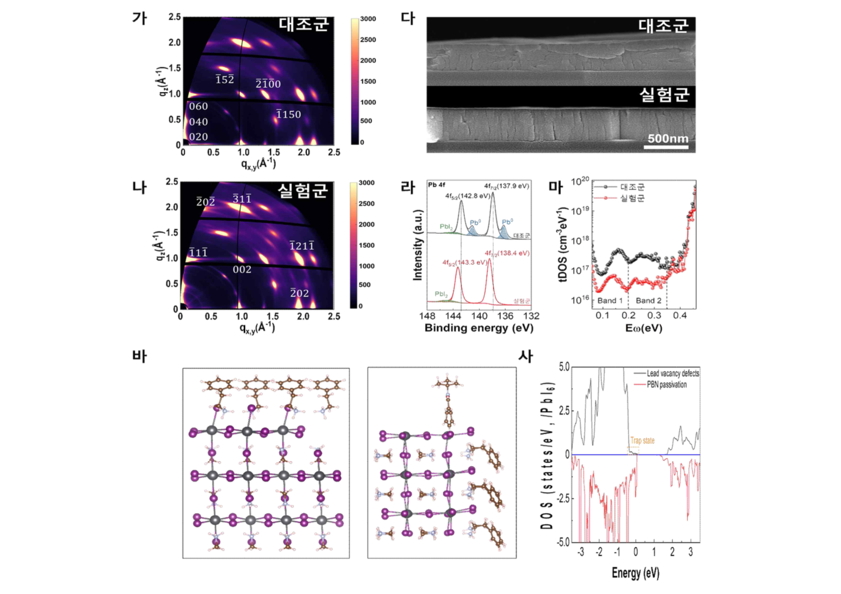(Figure 2) Analysis of the crystallinity of the quasi-two-dimensional perovskite material developed through this research technology (가, 나), cross-sectional observation image of the quasi-two-dimensional perovskite material (다), defect passivation effect (라, 마) and molecular simulation-related data (바, 사). - When the functional monomolecular post-processing method developed in this study was applied to a quasi-two-dimensional perovskite material, the crystal arrangement in the vertical direction was induced using a grazing angle X-ray diffraction measurement method and a scanning electron microscope using facilities in the Pohang Accelerator Laboratory and was confirmed through analysis. In addition, X-rays to confirm the passivation function of defects present inside the perovskite material of the treated monomolecular molecule. Using admittance and molecular simulation analysis techniques, it was confirmed that defects inside the material were reduced by the functional single molecule developed in this study.

Although quasi-two-dimensional perovskite materials with excellent environmental stability can overcome the low long-term stability of existing materials, they are receiving a lot of attention from the academic world. There is a limitation that the difficulty in controlling crystal growth and the low electrical properties due to the defect of the material itself degrade the performance of the solar cell.

Accordingly, the research team succeeded in controlling defects and crystals of quasi-two-dimensional perovskite materials using a simple solution process.

The quasi-two-dimensional perovskite material, which introduced the functional single molecule post-processing method developed by the research team, improved the quality of the material by passivating ionic defects on the surface and inside of the material by the functional single molecule.

* passivation: A state in which a metal has lost its reactivity in its normal state.

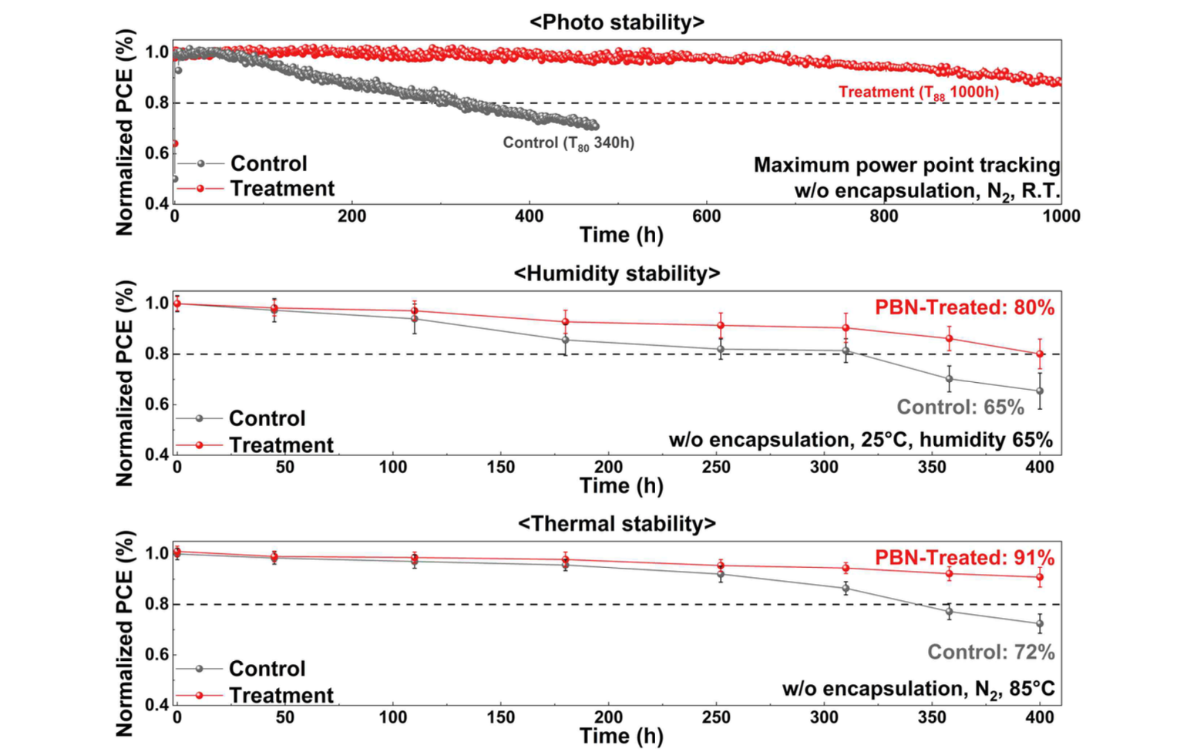(Figure 3) A graph related to the stability of quasi-two-dimensional perovskite solar cells improved through this research technology. Photostability, humidity stability, and thermal stability tests, respectively, from above. - When the functional monomolecular post-processing method developed in this study is applied to quasi-two-dimensional perovskite solar cells, it was confirmed to have higher stability than conventional solar cells in long-term stability tests for each item such as light, humidity, and heat.

The solar cell using the developed quasi-two-dimensional perovskite material showed a high efficiency of 20.05% and showed excellent photostability with a decrease of about 12% compared to the initial efficiency even after 1,000 hours of accelerated experiments, as well as high thermal and moisture resistance.

Professor Kwanghee Lee said, "Through this study, we presented a clue to the development of high-performance quasi-two-dimensional perovskite material-based optoelectronic devices. In the future, it is expected that it will be used in various fields closely related to real life, such as the development of integrated solar cells for vehicles and buildings, and semiconductor devices based on high-performance perovskite materials."

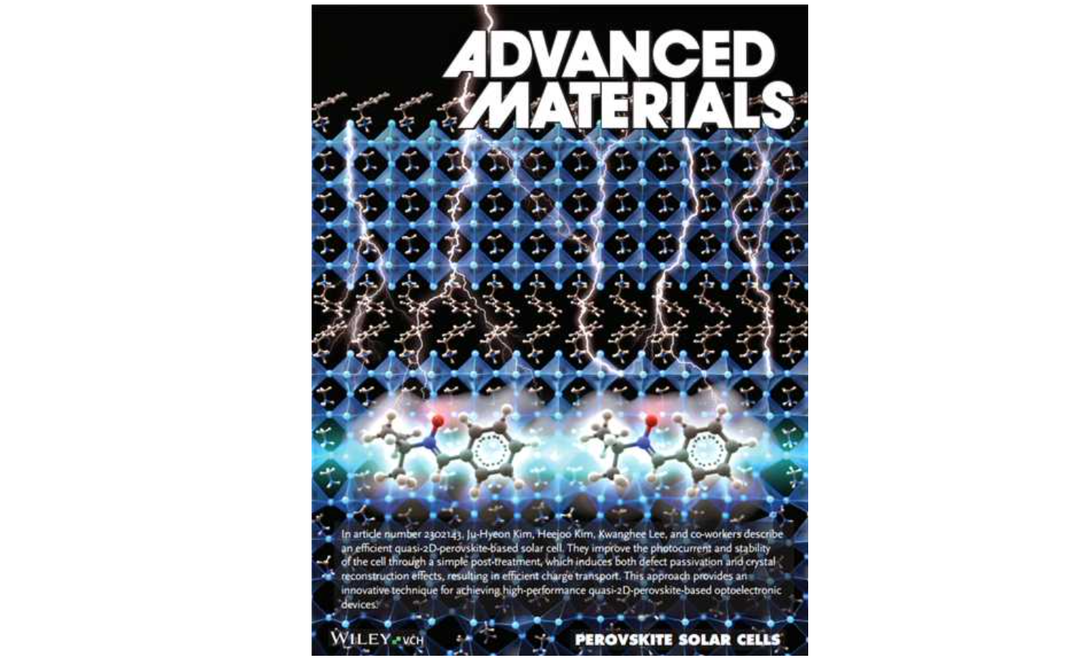(Figure 4) A picture of this study was selected as the front cover paper. - A picture showing the increase in crystallinity and electrical properties of quasi-two-dimensional perovskite materials through the post-processing of functional monomolecules developed in this study.

The results of this research, which were carried out with support from the Ministry of Science and ICT and the National Research Foundation of Korea, which were supported by the climate change response technology development project, were published as the front cover (frontispiece) paper in Advanced Materials, an international academic journal in the field of materials and was published on August 3.



