Discovery of a powerful antibiotic drug against super bacteria

- Success in discovery of antibacterial peptoid effective drug and identification of mechanism

▲ Department of Chemistry Professor Jiwon Seo

A research team in Korea has discovered a powerful antibiotic drug that kills super bacteria that have become resistant to existing antibiotics.

The National Research Foundation of Korea (Chairman Kwang-bok Lee) announced that a joint research team led by Professor Jiwon Seo of the Gwangju Institute of Science and Technology and Dr. Seongsoo Lee of the Korea Basic Science Institute discovered an effective antibacterial treatment substance with reduced toxicity while being effective against multidrug-resistant bacteria.

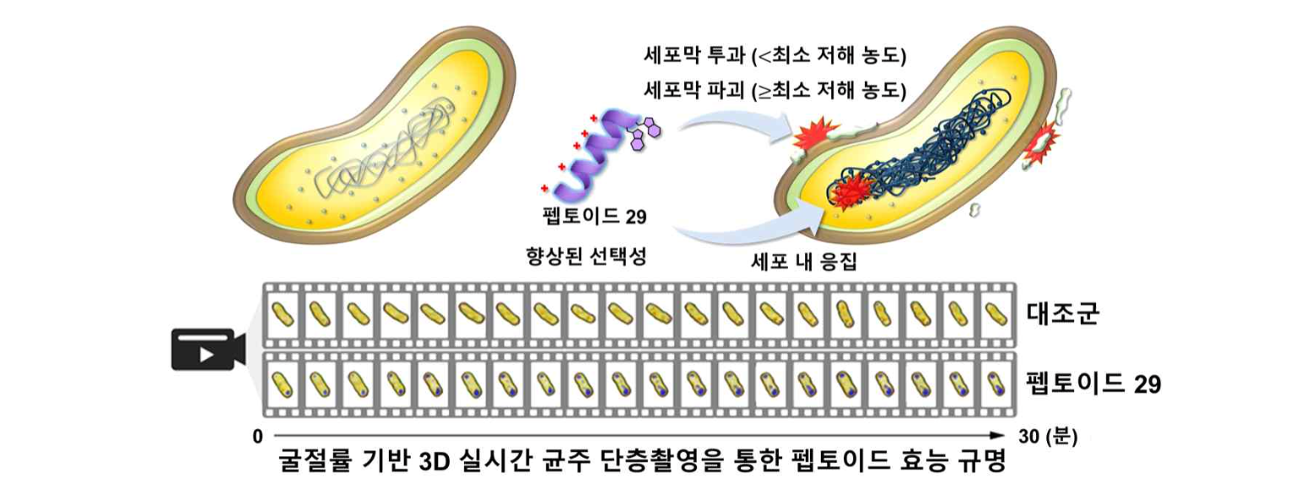(Figure 1) Identification of antibiotic principles for the treatment of multidrug-resistant bacteria using 3-dimensional holotomography. Principles of cell membrane disruption and intracellular protein/nucleic acid aggregation by antibacterial peptoids. This was directly identified through refractive index-based 3D real-time strain tomography.

Superbacterial infections that have become resistant to antibiotics do not spread as quickly as coronaviruses, but the fatality rate is much higher once infected.

he World Health Organization (WHO) has estimated that the number of deaths caused by multidrug-resistant bacteria* will reach 10 million annually by 2050. This is equivalent to the number of deaths from cancer last year.

In 2016, multidrug-resistant bacteria that are resistant to all antibiotics possessed by humankind were discovered in the United States, and it was reported by the Centers for Disease Control and Prevention (CDC) that deaths occurred as a result of infection with this bacteria. Therefore, the development of new antibiotics capable of overcoming resistance is urgently required.

* Multidrug-resistant bacteria: Bacteria that are resistant to multiple antibiotics, limiting the availability of antibiotics for the treatment of infectious diseases.

The research team paid attention to the antibacterial peptides possessed by the organism's own self-defense immune system.

The research team first developed an antibacterial peptoid* designed to bind well with bacterial cell membranes. This peptoid showed low toxicity to human cells such as red blood cells, but showed broad activity against various bacterial strains including multidrug-resistant bacteria.

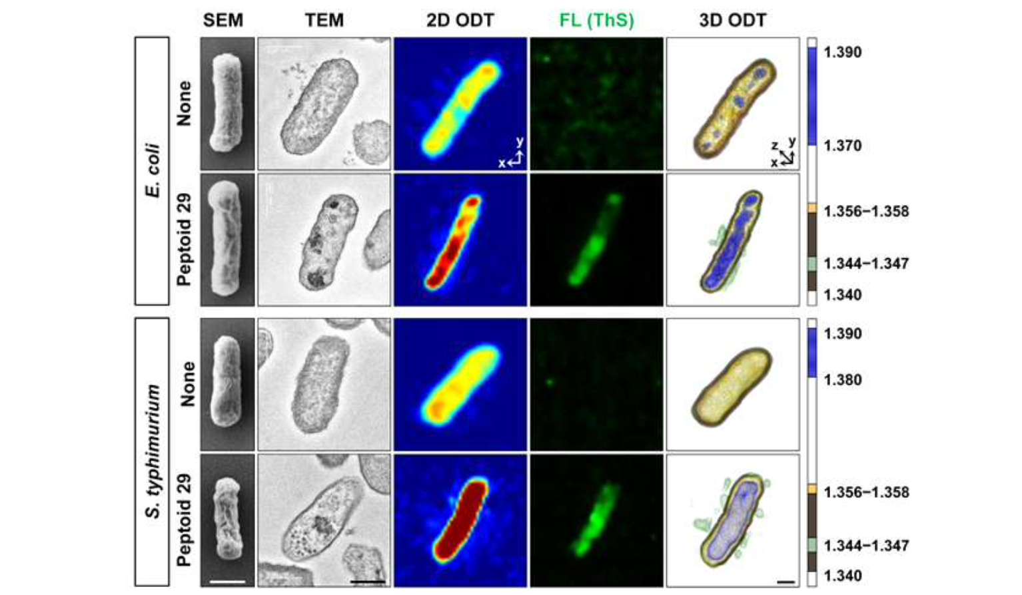(Figure 2) Cross-validation of multi-target mechanism effect of antibacterial peptoid treatment against Gram-negative bacteria (E. coli, Salmonella). Mechanism cross-validation and identification was through electron microscopy, fluorescence microscopy, and 3D holography tomography microscopy.

In addition, the multi-target mechanism ** action that induces the aggregation of various organelles and genes in cells along with destruction of the cell membrane was revealed.

The research team synthesized a library of 80 kinds of peptoids and discovered peptoid 29 as an effective substance through antibacterial activity and toxicity screening. It was confirmed that the action of peptoid 29 to kill bacteria occurred in a short time.

* peptoid: A new substance derived from a peptide that artificially mimics the structure of a representative peptide biomolecule.

** multi-target mechanism: This refers to the principle of simultaneously attacking and killing several targets essential for the survival and reproduction of bacteria, and is known to be effective in suppressing the expression of resistance.

In the process of killing bacteria by antibacterial peptoids, they succeeded in directly identifying the mechanism, which previously could only be proved indirectly, using a refractive index-based 3D holographic tomography microscope* for the first time in the world.

* refractive index-based 3D holography tomography microscope: Microscope capable of intracellular tomography. Continuous images can be obtained by real-time monitoring of cell membranes, cytoplasm, and organelles with different refractive indices.

Professor Jiwon Seo said, "The antibacterial peptoid based on the multi-target mechanism discovered this time is expected to lead to research on the development of multi-drug resistant bacteria in the future."

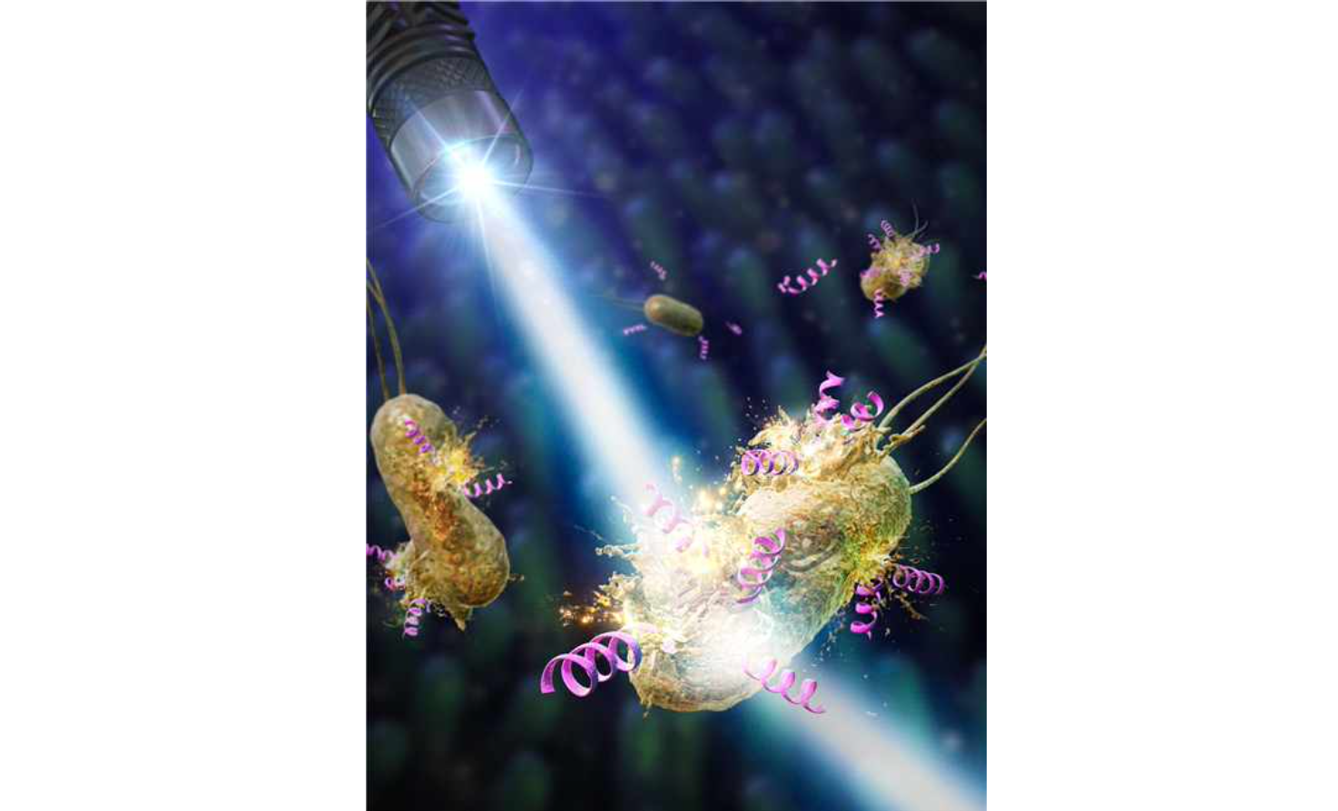(Figure 3) Journal cover art (front inside cover) representative image. Imaging of bacterial killing through a multi-target mechanism of antimicrobial peptoids (pink). Selected for Advanced Science inside front cover.

The outcome of this research, which was carried out with the support of the mid-level researcher support project promoted by the Ministry of Science and ICT and the National Research Foundation of Korea, was published on the online edition of the journal cover on June 21, 2023, in the international journal Advanced Science.



