“Treatment of myocardial infarction by applying it to the heart” GIST-Chonnam National University Hospital develops hydrogel myocardial patch

- Developed a ‘conductive hydrogel myocardial patch’ that can be easily applied to the heart of patients with myocardial infarction and treated
- High therapeutic effect expected due to excellent electrical activity and adhesiveness... published in ‘ACS Nano’

▲ [Photo] (From left) GIST School of Materials Science and Engineering Professor Jae Young Lee, Ph.D. student Mingyu Lee, Chonnam National University Hospital Professor Youngkeun Ahn, and Professor Yong Sook Kim

GIST (Gwangju Institute of Science and Technology, President Kichul Lim) School of Materials Science and Engineering Professor Jae Young Lee’s research team, along with Chonnam National University Hospital Professor Youngkeun Ahn, succeeded in producing a ‘conductive hydrogel myocardial patch’ that can be applied to the heart to treat myocardial infarction.

Ischemic heart disease, one of the common causes of death, is a disease caused by necrosis of the myocardium when blood vessels are blocked due to myocardial infarction or atherosclerosis and oxygen supply to the heart becomes difficult.

Heart failure, in which cardiac function does not recover after myocardial infarction and worsens, is also rapidly increasing, but heart transplant donors are in short supply compared to the demand, and new myocardial infarction treatments based on biomaterials are being studied.

The use of 'myocardial patches' can prevent thinning of the ventricular wall and dilation of the ventricles by physically supporting the heart's beating, but surgical sutures, medical staples, etc. to secure the myocardial patch can cause side effects such as bleeding or inflammatory reactions.

Accordingly, myocardial patches that can be adhered to the heart are attracting attention, and among them, the 'conductive hydrogel myocardial patch', which has electrical conductivity, is known to promote the regeneration of cardiac function with reduced electrical activity, enabling effective treatment. However, the myocardial patches developed so far have low electrical activity with concerns about potential toxicity.

The research team is attracting attention by producing a 'conductive hydrogel myocardial patch' that can be applied to the heart and has high electrical conductivity and adhesiveness.

This patch can be stably adhered to the outer wall of the heart without invasiveness, and can also regenerate electrical activity in myocardial tissue thanks to its high electrical conductivity.

The research team introduced ‘MXene*’, a two-dimensional conductive material, to realize high electrical activity. By mixing biocompatible natural polymer oxidized dextran and gelatin, it was designed to create a conductive hydrogel myocardial patch on the heart surface in a short time and show strong adhesion.

* MXene: MXene is a two-dimensional nanomaterial with a layered structure formed by combining carbon or nitrogen with a transition metal. It has high electrical conductivity and has hydrophilicity due to the presence of hydroxide or oxygen on the surface, so it can easily interact with hydrogel.

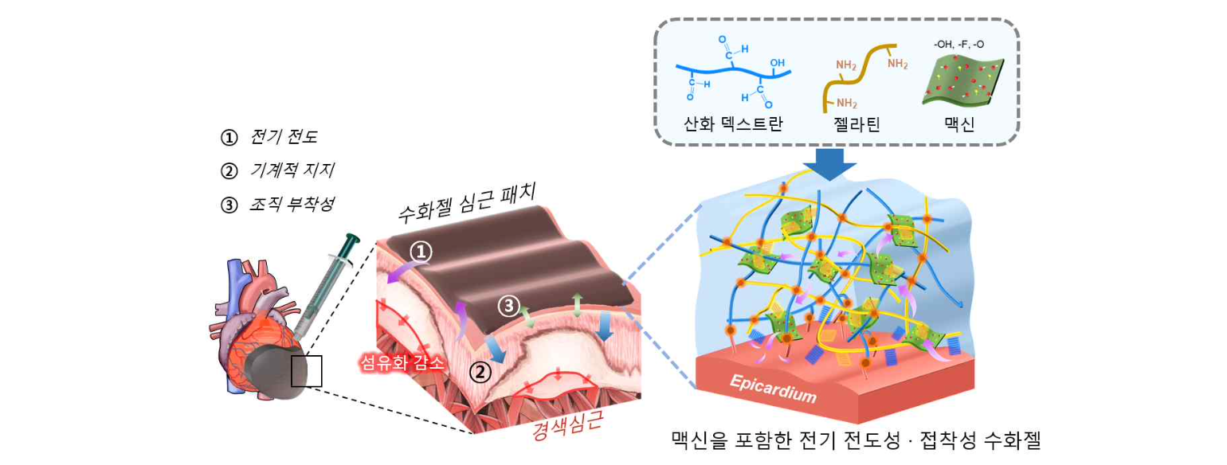[Figure 1] A schematic diagram of an electrically conductive and adhesive hydrogel myocardial patch that can be applied to the heart. A myocardial patch that can form a hydrogel within 5 minutes after mixing the solution and can be formed in situ on the outer wall of the heart. It has mechanical properties similar to myocardium, high electrical conductivity, and stable tissue adhesion, so it can effectively regenerate myocardium.

This myocardial patch not only formed a hydrogel within 5 minutes after mixing the solution and could be applied to the outer heart wall, but also showed mechanical properties similar to myocardial tissue. In addition, it can promote regeneration by increasing the electrical activity of necrotic myocardium and has stable adhesion that can withstand physical shock.

Compared to fibrin glue, a biological adhesive currently used for medical purposes, it was confirmed that it showed 10 times higher adhesiveness in heart tissue.

In particular, it showed excellent biocompatibility with cardiomyocytes, such as improved maturity of cardiomyocytes cultured on hydrogel.

In addition, this myocardial patch was effective in regenerating the function and structure of the damaged heart after myocardial infarction.

When this myocardial patch was attached to the heart of a laboratory rat that suffered myocardial infarction, after 2 weeks, ventricular fibrosis* was reduced and cardiac function was restored through ultrasound examination. New blood vessels and electrical activity in myocardial tissue increased and the inflammatory response decreased.

* fibrosis: A phenomenon in which fibrous connective tissue is excessively accumulated. In the case of the heart, the tissue hardens, resulting in structural changes and reduced function.

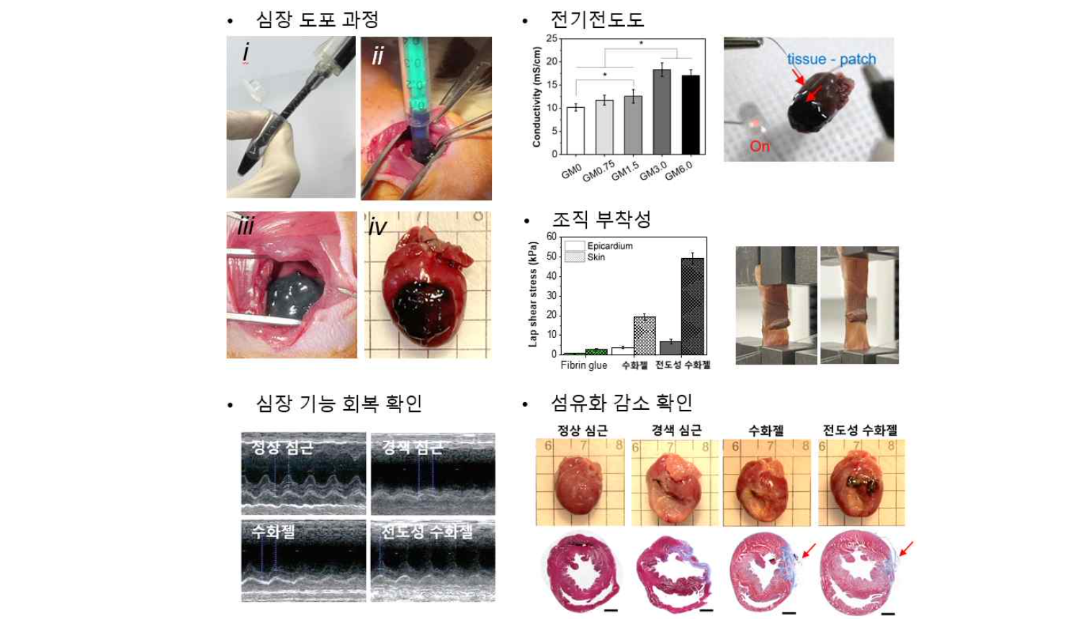[Picture 2] Results of characterization of the electrically conductive and adhesive hydrogel myocardial patch: applicability, electrical conductivity, tissue adhesion, recovery of cardiac function and reduction of fibrosis of the hydrogel myocardial patch.

Professor Jae Young Lee said, "A conductive hydrogel myocardial patch that can be easily applied to the extracardiac wall beyond the limitations of existing myocardial patches was created. It is expected to be used as a myocardial patch platform that can easily and effectively treat myocardial infarction in the future."

This joint research, led by Professor Lee, Chonnam National University Hospital Professors Youngkeun Ahn and Yong Sook Kim, and conducted by Ph.D. student Mingyu Lee, was carried out with support from the National Research Foundation of Korea's basic research laboratory project, and was published in 'ACS Nano', an international journal in the field of materials, on June 20 day was published.



