GIST opens a new way to treat non-alcoholic fatty liver disease

- Professor Chang-Myung Oh’s research team found a way to improve fatty liver by suppressing specific proteins
- Influence on hepatic fat metabolism control and inflammatory response... expected new treatment possibilities

▲ Department of Biomedical Science and Engineering Professor Chang-Myung Oh and master's graduate Jibeom Lee

GIST (Gwangju Institute of Science and Technology, President Kichul Lim) Department of Biomedical Science and Engineering Professor Chang-Myung Oh's research is attracting attention by discovering a protein that affects non-alcoholic fatty liver and suggesting a method to treat non-alcoholic fatty liver by suppressing it.

Non-alcoholic fatty liver is a metabolic disease that is increasing worldwide along with obesity and diabetes, but many studies are needed because effective treatment methods have not been developed.

The research team found that inhibiting a protein called ‘lymphocyte antigen 6D (LY6D)*’ could prevent and treat non-alcoholic fatty liver disease. Rat experiments demonstrated that this protein affects the regulation of fat metabolism and inflammatory responses in the liver.

* lymphocyte antigen 6D (LY6D, lymphocyte antigen 6 family member D): A protein located in the extracellular region and plasma membrane, predicted as a marker for the early stage of lymphocyte development, but its exact function and role are unknown.

The research team found that this protein was increased in mice fed a high-sugar diet, and severe fat accumulation was caused when the protein was highly expressed.

In addition, through the Genotypic-Tissue Expression Project Database*, it was confirmed that people with high expression of this protein in the liver had more severe histological changes in fatty liver disease.

* Genotype-Tissue Expression, GTEx: A project that organizes genetic mutations and gene expression changes in 54 tissues. It describes genetic variations and their effects on gene expression, and provides public databases and tissue biobanks.

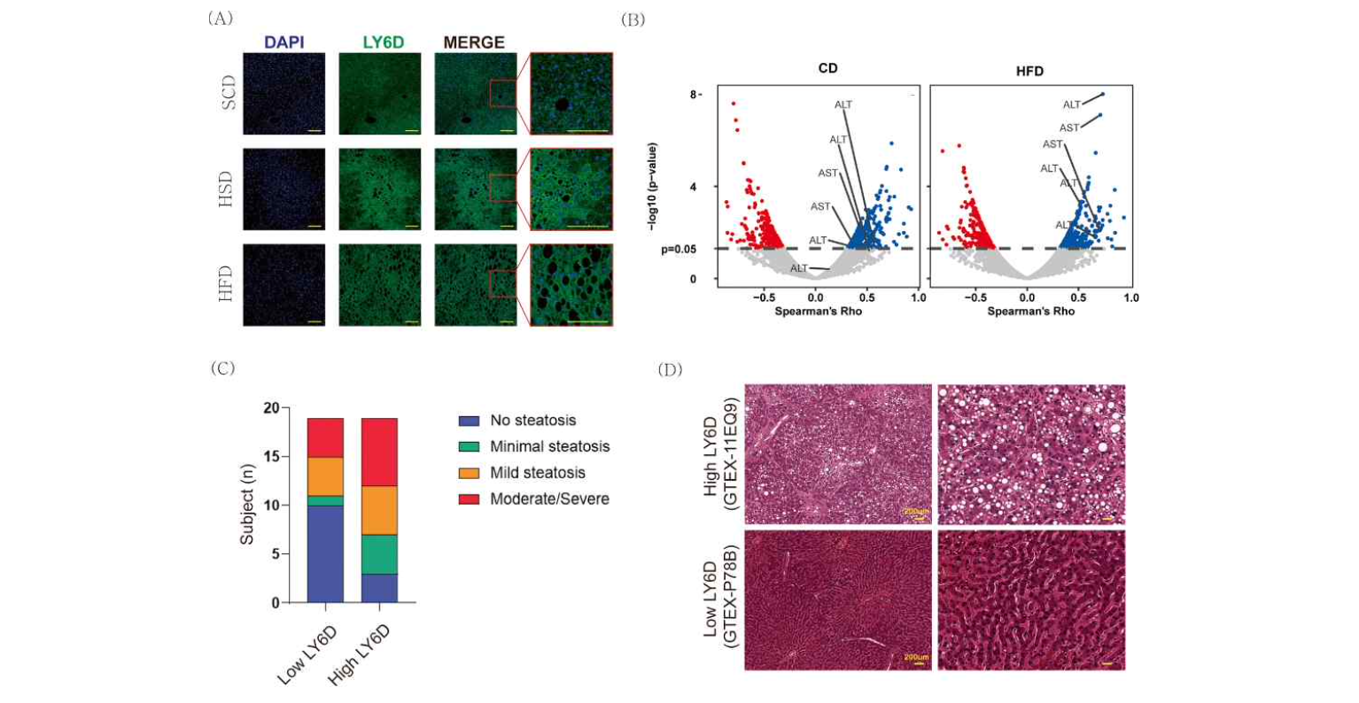[Figure 1] Confirmation that LY6D expression varies depending on the diet in rat liver, and the degree of fatty liver varies according to the LY6D expression level in human liver tissue

When the research team expressed the gene of this protein more than 100 times, it was confirmed that genes related to high fat intake or fat metabolism were more expressed than the control group. Conversely, inhibition of this protein in mice with non-alcoholic fatty liver improved symptoms.

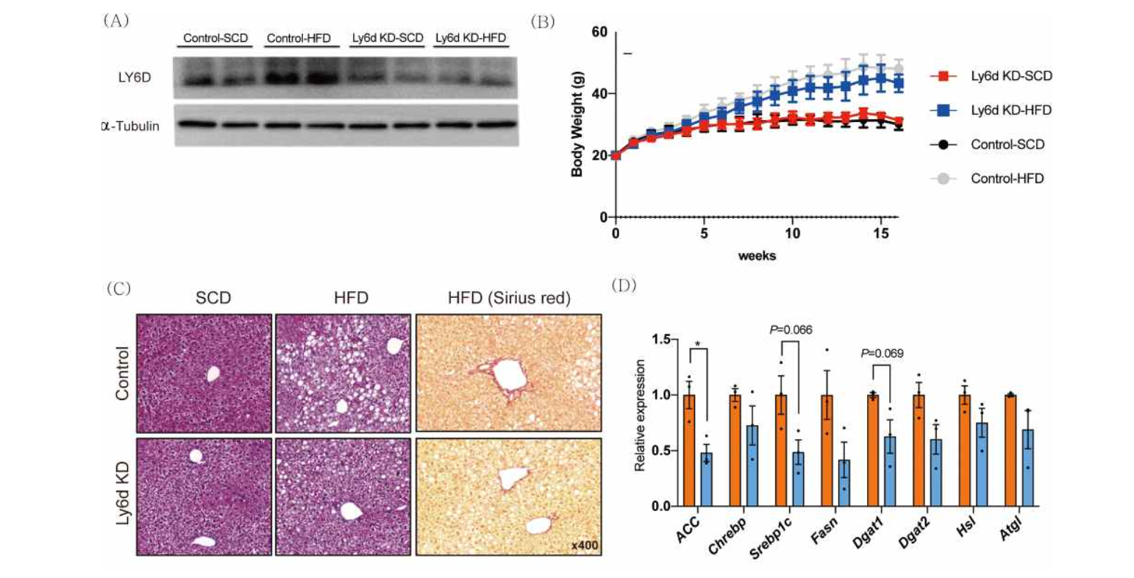[Figure 2] Targeting the liver-specific Ly6d inhibition mouse model, it was confirmed that fatty liver due to high-fat diet was improved in the mouse model

Professor Chang-Myung Oh said, "Through this research result, a new treatment target for non-alcoholic fatty liver was found. Inhibiting this protein to induce fat metabolism control and inflammation suppression in the liver is expected to open up new treatment possibilities."

The research, led by Professor Oh and conducted by Jibeom Lee, a master's graduate from GIST, was supported by the Korea Research Foundation's Excellent New Research Project and the GIST Integrated Institute of Biomedical Research, and was published on July 3 in the international journal Experimental & Molecular Medicine (EMM).



