"I caught two rabbits, efficiency and longevity!" development of organic solar cell process simplification technology

- Breaking away from the existing process of multi-layer coating... Simplified by introducing a material that forms a protective layer on its own
- Higher battery efficiency and significantly longer lifespan, published in 「Advanced Science」, an internationally renowned academic journal

▲ (From left) Dr. Hongkyu Kang, Director Kwanghee Lee, Dr. Soyeong Jeong (first author)

enomenon in which the strong oxidizer generated on the surface of a photocatalyst irradiated with ultraviolet rays decomposes substances adsorbed on the surface of a photocatalyst.

Several attempts have been made to cover the passivation layer on the zinc oxide, but the manufacturing cost has risen due to the complicated coating process.

The research team applied 'fullerene-based self-assembly material (hereafter referred to as C60-SAM)'*, a single-molecular material*, on zinc oxide to form a protective layer on its own, securing the stability of zinc oxide and improving the efficiency and lifespan of the battery. In addition, it succeeded in simplifying the coating process.

* monomolecular substance: a substance made by connecting a small number of organic substances, which has higher solubility than polymers and is easy to synthesize, enabling various uses

* fullerene-based self-assembled material (C60-SAM): A material that spontaneously forms a thin ‘Self-Assembled Monolayer’ on the surface through interactions between functional groups based on fullerene (C60)

Taking advantage of the fact that C60-SAM forms a thin layer on the surface when it meets zinc oxide, the research team mixed C60-SAM with a photoactive material to coat it and reacted with zinc oxide to form a protective layer on its own. A condensation reaction* occurred between the carboxylic acid end group of C60-SAM and the hydroxyl group on the surface of zinc oxide, and a protective layer could be stably formed between them.

* condensation reaction: a reaction in which two or more molecules of an organic compound react to remove simple molecules such as water to form a new compound

In particular, the lifespan of organic solar cells has been significantly improved, with the time it takes for the efficiency of organic solar cells to drop by 10% to about 24 times, from 20 minutes to 8 hours.

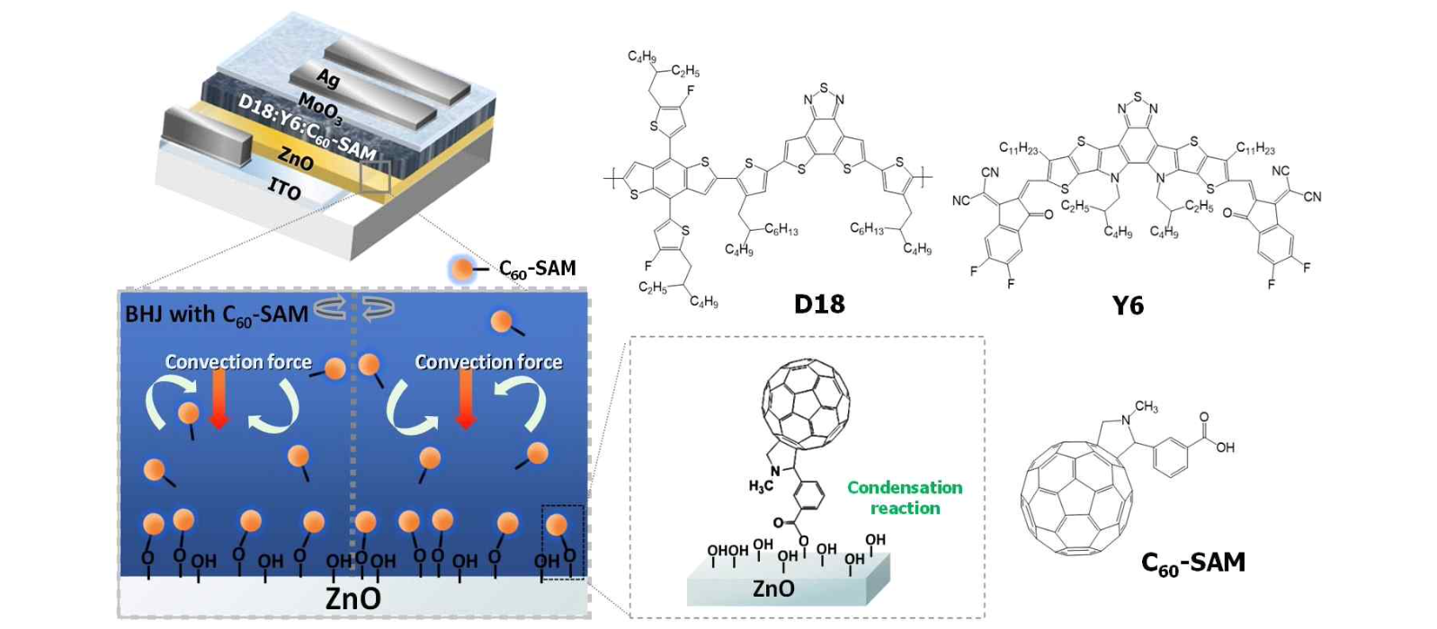▲ Molecular structure and vertical self-assembly mechanism diagram of organic solar cell structure, photoactive material and C60-SAM material

Dr. Hongkyu Kang said, "This study is significant in solving the stability problem that occurs between the electron transport layer and the photoactive layer of an inverted organic solar cell with a new method of forming a protective film using a self-assembled layer. Organic solar cells can greatly improve mass productivity even if only one coating process is reduced, which will be of great help to commercialization."

This research, which was conducted jointly by the research team of Dr. Hongkyu Kang, Director Kwanghee Lee of the Research Institute for Solar and Sustainable Energies and the research team of Professor James R. Durrant of Imperial College London, and in which Dr. Soyeong Jeong from GIST participated as the first author, was part of the Climate Change Response Technology Development Project of the Ministry of Science and ICT and was carried out with the support of the new researcher support project and the GIST development project supervised by the Next Generation Energy Research Institute.



