Development of an electrolyte to innovate the performance of redox batteries with “no risk of explosion, high capacity and high output”

- GIST Professors Seung Joon Yoo and Sukwon Hong's research team developed a functional electrolyte that uses organic molecules as an energy storage source
- Realization of high-capacity redox battery by increasing solubility more than 6 times... published in 「ACS Energy Letters」

▲ (From left) School of Materials Science and Engineering Professor Seung Joon Yoo, master's student Jinhyuck Ko, Department of Chemistry Professor Sukwon Hong, Ph.D. student Jinhwan Byeon

Lithium-ion batteries, which are widely used in energy storage systems (ESS)* today, have a short lifespan and there is a risk of explosion due to battery overheating, so batteries of various materials are being researched. One of them is the ‘redox battery’, which is relatively inexpensive, has a long lifespan, and has a low risk of explosion.

Redox is a compound word of reduction and oxidation. A redox battery is a battery that stores and releases electricity as chemical energy in the electrolyte by causing an ‘oxidation-reduction’ action of active materials* in the electrolyte. Since water-based electrolyte is used, fire caused by overheating of the battery can be fundamentally blocked.

* energy storage system: A device that stores electricity generated by solar and wind power in large quantities and releases it when needed. It is essential for expanding new and renewable energy.

* active material: A material that produces electrical energy through a chemical reaction when the battery is discharged.

GIST (Gwangju Institute of Science and Technology, Acting President Raekil Park) Professor Seung Joon Yoo and Professor Sukwon Hong's joint research team developed an electrolyte that greatly improves the performance of redox-active organic molecules* and succeeded in realizing a high-capacity, high-output redox battery.

It is a hybrid battery that maximizes capacity by adding the energy storage/release mechanism of the ‘oxidation-reduction’ of a secondary battery to a supercapacitor* capable of high output.

* redox active organic molecule: It is an active material capable of high energy storage because solubility or electrochemical redox potential can be controlled through various synthesis methods and molecular structure design.

* supercapacitor: An energy storage device that stores energy and supplies electricity with high output instantaneously when needed. It has low energy storage capacity but strong instantaneous output capacity.

By using the ‘hydrotrope supported electrolyte’* developed by the research team, the solubility of organic molecules used in redox batteries is significantly improved to six times higher than before, enabling the development of high-capacity redox batteries.

To increase the energy capacity of electrochemical-based ESSs such as redox batteries, high concentrations of active materials must be soluble in the electrolyte. However, there is a problem in that the solubility of the active material itself is low or the solubility is lowered when a supporting electrolyte is added to increase the ionic conductivity.

The research team focused on the concept of ‘hydrotrope’, which makes substances that do not easily combine with water molecules dissolve easily in water, and developed a molecule that has a hydrotrope structure and acts as a supporting electrolyte. With this support electrolyte, it is possible to simultaneously improve the solubility and ionic conductivity of active substances.

* hydrotrope: A low-molecular-weight substance that has an ‘amphiphilic property’ that is friendly to both water and oil. Unlike conventional surfactants, it is a generic term for molecular structures known to improve the aqueous solubility of substances that are insoluble in water through amorphous nanostructures.

* supporting electrolyte: An electrolyte dissolved for the purpose of lowering the resistance of a solution in an electrochemical-based battery, etc.

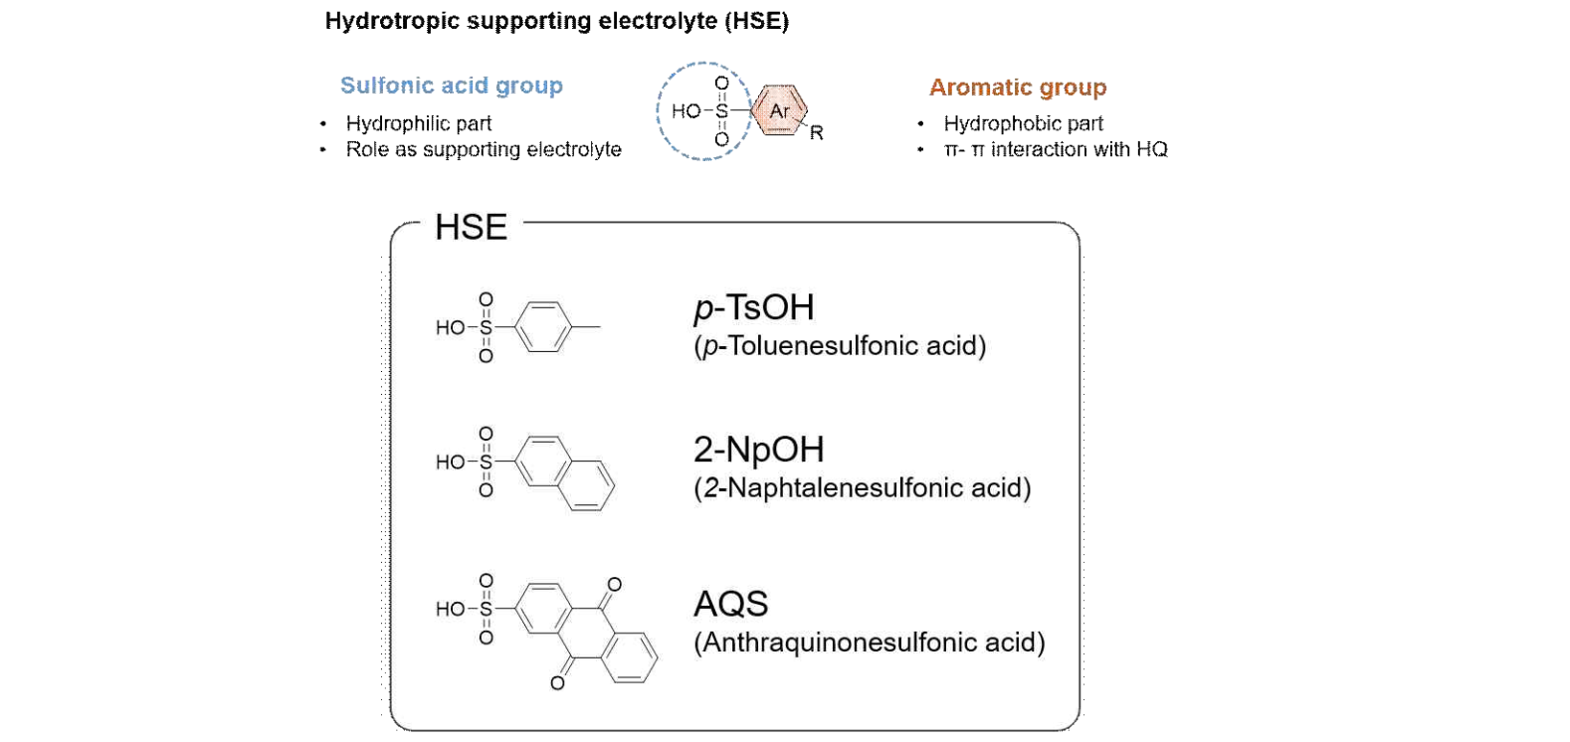[Figure 1] Hydrotrope supported electrolyte (HSE) molecular structure and function of each structure and types of HSE used in this study.

In addition, the research team devised a redox-active organic molecule optimized for this supporting electrolyte, enabling the battery to operate stably even in a high-concentration electrolyte solution.

Even in a high concentration (0.5Mol/L) electrolyte, the active organic molecules operated stably. This is the highest concentration among quinone-based redox batteries developed to date.

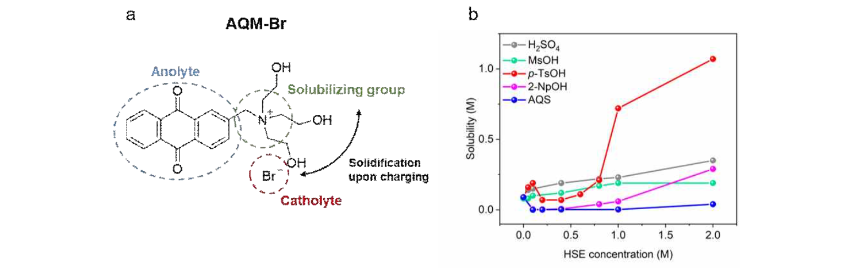[Figure 2] a. 2-[N,N,N-tris(2-hydroxyethyl)]anthracenemethanaminum-9,10-dione bromide (AQM-Br), an organic molecule with electrochemical activity (redox activity) optimized for the newly developed HSE
b. Solubility change graph for each concentration in each HSE solution of AQM-Br. When p-TsOH electrolyte is used, the solubility is rapidly improved.

In particular, the research team introduced a nuclear magnetic resonance measurement method using the nuclear overhauser effect* for the first time in the related field to identify the physicochemical principle that hydrotrope electrolytes increase the solubility of redox active materials. It was confirmed that the mechanism of action of the hydrotrope occurs differently depending on the structure of the active substance, and guidelines for the molecular structure optimized for each mechanism were presented.

* intermolecular nuclear overhauser effect: This is a method of measuring the distance between hydrogen atoms in each molecule by using nuclear spin transfer between hydrogen atoms in different molecules.

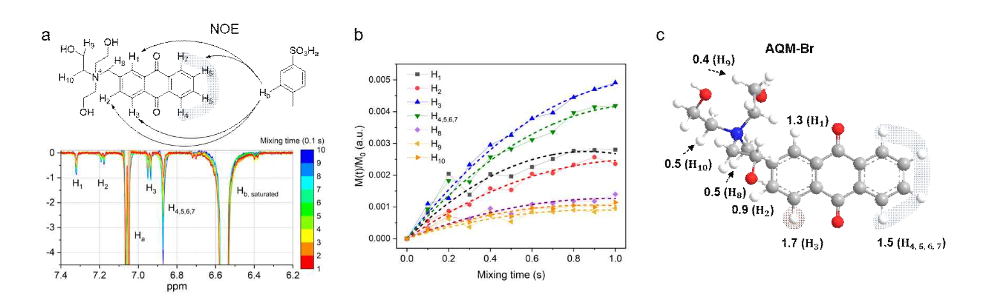[Figure 3] a. Intermolecular nuclear overhauser effect measurement conceptual diagram and actual acquired spectrum
b. Intensity change of the nuclear Oberhauser spectrum with time
c. Nuclear Overhauser effect intensity distribution of each hydrogen in AQM-Br and its indirect distance from the hydrotrope.

School of Materials Science and Engineering Professor Seung Joon Yoo said, "As a result of this research, it is possible to improve the low solubility, which is a chronic limitation of redox-active organic molecules, and it is expected that there will be achievements in the development of energy storage sources with various molecular structures as well as the development of high-capacity and high-output redox batteries. Taking advantage of the advantage of using liquid as an energy storage source in the future will help develop application technologies such as large-sized ESS."

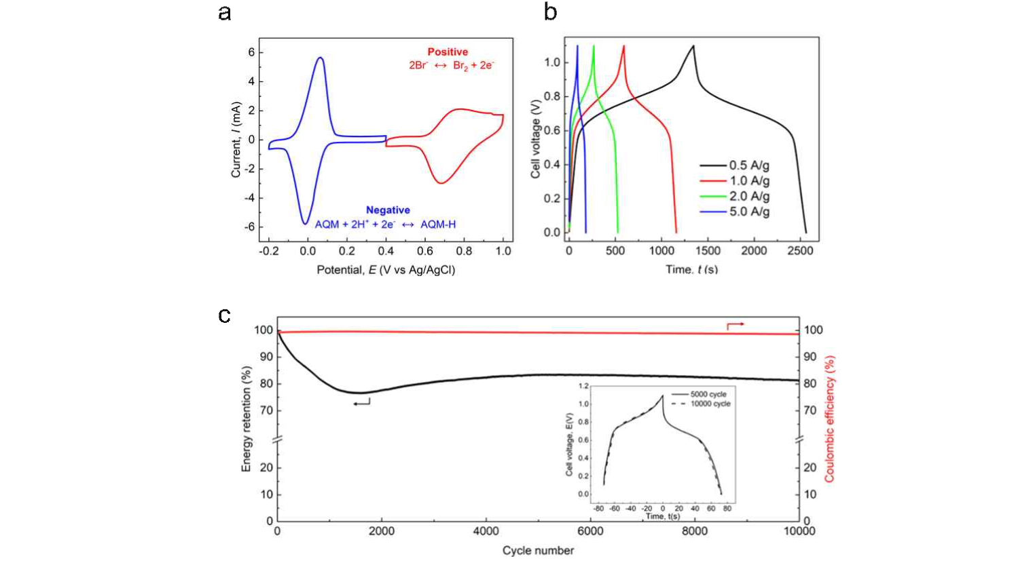[Figure 4] Performance analysis of redox supercapacitor using AQM-Br.
a. Measurement of the electrochemical stability of AQM-Br by cyclic voltammetry
b. Measurement of charge/discharge performance of supercapacitor according to current level
c. Confirmed that performance remains stable during 10,000 charge/discharge cycles

This research was jointly led by School of Materials Science and Engineering Professor Seung Joon Yoo and Department of Chemistry Professor Sukwon Hong and conducted by co-first authors Ph.D. student Jinhwan Byeon and master's student Jinhyuck Ko with the support of the Personal Basic Research Project of the Ministry of Science and ICT and the National Research Foundation of Korea, and was published on April 21 in ACS Energy Letters, an internationally renowned journal in the field of electrochemistry and energy.



