GIST succeeded in generating extreme ultraviolet rays with ‘liquid film’

- Breaking the existing method and using a liquid rather than a solid... Even if it hits a high-power laser beam, it's fine
- Expected development of extreme ultraviolet light source for semiconductor imaging, published in <Nature Communications>

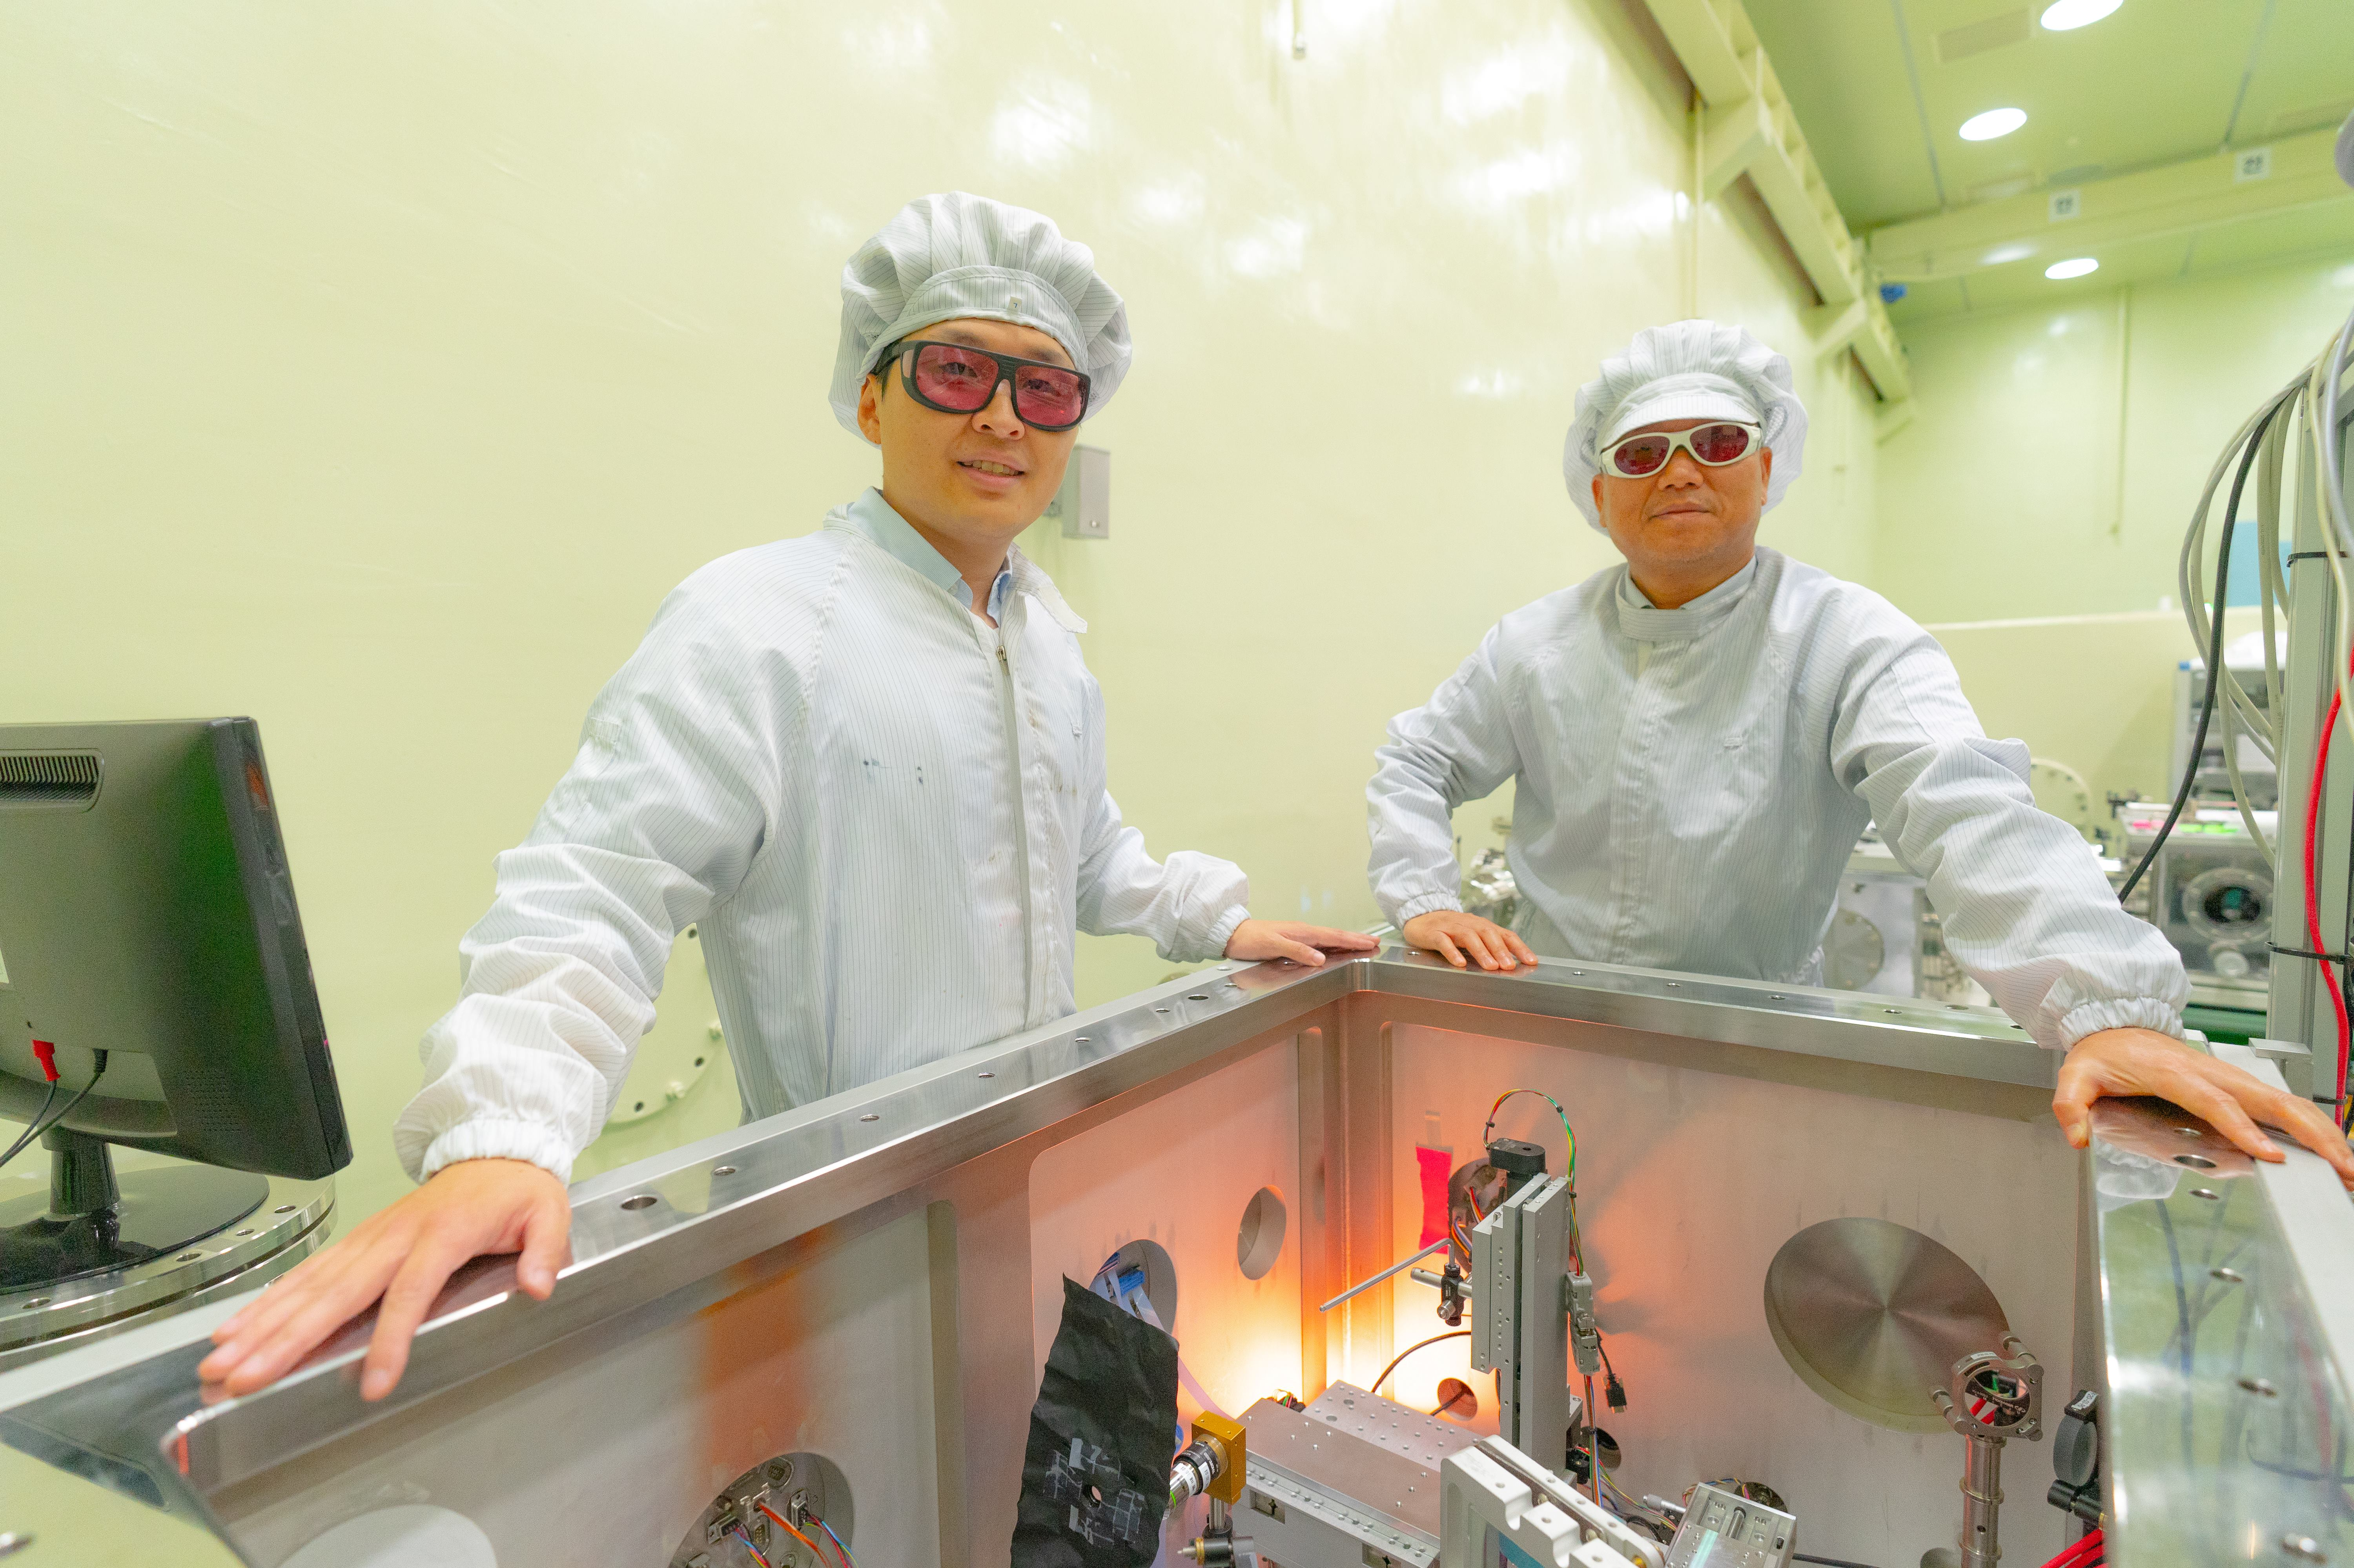▲ (From left) Dr. Yang Hwan Kim from the Center for Relativistic Laser at Institute for Basic Science and Professor Kyung Taec Kim of Department of Physics and Optical Sciences at GIST

GIST (Gwangju Institute of Science and Technology, Acting President Raekil Park) has succeeded in creating extreme ultraviolet rays by focusing (collecting and confining) high-power lasers on a liquid film.

Extreme ultraviolet rays are short-wavelength light with a wavelength of 10 to 124 nm (nanometer, 1 nm is one billionth of a meter), and it is used for precise work such as drawing circuits on semiconductor substrates or imaging to observe materials with nanometer resolution.

Since a large number of EUV pulses per unit time are required to study the interaction between laser and plasma or EUV imaging, it is essential to develop an extreme ultraviolet light source that is generated at a high repetition rate*.

To create extreme ultraviolet rays, a high-power laser must be focused on a dense target like a solid, and electrons generated through the ionization process must be accelerated to a speed close to that of light. It was difficult to create extreme ultraviolet rays with a high repetition rate.

* repetition rate: The degree to which pulses (waves) generated per unit time are repeated

The research team paid attention to the fact that the liquid can flow without changing its shape if conditions such as speed and viscosity are satisfied when the liquid flows.

By colliding two jets of liquid at high pressure, they create a thin film of liquid that retains its shape while flowing quickly. An ultra-high-power laser was focused on this liquid film to generate extreme ultraviolet rays.

The flat shape of the liquid film is also damaged when the laser beam hits it, but since the liquid film flows down quickly, a clean liquid film is naturally regenerated before the next laser beam hits it. Using this, the research team succeeded in generating extreme ultraviolet rays by focusing the laser at a high repetition rate of 1 kHz (kilohertz, 1,000 waves in one second).

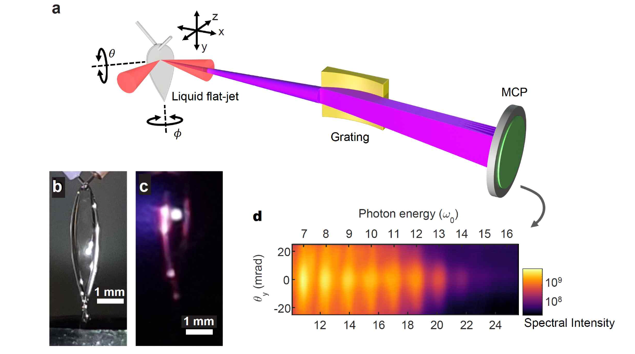▲ A schematic diagram of an extreme ultraviolet generation experiment using a liquid film. (a) Generation experiment device, (b) liquid film, (c) plasma generation by focusing laser on the liquid film, (d) generated extreme ultraviolet spectrum.

By using a liquid, it was possible to develop an extreme ultraviolet light source with a high repetition rate. It has become possible to measure plasma dynamics, which was previously impossible, and to measure extreme ultraviolet wave shapes that occur in the relativistic domain.

If this technology is developed, it is expected that it will be possible to develop powerful extreme ultraviolet light sources for use in industrial settings, such as imaging technology using extreme ultraviolet rays.

Department of Physics and Photon Science Professor Kyung Taec Kim said, "This research achievement is significant in that it succeeded for the first time in a new method using a liquid film. It is expected to be used not only in basic research such as ultra-fast laser-plasma interaction research but also in industrial settings."

This research, led by Professor Kim and conducted by Dr. Yang Hwan Kim from the Center for Relativistic Laser at the Institute for Basic Science, was supported by the National Research Foundation of Korea's mid-level researcher support project and the Institute for Basic Science's support for laser-matter interaction research in the field of relativity using superpower lasers. The study was conducted and published on April 22 in the internationally renowned journal 'Nature Communications'.



