“Opening a new chapter to increase the efficiency of future devices” to succeed in controlling interactions within materials with artificial composite structures

- GIST-Sungkyunkwan University succeeds in precise control of electron-lattice interaction... up to 300 times stronger
- Expected to improve solar cell efficiency by presenting a new platform to enhance the performance of future thermoelectric and photoelectric devices

▲ GIST Department of Physics and Photon Science Ph.D. student In Hyeok Choi and Professor Lee Jong-seok

GIST (Gwangju Institute of Science and Technology, Acting President Raekil Park) succeeded in freely controlling the strength of interaction between electrons and lattice* through precise control at the atomic level in a superlattice* structure made of metals and nonmetals with a research team from Sungkyunkwan University.

The results of this research were published online on April 13, 2023 in Advanced Science, a world-renowned academic journal in the field of basic and applied research in materials science.

* superlattice: A structure in which two or more types of materials are made of periodic layers that are usually several nanometers thick.

* lattice: Refers to a structure that is repeatedly arranged according to the rule of symmetry, and the smallest unit of the structure that is repeatedly arranged is called a lattice point.

The interaction between electrons and lattice is a fundamental action that occurs inside a solid and plays a large role in determining the physical properties of electrons such as superconductivity and the performance of thermoelectric devices and photoelectric devices.

In order to increase the efficiency of future devices, the strength of this interaction must be increased. Since the strength of the interaction between electrons and lattice is a unique property of each material, it was not only difficult to artificially control but also to measure quantitatively.

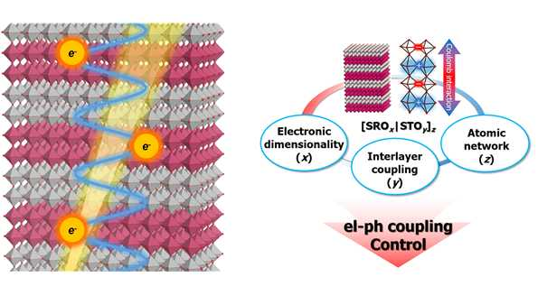
▲ Schematic diagram of electron-lattice interaction control in a metal-nonmetal superlattice

The research team succeeded in precisely adjusting the thickness and number of repetitions of each layer of the artificial composite structure* on an atomic level, allowing the strength of the interaction between electrons and lattice to be freely controlled. In particular, it attracted attention by increasing its intensity by more than 300 times under optimal conditions.

* artificial heterostructure: A structure in which different materials are artificially joined together, and various physical phenomena can be induced through interactions between materials.

The artificial composite structure was made in the form of a superlattice in which strontium ruthenate (SrRuO3), a metal oxide, and strontium titanate (SrTiO3), a non-metal oxide, were combined. The research team adjusted the thickness and number of repetitions of these metal oxides and non-metal oxides. The thinner the thickness and the greater the number of repetitions, the stronger the interaction.

In addition, the research team found that the strength of the interaction can be greatly increased by the interaction between the two-dimensional state electrons and the superlattice in the metal oxide.

When the thickness of the metal oxide is reduced, electrons change from a three-dimensional state to a two-dimensional state. Electrons in a two-dimensional state can only move in a direction parallel to the sample, reducing the electric field shielding effect* in the vertical direction. As a result, a strong interaction occurs between the superlattice and the two-dimensional state electrons, which causes electromagnetic interaction between each layer of metal oxide while the electromagnetic force in the vertical direction is not canceled and diffuses.

* electric-field screening effect: A phenomenon in which free electrons in metal move along the external electric field and cancel the electric field inside the metal.

In particular, the strength of the interaction between electrons and the lattice could be precisely measured through pump-probe thermal reflectance* experiments using an ultrashort femtosecond laser.

When a solid is irradiated with light, the light energy is transferred to the electrons of the solid, increasing the temperature by hundreds of degrees or more, and a non-equilibrium state occurs where the temperature of the electrons and the lattice are different. At this time, the equilibrium state with the same temperature is restored through the interaction between the electron and the lattice. The research team quantitatively confirmed the strength of the interaction by tracking and measuring the time taken during this process in real time using the pump-probe thermal reflectance.

* pump-probe thermal reflectance: A technology that can track the reflectance of a photoexcited material in femtosecond units (1/1000 trillionth of a second) by using the path difference between the pump and probe beams.

GIST Department of Physics and Photon Science Professor Lee Jong-seok said, "It was found that the strength of the interaction between electrons and lattice, which is a unique property of matter, can be controlled and greatly improved. This study presented a new platform to fundamentally improve the operating speed and efficiency of thermoelectric and photoelectric devices and is expected to greatly contribute to improving the energy efficiency of photoelectric devices and thermoelectric devices in the future."

This research was conducted by GIST Professor Jong Seok Lee and Professor WooSeok Choi of the Department of Physics at Sungkyunkwan University and with GIST Ph.D. student In Hyeok Choi and Sungkyunkwan UniversityDr. Seung Gyo Jeong with support from the National Research Foundation of Korea mid-level researcher project and the nano and material technology development projects.



