Despite global warming, the cold wave from the Arctic remains, making predictions more difficult

- Analysis of 40-year data and future climate forecast data by a Korea-US joint research team including GIST Professor Jin-Ho Yoon
- Arctic warming makes it difficult to predict cold waves in mid-latitude regions... Published in Nature’s sister magazine on March 27

▲ (From left) School of Earth Sciences and Environmental Engineering Professor Jin-Ho Yoon and Ph.D. student Yungi Hong

As global warming intensifies, contrary to the rising temperature of the earth and the Arctic, abnormal weather phenomena such as cold waves and heavy snowfall in winter have recently occurred in mid-latitude regions such as East Asia and North America.

This phenomenon, in which Arctic warming leads to cold waves in mid-latitude regions in winter, is called the ‘Warm Arctic Cold Continent (WACC)’.

However, as global warming progresses, a new study finds that the link between Arctic warming in winter and mid-latitude temperatures becomes more uncertain than at present.

The Korea-US joint research team, in which GIST (Gwangju Institute of Science and Technology, Acting President Raekil Park) participated, comprehensively analyzed past climate data for the past 40 years and future climate projections that predicted global warming by 1.5 degrees or 2.0 degrees. As a result of the analysis, it was revealed that even if the earth becomes hotter, the arctic cold wave in winter still exists, but the correlation will decrease.

According to domestic media, 1) in the winter of 2022 and 2023, abnormally high temperatures and extreme cold appear alternately, and the number of patients with cold diseases that occurred from December to January 27 increased by 66% compared to the same period last year. 2) When comparing Seoul temperatures in the winter of 2023 with previous years, it was reported that mid-December was the coldest since meteorological observations and early January was the warmest since meteorological observations.

1) “Cold disease patients continue to rise... 66% increase from last winter”, KBS, January 29, 2023
2) “Breaking a new record for cold weather in the middle of the day, why extreme weather without a middle?”, MBC, January 24, 2023

In fact, as a result of the research team's analysis, the temperature in the Arctic region is becoming warmer on average by more than twice as much as in other regions* due to climate change, and this phenomenon is related to the decrease of glaciers and the increase in atmospheric and ocean temperatures. Rapidly rising Arctic temperatures have a significant impact on the climate of not only the Arctic region but also the mid-latitude regions.

* For every 1 degree increase in global temperature, the Arctic temperature increases by about 2.5 degrees.
** For past climate data, the research team used reanalysis data from the European Center for Medium-Range Weather Forecasting (ECMWF), a European medium-scale forecasting center. The results of the 'HAPPI Project (Half a degree Additional Warming, Prognosis and Projected Impacts)' conducted by various international research teams were used.

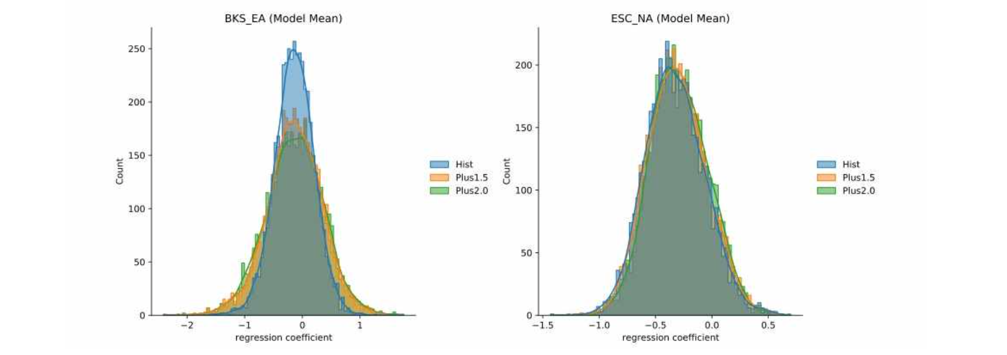▲ Distribution of regression coefficients for three scenarios (past, 1.5 degree and 2.0 degree warming scenarios) in the HAPPI model. In all scenarios, East Asia (Figure 2 left) and North America (Figure 2 right) have negative correlations with respect to the Barents Kara Sea and the East Siberian Sea, respectively, as in the observations. (Figure 2 left) In the 1.5 degree and 2.0 degree warming scenarios, it can be seen that the distribution of correlations in East Asia widens.

Through data analysis, the research team confirmed that the climate pattern of 'warm arctic, cold continent' exists every year, but its intensity is changing every year. It was analyzed that this phenomenon appears regardless of global warming and is a pattern that appears repeatedly in winter.

The research team predicted that even if the earth warmed by 1.5 degrees or 2.0 degrees, these patterns would exist, but the variability would increase. So far, arctic warming has been used as a predictor of cold waves in winter, but this suggests that it may become difficult to use arctic warming as a useful factor in predicting mid-latitude cold waves in the future under warmer conditions.

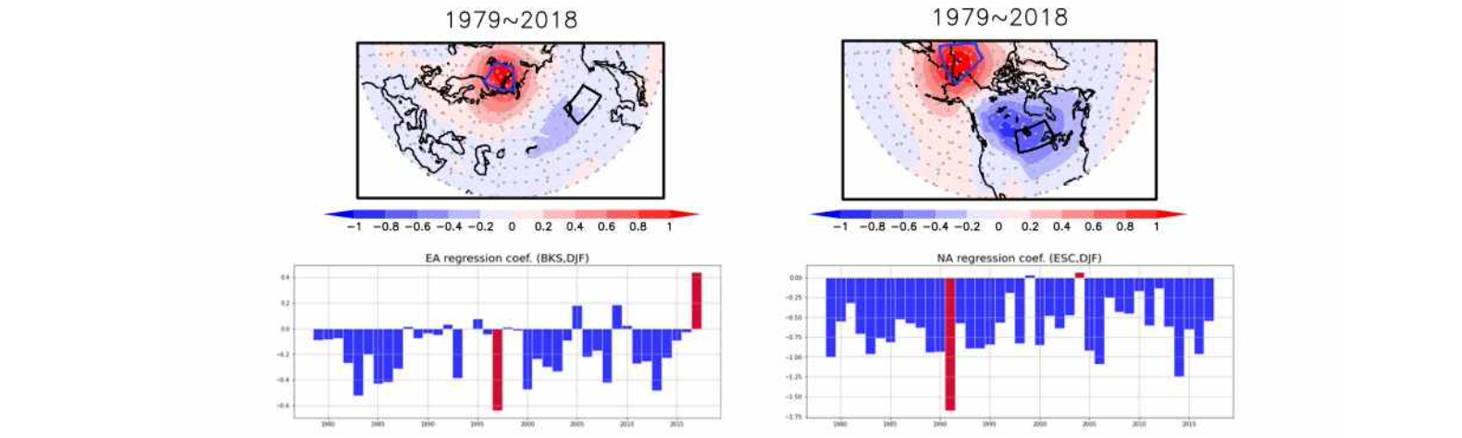▲ 850 hPa temperature regression analysis results for the Barents Kara Sea temperature (left) and the East Siberian Churhae temperature (right): (Figure 1 top) East Asia and North America showed a negative correlation for the Barents Kara Sea and the East Siberian Sea, respectively. (Figure 1 bottom) Looking at the regression coefficients for each year in East Asia and North America, there is an overall negative correlation, with annual variability.

Professor Jin-Ho Yoon said, "While many studies are being conducted on the causes of abnormally high temperatures and cold waves that occurred several times in the winter of 2022 and 2023 (December-February each year), cold waves from the Arctic are recognized as a major pattern. Through this study, it was revealed that arctic cold waves still exist even in a hotter future than now, and forecasting may become more difficult."

This research was led by GIST School of Earth Sciences and Environmental Engineering Professor Jin-Ho Yoon and Ph.D. student Yungi Hong with participation by Utah State University Professor S.-Y. Simon Wang, Seoul National University Professor Seok-Woo Son and Professor Sang-Woo Kim, Chonnam National University Professor Jee-Hoon Jeong, Pukyong National University Professor Baekmin Kim, and KAIST Professor Hyungjun Kim and was supported by the National Research Foundation of Korea Marine Polar Base Technology Development Project, Mid-sized Research Project, and GIST Research Institute.

The research results were published online on March 27, 2023 (Monday), in npj Climate and Atmospheric Science, a sister journal of Nature, an internationally renowned academic journal in the field of meteorology.



