“The era of next-generation electric vehicles with extended lifespan is on the way”
Development of core technology for lithium metal batteries that last four times longer

- Simple electrochemical surface treatment realizes 2.5 times capacity retention rate and 4 times life span
- GIST Professor KwangSup Eom’s team published a thesis in 「Small」, a renowned international academic journal in the field of materials engineering

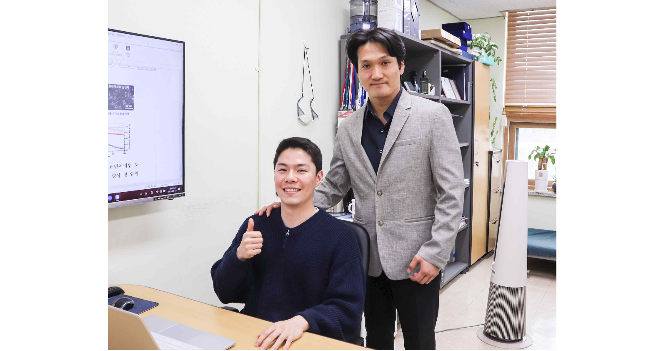▲ (From left) GIST School of Materials Science and Engineering doctoral student Subin Kim and Professor KwangSup Eom

As the demand for secondary batteries increases due to the expansion of electric vehicles, the need for next-generation secondary batteries with higher capacity and faster charging and discharging than the currently widely used lithium-ion batteries is growing.

In the case of graphite, an anode material* for lithium-ion batteries that is commercialized today, it has almost reached its theoretical limit, and it is necessary to develop an anode material with higher capacity to increase energy density. Lithium metal batteries, which replace graphite with lithium metal, can theoretically realize 10 times higher capacity than lithium-ion batteries, and are in the limelight as a next-generation secondary battery system for realizing high energy density*.

However, in lithium metal batteries, lithium dendrites* grow during charging and discharging, breaking through the separator* and causing a short circuit in the battery. It was not commercialized due to safety and durability issues, such as continuous electrolyte decomposition and lithium metal loss, which rapidly reduced the charging and discharging efficiency.

* anode material: It plays an important role in the charging speed and lifespan of a battery by allowing current to flow while storing and releasing lithium ions from the anode.

* energy density: Energy stored in unit volume or unit weight. An indicator of battery efficiency.

* lithium dendrite (Li-dendrite): In the process of charging a lithium metal battery, lithium is non-uniformly deposited on the electrode and grows as a dendrite.

* separator: A thin film of insulating material that prevents contact between the positive and negative electrodes inside the battery relating to the safety of the battery.

GIST (Gwangju Institute of Science and Technology, Acting President Raekil Park) School of Materials Science and Engineering Professor KwangSup Eom's team developed a technology that significantly improves the capacity retention rate and durability of lithium metal batteries through electrochemical pretreatment of copper current collectors*.

* current collector: A part that supplies current to the negative and positive electrodes inside the battery and plays an important role in the charging and discharging speed and stability of the battery.

The research team identified for the first time the catalytic effect of lithium nitrate (LiNO3) decomposition of thiourea in an organic electrolyte. Through a simple electrochemical process using this, an inorganic material-rich artificial solid film was formed on the surface of a copper current collector used for a lithium metal battery anode.

The strong physical properties and ionic conductivity of the artificial solid film had the effect of suppressing the growth of lithium dendrites, which degrades the performance and durability of batteries. It was confirmed that this was due to the large amount of inorganics resulting from the catalytic decomposition of lithium nitrate.

As a result of using a lithium metal anode using the developed copper current collector, the research team succeeded in manufacturing a lithium metal battery with a capacity retention rate 2.5 times higher and a lifespan 4 times higher than that of the existing copper current collector. Existing copper current collectors have reduced their capacity to less than 70% after about 30 charge/discharge cycles. The negative electrode using the newly developed copper current collector was charged more than 120 times. It showed stable performance, such as maintaining more than 70% capacity even after discharging.

In particular, since the electrochemical treatment is performed only by applying a simple electrical signal such as voltage scan*, the electrode manufacturing process can be simplified.

* voltage scan: An electrochemical experiment that changes the voltage, which is the difference between the electrochemical energy levels of the cathode and anode in a battery, at a constant rate.

Professor KwangSup Eom said, "This research achievement is of great significance in that it secured sufficient stability to be used as a current collector for a negative electrode of a lithium metal battery with a small amount of electrolyte additives and simple electrochemical surface treatment. It is expected to contribute to the commercialization of electric vehicles equipped with high-energy lithium metal batteries in the future."

The research was conducted by GIST School of Materials Science and Engineering Professor KwangSup Eom and Ph.D. student Subin Kim with the support of GIST Next Generation Energy Research Institute and Hyundai Motor Company NGV and was published online on March 22, 2023 in Small, an internationally renowned academic journal in the field of materials engineering.



